  Year 6 · Add, subtract, multiply and divide · Step 3  Common multiples | 
  Year 6 · Add, subtract, multiply and divide · Step 3
  Common multiples
  1 | Write the first 8 multiples of each number.  a) 3:  b) 5:  Hint: A multiple is in the times table of the number. Count up in steps of the number: start at it, then add it again and again.
  1 | Write the first 8 multiples of each number.  a) 3:  b) 5:  Hint: A multiple is in the times table of the number. Count up in steps of the number: start at it, then add it again and again.
  2 | Sort the numbers into the diagram. Write each group.  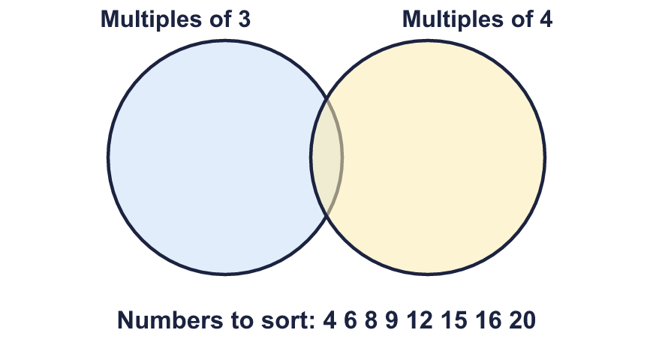  Multiples of 3 only:  Multiples of both:  Multiples of 4 only:  Neither:  Hint: Write the multiples of each number as a list. A common multiple is in BOTH lists.  Multiples of 3 are yellow. Multiples of 4 are orange. Both: yellow with a bold number.  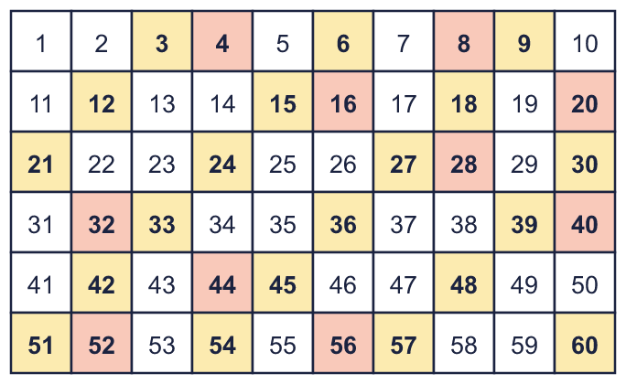
  2 | Sort the numbers into the diagram. Write each group.  Multiples of 3 only:  Multiples of both:  Multiples of 4 only:  Neither:  Hint: Write the multiples of each number as a list. A common multiple is in BOTH lists.  Multiples of 3 are yellow. Multiples of 4 are orange. Both: yellow with a bold number.
  3 | Write the first three common multiples of each pair.  a) 2 and 4:  b) 4 and 5:  c) 3 and 6:  Hint: Write the multiples of each number as a list. A common multiple is in BOTH lists.
  3 | Write the first three common multiples of each pair.  a) 2 and 4:  b) 4 and 5:  c) 3 and 6:  Hint: Write the multiples of each number as a list. A common multiple is in BOTH lists.
  4 | Find the lowest common multiple of each pair.  a) 10 and 15:  b) 4 and 6:  c) 8 and 12:  Hint: The lowest common multiple is the first number that is in both lists of multiples.
  4 | Find the lowest common multiple of each pair.  a) 10 and 15:  b) 4 and 6:  c) 8 and 12:  Hint: The lowest common multiple is the first number that is in both lists of multiples.
  5 | Circle the common multiples of 5 and 6. Write them below.  15 18 20 24 30 36 45  Hint: A common multiple can be divided by 5 and by 6 with nothing left over.
  5 | Circle the common multiples of 5 and 6. Write them below.  15 18 20 24 30 36 45  Hint: A common multiple can be divided by 5 and by 6 with nothing left over.
  6 | Write the first two common multiples of all three numbers.  a) 3, 5, 6:  b) 2, 3, 4:  Hint: Find the lowest common multiple of the first two numbers, then check it works for the third. Add it again to find the next one.
  6 | Write the first two common multiples of all three numbers.  a) 3, 5, 6:  b) 2, 3, 4:  Hint: Find the lowest common multiple of the first two numbers, then check it works for the third. Add it again to find the next one.
  7 | List all the common multiples of 3 and 4 that are more than 20 and less than 40.  Hint: Find the lowest common multiple of 3 and 4 first. Then keep adding it until you pass 40.
  7 | List all the common multiples of 3 and 4 that are more than 20 and less than 40.  Hint: Find the lowest common multiple of 3 and 4 first. Then keep adding it until you pass 40.
  8 | Mason plays tennis every 3 days. Gill plays tennis every 5 days. They both played today.  In how many days will they next both play on the same day?  Hint: They both play again on a day that is a multiple of both numbers. You want the lowest one.
  8 | Mason plays tennis every 3 days. Gill plays tennis every 5 days. They both played today.  In how many days will they next both play on the same day?  Hint: They both play again on a day that is a multiple of both numbers. You want the lowest one.

  9 | a) Will both lights flash together at 408 seconds? Write yes or no.  b) After how many seconds will they next flash together?  Hint: The lights flash together at the common multiples of 8 and 12. Is 408 in the list?
    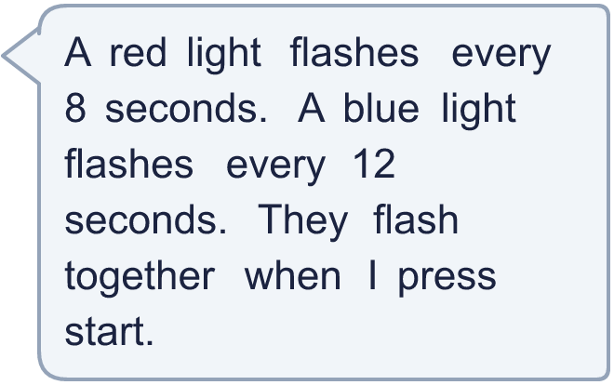
  9 | a) Will both lights flash together at 408 seconds? Write yes or no.  b) After how many seconds will they next flash together?  Hint: The lights flash together at the common multiples of 8 and 12. Is 408 in the list?
  10 | On her 72th birthday, Gran says: “My age is a multiple of both your ages today.” Her two grandchildren are in different school years (aged 5 to 16).  How old could the grandchildren be? Find two different answers.  Hint: Their ages must both divide exactly into 72. Try the numbers from 5 to 16 one at a time.
  10 | On her 72th birthday, Gran says: “My age is a multiple of both your ages today.” Her two grandchildren are in different school years (aged 5 to 16).  How old could the grandchildren be? Find two different answers.  Hint: Their ages must both divide exactly into 72. Try the numbers from 5 to 16 one at a time.
  11 | Is Boba correct? Circle yes or no.  Yes / No  Explain how you know.  Hint: Check the lists of multiples. Is there a smaller number than 96 in both lists?
     | 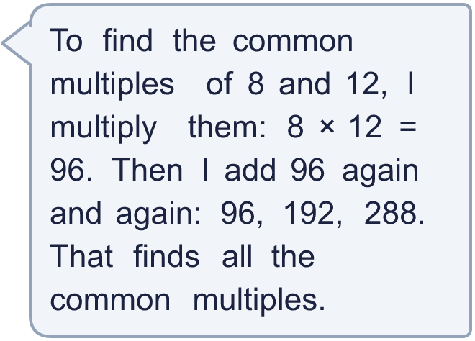
  11 | Is Boba correct? Circle yes or no.  Yes / No  Explain how you know.  Hint: Check the lists of multiples. Is there a smaller number than 96 in both lists?
  12 | How tall could the towers be?  Hint: The height is a multiple of 6 and a multiple of 7. List the common multiples between 40 and 100.
     | 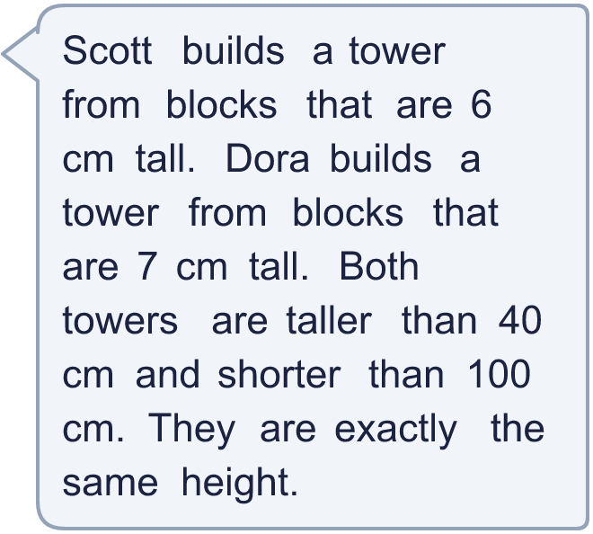
  12 | How tall could the towers be?  Hint: The height is a multiple of 6 and a multiple of 7. List the common multiples between 40 and 100.
  13 | • It is a common multiple of 8 and 12.  • It is more than 45 and less than 105.  • The digits add up to 9.  What is my number?  Hint: Start with the first clue: list some common multiples. Then use the other clues to cross numbers out.
     | 
  13 | • It is a common multiple of 8 and 12.  • It is more than 45 and less than 105.  • The digits add up to 9.  What is my number?  Hint: Start with the first clue: list some common multiples. Then use the other clues to cross numbers out.
  14 | Write three different numbers between 100 and 200 that are common multiples of 6 and 9.  Hint: Find the lowest common multiple of 6 and 9, then keep adding it on until you are past 200.
  14 | Write three different numbers between 100 and 200 that are common multiples of 6 and 9.  Hint: Find the lowest common multiple of 6 and 9, then keep adding it on until you are past 200.

Year 6 · Add, subtract, multiply and divide · Step 3
Common multiples
Answers (teacher copy)

  1 | Write the first 8 multiples of each number.  a) 3: 3, 6, 9, 12, 15, 18, 21, 24  b) 5: 5, 10, 15, 20, 25, 30, 35, 40  Hint: A multiple is in the times table of the number. Count up in steps of the number: start at it, then add it again and again.
  2 | Sort the numbers into the diagram. Write each group.  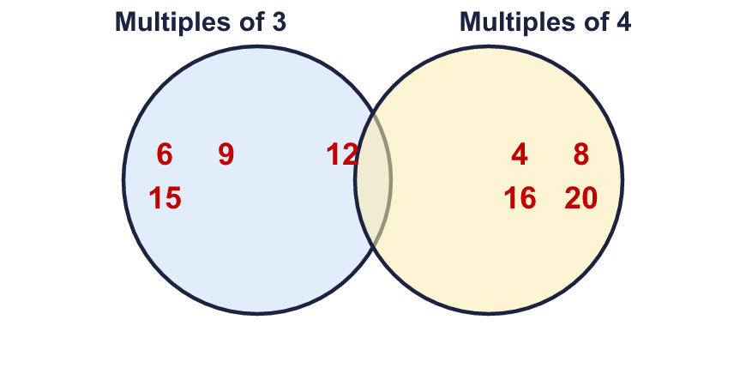  Multiples of 3 only: 6, 9, 15  Multiples of both: 12  Multiples of 4 only: 4, 8, 16, 20  Neither: none  Hint: Write the multiples of each number as a list. A common multiple is in BOTH lists.  Multiples of 3 are yellow. Multiples of 4 are orange. Both: yellow with a bold number.
  3 | Write the first three common multiples of each pair.  a) 2 and 4: 4, 8, 12  b) 4 and 5: 20, 40, 60  c) 3 and 6: 6, 12, 18  Hint: Write the multiples of each number as a list. A common multiple is in BOTH lists.
  4 | Find the lowest common multiple of each pair.  a) 10 and 15: 30  b) 4 and 6: 12  c) 8 and 12: 24  Hint: The lowest common multiple is the first number that is in both lists of multiples.
  5 | Circle the common multiples of 5 and 6. Write them below.  15 18 20 24 30 36 45  30  Hint: A common multiple can be divided by 5 and by 6 with nothing left over.
  6 | Write the first two common multiples of all three numbers.  a) 3, 5, 6: 30, 60  b) 2, 3, 4: 12, 24  Hint: Find the lowest common multiple of the first two numbers, then check it works for the third. Add it again to find the next one.
  7 | List all the common multiples of 3 and 4 that are more than 20 and less than 40.  24, 36  Hint: Find the lowest common multiple of 3 and 4 first. Then keep adding it until you pass 40.
  8 | Mason plays tennis every 3 days. Gill plays tennis every 5 days. They both played today.  In how many days will they next both play on the same day? 15  Hint: They both play again on a day that is a multiple of both numbers. You want the lowest one.
  9 | a) Will both lights flash together at 408 seconds? Write yes or no. Yes  b) After how many seconds will they next flash together? 24  Hint: The lights flash together at the common multiples of 8 and 12. Is 408 in the list?
  10 | On her 72th birthday, Gran says: “My age is a multiple of both your ages today.” Her two grandchildren are in different school years (aged 5 to 16).  How old could the grandchildren be? Find two different answers.  Any two different ages from 5 to 16 that are both factors of 72, for example 8 and 12 or 6 and 8  Hint: Their ages must both divide exactly into 72. Try the numbers from 5 to 16 one at a time.
  11 | Is Boba correct? Circle yes or no.  Yes / No  Explain how you know.  24 is a common multiple of 8 and 12 that Boba misses, because 24 is less than 96. 24 ÷ 8 = 3 and 24 ÷ 12 = 2.  Hint: Check the lists of multiples. Is there a smaller number than 96 in both lists?
  12 | How tall could the towers be? 42, 84  Hint: The height is a multiple of 6 and a multiple of 7. List the common multiples between 40 and 100.
  13 | • It is a common multiple of 8 and 12.  • It is more than 45 and less than 105.  • The digits add up to 9.  What is my number? 72  Hint: Start with the first clue: list some common multiples. Then use the other clues to cross numbers out.
  14 | Write three different numbers between 100 and 200 that are common multiples of 6 and 9.  Any three of the common multiples of 6 and 9 between 100 and 200, for example 108, 126, 144  Hint: Find the lowest common multiple of 6 and 9, then keep adding it on until you are past 200.

