  Year 6 · Add, subtract, multiply and divide · Step 10  Dividing using factors | 
  Year 6 · Add, subtract, multiply and divide · Step 10
  Dividing using factors
  1 | Divide in two steps using factors. Write both answers.
    a) | 700 ÷ 10 = |  | then ÷ 2 =
    b) | 450 ÷ 10 = |  | then ÷ 3 =
  1 | Divide in two steps using factors. Write both answers.
    a) | 700 ÷ 10 = |  | then ÷ 2 =
    b) | 450 ÷ 10 = |  | then ÷ 3 =
  2 | 1,488 ÷ 48 can be worked out in two steps using factors of 48.
    1,488 ÷ 48 = 1,488 ÷ 6 ÷ |  | =
  2 | 1,488 ÷ 48 can be worked out in two steps using factors of 48.
    1,488 ÷ 48 = 1,488 ÷ 6 ÷ |  | =
  3 | Use factors to work out each division.  a) 3,600 ÷ 30 =  b) 625 ÷ 25 =  c) 1,275 ÷ 15 =  d) 360 ÷ 40 =
  3 | Use factors to work out each division.  a) 3,600 ÷ 30 =  b) 625 ÷ 25 =  c) 1,275 ÷ 15 =  d) 360 ÷ 40 =
  4 | Ron is working out 1,776 ÷ 48. Which methods give the correct answer? Write the letters.  a) 1,776 ÷ 12 ÷ 8  b) 1,776 ÷ 6 ÷ 10  c) 1,776 ÷ 6 ÷ 8
  4 | Ron is working out 1,776 ÷ 48. Which methods give the correct answer? Write the letters.  a) 1,776 ÷ 12 ÷ 8  b) 1,776 ÷ 6 ÷ 10  c) 1,776 ÷ 6 ÷ 8
  5 | These divisions give the same answer. Write the missing number.
    900 ÷ 30 = 900 ÷ 5 ÷
  5 | These divisions give the same answer. Write the missing number.
    900 ÷ 30 = 900 ÷ 5 ÷
  6 | Work out the divisions.  a) 4,800 ÷ 60 =  b) 11,000 ÷ 20 =
  6 | Work out the divisions.  a) 4,800 ÷ 60 =  b) 11,000 ÷ 20 =
  7 | Mo and Dora are working out 1,152 ÷ 24.  Mo says: “I will divide by 8, then divide by 6.”  Dora says: “I will divide by 4, then divide by 6.”  Who is correct?
  7 | Mo and Dora are working out 1,152 ÷ 24.  Mo says: “I will divide by 8, then divide by 6.”  Dora says: “I will divide by 4, then divide by 6.”  Who is correct?
  8 | Use factors to work out each division.  a) 5,712 ÷ 16 =  b) 3,852 ÷ 18 =
  8 | Use factors to work out each division.  a) 5,712 ÷ 16 =  b) 3,852 ÷ 18 =

  9 | a) Jack’s answer:  b) Rosie’s answer:
    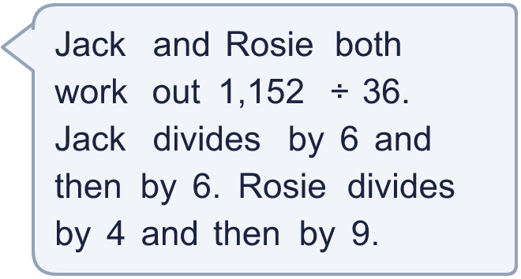
  9 | a) Jack’s answer:  b) Rosie’s answer:
  10 | Is Boba correct? Circle yes or no.  Yes / No  Explain how you know.
     | 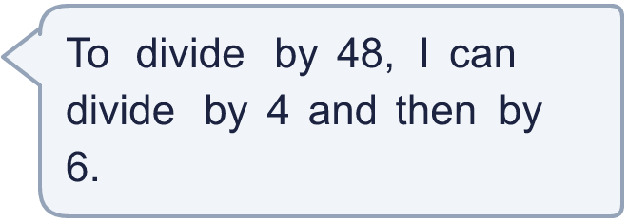
  10 | Is Boba correct? Circle yes or no.  Yes / No  Explain how you know.
  11 | What number did I start with?
     | 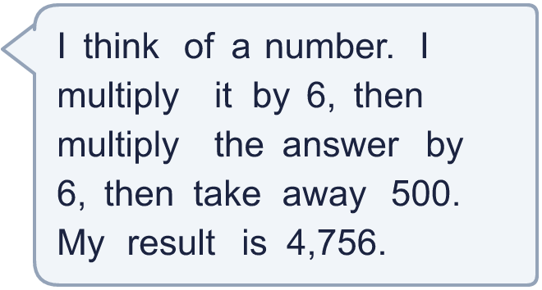
  11 | What number did I start with?
  12 | These divisions give the same answer. Write the missing numbers.
    1,080 ÷ 8 ÷ 3 = 1,080 ÷ 2 ÷
    = 1,080 ÷
  12 | These divisions give the same answer. Write the missing numbers.
    1,080 ÷ 8 ÷ 3 = 1,080 ÷ 2 ÷
    = 1,080 ÷
  13 | A school has 5,040 pencils. They are shared equally between 36 classes.  How many pencils does each class get?
  13 | A school has 5,040 pencils. They are shared equally between 36 classes.  How many pencils does each class get?
  14 | Write two different ways to divide by 48 in two steps, using two factors.
  14 | Write two different ways to divide by 48 in two steps, using two factors.

Year 6 · Add, subtract, multiply and divide · Step 10
Dividing using factors
Answers (teacher copy)

  1 | Divide in two steps using factors. Write both answers.  a) 700 ÷ 10 = 70 then ÷ 2 = 35  b) 450 ÷ 10 = 45 then ÷ 3 = 15
  2 | 1,488 ÷ 48 can be worked out in two steps using factors of 48.  1,488 ÷ 48 = 1,488 ÷ 6 ÷ 8 = 31
  3 | Use factors to work out each division.  a) 3,600 ÷ 30 = 120  b) 625 ÷ 25 = 25  c) 1,275 ÷ 15 = 85  d) 360 ÷ 40 = 9
  4 | Ron is working out 1,776 ÷ 48. Which methods give the correct answer? Write the letters.  a) 1,776 ÷ 12 ÷ 8  b) 1,776 ÷ 6 ÷ 10  c) 1,776 ÷ 6 ÷ 8  c
  5 | These divisions give the same answer. Write the missing number.  900 ÷ 30 = 900 ÷ 5 ÷ 6
  6 | Work out the divisions.  a) 4,800 ÷ 60 = 80  b) 11,000 ÷ 20 = 550
  7 | Mo and Dora are working out 1,152 ÷ 24.  Mo says: “I will divide by 8, then divide by 6.”  Dora says: “I will divide by 4, then divide by 6.”  Who is correct? Dora
  8 | Use factors to work out each division.  a) 5,712 ÷ 16 = 357  b) 3,852 ÷ 18 = 214
  9 | a) Jack’s answer: 32  b) Rosie’s answer: 32
  10 | Is Boba correct? Circle yes or no.  Yes / No  Explain how you know.  4 × 6 = 24, not 48. Dividing by 4 and then 6 is the same as dividing by 24.
  11 | What number did I start with? 146
  12 | These divisions give the same answer. Write the missing numbers.  1,080 ÷ 8 ÷ 3 = 1,080 ÷ 2 ÷ 12 = 1,080 ÷ 24
  13 | A school has 5,040 pencils. They are shared equally between 36 classes.  How many pencils does each class get? 140
  14 | Write two different ways to divide by 48 in two steps, using two factors.  Any two pairs of factors with a product of 48, for example 6 × 8 or 4 × 12

