Factors to help you:  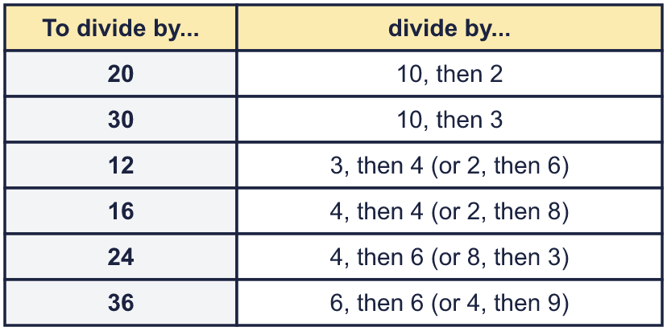 |  | Factors to help you:
  Year 6 · Add, subtract, multiply and divide · Step 10  Dividing using factors | 
  Year 6 · Add, subtract, multiply and divide · Step 10
  Dividing using factors
  1 | Divide in two steps using factors. Write both answers.  Hint: 20 = 10 × 2, so dividing by 20 is the same as dividing by 10 and then by 2. Use the answer from the first step.
    a) | 700 ÷ 10 = |  | then ÷ 2 =
    b) | 450 ÷ 10 = |  | then ÷ 3 =
  1 | Divide in two steps using factors. Write both answers.  Hint: 20 = 10 × 2, so dividing by 20 is the same as dividing by 10 and then by 2. Use the answer from the first step.
    a) | 700 ÷ 10 = |  | then ÷ 2 =
    b) | 450 ÷ 10 = |  | then ÷ 3 =
  2 | 1,488 ÷ 48 can be worked out in two steps using factors of 48.  Hint: 48 = 6 × 8. Divide by 6 first, then by 8.
    1,488 ÷ 48 = 1,488 ÷ 6 ÷ |  | =
  2 | 1,488 ÷ 48 can be worked out in two steps using factors of 48.  Hint: 48 = 6 × 8. Divide by 6 first, then by 8.
    1,488 ÷ 48 = 1,488 ÷ 6 ÷ |  | =
  3 | Use factors to work out each division.  a) 3,600 ÷ 30 =  b) 625 ÷ 25 =  c) 1,275 ÷ 15 =  d) 360 ÷ 40 =  Hint: Split the divisor into two smaller factors, for example 18 = 3 × 6. Divide by one, then by the other.
  3 | Use factors to work out each division.  a) 3,600 ÷ 30 =  b) 625 ÷ 25 =  c) 1,275 ÷ 15 =  d) 360 ÷ 40 =  Hint: Split the divisor into two smaller factors, for example 18 = 3 × 6. Divide by one, then by the other.
  4 | Ron is working out 1,776 ÷ 48. Which methods give the correct answer? Write the letters.  a) 1,776 ÷ 12 ÷ 8  b) 1,776 ÷ 6 ÷ 10  c) 1,776 ÷ 6 ÷ 8  Hint: A method works if the two numbers you divide by multiply to make 48.
  4 | Ron is working out 1,776 ÷ 48. Which methods give the correct answer? Write the letters.  a) 1,776 ÷ 12 ÷ 8  b) 1,776 ÷ 6 ÷ 10  c) 1,776 ÷ 6 ÷ 8  Hint: A method works if the two numbers you divide by multiply to make 48.
  5 | These divisions give the same answer. Write the missing number.  Hint: 5 × ? = 30. Which number multiplied by 5 makes 30?
    900 ÷ 30 = 900 ÷ 5 ÷
  5 | These divisions give the same answer. Write the missing number.  Hint: 5 × ? = 30. Which number multiplied by 5 makes 30?
    900 ÷ 30 = 900 ÷ 5 ÷
  6 | Work out the divisions.  a) 4,800 ÷ 60 =  b) 11,000 ÷ 20 =  Hint: Divide by 10 first (move the digits one place to the right). Then divide by the other factor.
  6 | Work out the divisions.  a) 4,800 ÷ 60 =  b) 11,000 ÷ 20 =  Hint: Divide by 10 first (move the digits one place to the right). Then divide by the other factor.
  7 | Mo and Dora are working out 1,152 ÷ 24.  Mo says: “I will divide by 8, then divide by 6.”  Dora says: “I will divide by 4, then divide by 6.”  Who is correct?  Hint: Multiply each pair of numbers. Does it make 24?
  7 | Mo and Dora are working out 1,152 ÷ 24.  Mo says: “I will divide by 8, then divide by 6.”  Dora says: “I will divide by 4, then divide by 6.”  Who is correct?  Hint: Multiply each pair of numbers. Does it make 24?
  8 | Use factors to work out each division.  a) 5,712 ÷ 16 =  b) 3,852 ÷ 18 =  Hint: 16 = 4 × 4 and 18 = 3 × 6. Divide twice.
  8 | Use factors to work out each division.  a) 5,712 ÷ 16 =  b) 3,852 ÷ 18 =  Hint: 16 = 4 × 4 and 18 = 3 × 6. Divide twice.

  9 | a) Jack’s answer:  b) Rosie’s answer:  Hint: Both of them divide by a total of 36, because 6 × 6 = 36 and 4 × 9 = 36. So they get the same answer.
    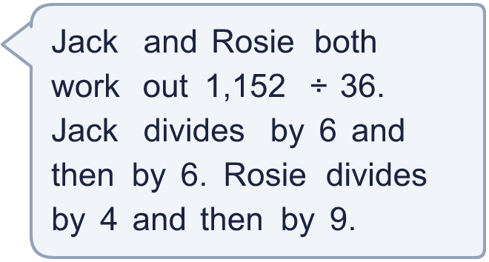
  9 | a) Jack’s answer:  b) Rosie’s answer:  Hint: Both of them divide by a total of 36, because 6 × 6 = 36 and 4 × 9 = 36. So they get the same answer.
  10 | Is Boba correct? Circle yes or no.  Yes / No  Explain how you know.  Hint: Multiply the two numbers you divide by. Do you get 48?
     | 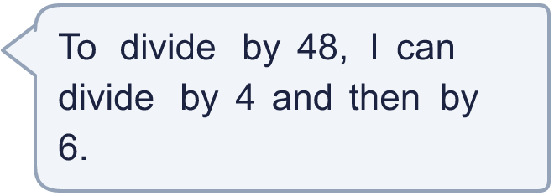
  10 | Is Boba correct? Circle yes or no.  Yes / No  Explain how you know.  Hint: Multiply the two numbers you divide by. Do you get 48?
  11 | What number did I start with?  Hint: Work backwards. Add 500, then divide by 6, then divide by 6. Or divide by 36 in one go.
     | 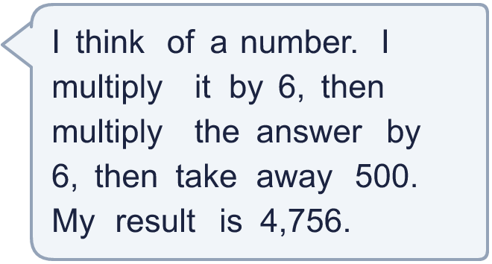
  11 | What number did I start with?  Hint: Work backwards. Add 500, then divide by 6, then divide by 6. Or divide by 36 in one go.
  12 | These divisions give the same answer. Write the missing numbers.  Hint: Dividing by 8 and then 3 is the same as dividing by 8 × 3.
    1,080 ÷ 8 ÷ 3 = 1,080 ÷ 2 ÷
    = 1,080 ÷
  12 | These divisions give the same answer. Write the missing numbers.  Hint: Dividing by 8 and then 3 is the same as dividing by 8 × 3.
    1,080 ÷ 8 ÷ 3 = 1,080 ÷ 2 ÷
    = 1,080 ÷
  13 | A school has 5,040 pencils. They are shared equally between 36 classes.  How many pencils does each class get?  Hint: Use factors of 36. For example divide by 6, then by 6 again.
  13 | A school has 5,040 pencils. They are shared equally between 36 classes.  How many pencils does each class get?  Hint: Use factors of 36. For example divide by 6, then by 6 again.
  14 | Write two different ways to divide by 48 in two steps, using two factors.  Hint: Find two numbers that multiply to make 48, both bigger than 1. Dividing by each in turn is the same as dividing by 48.
  14 | Write two different ways to divide by 48 in two steps, using two factors.  Hint: Find two numbers that multiply to make 48, both bigger than 1. Dividing by each in turn is the same as dividing by 48.

Year 6 · Add, subtract, multiply and divide · Step 10
Dividing using factors
Answers (teacher copy)

Factors to help you:
  1 | Divide in two steps using factors. Write both answers.  a) 700 ÷ 10 = 70 then ÷ 2 = 35  b) 450 ÷ 10 = 45 then ÷ 3 = 15  Hint: 20 = 10 × 2, so dividing by 20 is the same as dividing by 10 and then by 2. Use the answer from the first step.
  2 | 1,488 ÷ 48 can be worked out in two steps using factors of 48.  1,488 ÷ 48 = 1,488 ÷ 6 ÷ 8 = 31  Hint: 48 = 6 × 8. Divide by 6 first, then by 8.
  3 | Use factors to work out each division.  a) 3,600 ÷ 30 = 120  b) 625 ÷ 25 = 25  c) 1,275 ÷ 15 = 85  d) 360 ÷ 40 = 9  Hint: Split the divisor into two smaller factors, for example 18 = 3 × 6. Divide by one, then by the other.
  4 | Ron is working out 1,776 ÷ 48. Which methods give the correct answer? Write the letters.  a) 1,776 ÷ 12 ÷ 8  b) 1,776 ÷ 6 ÷ 10  c) 1,776 ÷ 6 ÷ 8  c  Hint: A method works if the two numbers you divide by multiply to make 48.
  5 | These divisions give the same answer. Write the missing number.  900 ÷ 30 = 900 ÷ 5 ÷ 6  Hint: 5 × ? = 30. Which number multiplied by 5 makes 30?
  6 | Work out the divisions.  a) 4,800 ÷ 60 = 80  b) 11,000 ÷ 20 = 550  Hint: Divide by 10 first (move the digits one place to the right). Then divide by the other factor.
  7 | Mo and Dora are working out 1,152 ÷ 24.  Mo says: “I will divide by 8, then divide by 6.”  Dora says: “I will divide by 4, then divide by 6.”  Who is correct? Dora  Hint: Multiply each pair of numbers. Does it make 24?
  8 | Use factors to work out each division.  a) 5,712 ÷ 16 = 357  b) 3,852 ÷ 18 = 214  Hint: 16 = 4 × 4 and 18 = 3 × 6. Divide twice.
  9 | a) Jack’s answer: 32  b) Rosie’s answer: 32  Hint: Both of them divide by a total of 36, because 6 × 6 = 36 and 4 × 9 = 36. So they get the same answer.
  10 | Is Boba correct? Circle yes or no.  Yes / No  Explain how you know.  4 × 6 = 24, not 48. Dividing by 4 and then 6 is the same as dividing by 24.  Hint: Multiply the two numbers you divide by. Do you get 48?
  11 | What number did I start with? 146  Hint: Work backwards. Add 500, then divide by 6, then divide by 6. Or divide by 36 in one go.
  12 | These divisions give the same answer. Write the missing numbers.  1,080 ÷ 8 ÷ 3 = 1,080 ÷ 2 ÷ 12 = 1,080 ÷ 24  Hint: Dividing by 8 and then 3 is the same as dividing by 8 × 3.
  13 | A school has 5,040 pencils. They are shared equally between 36 classes.  How many pencils does each class get? 140  Hint: Use factors of 36. For example divide by 6, then by 6 again.
  14 | Write two different ways to divide by 48 in two steps, using two factors.  Any two pairs of factors with a product of 48, for example 6 × 8 or 4 × 12  Hint: Find two numbers that multiply to make 48, both bigger than 1. Dividing by each in turn is the same as dividing by 48.

