  Year 6 · Add, subtract, multiply and divide · Step 13  Division problems | 
  Year 6 · Add, subtract, multiply and divide · Step 13
  Division problems
  1 | Use the bar model idea: split the number into two parts that are easy to divide.  a) 1,596 ÷ 7 =  b) 70 ÷ 7 =  c) 1,666 ÷ 7 =
  1 | Use the bar model idea: split the number into two parts that are easy to divide.  a) 1,596 ÷ 7 =  b) 70 ÷ 7 =  c) 1,666 ÷ 7 =
  2 | Work out the output of each function machine.  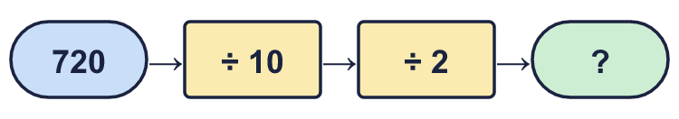  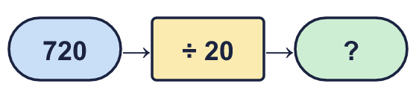
  2 | Work out the output of each function machine.
  3 | Work out each division in your head.  a) 32,000 ÷ 4 =  b) 4,000,000 ÷ 8 =  c) 21,000,000 ÷ 7 =
  3 | Work out each division in your head.  a) 32,000 ÷ 4 =  b) 4,000,000 ÷ 8 =  c) 21,000,000 ÷ 7 =
  4 | Work out each division. Write any remainder like this: 3,238 r 2.  a) 68,000 ÷ 20 =  b) 92,000 ÷ 30 =
  4 | Work out each division. Write any remainder like this: 3,238 r 2.  a) 68,000 ÷ 20 =  b) 92,000 ÷ 30 =
  5 | A coach can seat 24 people. 729 supporters are going to a match.  How many coaches are needed?
  5 | A coach can seat 24 people. 729 supporters are going to a match.  How many coaches are needed?
  6 | Eggs are packed in boxes of 10 or 15. There are 1,230 eggs. All the eggs go into the same size of box.  a) How many boxes of 10?  b) How many boxes of 15?
  6 | Eggs are packed in boxes of 10 or 15. There are 1,230 eggs. All the eggs go into the same size of box.  a) How many boxes of 10?  b) How many boxes of 15?
  7 | Write the remainder for each division.
    a) | 901 ÷ 17 = |  | remainder
    b) | 902 ÷ 17 = |  | remainder
    c) | 910 ÷ 17 = |  | remainder
    d) | 920 ÷ 17 = |  | remainder
  7 | Write the remainder for each division.
    a) | 901 ÷ 17 = |  | remainder
    b) | 902 ÷ 17 = |  | remainder
    c) | 910 ÷ 17 = |  | remainder
    d) | 920 ÷ 17 = |  | remainder
  8 | To divide by 4, you can halve 2 times. Work out 1,396 ÷ 4.
  8 | To divide by 4, you can halve 2 times. Work out 1,396 ÷ 4.

  9 | Is Boba correct? Circle yes or no.  Yes / No  Explain how you know.
     | 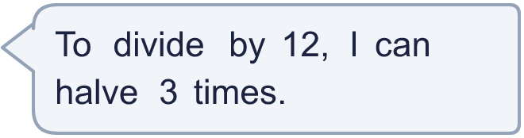
  9 | Is Boba correct? Circle yes or no.  Yes / No  Explain how you know.
  10 | Look at these divisions by 17: A: 901, B: 902, C: 910, D: 920, E: 903, F: 912, G: 925, H: 931.  a) Which have a remainder that is odd? Write the letters.  b) Which have a remainder greater than 6? Write the letters.
  10 | Look at these divisions by 17: A: 901, B: 902, C: 910, D: 920, E: 903, F: 912, G: 925, H: 931.  a) Which have a remainder that is odd? Write the letters.  b) Which have a remainder greater than 6? Write the letters.
  11 | 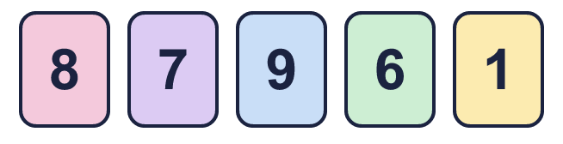  a) What is the smallest remainder you can make?  b) What is the greatest remainder you can make?
    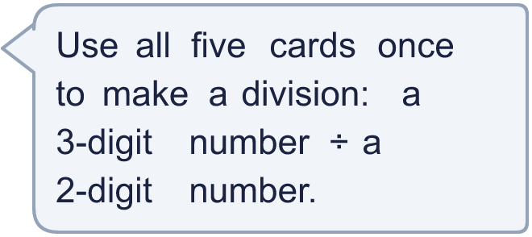
  11 | a) What is the smallest remainder you can make?  b) What is the greatest remainder you can make?
  12 | a) How many full boxes can she make?  b) How much money do the full boxes make?
     | 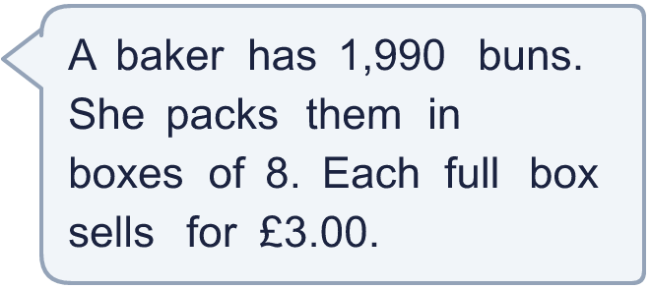
  12 | a) How many full boxes can she make?  b) How much money do the full boxes make?
  13 | Is Boba correct? Circle yes or no.  Yes / No  Explain how you know.
     | 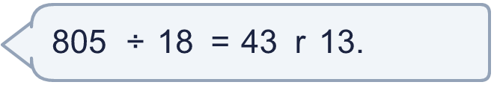
  13 | Is Boba correct? Circle yes or no.  Yes / No  Explain how you know.
  14 | Write three different numbers between 100 and 200 that leave a remainder of 3 when divided by 9.
  14 | Write three different numbers between 100 and 200 that leave a remainder of 3 when divided by 9.

Year 6 · Add, subtract, multiply and divide · Step 13
Division problems
Answers (teacher copy)

  1 | Use the bar model idea: split the number into two parts that are easy to divide.  a) 1,596 ÷ 7 = 228  b) 70 ÷ 7 = 10  c) 1,666 ÷ 7 = 238
  2 | Work out the output of each function machine.  a) 36  b) 36
  3 | Work out each division in your head.  a) 32,000 ÷ 4 = 8,000  b) 4,000,000 ÷ 8 = 500,000  c) 21,000,000 ÷ 7 = 3,000,000
  4 | Work out each division. Write any remainder like this: 3,238 r 2.  a) 68,000 ÷ 20 = 3,400  b) 92,000 ÷ 30 = 3,066 r 20
  5 | A coach can seat 24 people. 729 supporters are going to a match.  How many coaches are needed? 31
  6 | Eggs are packed in boxes of 10 or 15. There are 1,230 eggs. All the eggs go into the same size of box.  a) How many boxes of 10? 123  b) How many boxes of 15? 82
  7 | Write the remainder for each division.  a) 901 ÷ 17 = 0 remainder  b) 902 ÷ 17 = 1 remainder  c) 910 ÷ 17 = 9 remainder  d) 920 ÷ 17 = 2 remainder
  8 | To divide by 4, you can halve 2 times. Work out 1,396 ÷ 4.  349
  9 | Is Boba correct? Circle yes or no.  Yes / No  Explain how you know.  Halving 3 times is dividing by 8, not by 12. For example 48 ÷ 12 = 4, but halving 3 times gives 6.
  10 | Look at these divisions by 17: A: 901, B: 902, C: 910, D: 920, E: 903, F: 912, G: 925, H: 931.  a) Which have a remainder that is odd? Write the letters. B, C, F, G, H  b) Which have a remainder greater than 6? Write the letters. C, F, G, H
  11 | a) What is the smallest remainder you can make? 0  b) What is the greatest remainder you can make? 91
  12 | a) How many full boxes can she make? 248  b) How much money do the full boxes make? £744.00
  13 | Is Boba correct? Circle yes or no.  Yes / No  Explain how you know.  43 × 18 + 13 = 787, not 805. The correct answer is 44 r 13.
  14 | Write three different numbers between 100 and 200 that leave a remainder of 3 when divided by 9.  Any three numbers between 100 and 200 with remainder 3 when divided by 9, for example 111, 129, 156

