  Year 6 · Add, subtract, multiply and divide · Step 13  Division problems | 
  Year 6 · Add, subtract, multiply and divide · Step 13
  Division problems
  1 | Use the bar model idea: split the number into two parts that are easy to divide.  a) 1,596 ÷ 7 =  b) 70 ÷ 7 =  c) 1,666 ÷ 7 =  Hint: 1,666 is 1,596 + 70. Divide each part by 7, then add the two answers.  Bar model: split the number into parts that are easy to divide.  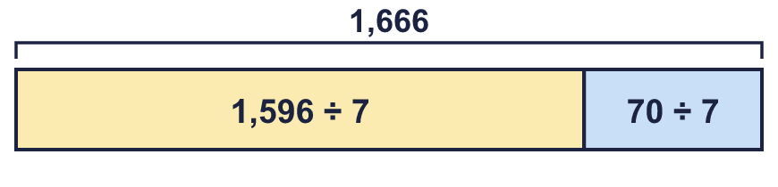
  1 | Use the bar model idea: split the number into two parts that are easy to divide.  a) 1,596 ÷ 7 =  b) 70 ÷ 7 =  c) 1,666 ÷ 7 =  Hint: 1,666 is 1,596 + 70. Divide each part by 7, then add the two answers.  Bar model: split the number into parts that are easy to divide.
  2 | Work out the output of each function machine.  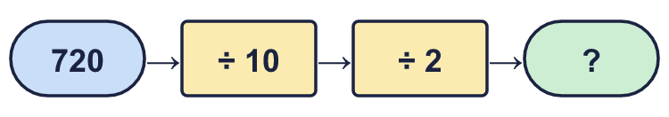  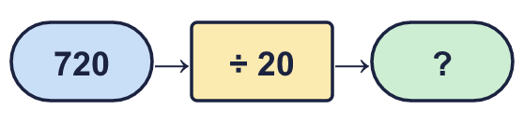  Hint: Both machines divide by 20 altogether (10 × 2 = 20), so the outputs are the same.
  2 | Work out the output of each function machine.  Hint: Both machines divide by 20 altogether (10 × 2 = 20), so the outputs are the same.
  3 | Work out each division in your head.  a) 32,000 ÷ 4 =  b) 4,000,000 ÷ 8 =  c) 21,000,000 ÷ 7 =  Hint: Use a known fact: 21 ÷ 7 = 3, so 21,000,000 ÷ 7 = 3,000,000. Count the zeros.
  3 | Work out each division in your head.  a) 32,000 ÷ 4 =  b) 4,000,000 ÷ 8 =  c) 21,000,000 ÷ 7 =  Hint: Use a known fact: 21 ÷ 7 = 3, so 21,000,000 ÷ 7 = 3,000,000. Count the zeros.
  4 | Work out each division. Write any remainder like this: 3,238 r 2.  a) 68,000 ÷ 20 =  b) 92,000 ÷ 30 =  Hint: One of these is easy to do in your head. For the other, use long division.
  4 | Work out each division. Write any remainder like this: 3,238 r 2.  a) 68,000 ÷ 20 =  b) 92,000 ÷ 30 =  Hint: One of these is easy to do in your head. For the other, use long division.
  5 | A coach can seat 24 people. 729 supporters are going to a match.  How many coaches are needed?  Hint: Divide. If there is a remainder, one more coach is needed.
  5 | A coach can seat 24 people. 729 supporters are going to a match.  How many coaches are needed?  Hint: Divide. If there is a remainder, one more coach is needed.
  6 | Eggs are packed in boxes of 10 or 15. There are 1,230 eggs. All the eggs go into the same size of box.  a) How many boxes of 10?  b) How many boxes of 15?  Hint: Divide the number of eggs by the box size.
  6 | Eggs are packed in boxes of 10 or 15. There are 1,230 eggs. All the eggs go into the same size of box.  a) How many boxes of 10?  b) How many boxes of 15?  Hint: Divide the number of eggs by the box size.
  7 | Write the remainder for each division.  Hint: Work out how many groups fit. The remainder is what is left over.
    a) | 901 ÷ 17 = |  | remainder
    b) | 902 ÷ 17 = |  | remainder
    c) | 910 ÷ 17 = |  | remainder
    d) | 920 ÷ 17 = |  | remainder
  7 | Write the remainder for each division.  Hint: Work out how many groups fit. The remainder is what is left over.
    a) | 901 ÷ 17 = |  | remainder
    b) | 902 ÷ 17 = |  | remainder
    c) | 910 ÷ 17 = |  | remainder
    d) | 920 ÷ 17 = |  | remainder
  8 | To divide by 4, you can halve 2 times. Work out 1,396 ÷ 4.  Hint: Halve 1,396, then halve the answer again.
  8 | To divide by 4, you can halve 2 times. Work out 1,396 ÷ 4.  Hint: Halve 1,396, then halve the answer again.

  9 | Is Boba correct? Circle yes or no.  Yes / No  Explain how you know.  Hint: Halving once divides by 2. Halving twice divides by 2 × 2 = 4. What do you get for 3 halvings?
     | 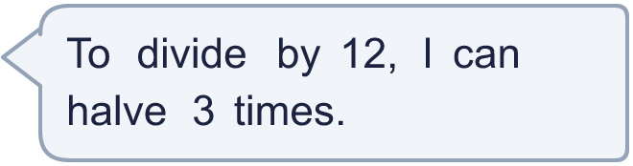
  9 | Is Boba correct? Circle yes or no.  Yes / No  Explain how you know.  Hint: Halving once divides by 2. Halving twice divides by 2 × 2 = 4. What do you get for 3 halvings?
  10 | Look at these divisions by 17: A: 901, B: 902, C: 910, D: 920, E: 903, F: 912, G: 925, H: 931.  a) Which have a remainder that is odd? Write the letters.  b) Which have a remainder greater than 6? Write the letters.  Hint: Work out each remainder first: write them in a list. Then pick out the odd ones and the ones bigger than 6.
  10 | Look at these divisions by 17: A: 901, B: 902, C: 910, D: 920, E: 903, F: 912, G: 925, H: 931.  a) Which have a remainder that is odd? Write the letters.  b) Which have a remainder greater than 6? Write the letters.  Hint: Work out each remainder first: write them in a list. Then pick out the odd ones and the ones bigger than 6.
  11 | 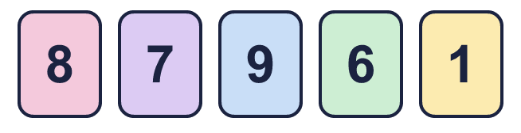  a) What is the smallest remainder you can make?  b) What is the greatest remainder you can make?  Hint: Try different cards. Work out the remainder each time. A big remainder needs a big divisor.
    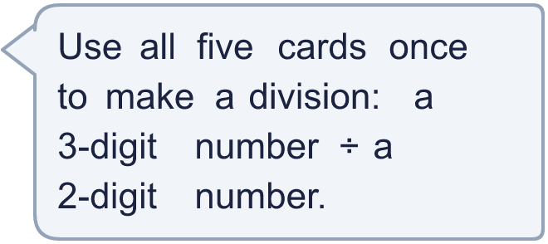
  11 | a) What is the smallest remainder you can make?  b) What is the greatest remainder you can make?  Hint: Try different cards. Work out the remainder each time. A big remainder needs a big divisor.
  12 | a) How many full boxes can she make?  b) How much money do the full boxes make?  Hint: a) Divide, then ignore the remainder. b) Multiply the number of boxes by the price of a box.
     | 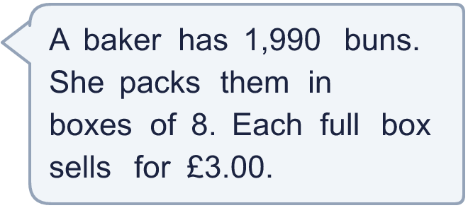
  12 | a) How many full boxes can she make?  b) How much money do the full boxes make?  Hint: a) Divide, then ignore the remainder. b) Multiply the number of boxes by the price of a box.
  13 | Is Boba correct? Circle yes or no.  Yes / No  Explain how you know.  Hint: To check a division with a remainder: multiply the answer by the divisor, then add the remainder. You should get the number you started with.
     | 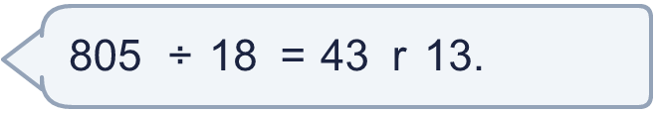
  13 | Is Boba correct? Circle yes or no.  Yes / No  Explain how you know.  Hint: To check a division with a remainder: multiply the answer by the divisor, then add the remainder. You should get the number you started with.
  14 | Write three different numbers between 100 and 200 that leave a remainder of 3 when divided by 9.  Hint: Start with a multiple of 9 that is between 100 and 200, then add 3.
  14 | Write three different numbers between 100 and 200 that leave a remainder of 3 when divided by 9.  Hint: Start with a multiple of 9 that is between 100 and 200, then add 3.

Year 6 · Add, subtract, multiply and divide · Step 13
Division problems
Answers (teacher copy)

  1 | Use the bar model idea: split the number into two parts that are easy to divide.  a) 1,596 ÷ 7 = 228  b) 70 ÷ 7 = 10  c) 1,666 ÷ 7 = 238  Hint: 1,666 is 1,596 + 70. Divide each part by 7, then add the two answers.  Bar model: split the number into parts that are easy to divide.
  2 | Work out the output of each function machine.  a) 36  b) 36  Hint: Both machines divide by 20 altogether (10 × 2 = 20), so the outputs are the same.
  3 | Work out each division in your head.  a) 32,000 ÷ 4 = 8,000  b) 4,000,000 ÷ 8 = 500,000  c) 21,000,000 ÷ 7 = 3,000,000  Hint: Use a known fact: 21 ÷ 7 = 3, so 21,000,000 ÷ 7 = 3,000,000. Count the zeros.
  4 | Work out each division. Write any remainder like this: 3,238 r 2.  a) 68,000 ÷ 20 = 3,400  b) 92,000 ÷ 30 = 3,066 r 20  Hint: One of these is easy to do in your head. For the other, use long division.
  5 | A coach can seat 24 people. 729 supporters are going to a match.  How many coaches are needed? 31  Hint: Divide. If there is a remainder, one more coach is needed.
  6 | Eggs are packed in boxes of 10 or 15. There are 1,230 eggs. All the eggs go into the same size of box.  a) How many boxes of 10? 123  b) How many boxes of 15? 82  Hint: Divide the number of eggs by the box size.
  7 | Write the remainder for each division.  a) 901 ÷ 17 = 0 remainder  b) 902 ÷ 17 = 1 remainder  c) 910 ÷ 17 = 9 remainder  d) 920 ÷ 17 = 2 remainder  Hint: Work out how many groups fit. The remainder is what is left over.
  8 | To divide by 4, you can halve 2 times. Work out 1,396 ÷ 4.  349  Hint: Halve 1,396, then halve the answer again.
  9 | Is Boba correct? Circle yes or no.  Yes / No  Explain how you know.  Halving 3 times is dividing by 8, not by 12. For example 48 ÷ 12 = 4, but halving 3 times gives 6.  Hint: Halving once divides by 2. Halving twice divides by 2 × 2 = 4. What do you get for 3 halvings?
  10 | Look at these divisions by 17: A: 901, B: 902, C: 910, D: 920, E: 903, F: 912, G: 925, H: 931.  a) Which have a remainder that is odd? Write the letters. B, C, F, G, H  b) Which have a remainder greater than 6? Write the letters. C, F, G, H  Hint: Work out each remainder first: write them in a list. Then pick out the odd ones and the ones bigger than 6.
  11 | a) What is the smallest remainder you can make? 0  b) What is the greatest remainder you can make? 91  Hint: Try different cards. Work out the remainder each time. A big remainder needs a big divisor.
  12 | a) How many full boxes can she make? 248  b) How much money do the full boxes make? £744.00  Hint: a) Divide, then ignore the remainder. b) Multiply the number of boxes by the price of a box.
  13 | Is Boba correct? Circle yes or no.  Yes / No  Explain how you know.  43 × 18 + 13 = 787, not 805. The correct answer is 44 r 13.  Hint: To check a division with a remainder: multiply the answer by the divisor, then add the remainder. You should get the number you started with.
  14 | Write three different numbers between 100 and 200 that leave a remainder of 3 when divided by 9.  Any three numbers between 100 and 200 with remainder 3 when divided by 9, for example 111, 129, 156  Hint: Start with a multiple of 9 that is between 100 and 200, then add 3.

