  Year 6 · Add, subtract, multiply and divide · Step 12  Long division with remainders | 
  Year 6 · Add, subtract, multiply and divide · Step 12
  Long division with remainders
  1 | Write the first nine multiples of 14.
  1 | Write the first nine multiples of 14.
  2 | Use long division. Write the remainder like this: 54 r 8.  a) 187 ÷ 15 =  b) 434 ÷ 12 =
  2 | Use long division. Write the remainder like this: 54 r 8.  a) 187 ÷ 15 =  b) 434 ÷ 12 =
  3 | Use long division. Write the remainder like this: 54 r 8.  a) 638 ÷ 13 =  b) 640 ÷ 14 =
  3 | Use long division. Write the remainder like this: 54 r 8.  a) 638 ÷ 13 =  b) 640 ÷ 14 =
  4 | Use long division. Write the remainder like this: 54 r 8.  a) 1,707 ÷ 18 =  b) 3,040 ÷ 24 =
  4 | Use long division. Write the remainder like this: 54 r 8.  a) 1,707 ÷ 18 =  b) 3,040 ÷ 24 =
  5 | Work out each division. Write the remainder as a fraction of the divisor, like this: 12 ³⁄₄.  a) 536 ÷ 18 =  b) 335 ÷ 20 =
  5 | Work out each division. Write the remainder as a fraction of the divisor, like this: 12 ³⁄₄.  a) 536 ÷ 18 =  b) 335 ÷ 20 =
  6 | A school has 364 pupils, 24 staff and 10 governors. Everyone is invited to a meal. Each table seats 10 people.  How many tables are needed?
  6 | A school has 364 pupils, 24 staff and 10 governors. Everyone is invited to a meal. Each table seats 10 people.  How many tables are needed?
  7 | Each newspaper needs 32 sheets of paper. Paper comes in packets of 150 sheets. Ms Lee has 10 packets.  How many newspapers can she print?
  7 | Each newspaper needs 32 sheets of paper. Paper comes in packets of 150 sheets. Ms Lee has 10 packets.  How many newspapers can she print?
  8 | 6,374 lorries need to cross the sea by ferry. The ferry carries 79 lorries on each journey.  How many journeys will it take?
  8 | 6,374 lorries need to cross the sea by ferry. The ferry carries 79 lorries on each journey.  How many journeys will it take?

  9 | Is Boba correct? Circle yes or no.  Yes / No  Explain how you know. Check with multiplication.
     | 
  9 | Is Boba correct? Circle yes or no.  Yes / No  Explain how you know. Check with multiplication.
  10 | Find the missing number.
    4,550 ÷ |  | = 49 r 42
  10 | Find the missing number.
    4,550 ÷ |  | = 49 r 42
  11 | a) How much at Party Supplies?  b) How much at Fun Stores?  c) Which shop is cheaper?
     | 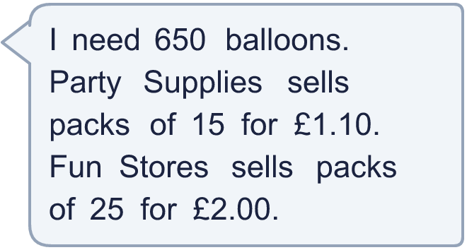
  11 | a) How much at Party Supplies?  b) How much at Fun Stores?  c) Which shop is cheaper?
  12 | Is Boba correct? Circle yes or no.  Yes / No  Explain how you know.
     | 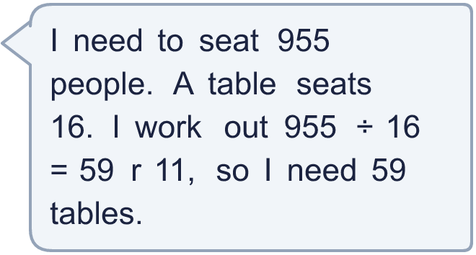
  12 | Is Boba correct? Circle yes or no.  Yes / No  Explain how you know.
  13 | A rope is 700 cm long. It is cut into pieces that are 16 cm long.  a) How many whole pieces can be cut?
    b) | How long is the piece that is left over?
    cm
  13 | A rope is 700 cm long. It is cut into pieces that are 16 cm long.  a) How many whole pieces can be cut?
    b) | How long is the piece that is left over?
    cm
  14 | Write three different numbers that give a remainder of 9 when divided by 24.
  14 | Write three different numbers that give a remainder of 9 when divided by 24.

Year 6 · Add, subtract, multiply and divide · Step 12
Long division with remainders
Answers (teacher copy)

  1 | Write the first nine multiples of 14.  14, 28, 42, 56, 70, 84, 98, 112, 126
  2 | Use long division. Write the remainder like this: 54 r 8.  a) 187 ÷ 15 = 12 r 7  b) 434 ÷ 12 = 36 r 2
  3 | Use long division. Write the remainder like this: 54 r 8.  a) 638 ÷ 13 = 49 r 1  b) 640 ÷ 14 = 45 r 10
  4 | Use long division. Write the remainder like this: 54 r 8.  a) 1,707 ÷ 18 = 94 r 15  b) 3,040 ÷ 24 = 126 r 16
  5 | Work out each division. Write the remainder as a fraction of the divisor, like this: 12 ³⁄₄.  a) 536 ÷ 18 = 29 ⁷⁄₉  b) 335 ÷ 20 = 16 ³⁄₄
  6 | A school has 364 pupils, 24 staff and 10 governors. Everyone is invited to a meal. Each table seats 10 people.  How many tables are needed? 40
  7 | Each newspaper needs 32 sheets of paper. Paper comes in packets of 150 sheets. Ms Lee has 10 packets.  How many newspapers can she print? 46
  8 | 6,374 lorries need to cross the sea by ferry. The ferry carries 79 lorries on each journey.  How many journeys will it take? 81
  9 | Is Boba correct? Circle yes or no.  Yes / No  Explain how you know. Check with multiplication.  113 × 24 = 2,712, which is not near 267. The correct answer is 11 r 3: 11 × 24 + 3 = 267.
  10 | Find the missing number.  4,550 ÷ 92 = 49 r 42
  11 | a) How much at Party Supplies? £48.40  b) How much at Fun Stores? £52.00  c) Which shop is cheaper? Party Supplies
  12 | Is Boba correct? Circle yes or no.  Yes / No  Explain how you know.  59 tables seat only 944 people. 11 people would be left standing, so a table is needed for them: 60 tables.
  13 | A rope is 700 cm long. It is cut into pieces that are 16 cm long.  a) How many whole pieces can be cut? 43  b) How long is the piece that is left over? 12 cm
  14 | Write three different numbers that give a remainder of 9 when divided by 24.  Any three numbers with remainder 9 when divided by 24, for example 297, 489, 753

