  Year 6 · Add, subtract, multiply and divide · Step 12  Long division with remainders | 
  Year 6 · Add, subtract, multiply and divide · Step 12
  Long division with remainders
  1 | Write the first nine multiples of 14.  Hint: Start with 14 and add 14 each time. These will help with long division.
  1 | Write the first nine multiples of 14.  Hint: Start with 14 and add 14 each time. These will help with long division.
  2 | Use long division. Write the remainder like this: 54 r 8.  a) 187 ÷ 15 =  b) 434 ÷ 12 =  Hint: Use the multiples of the divisor. When what is left is smaller than the divisor, it is the remainder.  Worked example: 525 ÷ 14. What is left at the end is the remainder.  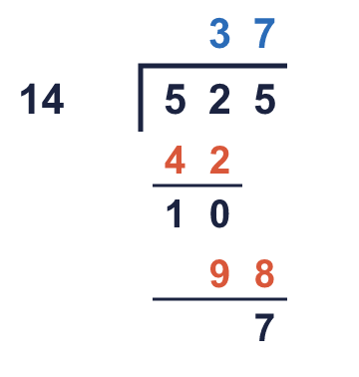
  2 | Use long division. Write the remainder like this: 54 r 8.  a) 187 ÷ 15 =  b) 434 ÷ 12 =  Hint: Use the multiples of the divisor. When what is left is smaller than the divisor, it is the remainder.  Worked example: 525 ÷ 14. What is left at the end is the remainder.
  3 | Use long division. Write the remainder like this: 54 r 8.  a) 638 ÷ 13 =  b) 640 ÷ 14 =  Hint: Write the multiples of the divisor in a list first. Then divide one digit at a time from the left.
  3 | Use long division. Write the remainder like this: 54 r 8.  a) 638 ÷ 13 =  b) 640 ÷ 14 =  Hint: Write the multiples of the divisor in a list first. Then divide one digit at a time from the left.
  4 | Use long division. Write the remainder like this: 54 r 8.  a) 1,707 ÷ 18 =  b) 3,040 ÷ 24 =  Hint: This takes more steps. After each subtraction, bring down the next digit and ask how many groups of the divisor fit.
  4 | Use long division. Write the remainder like this: 54 r 8.  a) 1,707 ÷ 18 =  b) 3,040 ÷ 24 =  Hint: This takes more steps. After each subtraction, bring down the next digit and ask how many groups of the divisor fit.
  5 | Work out each division. Write the remainder as a fraction of the divisor, like this: 12 ³⁄₄.  a) 536 ÷ 18 =  b) 335 ÷ 20 =  Hint: The remainder is the top of the fraction and the divisor is the bottom. Simplify the fraction if you can.  Worked example: 502 ÷ 16. What is left at the end is the remainder.  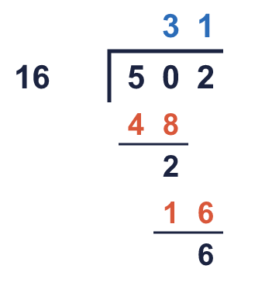
  5 | Work out each division. Write the remainder as a fraction of the divisor, like this: 12 ³⁄₄.  a) 536 ÷ 18 =  b) 335 ÷ 20 =  Hint: The remainder is the top of the fraction and the divisor is the bottom. Simplify the fraction if you can.  Worked example: 502 ÷ 16. What is left at the end is the remainder.
  6 | A school has 364 pupils, 24 staff and 10 governors. Everyone is invited to a meal. Each table seats 10 people.  How many tables are needed?  Hint: Add up all the people. Divide by the number at a table. If there is a remainder, one more table is needed.
  6 | A school has 364 pupils, 24 staff and 10 governors. Everyone is invited to a meal. Each table seats 10 people.  How many tables are needed?  Hint: Add up all the people. Divide by the number at a table. If there is a remainder, one more table is needed.
  7 | Each newspaper needs 32 sheets of paper. Paper comes in packets of 150 sheets. Ms Lee has 10 packets.  How many newspapers can she print?  Hint: Find the total number of sheets first. Then divide. Only complete newspapers count, so ignore the remainder.
  7 | Each newspaper needs 32 sheets of paper. Paper comes in packets of 150 sheets. Ms Lee has 10 packets.  How many newspapers can she print?  Hint: Find the total number of sheets first. Then divide. Only complete newspapers count, so ignore the remainder.
  8 | 6,374 lorries need to cross the sea by ferry. The ferry carries 79 lorries on each journey.  How many journeys will it take?  Hint: Divide. The last journey may not be full, but it still has to go: round UP if there is a remainder.
  8 | 6,374 lorries need to cross the sea by ferry. The ferry carries 79 lorries on each journey.  How many journeys will it take?  Hint: Divide. The last journey may not be full, but it still has to go: round UP if there is a remainder.

  9 | Is Boba correct? Circle yes or no.  Yes / No  Explain how you know. Check with multiplication.  Hint: Estimate first: is the answer about the right size? Then check by multiplying the answer by the divisor and adding the remainder.
     | 
  9 | Is Boba correct? Circle yes or no.  Yes / No  Explain how you know. Check with multiplication.  Hint: Estimate first: is the answer about the right size? Then check by multiplying the answer by the divisor and adding the remainder.
  10 | Find the missing number.  Hint: Take the remainder away from 4,550, then divide by 49. The divisor must be bigger than the remainder 42.
    4,550 ÷ |  | = 49 r 42
  10 | Find the missing number.  Hint: Take the remainder away from 4,550, then divide by 49. The divisor must be bigger than the remainder 42.
    4,550 ÷ |  | = 49 r 42
  11 | a) How much at Party Supplies?  b) How much at Fun Stores?  c) Which shop is cheaper?  Hint: Work out how many packs are needed: divide, then round UP. Multiply by the price of one pack.
     | 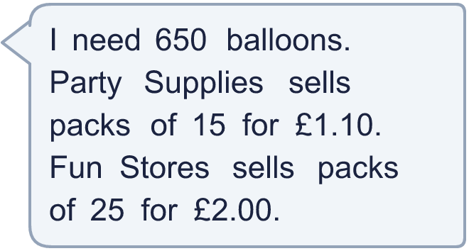
  11 | a) How much at Party Supplies?  b) How much at Fun Stores?  c) Which shop is cheaper?  Hint: Work out how many packs are needed: divide, then round UP. Multiply by the price of one pack.
  12 | Is Boba correct? Circle yes or no.  Yes / No  Explain how you know.  Hint: Think about what the remainder means in the story. Can the people left over just disappear?
     | 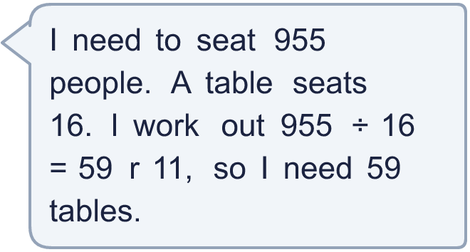
  12 | Is Boba correct? Circle yes or no.  Yes / No  Explain how you know.  Hint: Think about what the remainder means in the story. Can the people left over just disappear?
  13 | A rope is 700 cm long. It is cut into pieces that are 16 cm long.  a) How many whole pieces can be cut?  Hint: Divide the length by the length of one piece. The quotient is the number of whole pieces and the remainder is the piece left over.
    b) | How long is the piece that is left over?
    cm
  13 | A rope is 700 cm long. It is cut into pieces that are 16 cm long.  a) How many whole pieces can be cut?  Hint: Divide the length by the length of one piece. The quotient is the number of whole pieces and the remainder is the piece left over.
    b) | How long is the piece that is left over?
    cm
  14 | Write three different numbers that give a remainder of 9 when divided by 24.  Hint: Pick any number in the 24 times table. Add 9.
  14 | Write three different numbers that give a remainder of 9 when divided by 24.  Hint: Pick any number in the 24 times table. Add 9.

Year 6 · Add, subtract, multiply and divide · Step 12
Long division with remainders
Answers (teacher copy)

  1 | Write the first nine multiples of 14.  14, 28, 42, 56, 70, 84, 98, 112, 126  Hint: Start with 14 and add 14 each time. These will help with long division.
  2 | Use long division. Write the remainder like this: 54 r 8.  a) 187 ÷ 15 = 12 r 7  b) 434 ÷ 12 = 36 r 2  Hint: Use the multiples of the divisor. When what is left is smaller than the divisor, it is the remainder.  Worked example: 525 ÷ 14. What is left at the end is the remainder.
  3 | Use long division. Write the remainder like this: 54 r 8.  a) 638 ÷ 13 = 49 r 1  b) 640 ÷ 14 = 45 r 10  Hint: Write the multiples of the divisor in a list first. Then divide one digit at a time from the left.
  4 | Use long division. Write the remainder like this: 54 r 8.  a) 1,707 ÷ 18 = 94 r 15  b) 3,040 ÷ 24 = 126 r 16  Hint: This takes more steps. After each subtraction, bring down the next digit and ask how many groups of the divisor fit.
  5 | Work out each division. Write the remainder as a fraction of the divisor, like this: 12 ³⁄₄.  a) 536 ÷ 18 = 29 ⁷⁄₉  b) 335 ÷ 20 = 16 ³⁄₄  Hint: The remainder is the top of the fraction and the divisor is the bottom. Simplify the fraction if you can.  Worked example: 502 ÷ 16. What is left at the end is the remainder.
  6 | A school has 364 pupils, 24 staff and 10 governors. Everyone is invited to a meal. Each table seats 10 people.  How many tables are needed? 40  Hint: Add up all the people. Divide by the number at a table. If there is a remainder, one more table is needed.
  7 | Each newspaper needs 32 sheets of paper. Paper comes in packets of 150 sheets. Ms Lee has 10 packets.  How many newspapers can she print? 46  Hint: Find the total number of sheets first. Then divide. Only complete newspapers count, so ignore the remainder.
  8 | 6,374 lorries need to cross the sea by ferry. The ferry carries 79 lorries on each journey.  How many journeys will it take? 81  Hint: Divide. The last journey may not be full, but it still has to go: round UP if there is a remainder.
  9 | Is Boba correct? Circle yes or no.  Yes / No  Explain how you know. Check with multiplication.  113 × 24 = 2,712, which is not near 267. The correct answer is 11 r 3: 11 × 24 + 3 = 267.  Hint: Estimate first: is the answer about the right size? Then check by multiplying the answer by the divisor and adding the remainder.
  10 | Find the missing number.  4,550 ÷ 92 = 49 r 42  Hint: Take the remainder away from 4,550, then divide by 49. The divisor must be bigger than the remainder 42.
  11 | a) How much at Party Supplies? £48.40  b) How much at Fun Stores? £52.00  c) Which shop is cheaper? Party Supplies  Hint: Work out how many packs are needed: divide, then round UP. Multiply by the price of one pack.
  12 | Is Boba correct? Circle yes or no.  Yes / No  Explain how you know.  59 tables seat only 944 people. 11 people would be left standing, so a table is needed for them: 60 tables.  Hint: Think about what the remainder means in the story. Can the people left over just disappear?
  13 | A rope is 700 cm long. It is cut into pieces that are 16 cm long.  a) How many whole pieces can be cut? 43  b) How long is the piece that is left over? 12 cm  Hint: Divide the length by the length of one piece. The quotient is the number of whole pieces and the remainder is the piece left over.
  14 | Write three different numbers that give a remainder of 9 when divided by 24.  Any three numbers with remainder 9 when divided by 24, for example 297, 489, 753  Hint: Pick any number in the 24 times table. Add 9.

