Methods to help you:  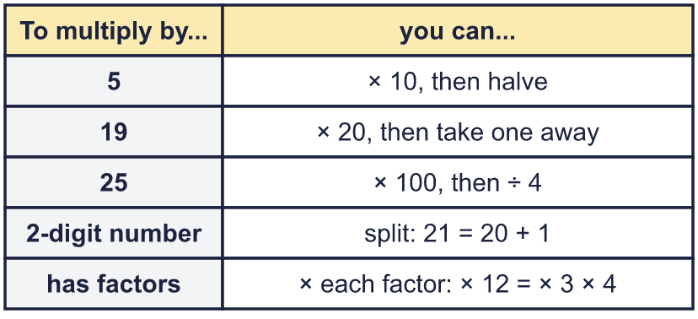 |  | Methods to help you:
  Year 6 · Add, subtract, multiply and divide · Step 8  Multiplication problems | 
  Year 6 · Add, subtract, multiply and divide · Step 8
  Multiplication problems
  1 | Use the bar model to work out the multiplication.  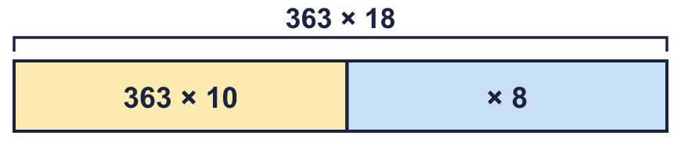  a) 363 × 10 =  b) 363 × 8 =  c) 363 × 18 =  Hint: Split 18 into 10 and 8. Work out each part, then add the two answers.
  1 | Use the bar model to work out the multiplication.  a) 363 × 10 =  b) 363 × 8 =  c) 363 × 18 =  Hint: Split 18 into 10 and 8. Work out each part, then add the two answers.
  2 | Use the rounding method to work out 32 × 39. Complete the number sentence.  Hint: 39 is 1 less than 40. Work out 32 × 40, then take away one 32.
    32 × 39 = 32 × 40 − |  | =
  2 | Use the rounding method to work out 32 × 39. Complete the number sentence.  Hint: 39 is 1 less than 40. Work out 32 × 40, then take away one 32.
    32 × 39 = 32 × 40 − |  | =
  3 | Multiply by 5. Use the times 10, then halve method.  a) 27 × 5 =  b) 157 × 5 =  c) 290 × 5 =  d) 1,399 × 5 =  Hint: × 5 is the same as × 10 and then ÷ 2. For example 64 × 5: 64 × 10 = 640, half of 640 = 320.
  3 | Multiply by 5. Use the times 10, then halve method.  a) 27 × 5 =  b) 157 × 5 =  c) 290 × 5 =  d) 1,399 × 5 =  Hint: × 5 is the same as × 10 and then ÷ 2. For example 64 × 5: 64 × 10 = 640, half of 640 = 320.
  4 | Fill in the missing numbers.  Hint: Both sides must have the same answer. Work out the missing number by dividing the product by the number you can see.
    a) | 36 × 4 = 12 × |  | so
    36 × 4 =
    b) | 16 × 6 = 8 × |  | so | 16 × 6 =
  4 | Fill in the missing numbers.  Hint: Both sides must have the same answer. Work out the missing number by dividing the product by the number you can see.
    a) | 36 × 4 = 12 × |  | so
    36 × 4 =
    b) | 16 × 6 = 8 × |  | so | 16 × 6 =
  5 | Use factors to help you multiply.  a) 9 × 14 =  b) 6 × 24 =  Hint: Break one number into factors. For example 8 × 15 = 8 × 3 × 5 = 24 × 5 = 120.
  5 | Use factors to help you multiply.  a) 9 × 14 =  b) 6 × 24 =  Hint: Break one number into factors. For example 8 × 15 = 8 × 3 × 5 = 24 × 5 = 120.
  6 | Multiply by 25. Use the times 100, then divide by 4 method.  a) 24 × 25 =  b) 16 × 25 =  Hint: × 25 is the same as × 100 and then ÷ 4. For example 32 × 25: 32 × 100 = 3,200, then 3,200 ÷ 4 = 800.
  6 | Multiply by 25. Use the times 100, then divide by 4 method.  a) 24 × 25 =  b) 16 × 25 =  Hint: × 25 is the same as × 100 and then ÷ 4. For example 32 × 25: 32 × 100 = 3,200, then 3,200 ÷ 4 = 800.
  7 | There are 56 seats on a coach. A school hires 9 coaches.  How many seats are there altogether?  Hint: Use factors or partition: 44 × 6 = 40 × 6 + 4 × 6.
  7 | There are 56 seats on a coach. A school hires 9 coaches.  How many seats are there altogether?  Hint: Use factors or partition: 44 × 6 = 40 × 6 + 4 × 6.
  8 | A laptop costs £99.99. A shop buys 4 laptops.  How much do they cost?  Hint: £99.99 is 1p less than £100.00. Work out 4 × £100.00 and take away 4p.
  8 | A laptop costs £99.99. A shop buys 4 laptops.  How much do they cost?  Hint: £99.99 is 1p less than £100.00. Work out 4 × £100.00 and take away 4p.

  9 | a) How many boxes can the factory pack in one day?  b) How many in 5 days?  Hint: a) Multiply the boxes by the number of machines. Use 1,000 × m + the rest. b) Multiply your answer to a) by the number of days.
     | 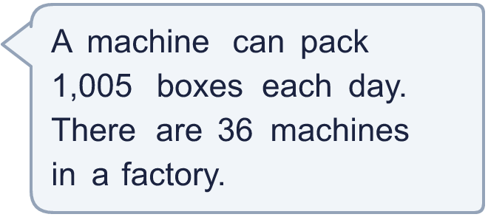
  9 | a) How many boxes can the factory pack in one day?  b) How many in 5 days?  Hint: a) Multiply the boxes by the number of machines. Use 1,000 × m + the rest. b) Multiply your answer to a) by the number of days.
  10 | 29 children go on a school trip by train. A train ticket costs £19.  What is the total cost of the tickets?  Hint: Think of 29 as 30 − 1 (or 30 − 1). Work out the easy multiplication, then take away.
  10 | 29 children go on a school trip by train. A train ticket costs £19.  What is the total cost of the tickets?  Hint: Think of 29 as 30 − 1 (or 30 − 1). Work out the easy multiplication, then take away.
  11 | Is Boba correct? Circle yes or no.  Yes / No  Explain how you know.  Hint: 5 is half of 10. So multiplying by 5 is the same as multiplying by 10 and then halving.
     | 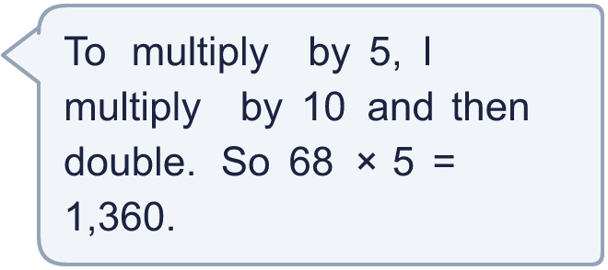
  11 | Is Boba correct? Circle yes or no.  Yes / No  Explain how you know.  Hint: 5 is half of 10. So multiplying by 5 is the same as multiplying by 10 and then halving.
  12 | How many different ways can you work out 34 × 21? Write two different calculations that give the answer.  Hint: Partition one of the numbers into tens and ones. Or use a factor. Check that your calculation gives 714.
  12 | How many different ways can you work out 34 × 21? Write two different calculations that give the answer.  Hint: Partition one of the numbers into tens and ones. Or use a factor. Check that your calculation gives 714.
  13 | Complete the multiplication in two different ways: ___ × ___ = 756  Hint: Find numbers that divide into 756 exactly. Try 2, 3, 4, 6, ... and divide 756 by each one.
  13 | Complete the multiplication in two different ways: ___ × ___ = 756  Hint: Find numbers that divide into 756 exactly. Try 2, 3, 4, 6, ... and divide 756 by each one.
  14 | Pencils are sold in packs of 48. Class A buys 26 packs. Class B buys 29 packs.  How many pencils do the two classes buy altogether?  Hint: You can add the packs first: 26 + 29. Then multiply by 48. Or work out each class separately and add.
  14 | Pencils are sold in packs of 48. Class A buys 26 packs. Class B buys 29 packs.  How many pencils do the two classes buy altogether?  Hint: You can add the packs first: 26 + 29. Then multiply by 48. Or work out each class separately and add.

Year 6 · Add, subtract, multiply and divide · Step 8
Multiplication problems
Answers (teacher copy)

Methods to help you:
  1 | Use the bar model to work out the multiplication.  a) 363 × 10 = 3,630  b) 363 × 8 = 2,904  c) 363 × 18 = 6,534  Hint: Split 18 into 10 and 8. Work out each part, then add the two answers.
  2 | Use the rounding method to work out 32 × 39. Complete the number sentence.  32 × 39 = 32 × 40 − 32 = 1,248  Hint: 39 is 1 less than 40. Work out 32 × 40, then take away one 32.
  3 | Multiply by 5. Use the times 10, then halve method.  a) 27 × 5 = 135  b) 157 × 5 = 785  c) 290 × 5 = 1,450  d) 1,399 × 5 = 6,995  Hint: × 5 is the same as × 10 and then ÷ 2. For example 64 × 5: 64 × 10 = 640, half of 640 = 320.
  4 | Fill in the missing numbers.  a) 36 × 4 = 12 × 12 so 36 × 4 = 144  b) 16 × 6 = 8 × 12 so 16 × 6 = 96  Hint: Both sides must have the same answer. Work out the missing number by dividing the product by the number you can see.
  5 | Use factors to help you multiply.  a) 9 × 14 = 126  b) 6 × 24 = 144  Hint: Break one number into factors. For example 8 × 15 = 8 × 3 × 5 = 24 × 5 = 120.
  6 | Multiply by 25. Use the times 100, then divide by 4 method.  a) 24 × 25 = 600  b) 16 × 25 = 400  Hint: × 25 is the same as × 100 and then ÷ 4. For example 32 × 25: 32 × 100 = 3,200, then 3,200 ÷ 4 = 800.
  7 | There are 56 seats on a coach. A school hires 9 coaches.  How many seats are there altogether? 504  Hint: Use factors or partition: 44 × 6 = 40 × 6 + 4 × 6.
  8 | A laptop costs £99.99. A shop buys 4 laptops.  How much do they cost? £399.96  Hint: £99.99 is 1p less than £100.00. Work out 4 × £100.00 and take away 4p.
  9 | a) How many boxes can the factory pack in one day? 36,180  b) How many in 5 days? 180,900  Hint: a) Multiply the boxes by the number of machines. Use 1,000 × m + the rest. b) Multiply your answer to a) by the number of days.
  10 | 29 children go on a school trip by train. A train ticket costs £19.  What is the total cost of the tickets? £551  Hint: Think of 29 as 30 − 1 (or 30 − 1). Work out the easy multiplication, then take away.
  11 | Is Boba correct? Circle yes or no.  Yes / No  Explain how you know.  × 5 is × 10 and then HALVE, not double. 68 × 10 = 680, and half of 680 is 340. So 68 × 5 = 340.  Hint: 5 is half of 10. So multiplying by 5 is the same as multiplying by 10 and then halving.
  12 | How many different ways can you work out 34 × 21? Write two different calculations that give the answer.  Any two correct methods for 34 × 21, for example 34 × 20 + 34 × 1 or 30 × 21 + 4 × 21  Hint: Partition one of the numbers into tens and ones. Or use a factor. Check that your calculation gives 714.
  13 | Complete the multiplication in two different ways: ___ × ___ = 756  Any two pairs of whole numbers that multiply to 756, for example 2 × 378 or 3 × 252  Hint: Find numbers that divide into 756 exactly. Try 2, 3, 4, 6, ... and divide 756 by each one.
  14 | Pencils are sold in packs of 48. Class A buys 26 packs. Class B buys 29 packs.  How many pencils do the two classes buy altogether? 2,640  Hint: You can add the packs first: 26 + 29. Then multiply by 48. Or work out each class separately and add.

