  Year 6 · Add, subtract, multiply and divide · Step 7  Multiplying up to 4 digits by 2 digits | 
  Year 6 · Add, subtract, multiply and divide · Step 7
  Multiplying up to 4 digits by 2 digits
  1 | Use partitioning to work out 1,741 × 42.  a) 1,741 × 2 =  b) 1,741 × 40 =  c) 1,741 × 42 =  Hint: Split 42 into 40 and 2. Multiply by each part, then add the two answers.  Worked example, partitioning the 2-digit number:  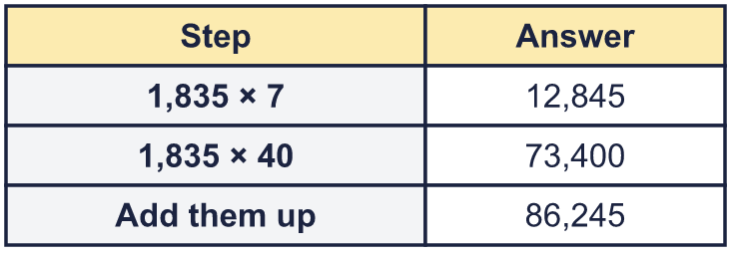
  1 | Use partitioning to work out 1,741 × 42.  a) 1,741 × 2 =  b) 1,741 × 40 =  c) 1,741 × 42 =  Hint: Split 42 into 40 and 2. Multiply by each part, then add the two answers.  Worked example, partitioning the 2-digit number:
  2 | Work out the multiplications.  a) 393 × 21 =  b) 3,325 × 39 =  Hint: Multiply by the ones digit first. Then multiply by the tens digit: write a 0 in the ones place before you start. Add the two answers.  Worked example: 430 × 33. Multiply by the ones, then by the tens (add a zero), then add.  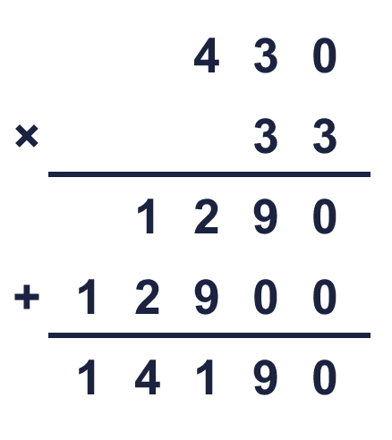
  2 | Work out the multiplications.  a) 393 × 21 =  b) 3,325 × 39 =  Hint: Multiply by the ones digit first. Then multiply by the tens digit: write a 0 in the ones place before you start. Add the two answers.  Worked example: 430 × 33. Multiply by the ones, then by the tens (add a zero), then add.
  3 | Write the missing digits in the multiplication.  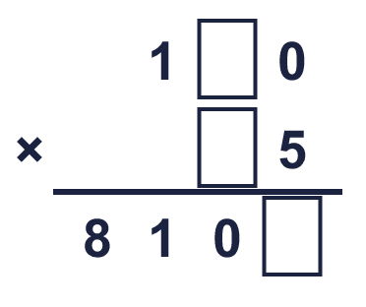  Missing digits, from top to bottom and left to right:  Hint: Look at the ones digits first: what times what ends in that digit? Then check the size of the answer.  Worked example: 478 × 20. Multiply by the ones, then by the tens (add a zero), then add.  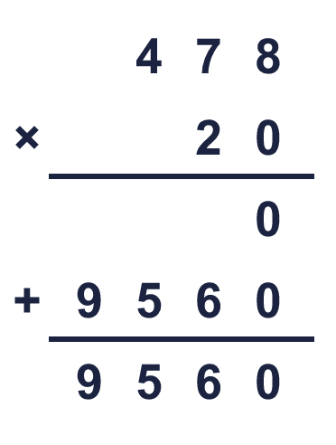
  3 | Write the missing digits in the multiplication.  Missing digits, from top to bottom and left to right:  Hint: Look at the ones digits first: what times what ends in that digit? Then check the size of the answer.  Worked example: 478 × 20. Multiply by the ones, then by the tens (add a zero), then add.
  4 | Look at this calculation: 1,055 × 35. Without working it out, which of these could be the answer? Use the ones digit and an estimate.  3,692 36,927 36,925  Hint: Look at the ones digits: 5 × 5 = 25, so the answer must end in 5. Then estimate: 1,000 × 40 = 40,000.
  4 | Look at this calculation: 1,055 × 35. Without working it out, which of these could be the answer? Use the ones digit and an estimate.  3,692 36,927 36,925  Hint: Look at the ones digits: 5 × 5 = 25, so the answer must end in 5. Then estimate: 1,000 × 40 = 40,000.
  5 | Estimate 7,943 × 39 by rounding each number to its first digit (1 significant figure).  Estimate:  Hint: Round 7,943 to 8,000 and 39 to 40. Then multiply the rounded numbers.
  5 | Estimate 7,943 × 39 by rounding each number to its first digit (1 significant figure).  Estimate:  Hint: Round 7,943 to 8,000 and 39 to 40. Then multiply the rounded numbers.
  6 | A car park has 195 rows of 19 spaces. 1,850 cars are already parked.  How many empty spaces are there?  Hint: First find the total number of spaces: rows × spaces in a row. Then take away the cars that are parked.
  6 | A car park has 195 rows of 19 spaces. 1,850 cars are already parked.  How many empty spaces are there?  Hint: First find the total number of spaces: rows × spaces in a row. Then take away the cars that are parked.
  7 | Mr Smith tiles his kitchen floor with 274 tiles. Each tile costs 19p.  How much does it cost to tile the floor?  Hint: Multiply the number of tiles by the price in pence. Then change the pence into pounds: 100p = £1.
  7 | Mr Smith tiles his kitchen floor with 274 tiles. Each tile costs 19p.  How much does it cost to tile the floor?  Hint: Multiply the number of tiles by the price in pence. Then change the pence into pounds: 100p = £1.
  8 | There are 15 classes in a school. Each class has 24 children. A theatre has 400 seats.  Is there room for every child? Write yes or no.  Hint: Work out how many children there are altogether: classes × children in each class. Then compare it with the number of seats.
  8 | There are 15 classes in a school. Each class has 24 children. A theatre has 400 seats.  Is there room for every child? Write yes or no.  Hint: Work out how many children there are altogether: classes × children in each class. Then compare it with the number of seats.

  9 | Is Boba correct? Circle yes or no.  Yes / No  Explain how you know. Look at the ones digit.  Hint: Multiply only the ones digits. The ones digit of that answer is the ones digit of the full answer.
     | 
  9 | Is Boba correct? Circle yes or no.  Yes / No  Explain how you know. Look at the ones digit.  Hint: Multiply only the ones digits. The ones digit of that answer is the ones digit of the full answer.
  10 | Rosie does 55 sit-ups every day for a year of 365 days. Annie does 492 sit-ups every day in July (31 days).  a) Who does more sit-ups?  b) How many more?  Hint: Work out each person’s total first: sit-ups a day × number of days. Then find the difference.
  10 | Rosie does 55 sit-ups every day for a year of 365 days. Annie does 492 sit-ups every day in July (31 days).  a) Who does more sit-ups?  b) How many more?  Hint: Work out each person’s total first: sit-ups a day × number of days. Then find the difference.
  11 | 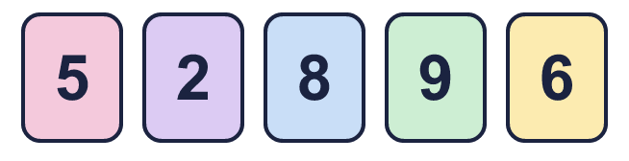  a) What is the greatest product you can make?  b) What is the greatest odd product you can make?  Hint: a) Put the biggest digits in the highest places, but try swapping the tens digit of the 2-digit number. b) A product is odd only if both ones digits are odd.
    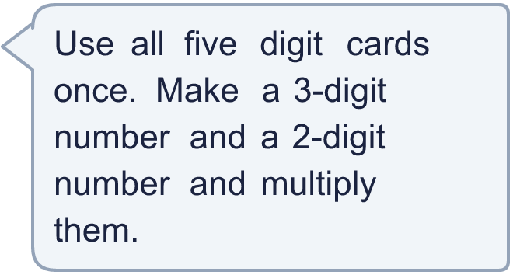
  11 | a) What is the greatest product you can make?  b) What is the greatest odd product you can make?  Hint: a) Put the biggest digits in the highest places, but try swapping the tens digit of the 2-digit number. b) A product is odd only if both ones digits are odd.
  12 | What number did I start with?  Hint: Do the opposite: divide 104,496 by 28. You can check by multiplying your answer by 28.
     | 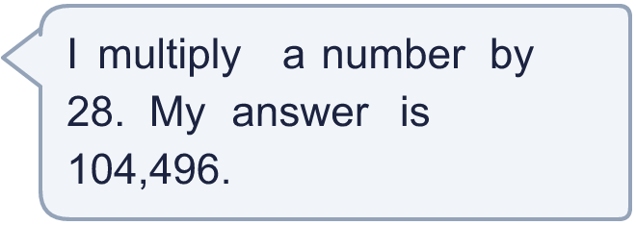
  12 | What number did I start with?  Hint: Do the opposite: divide 104,496 by 28. You can check by multiplying your answer by 28.
  13 | Look at 3,499 × 20. Is the answer more than 60,000 and less than 80,000? Circle yes or no.  Yes / No  Explain how you know. Use an estimate.  Hint: Round each number to its first digit. Multiply them to get an estimate. Is your estimate in the range?
  13 | Look at 3,499 × 20. Is the answer more than 60,000 and less than 80,000? Circle yes or no.  Yes / No  Explain how you know. Use an estimate.  Hint: Round each number to its first digit. Multiply them to get an estimate. Is your estimate in the range?
  14 | Write a 4-digit number and a 2-digit number that multiply to give an answer between 100,000 and 120,000.  Hint: Estimate first. For example 4,000 × 30 = 120,000. Then adjust one of the numbers up or down.
  14 | Write a 4-digit number and a 2-digit number that multiply to give an answer between 100,000 and 120,000.  Hint: Estimate first. For example 4,000 × 30 = 120,000. Then adjust one of the numbers up or down.

Year 6 · Add, subtract, multiply and divide · Step 7
Multiplying up to 4 digits by 2 digits
Answers (teacher copy)

  1 | Use partitioning to work out 1,741 × 42.  a) 1,741 × 2 = 3,482  b) 1,741 × 40 = 69,640  c) 1,741 × 42 = 73,122  Hint: Split 42 into 40 and 2. Multiply by each part, then add the two answers.  Worked example, partitioning the 2-digit number:
  2 | Work out the multiplications.  a) 393 × 21 = 8,253  b) 3,325 × 39 = 129,675  Hint: Multiply by the ones digit first. Then multiply by the tens digit: write a 0 in the ones place before you start. Add the two answers.  Worked example: 430 × 33. Multiply by the ones, then by the tens (add a zero), then add.
  3 | Write the missing digits in the multiplication.  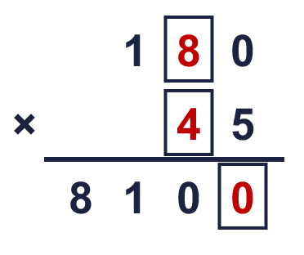  Missing digits, from top to bottom and left to right: 8 4 0  Hint: Look at the ones digits first: what times what ends in that digit? Then check the size of the answer.  Worked example: 478 × 20. Multiply by the ones, then by the tens (add a zero), then add.
  4 | Look at this calculation: 1,055 × 35. Without working it out, which of these could be the answer? Use the ones digit and an estimate.  3,692 36,927 36,925  36,925  Hint: Look at the ones digits: 5 × 5 = 25, so the answer must end in 5. Then estimate: 1,000 × 40 = 40,000.
  5 | Estimate 7,943 × 39 by rounding each number to its first digit (1 significant figure).  Estimate: 320,000  Hint: Round 7,943 to 8,000 and 39 to 40. Then multiply the rounded numbers.
  6 | A car park has 195 rows of 19 spaces. 1,850 cars are already parked.  How many empty spaces are there? 1,855  Hint: First find the total number of spaces: rows × spaces in a row. Then take away the cars that are parked.
  7 | Mr Smith tiles his kitchen floor with 274 tiles. Each tile costs 19p.  How much does it cost to tile the floor? £52.06  Hint: Multiply the number of tiles by the price in pence. Then change the pence into pounds: 100p = £1.
  8 | There are 15 classes in a school. Each class has 24 children. A theatre has 400 seats.  Is there room for every child? Write yes or no. Yes  Hint: Work out how many children there are altogether: classes × children in each class. Then compare it with the number of seats.
  9 | Is Boba correct? Circle yes or no.  Yes / No  Explain how you know. Look at the ones digit.  3 × 6 = 18, so the answer must end in 8. 43,517 ends in 7. The correct answer is 43,518.  Hint: Multiply only the ones digits. The ones digit of that answer is the ones digit of the full answer.
  10 | Rosie does 55 sit-ups every day for a year of 365 days. Annie does 492 sit-ups every day in July (31 days).  a) Who does more sit-ups? Rosie  b) How many more? 4,823  Hint: Work out each person’s total first: sit-ups a day × number of days. Then find the difference.
  11 | a) What is the greatest product you can make? 81,890  b) What is the greatest odd product you can make? 56,925  Hint: a) Put the biggest digits in the highest places, but try swapping the tens digit of the 2-digit number. b) A product is odd only if both ones digits are odd.
  12 | What number did I start with? 3,732  Hint: Do the opposite: divide 104,496 by 28. You can check by multiplying your answer by 28.
  13 | Look at 3,499 × 20. Is the answer more than 60,000 and less than 80,000? Circle yes or no.  Yes / No  Explain how you know. Use an estimate.  3,000 × 20 = 60,000, and the answer 69,980 is between 60,000 and 80,000.  Hint: Round each number to its first digit. Multiply them to get an estimate. Is your estimate in the range?
  14 | Write a 4-digit number and a 2-digit number that multiply to give an answer between 100,000 and 120,000.  Any 4-digit × 2-digit with a product between 100,000 and 120,000, for example 1,112 × 90 or 1,119 × 90  Hint: Estimate first. For example 4,000 × 30 = 120,000. Then adjust one of the numbers up or down.

