  Year 6 · Add, subtract, multiply and divide · Step 5  Prime numbers to 100 | 
  Year 6 · Add, subtract, multiply and divide · Step 5
  Prime numbers to 100
  1 | Write the prime numbers in each list.  a) 2 4 7 5 6 3 9  b) 23 36 21 9 22 17 35
  1 | Write the prime numbers in each list.  a) 2 4 7 5 6 3 9  b) 23 36 21 9 22 17 35
  2 | Write all the factors of each number.  a) 11:  b) 14:  c) 31:
  2 | Write all the factors of each number.  a) 11:  b) 14:  c) 31:
  3 | Write how many factors each number has.  a) 15:  b) 1:  c) 2:  d) 11:
  3 | Write how many factors each number has.  a) 15:  b) 1:  c) 2:  d) 11:
  4 | List all the prime numbers between 50 and 70.
  4 | List all the prime numbers between 50 and 70.
  5 | Is each number prime? Write yes or no.  a) 56:  b) 73:  c) 69:
  5 | Is each number prime? Write yes or no.  a) 56:  b) 73:  c) 69:
  6 | Write each number as a product of prime numbers.  a) 20 =  b) 12 =  c) 18 =
  6 | Write each number as a product of prime numbers.  a) 20 =  b) 12 =  c) 18 =
  7 | Two of these prime numbers add up to 40. Which two?  5 7 11 17 23
  7 | Two of these prime numbers add up to 40. Which two?  5 7 11 17 23
  8 | Twin primes are two prime numbers that are exactly 2 apart. Which pairs are twin primes? Write the letters.  a) 29 and 31  b) 31 and 37  c) 59 and 61  d) 13 and 17
  8 | Twin primes are two prime numbers that are exactly 2 apart. Which pairs are twin primes? Write the letters.  a) 29 and 31  b) 31 and 37  c) 59 and 61  d) 13 and 17

  9 | Is Boba correct? Circle yes or no.  Yes / No  Explain how you know.
     | 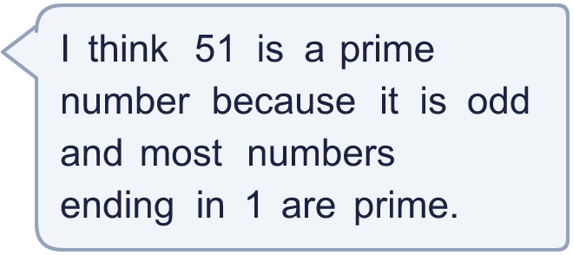
  9 | Is Boba correct? Circle yes or no.  Yes / No  Explain how you know.
  10 | Write 57 as a product of two numbers that are both bigger than 1.
     | 
  10 | Write 57 as a product of two numbers that are both bigger than 1.
  11 | • It is a prime number between 69 and 111.  • The digits add up to 17.  • The ones digit is 9.  What is my number?
    
  11 | • It is a prime number between 69 and 111.  • The digits add up to 17.  • The ones digit is 9.  What is my number?
  12 | Find all the pairs of prime numbers that add up to 40.  Write each pair like this: 7 + 13.
  12 | Find all the pairs of prime numbers that add up to 40.  Write each pair like this: 7 + 13.
  13 | Look at the prime numbers from 1 to 25 and from 26 to 50.  a) Which range has more prime numbers? Write the range.  b) How many prime numbers are in that range?
  13 | Look at the prime numbers from 1 to 25 and from 26 to 50.  a) Which range has more prime numbers? Write the range.  b) How many prime numbers are in that range?
  14 | Write three different numbers that are not prime, are odd and have two digits, and are not divisible by 3 or 5.
  14 | Write three different numbers that are not prime, are odd and have two digits, and are not divisible by 3 or 5.

Year 6 · Add, subtract, multiply and divide · Step 5
Prime numbers to 100
Answers (teacher copy)

  1 | Write the prime numbers in each list.  a) 2 4 7 5 6 3 9 2, 7, 5, 3  b) 23 36 21 9 22 17 35 23, 17
  2 | Write all the factors of each number.  a) 11: 1, 11  b) 14: 1, 2, 7, 14  c) 31: 1, 31
  3 | Write how many factors each number has.  a) 15: 4  b) 1: 1  c) 2: 2  d) 11: 2
  4 | List all the prime numbers between 50 and 70.  53, 59, 61, 67
  5 | Is each number prime? Write yes or no.  a) 56: No  b) 73: Yes  c) 69: No
  6 | Write each number as a product of prime numbers.  a) 20 = 2 × 2 × 5  b) 12 = 2 × 2 × 3  c) 18 = 2 × 3 × 3
  7 | Two of these prime numbers add up to 40. Which two?  5 7 11 17 23  17 and 23
  8 | Twin primes are two prime numbers that are exactly 2 apart. Which pairs are twin primes? Write the letters.  a) 29 and 31  b) 31 and 37  c) 59 and 61  d) 13 and 17  a, c
  9 | Is Boba correct? Circle yes or no.  Yes / No  Explain how you know.  51 is not prime: 51 ÷ 3 = 17, so 3 × 17 = 51. It has more than two factors.
  10 | Write 57 as a product of two numbers that are both bigger than 1. 3 × 19
  11 | • It is a prime number between 69 and 111.  • The digits add up to 17.  • The ones digit is 9.  What is my number? 89
  12 | Find all the pairs of prime numbers that add up to 40.  Write each pair like this: 7 + 13. 3 + 37, 11 + 29, 17 + 23
  13 | Look at the prime numbers from 1 to 25 and from 26 to 50.  a) Which range has more prime numbers? Write the range. 1 to 25  b) How many prime numbers are in that range? 9
  14 | Write three different numbers that are not prime, are odd and have two digits, and are not divisible by 3 or 5.  Any three numbers that fit, for example 49, 77, 91

