Primes up to 100 (shaded) to help you:  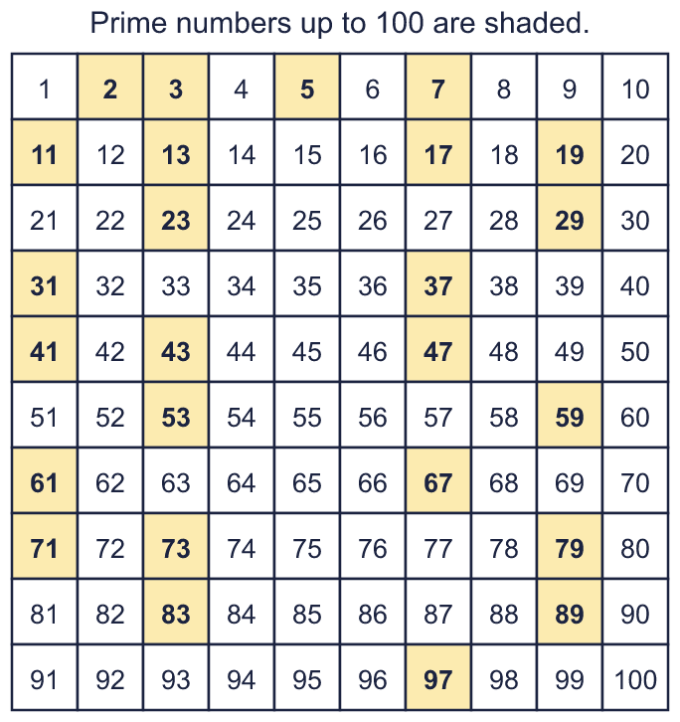 |  | Primes up to 100 (shaded) to help you:
  Year 6 · Add, subtract, multiply and divide · Step 5  Prime numbers to 100 | 
  Year 6 · Add, subtract, multiply and divide · Step 5
  Prime numbers to 100
  1 | Write the prime numbers in each list.  a) 2 4 7 5 6 3 9  b) 23 36 21 9 22 17 35  Hint: A prime number has exactly TWO factors: 1 and itself. Check the numbers one at a time: does anything other than 1 and itself divide it?
  1 | Write the prime numbers in each list.  a) 2 4 7 5 6 3 9  b) 23 36 21 9 22 17 35  Hint: A prime number has exactly TWO factors: 1 and itself. Check the numbers one at a time: does anything other than 1 and itself divide it?
  2 | Write all the factors of each number.  a) 11:  b) 14:  c) 31:  Hint: Try 1, 2, 3, 4 ... in turn. Stop when you reach a number whose partner you have already found.  Worked example: a factor tree for 16  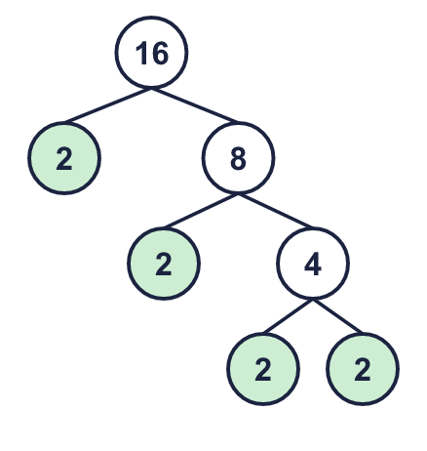
  2 | Write all the factors of each number.  a) 11:  b) 14:  c) 31:  Hint: Try 1, 2, 3, 4 ... in turn. Stop when you reach a number whose partner you have already found.  Worked example: a factor tree for 16
  3 | Write how many factors each number has.  a) 15:  b) 1:  c) 2:  d) 11:  Hint: A prime number has exactly TWO factors: 1 and itself. Is the number prime if it has more or fewer?
  3 | Write how many factors each number has.  a) 15:  b) 1:  c) 2:  d) 11:  Hint: A prime number has exactly TWO factors: 1 and itself. Is the number prime if it has more or fewer?
  4 | List all the prime numbers between 50 and 70.  Hint: Cross out the multiples of 2, 3, 5 and 7 first. The numbers left are prime.
  4 | List all the prime numbers between 50 and 70.  Hint: Cross out the multiples of 2, 3, 5 and 7 first. The numbers left are prime.
  5 | Is each number prime? Write yes or no.  a) 56:  b) 73:  c) 69:  Hint: Test the small primes 2, 3, 5 and 7. If none of them divide the number exactly, it is prime (for numbers up to 100).
  5 | Is each number prime? Write yes or no.  a) 56:  b) 73:  c) 69:  Hint: Test the small primes 2, 3, 5 and 7. If none of them divide the number exactly, it is prime (for numbers up to 100).
  6 | Write each number as a product of prime numbers.  a) 20 =  b) 12 =  c) 18 =  Hint: Split the number into two factors. Keep splitting any factor that is not prime. Write the primes in order, smallest first.  Worked example: a factor tree for 40  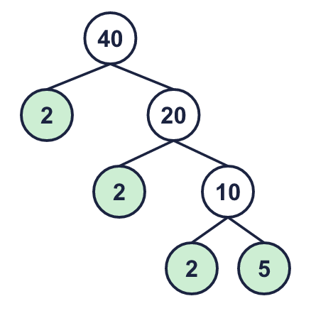
  6 | Write each number as a product of prime numbers.  a) 20 =  b) 12 =  c) 18 =  Hint: Split the number into two factors. Keep splitting any factor that is not prime. Write the primes in order, smallest first.  Worked example: a factor tree for 40
  7 | Two of these prime numbers add up to 40. Which two?  5 7 11 17 23  Hint: Try adding the biggest number to each of the others. Which pair makes 40?
  7 | Two of these prime numbers add up to 40. Which two?  5 7 11 17 23  Hint: Try adding the biggest number to each of the others. Which pair makes 40?
  8 | Twin primes are two prime numbers that are exactly 2 apart. Which pairs are twin primes? Write the letters.  a) 29 and 31  b) 31 and 37  c) 59 and 61  d) 13 and 17  Hint: Take the smaller number away from the bigger one. Is the difference 2?
  8 | Twin primes are two prime numbers that are exactly 2 apart. Which pairs are twin primes? Write the letters.  a) 29 and 31  b) 31 and 37  c) 59 and 61  d) 13 and 17  Hint: Take the smaller number away from the bigger one. Is the difference 2?

  9 | Is Boba correct? Circle yes or no.  Yes / No  Explain how you know.  Hint: Test whether any number other than 1 and 51 divides it. Try 3, 5 and 7.
     | 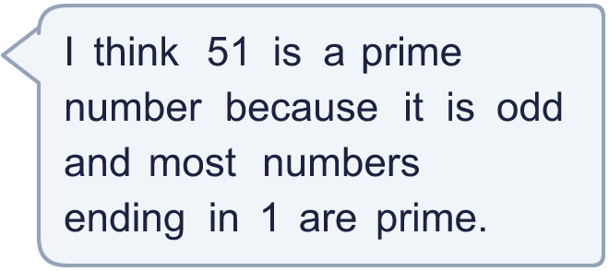
  9 | Is Boba correct? Circle yes or no.  Yes / No  Explain how you know.  Hint: Test whether any number other than 1 and 51 divides it. Try 3, 5 and 7.
  10 | Write 57 as a product of two numbers that are both bigger than 1.  Hint: Find a number bigger than 1 (not 57) that divides 57 exactly.
     | 
  10 | Write 57 as a product of two numbers that are both bigger than 1.  Hint: Find a number bigger than 1 (not 57) that divides 57 exactly.
  11 | • It is a prime number between 69 and 111.  • The digits add up to 17.  • The ones digit is 9.  What is my number?  Hint: List the prime numbers in the range first. Then use the other clues to cross numbers out.
    
  11 | • It is a prime number between 69 and 111.  • The digits add up to 17.  • The ones digit is 9.  What is my number?  Hint: List the prime numbers in the range first. Then use the other clues to cross numbers out.
  12 | Find all the pairs of prime numbers that add up to 40.  Write each pair like this: 7 + 13.  Hint: Write the primes less than 40. For each prime, take it away from 40 and check if the answer is prime too.
  12 | Find all the pairs of prime numbers that add up to 40.  Write each pair like this: 7 + 13.  Hint: Write the primes less than 40. For each prime, take it away from 40 and check if the answer is prime too.
  13 | Look at the prime numbers from 1 to 25 and from 26 to 50.  a) Which range has more prime numbers? Write the range.  b) How many prime numbers are in that range?  Hint: List the prime numbers in each range and count them. The shaded hundred square helps.
  13 | Look at the prime numbers from 1 to 25 and from 26 to 50.  a) Which range has more prime numbers? Write the range.  b) How many prime numbers are in that range?  Hint: List the prime numbers in each range and count them. The shaded hundred square helps.
  14 | Write three different numbers that are not prime, are odd and have two digits, and are not divisible by 3 or 5.  Hint: The smallest prime factor of your number must be 7 or more. Try multiples of 7, 11 and 13.
  14 | Write three different numbers that are not prime, are odd and have two digits, and are not divisible by 3 or 5.  Hint: The smallest prime factor of your number must be 7 or more. Try multiples of 7, 11 and 13.

Year 6 · Add, subtract, multiply and divide · Step 5
Prime numbers to 100
Answers (teacher copy)

Primes up to 100 (shaded) to help you:
  1 | Write the prime numbers in each list.  a) 2 4 7 5 6 3 9 2, 7, 5, 3  b) 23 36 21 9 22 17 35 23, 17  Hint: A prime number has exactly TWO factors: 1 and itself. Check the numbers one at a time: does anything other than 1 and itself divide it?
  2 | Write all the factors of each number.  a) 11: 1, 11  b) 14: 1, 2, 7, 14  c) 31: 1, 31  Hint: Try 1, 2, 3, 4 ... in turn. Stop when you reach a number whose partner you have already found.  Worked example: a factor tree for 16
  3 | Write how many factors each number has.  a) 15: 4  b) 1: 1  c) 2: 2  d) 11: 2  Hint: A prime number has exactly TWO factors: 1 and itself. Is the number prime if it has more or fewer?
  4 | List all the prime numbers between 50 and 70.  53, 59, 61, 67  Hint: Cross out the multiples of 2, 3, 5 and 7 first. The numbers left are prime.
  5 | Is each number prime? Write yes or no.  a) 56: No  b) 73: Yes  c) 69: No  Hint: Test the small primes 2, 3, 5 and 7. If none of them divide the number exactly, it is prime (for numbers up to 100).
  6 | Write each number as a product of prime numbers.  a) 20 = 2 × 2 × 5  b) 12 = 2 × 2 × 3  c) 18 = 2 × 3 × 3  Hint: Split the number into two factors. Keep splitting any factor that is not prime. Write the primes in order, smallest first.  Worked example: a factor tree for 40
  7 | Two of these prime numbers add up to 40. Which two?  5 7 11 17 23  17 and 23  Hint: Try adding the biggest number to each of the others. Which pair makes 40?
  8 | Twin primes are two prime numbers that are exactly 2 apart. Which pairs are twin primes? Write the letters.  a) 29 and 31  b) 31 and 37  c) 59 and 61  d) 13 and 17  a, c  Hint: Take the smaller number away from the bigger one. Is the difference 2?
  9 | Is Boba correct? Circle yes or no.  Yes / No  Explain how you know.  51 is not prime: 51 ÷ 3 = 17, so 3 × 17 = 51. It has more than two factors.  Hint: Test whether any number other than 1 and 51 divides it. Try 3, 5 and 7.
  10 | Write 57 as a product of two numbers that are both bigger than 1. 3 × 19  Hint: Find a number bigger than 1 (not 57) that divides 57 exactly.
  11 | • It is a prime number between 69 and 111.  • The digits add up to 17.  • The ones digit is 9.  What is my number? 89  Hint: List the prime numbers in the range first. Then use the other clues to cross numbers out.
  12 | Find all the pairs of prime numbers that add up to 40.  Write each pair like this: 7 + 13. 3 + 37, 11 + 29, 17 + 23  Hint: Write the primes less than 40. For each prime, take it away from 40 and check if the answer is prime too.
  13 | Look at the prime numbers from 1 to 25 and from 26 to 50.  a) Which range has more prime numbers? Write the range. 1 to 25  b) How many prime numbers are in that range? 9  Hint: List the prime numbers in each range and count them. The shaded hundred square helps.
  14 | Write three different numbers that are not prime, are odd and have two digits, and are not divisible by 3 or 5.  Any three numbers that fit, for example 49, 77, 91  Hint: The smallest prime factor of your number must be 7 or more. Try multiples of 7, 11 and 13.

