Squares and cubes to help you:  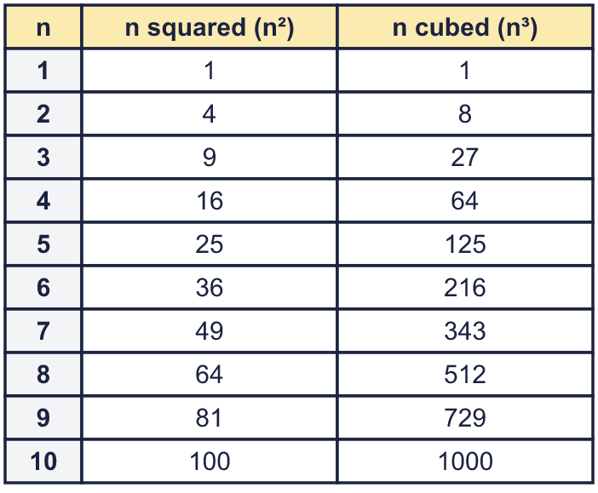 |  | Squares and cubes to help you:
  Year 6 · Add, subtract, multiply and divide · Step 6  Square and cube numbers | 
  Year 6 · Add, subtract, multiply and divide · Step 6
  Square and cube numbers
  1 | Work out each square number.  a) 5² =  b) 2² =  c) 9² =  d) 10² =  Hint: n² means n × n. For example 5² = 5 × 5 = 25.  3² is 3 groups of 3:  
  1 | Work out each square number.  a) 5² =  b) 2² =  c) 9² =  d) 10² =  Hint: n² means n × n. For example 5² = 5 × 5 = 25.  3² is 3 groups of 3:
  2 | Work out each cube number.  a) 2³ =  b) 3³ =  c) 6³ =  d) 10³ =  Hint: n³ means n × n × n. For example 3³ = 3 × 3 × 3 = 27. Work out n × n first, then multiply by n again.
  2 | Work out each cube number.  a) 2³ =  b) 3³ =  c) 6³ =  d) 10³ =  Hint: n³ means n × n × n. For example 3³ = 3 × 3 × 3 = 27. Work out n × n first, then multiply by n again.
  3 | Work out each calculation.  a) 9 squared =  b) 5 cubed =  c) 2 cubed =  d) 6 squared =  Hint: “Squared” means multiply the number by itself once more: n × n. “Cubed” means n × n × n.
  3 | Work out each calculation.  a) 9 squared =  b) 5 cubed =  c) 2 cubed =  d) 6 squared =  Hint: “Squared” means multiply the number by itself once more: n × n. “Cubed” means n × n × n.
  4 | Write <, > or = in each box.  Hint: Work out both sides first. Then compare the two numbers.  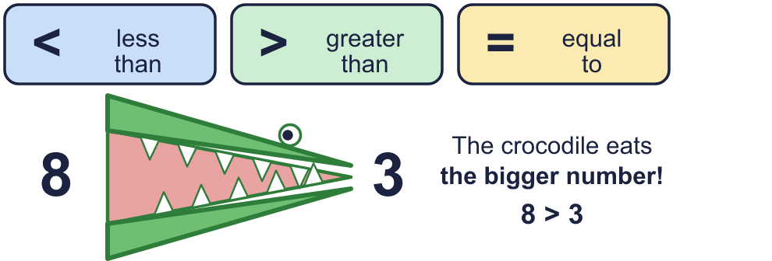
    a) | 4² |  | 2 × 8
    b) | 5² |  | 3³
    c) | 10² |  | 5³
    d) | 2³ |  | 3²
  4 | Write <, > or = in each box.  Hint: Work out both sides first. Then compare the two numbers.
    a) | 4² |  | 2 × 8
    b) | 5² |  | 3³
    c) | 10² |  | 5³
    d) | 2³ |  | 3²
  5 | List all the square numbers between 50 and 150.  Hint: Find the first square above 50 by trying n × n for n = 7, 8, ... Keep going until you pass 150.
  5 | List all the square numbers between 50 and 150.  Hint: Find the first square above 50 by trying n × n for n = 7, 8, ... Keep going until you pass 150.
  6 | Write the missing number.  Hint: Think: which number multiplied by itself (or three times) makes it? Use the table to check.
    a) |  | ² = 121
    b) |  | ³ = 1000
  6 | Write the missing number.  Hint: Think: which number multiplied by itself (or three times) makes it? Use the table to check.
    a) |  | ² = 121
    b) |  | ³ = 1000
  7 | Work out 10 cubed take away 10 squared.  Hint: Work out 10³ first and 10² first. Then take the smaller one away from the bigger one.
  7 | Work out 10 cubed take away 10 squared.  Hint: Work out 10³ first and 10² first. Then take the smaller one away from the bigger one.
  8 | A big cube is made from small cubes. How many small cubes do you need?  a) a 5 × 5 × 5 cube:  b) a 3 × 3 × 3 cube:  Hint: A 3 × 3 × 3 cube has 3 layers of 3 × 3 = 9 small cubes, so 3 × 9 = 27.
  8 | A big cube is made from small cubes. How many small cubes do you need?  a) a 5 × 5 × 5 cube:  b) a 3 × 3 × 3 cube:  Hint: A 3 × 3 × 3 cube has 3 layers of 3 × 3 = 9 small cubes, so 3 × 9 = 27.

  9 | Is Boba correct? Circle yes or no.  Yes / No  Explain how you know.  Hint: The small 3 tells you how many times to write the number in the multiplication.
     | 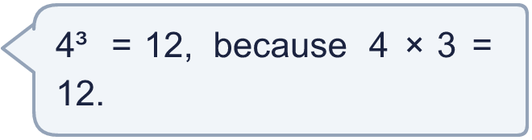
  9 | Is Boba correct? Circle yes or no.  Yes / No  Explain how you know.  Hint: The small 3 tells you how many times to write the number in the multiplication.
  10 | Find two different square numbers that add up to 37.  Hint: List the square numbers less than 37. Take each one away from 37 and check if what is left is a square number.
  10 | Find two different square numbers that add up to 37.  Hint: List the square numbers less than 37. Take each one away from 37 and check if what is left is a square number.
  11 | Hint: Area of a square = side × side. Volume of a cube = edge × edge × edge.
     | 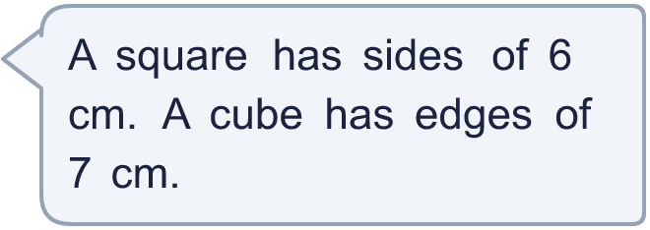
    a) | What is the area of the square?
    cm²
    b) | What is the volume of the cube?
    cm³
  11 | Hint: Area of a square = side × side. Volume of a cube = edge × edge × edge.
    a) | What is the area of the square?
    cm²
    b) | What is the volume of the cube?
    cm³
  12 | Think about the whole numbers from 1 to 100.  a) How many of them are square numbers?  b) How many of them are cube numbers?  Hint: The biggest square is the biggest n with n × n not more than 100. Count n = 1, 2, 3 ... up to it. Do the same for cubes.
  12 | Think about the whole numbers from 1 to 100.  a) How many of them are square numbers?  b) How many of them are cube numbers?  Hint: The biggest square is the biggest n with n × n not more than 100. Count n = 1, 2, 3 ... up to it. Do the same for cubes.
  13 | Find the number between 100 and 1000 that is both a square number and a cube number.  Hint: A number that is both a square and a cube is a cube of a square number. Check the cube numbers one by one: is each also a square?
  13 | Find the number between 100 and 1000 that is both a square number and a cube number.  Hint: A number that is both a square and a cube is a cube of a square number. Check the cube numbers one by one: is each also a square?
  14 | Write three different even square numbers between 50 and 300.  Hint: A square number is even when the number you square is even. Try 2², 4², 6², ... and check the range.
  14 | Write three different even square numbers between 50 and 300.  Hint: A square number is even when the number you square is even. Try 2², 4², 6², ... and check the range.

Year 6 · Add, subtract, multiply and divide · Step 6
Square and cube numbers
Answers (teacher copy)

Squares and cubes to help you:
  1 | Work out each square number.  a) 5² = 25  b) 2² = 4  c) 9² = 81  d) 10² = 100  Hint: n² means n × n. For example 5² = 5 × 5 = 25.  3² is 3 groups of 3:
  2 | Work out each cube number.  a) 2³ = 8  b) 3³ = 27  c) 6³ = 216  d) 10³ = 1,000  Hint: n³ means n × n × n. For example 3³ = 3 × 3 × 3 = 27. Work out n × n first, then multiply by n again.
  3 | Work out each calculation.  a) 9 squared = 81  b) 5 cubed = 125  c) 2 cubed = 8  d) 6 squared = 36  Hint: “Squared” means multiply the number by itself once more: n × n. “Cubed” means n × n × n.
  4 | Write <, > or = in each box.  a) 4² = 2 × 8  b) 5² < 3³  c) 10² < 5³  d) 2³ < 3²  Hint: Work out both sides first. Then compare the two numbers.
  5 | List all the square numbers between 50 and 150.  64, 81, 100, 121, 144  Hint: Find the first square above 50 by trying n × n for n = 7, 8, ... Keep going until you pass 150.
  6 | Write the missing number.  a) 11 ² = 121  b) 10 ³ = 1000  Hint: Think: which number multiplied by itself (or three times) makes it? Use the table to check.
  7 | Work out 10 cubed take away 10 squared.  900  Hint: Work out 10³ first and 10² first. Then take the smaller one away from the bigger one.
  8 | A big cube is made from small cubes. How many small cubes do you need?  a) a 5 × 5 × 5 cube: 125  b) a 3 × 3 × 3 cube: 27  Hint: A 3 × 3 × 3 cube has 3 layers of 3 × 3 = 9 small cubes, so 3 × 9 = 27.
  9 | Is Boba correct? Circle yes or no.  Yes / No  Explain how you know.  4³ means 4 × 4 × 4, which is 64, not 12.  Hint: The small 3 tells you how many times to write the number in the multiplication.
  10 | Find two different square numbers that add up to 37.  1 and 36  Hint: List the square numbers less than 37. Take each one away from 37 and check if what is left is a square number.
  11 | a) What is the area of the square? 36 cm²  b) What is the volume of the cube? 343 cm³  Hint: Area of a square = side × side. Volume of a cube = edge × edge × edge.
  12 | Think about the whole numbers from 1 to 100.  a) How many of them are square numbers? 10  b) How many of them are cube numbers? 4  Hint: The biggest square is the biggest n with n × n not more than 100. Count n = 1, 2, 3 ... up to it. Do the same for cubes.
  13 | Find the number between 100 and 1000 that is both a square number and a cube number.  729  Hint: A number that is both a square and a cube is a cube of a square number. Check the cube numbers one by one: is each also a square?
  14 | Write three different even square numbers between 50 and 300.  Any three even square numbers between 50 and 300, for example 64, 100, 144  Hint: A square number is even when the number you square is even. Try 2², 4², 6², ... and check the range.

