  Year 6 · Add, subtract, multiply and divide · Step 17  Using known facts | 
  Year 6 · Add, subtract, multiply and divide · Step 17
  Using known facts
  1 | You know that 17 × 8 = 136. Use this fact to help you.  a) 170 × 8 =  b) 17 × 80 =  c) 1,700 × 8 =
  1 | You know that 17 × 8 = 136. Use this fact to help you.  a) 170 × 8 =  b) 17 × 80 =  c) 1,700 × 8 =
  2 | You know that 132 ÷ 6 = 22. Use this fact to help you.  a) 1,320 ÷ 6 =  b) 132 ÷ 22 =  c) 1,320 ÷ 22 =
  2 | You know that 132 ÷ 6 = 22. Use this fact to help you.  a) 1,320 ÷ 6 =  b) 132 ÷ 22 =  c) 1,320 ÷ 22 =
  3 | You know that 670 + 110 = 780. Use this fact to help you.  a) 6,700 + 1,100 =  b) 780 − 110 =  c) 7,800 − 6,700 =
  3 | You know that 670 + 110 = 780. Use this fact to help you.  a) 6,700 + 1,100 =  b) 780 − 110 =  c) 7,800 − 6,700 =
  4 | You know that 2 × £25 = £50. Use this fact to help you.
    a) | 20 × £25 = £
    b) | 2 × £250 = £
    c) | £50 ÷ 2 = £
  4 | You know that 2 × £25 = £50. Use this fact to help you.
    a) | 20 × £25 = £
    b) | 2 × £250 = £
    c) | £50 ÷ 2 = £
  5 | You know that 3,900 + 2,300. Which of these have the same answer? Write the letters.  a) 4,500 + 2,000  b) 4,200 + 2,600  c) 3,600 + 2,600  d) 4,200 + 2,000
  5 | You know that 3,900 + 2,300. Which of these have the same answer? Write the letters.  a) 4,500 + 2,000  b) 4,200 + 2,600  c) 3,600 + 2,600  d) 4,200 + 2,000
  6 | You know that 21 × 15 = 315. Use this fact to help you.  Find the missing number.
    21 × |  | = 336
  6 | You know that 21 × 15 = 315. Use this fact to help you.  Find the missing number.
    21 × |  | = 336
  7 | You know that 32 × 25 = 800. Use this fact to help you.  Work out each answer. Halve one number and double the other, or the other way round.  a) 16 × 50 =  b) 64 × 25 =
  7 | You know that 32 × 25 = 800. Use this fact to help you.  Work out each answer. Halve one number and double the other, or the other way round.  a) 16 × 50 =  b) 64 × 25 =
  8 | You know that 7 × 9 = 63. Use this fact to help you.  a) 7 × 90 =  b) 700 × 9 =  c) 6,300 ÷ 9 =
  8 | You know that 7 × 9 = 63. Use this fact to help you.  a) 7 × 90 =  b) 700 × 9 =  c) 6,300 ÷ 9 =

  9 | Is Boba correct? Circle yes or no.  Yes / No  Explain how you know.
     | 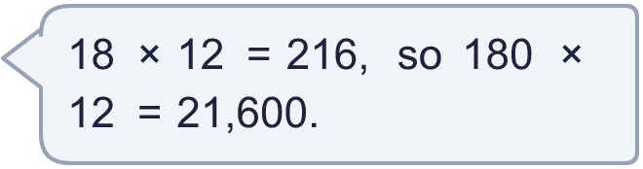
  9 | Is Boba correct? Circle yes or no.  Yes / No  Explain how you know.
  10 | 8 pens cost £2.80.  a) How much does 1 pen cost?  b) How much do 80 pens cost?
  10 | 8 pens cost £2.80.  a) How much does 1 pen cost?  b) How much do 80 pens cost?
  11 | 5,240 + 2,920 = 8,160. Which of these also make 8,160?  a) 5,340 + 3,020  b) 5,340 + 2,820  c) 5,040 + 3,120  d) 5,140 + 3,120  Write the letters:
  11 | 5,240 + 2,920 = 8,160. Which of these also make 8,160?  a) 5,340 + 3,020  b) 5,340 + 2,820  c) 5,040 + 3,120  d) 5,140 + 3,120  Write the letters:
  12 | You know that 12 × 7 = 84. Write three more facts you can work out from it.
  12 | You know that 12 × 7 = 84. Write three more facts you can work out from it.
  13 | You know that 48 × 25 = 1,200. Use this fact to help you.  Find the missing numbers.
    a) |  | × 25 = 2,400
    b) | 48 × |  | = 24,000
  13 | You know that 48 × 25 = 1,200. Use this fact to help you.  Find the missing numbers.
    a) |  | × 25 = 2,400
    b) | 48 × |  | = 24,000
  14 | Is Boba correct? Circle yes or no.  Yes / No  Explain how you know.
    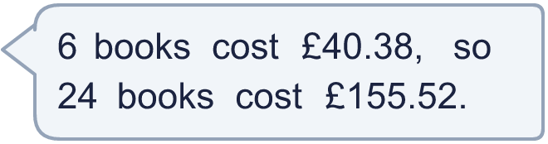
  14 | Is Boba correct? Circle yes or no.  Yes / No  Explain how you know.

Year 6 · Add, subtract, multiply and divide · Step 17
Using known facts
Answers (teacher copy)

  1 | You know that 17 × 8 = 136. Use this fact to help you.  a) 170 × 8 = 1,360  b) 17 × 80 = 1,360  c) 1,700 × 8 = 13,600
  2 | You know that 132 ÷ 6 = 22. Use this fact to help you.  a) 1,320 ÷ 6 = 220  b) 132 ÷ 22 = 6  c) 1,320 ÷ 22 = 60
  3 | You know that 670 + 110 = 780. Use this fact to help you.  a) 6,700 + 1,100 = 7,800  b) 780 − 110 = 670  c) 7,800 − 6,700 = 1,100
  4 | You know that 2 × £25 = £50. Use this fact to help you.  a) 20 × £25 = £ 500  b) 2 × £250 = £ 500  c) £50 ÷ 2 = £ 25
  5 | You know that 3,900 + 2,300. Which of these have the same answer? Write the letters.  a) 4,500 + 2,000  b) 4,200 + 2,600  c) 3,600 + 2,600  d) 4,200 + 2,000  c, d
  6 | You know that 21 × 15 = 315. Use this fact to help you.  Find the missing number.  21 × 16 = 336
  7 | You know that 32 × 25 = 800. Use this fact to help you.  Work out each answer. Halve one number and double the other, or the other way round.  a) 16 × 50 = 800  b) 64 × 25 = 1,600
  8 | You know that 7 × 9 = 63. Use this fact to help you.  a) 7 × 90 = 630  b) 700 × 9 = 6,300  c) 6,300 ÷ 9 = 700
  9 | Is Boba correct? Circle yes or no.  Yes / No  Explain how you know.  18 × 10 = 180, so the answer is only 10 times bigger: 216 × 10 = 2,160, not 21,600.
  10 | 8 pens cost £2.80.  a) How much does 1 pen cost? £0.35  b) How much do 80 pens cost? £28.00
  11 | 5,240 + 2,920 = 8,160. Which of these also make 8,160?  a) 5,340 + 3,020  b) 5,340 + 2,820  c) 5,040 + 3,120  d) 5,140 + 3,120  Write the letters: b, c
  12 | You know that 12 × 7 = 84. Write three more facts you can work out from it.  Any three different true facts, for example 84 ÷ 12 = 7, 84 ÷ 7 = 12 and 7 × 12 = 84
  13 | You know that 48 × 25 = 1,200. Use this fact to help you.  Find the missing numbers.  a) 96 × 25 = 2,400  b) 48 × 500 = 24,000
  14 | Is Boba correct? Circle yes or no.  Yes / No  Explain how you know.  24 books is 4 times as many as 6 books, so they cost 4 times as much: 4 × £40.38 = £161.52, not £155.52.

