To a smaller unit multiply. To a bigger unit divide:  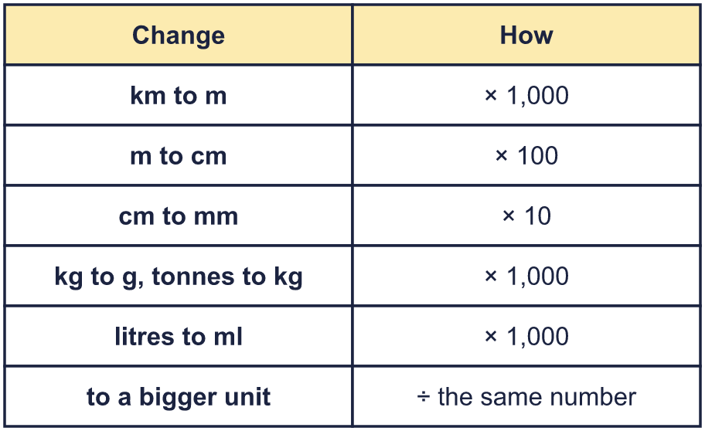 |  | To a smaller unit multiply. To a bigger unit divide:
  Year 6 · Converting units · Step 2  Converting metric units | 
  Year 6 · Converting units · Step 2
  Converting metric units
  1 | Use the bar model to work out how many ml are in 3 litres.  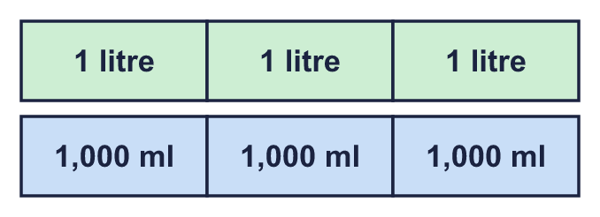  a) 3 litres = ml  Hint: Each box is worth 1,000 ml. Count the boxes, then multiply.
  1 | Use the bar model to work out how many ml are in 3 litres.  a) 3 litres = ml  Hint: Each box is worth 1,000 ml. Count the boxes, then multiply.
  2 | Complete the conversions.  a) 15 m = cm  b) 9 km = m  c) 12 kg = g  d) 8 cm = mm  Hint: Multiply. The small unit is the one with more of them.
  2 | Complete the conversions.  a) 15 m = cm  b) 9 km = m  c) 12 kg = g  d) 8 cm = mm  Hint: Multiply. The small unit is the one with more of them.
  3 | Complete the conversions.  a) 4,000 g = kg  b) 30 mm = cm  c) 300 cm = m  d) 25,000 m = km  Hint: Divide. How many of the small unit make 1 of the big unit?
  3 | Complete the conversions.  a) 4,000 g = kg  b) 30 mm = cm  c) 300 cm = m  d) 25,000 m = km  Hint: Divide. How many of the small unit make 1 of the big unit?
  4 | Complete the conversions. Take care with the decimal point.  a) 2.77 tonnes = kg  b) 0.73 litres = ml  c) 3.97 m = cm  d) 1.56 km = m  Hint: Multiply. Move each digit to the left: 100 moves two places, 1,000 moves three places.
  4 | Complete the conversions. Take care with the decimal point.  a) 2.77 tonnes = kg  b) 0.73 litres = ml  c) 3.97 m = cm  d) 1.56 km = m  Hint: Multiply. Move each digit to the left: 100 moves two places, 1,000 moves three places.
  5 | Complete the conversions. The answers are decimals.  a) 2,275 kg = tonnes  b) 8,162 cm = m  c) 5,492 mm = cm  d) 6,673 m = km  Hint: Divide. Move each digit to the right: 100 moves two places, 1,000 moves three places.
  5 | Complete the conversions. The answers are decimals.  a) 2,275 kg = tonnes  b) 8,162 cm = m  c) 5,492 mm = cm  d) 6,673 m = km  Hint: Divide. Move each digit to the right: 100 moves two places, 1,000 moves three places.
  6 | Complete the pattern. Each amount is 10 times bigger than the one before.  a) 0.1 m = cm  b) 1 m = cm  c) 10 m = cm  Hint: Look at your first answer. Multiply it by 10 each time.
  6 | Complete the pattern. Each amount is 10 times bigger than the one before.  a) 0.1 m = cm  b) 1 m = cm  c) 10 m = cm  Hint: Look at your first answer. Multiply it by 10 each time.
  7 | Write <, > or = in each box.  a) 0.66 km 610 m  b) 98 cm 0.48 m  c) 3.9 cm 39 mm  d) 0.85 m 84 cm  Hint: Change both amounts to the same unit first.
  7 | Write <, > or = in each box.  a) 0.66 km 610 m  b) 98 cm 0.48 m  c) 3.9 cm 39 mm  d) 0.85 m 84 cm  Hint: Change both amounts to the same unit first.
  8 | What amounts do the arrows show? Write each one in g.  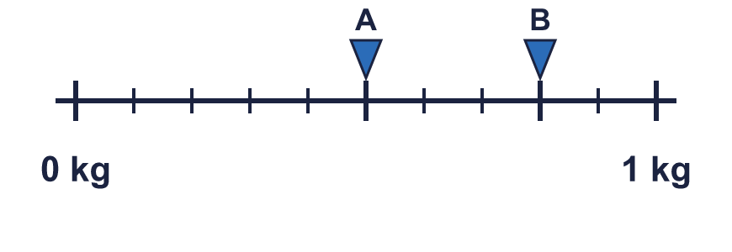  Hint: The line is split into 10 equal steps. Work out how many g one step is.
  8 | What amounts do the arrows show? Write each one in g.  Hint: The line is split into 10 equal steps. Work out how many g one step is.

  9 | Ron and Mo are changing 8.3 km into cm.  Who is correct? Write Ron, Mo or Both.  Explain how you know.  Hint: Work out 8.3 × 1,000, then multiply your answer by 100. What do you get if you multiply 8.3 by 1,000?
     | 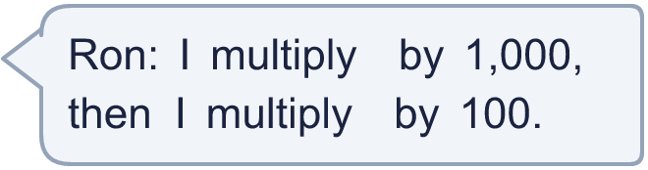
     | 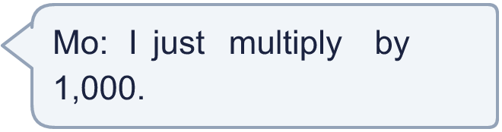
  9 | Ron and Mo are changing 8.3 km into cm.  Who is correct? Write Ron, Mo or Both.  Explain how you know.  Hint: Work out 8.3 × 1,000, then multiply your answer by 100. What do you get if you multiply 8.3 by 1,000?
  10 | 5 identical bags have a mass of 1.25 kg altogether.  What is the mass of one bag? Give your answer in grams.  Hint: Change the kilograms to grams first. Then divide by 5.
  10 | 5 identical bags have a mass of 1.25 kg altogether.  What is the mass of one bag? Give your answer in grams.  Hint: Change the kilograms to grams first. Then divide by 5.
  11 | Car A has a mass of 6.9 tonnes.  Car B has a mass of 6,780,000 g.  Which car is heavier? By how many grams?  Hint: Write both masses in grams. 1 tonne = 1,000 kg and 1 kg = 1,000 g, so 1 tonne = 1,000,000 g.
  11 | Car A has a mass of 6.9 tonnes.  Car B has a mass of 6,780,000 g.  Which car is heavier? By how many grams?  Hint: Write both masses in grams. 1 tonne = 1,000 kg and 1 kg = 1,000 g, so 1 tonne = 1,000,000 g.
  12 | Here are five distances.  A: 13.52 m  B: 1,138 cm  C: 1,820 mm  D: 3,159 cm  E: 12.17 m  Write the letters in order, from the shortest to the longest.  Hint: Change every distance to the same unit, such as centimetres. Then put them in order.
  12 | Here are five distances.  A: 13.52 m  B: 1,138 cm  C: 1,820 mm  D: 3,159 cm  E: 12.17 m  Write the letters in order, from the shortest to the longest.  Hint: Change every distance to the same unit, such as centimetres. Then put them in order.
  13 | Three of these lengths are equal. One is different.  A: 0.696 km  B: 696,000 cm  C: 696 m  D: 69,600 cm  Which one is the odd one out? Write its letter.  Hint: Change them all to the same unit. Which one does not match the others?
  13 | Three of these lengths are equal. One is different.  A: 0.696 km  B: 696,000 cm  C: 696 m  D: 69,600 cm  Which one is the odd one out? Write its letter.  Hint: Change them all to the same unit. Which one does not match the others?
  14 | Challenge  Dora says: “0.94 kg = 9,400 g.”  Is Dora correct? Circle yes or no.  Yes / No  Explain. If not, write the correct answer.  Hint: Multiply 0.94 by 1,000. Does your answer match?
  14 | Challenge  Dora says: “0.94 kg = 9,400 g.”  Is Dora correct? Circle yes or no.  Yes / No  Explain. If not, write the correct answer.  Hint: Multiply 0.94 by 1,000. Does your answer match?

Year 6 · Converting units · Step 2
Converting metric units
Answers (teacher copy)

To a smaller unit multiply. To a bigger unit divide:
  1 | Use the bar model to work out how many ml are in 3 litres.  a) 3 litres = 3,000 ml  Hint: Each box is worth 1,000 ml. Count the boxes, then multiply.
  2 | Complete the conversions.  a) 15 m = 1,500 cm  b) 9 km = 9,000 m  c) 12 kg = 12,000 g  d) 8 cm = 80 mm  Hint: Multiply. The small unit is the one with more of them.
  3 | Complete the conversions.  a) 4,000 g = 4 kg  b) 30 mm = 3 cm  c) 300 cm = 3 m  d) 25,000 m = 25 km  Hint: Divide. How many of the small unit make 1 of the big unit?
  4 | Complete the conversions. Take care with the decimal point.  a) 2.77 tonnes = 2,770 kg  b) 0.73 litres = 730 ml  c) 3.97 m = 397 cm  d) 1.56 km = 1,560 m  Hint: Multiply. Move each digit to the left: 100 moves two places, 1,000 moves three places.
  5 | Complete the conversions. The answers are decimals.  a) 2,275 kg = 2.275 tonnes  b) 8,162 cm = 81.62 m  c) 5,492 mm = 549.2 cm  d) 6,673 m = 6.673 km  Hint: Divide. Move each digit to the right: 100 moves two places, 1,000 moves three places.
  6 | Complete the pattern. Each amount is 10 times bigger than the one before.  a) 0.1 m = 10 cm  b) 1 m = 100 cm  c) 10 m = 1,000 cm  Hint: Look at your first answer. Multiply it by 10 each time.
  7 | Write <, > or = in each box.  a) 0.66 km > 610 m  b) 98 cm > 0.48 m  c) 3.9 cm = 39 mm  d) 0.85 m > 84 cm  Hint: Change both amounts to the same unit first.
  8 | What amounts do the arrows show? Write each one in g.  A = 500 g  B = 800 g  Hint: The line is split into 10 equal steps. Work out how many g one step is.
  9 | Ron and Mo are changing 8.3 km into cm.  Who is correct? Write Ron, Mo or Both.  Ron  Explain how you know.  Ron is correct. 8.3 km = 8,300 m = 830,000 cm, so the change is × 100,000.  Hint: Work out 8.3 × 1,000, then multiply your answer by 100. What do you get if you multiply 8.3 by 1,000?
  10 | 5 identical bags have a mass of 1.25 kg altogether.  What is the mass of one bag? Give your answer in grams.  250 g  Hint: Change the kilograms to grams first. Then divide by 5.
  11 | Car A has a mass of 6.9 tonnes.  Car B has a mass of 6,780,000 g.  Which car is heavier? By how many grams?  Car A  120,000 g  Hint: Write both masses in grams. 1 tonne = 1,000 kg and 1 kg = 1,000 g, so 1 tonne = 1,000,000 g.
  12 | Here are five distances.  A: 13.52 m  B: 1,138 cm  C: 1,820 mm  D: 3,159 cm  E: 12.17 m  Write the letters in order, from the shortest to the longest.  C, B, E, A, D  Hint: Change every distance to the same unit, such as centimetres. Then put them in order.
  13 | Three of these lengths are equal. One is different.  A: 0.696 km  B: 696,000 cm  C: 696 m  D: 69,600 cm  Which one is the odd one out? Write its letter.  B  Hint: Change them all to the same unit. Which one does not match the others?
  14 | Challenge  Dora says: “0.94 kg = 9,400 g.”  Is Dora correct? Circle yes or no.  Yes / No  Explain. If not, write the correct answer.  No. 0.94 kg = 940 g.  Hint: Multiply 0.94 by 1,000. Does your answer match?

