  Year 6 · Converting units · Step 5  Imperial units | 
  Year 6 · Converting units · Step 5
  Imperial units
  1 | Is each unit metric or imperial?  a) pound  b) foot  c) litre  d) centimetre  e) inch
  1 | Is each unit metric or imperial?  a) pound  b) foot  c) litre  d) centimetre  e) inch
  2 | Use the table to write the missing numbers.  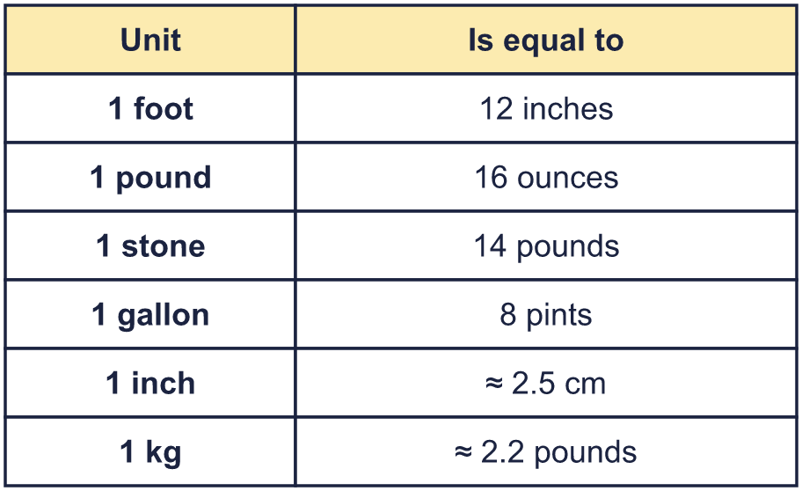  a) 1 gallon = pints  b) 1 pound = ounces  c) 1 stone = pounds  d) 1 foot = inches
  2 | Use the table to write the missing numbers.  a) 1 gallon = pints  b) 1 pound = ounces  c) 1 stone = pounds  d) 1 foot = inches
  3 | 1 foot = 12 inches. Complete the conversions.  a) 3 feet = inches  b) 2 feet = inches  c) 10 feet = inches  d) 6 feet = inches
  3 | 1 foot = 12 inches. Complete the conversions.  a) 3 feet = inches  b) 2 feet = inches  c) 10 feet = inches  d) 6 feet = inches
  4 | 1 gallon = 8 pints. Complete the conversions.  a) 3 gallons = pints  b) gallons = 56 pints  c) 10 gallons = pints  d) gallons = 200 pints
  4 | 1 gallon = 8 pints. Complete the conversions.  a) 3 gallons = pints  b) gallons = 56 pints  c) 10 gallons = pints  d) gallons = 200 pints
  5 | 1 pound = 16 ounces and 1 stone = 14 pounds. Complete the conversions.  a) 5 pounds = ounces  b) 4 stone = pounds  c) pounds = 48 ounces  d) stone = 112 pounds
  5 | 1 pound = 16 ounces and 1 stone = 14 pounds. Complete the conversions.  a) 5 pounds = ounces  b) 4 stone = pounds  c) pounds = 48 ounces  d) stone = 112 pounds
  6 | 1 inch ≈ 2.5 cm. Complete the conversions.  a) 2 inches ≈ cm  b) 100 inches ≈ cm  c) inches ≈ 35 cm  d) inches ≈ 15 cm
  6 | 1 inch ≈ 2.5 cm. Complete the conversions.  a) 2 inches ≈ cm  b) 100 inches ≈ cm  c) inches ≈ 35 cm  d) inches ≈ 15 cm
  7 | 1 kg ≈ 2.2 pounds. Complete the conversions.  a) 15 kg ≈ pounds  b) 4 kg ≈ pounds  c) kg ≈ 33 pounds  d) kg ≈ 8.8 pounds
  7 | 1 kg ≈ 2.2 pounds. Complete the conversions.  a) 15 kg ≈ pounds  b) 4 kg ≈ pounds  c) kg ≈ 33 pounds  d) kg ≈ 8.8 pounds
  8 | Sam is 5 feet 4 inches tall. 1 foot = 12 inches.  How tall is Sam in inches?
  8 | Sam is 5 feet 4 inches tall. 1 foot = 12 inches.  How tall is Sam in inches?

  9 | 1 stone = 14 pounds and 1 pound = 16 ounces.  Zach has a mass of 5 stone. How many ounces is that?
  9 | 1 stone = 14 pounds and 1 pound = 16 ounces.  Zach has a mass of 5 stone. How many ounces is that?
  10 | The world’s tallest man was 8 feet 6 inches tall. 1 foot = 12 inches and 1 inch ≈ 2.5 cm.  How tall was he in inches? About how tall was he in centimetres?
  10 | The world’s tallest man was 8 feet 6 inches tall. 1 foot = 12 inches and 1 inch ≈ 2.5 cm.  How tall was he in inches? About how tall was he in centimetres?
  11 | Ms Khan’s car has a fuel tank that holds 12 gallons. The tank is a quarter full. 1 gallon = 8 pints.  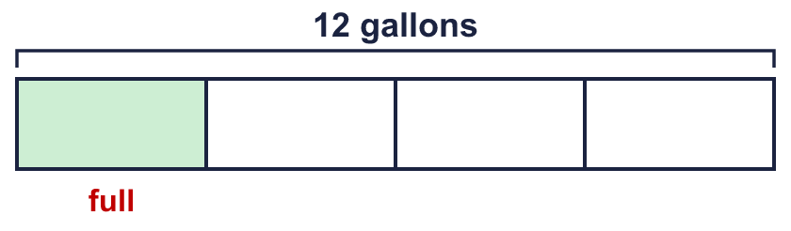  How many pints of petrol does Ms Khan need to fill the tank?
  11 | Ms Khan’s car has a fuel tank that holds 12 gallons. The tank is a quarter full. 1 gallon = 8 pints.  How many pints of petrol does Ms Khan need to fill the tank?
  12 | In each pair, which measurement is greater? Write it down. Show your working in your book.  a) 5 pounds or 56 ounces  b) 15 gallons or 152 pints  c) 6 feet 9 inches or 227.5 cm
  12 | In each pair, which measurement is greater? Write it down. Show your working in your book.  a) 5 pounds or 56 ounces  b) 15 gallons or 152 pints  c) 6 feet 9 inches or 227.5 cm
  13 | Write <, >, = or ≈ in each box.  a) 3 feet 36 inches  b) 5 pounds 72 ounces  c) 5 gallons 48 pints
  13 | Write <, >, = or ≈ in each box.  a) 3 feet 36 inches  b) 5 pounds 72 ounces  c) 5 gallons 48 pints
  14 | Challenge  An airline lets each passenger take a suitcase with a mass of up to 30 kg. Zach’s suitcase has a mass of 33 pounds. 1 kg ≈ 2.2 pounds.  Is Zach’s suitcase over the limit? Circle yes or no.  Yes / No
  14 | Challenge  An airline lets each passenger take a suitcase with a mass of up to 30 kg. Zach’s suitcase has a mass of 33 pounds. 1 kg ≈ 2.2 pounds.  Is Zach’s suitcase over the limit? Circle yes or no.  Yes / No

Year 6 · Converting units · Step 5
Imperial units
Answers (teacher copy)

  1 | Is each unit metric or imperial?  a) pound imperial  b) foot imperial  c) litre metric  d) centimetre metric  e) inch imperial
  2 | Use the table to write the missing numbers.  a) 1 gallon = 8 pints  b) 1 pound = 16 ounces  c) 1 stone = 14 pounds  d) 1 foot = 12 inches
  3 | 1 foot = 12 inches. Complete the conversions.  a) 3 feet = 36 inches  b) 2 feet = 24 inches  c) 10 feet = 120 inches  d) 6 feet = 72 inches
  4 | 1 gallon = 8 pints. Complete the conversions.  a) 3 gallons = 24 pints  b) 7 gallons = 56 pints  c) 10 gallons = 80 pints  d) 25 gallons = 200 pints
  5 | 1 pound = 16 ounces and 1 stone = 14 pounds. Complete the conversions.  a) 5 pounds = 80 ounces  b) 4 stone = 56 pounds  c) 3 pounds = 48 ounces  d) 8 stone = 112 pounds
  6 | 1 inch ≈ 2.5 cm. Complete the conversions.  a) 2 inches ≈ 5 cm  b) 100 inches ≈ 250 cm  c) 14 inches ≈ 35 cm  d) 6 inches ≈ 15 cm
  7 | 1 kg ≈ 2.2 pounds. Complete the conversions.  a) 15 kg ≈ 33 pounds  b) 4 kg ≈ 8.8 pounds  c) 15 kg ≈ 33 pounds  d) 4 kg ≈ 8.8 pounds
  8 | Sam is 5 feet 4 inches tall. 1 foot = 12 inches.  How tall is Sam in inches?  64 inches
  9 | 1 stone = 14 pounds and 1 pound = 16 ounces.  Zach has a mass of 5 stone. How many ounces is that?  1,120 ounces
  10 | The world’s tallest man was 8 feet 6 inches tall. 1 foot = 12 inches and 1 inch ≈ 2.5 cm.  How tall was he in inches? About how tall was he in centimetres?  102 inches  255 cm
  11 | Ms Khan’s car has a fuel tank that holds 12 gallons. The tank is a quarter full. 1 gallon = 8 pints.  How many pints of petrol does Ms Khan need to fill the tank?  72 pints
  12 | In each pair, which measurement is greater? Write it down. Show your working in your book.  a) 5 pounds or 56 ounces 5 pounds  b) 15 gallons or 152 pints 152 pints  c) 6 feet 9 inches or 227.5 cm 227.5 cm
  13 | Write <, >, = or ≈ in each box.  a) 3 feet = 36 inches  b) 5 pounds > 72 ounces  c) 5 gallons < 48 pints
  14 | Challenge  An airline lets each passenger take a suitcase with a mass of up to 30 kg. Zach’s suitcase has a mass of 33 pounds. 1 kg ≈ 2.2 pounds.  Is Zach’s suitcase over the limit? Circle yes or no.  Yes / No  Difference: 15 kg

