  Year 6 · Converting units · Step 5  Imperial units | 
  Year 6 · Converting units · Step 5
  Imperial units
  1 | Is each unit metric or imperial?  a) pound  b) foot  c) litre  d) centimetre  e) inch  Hint: Metric units are based on 10, 100 and 1,000. Pounds, feet and gallons are imperial.
  1 | Is each unit metric or imperial?  a) pound  b) foot  c) litre  d) centimetre  e) inch  Hint: Metric units are based on 10, 100 and 1,000. Pounds, feet and gallons are imperial.
  2 | Use the table to write the missing numbers.  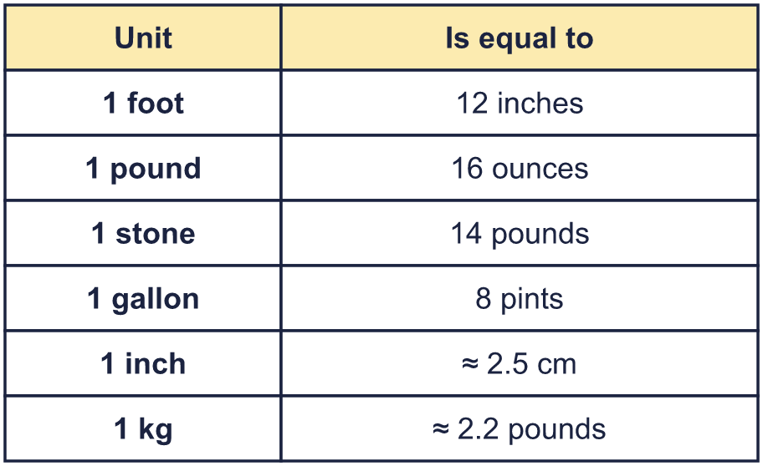  a) 1 gallon = pints  b) 1 pound = ounces  c) 1 stone = pounds  d) 1 foot = inches  Hint: Find each unit in the first column of the table.
  2 | Use the table to write the missing numbers.  a) 1 gallon = pints  b) 1 pound = ounces  c) 1 stone = pounds  d) 1 foot = inches  Hint: Find each unit in the first column of the table.
  3 | 1 foot = 12 inches. Complete the conversions.  Each foot is 12 inches:  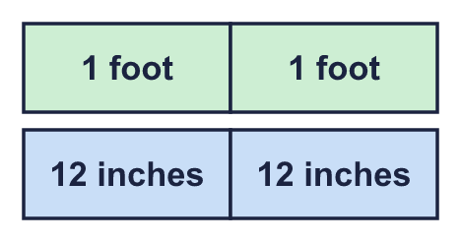  a) 3 feet = inches  b) 2 feet = inches  c) 10 feet = inches  d) 6 feet = inches  Hint: Multiply the number of feet by 12.
  3 | 1 foot = 12 inches. Complete the conversions.  Each foot is 12 inches:  a) 3 feet = inches  b) 2 feet = inches  c) 10 feet = inches  d) 6 feet = inches  Hint: Multiply the number of feet by 12.
  4 | 1 gallon = 8 pints. Complete the conversions.  Each gallon is 8 pints:  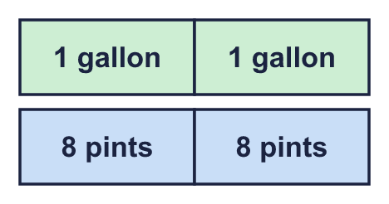  a) 3 gallons = pints  b) gallons = 56 pints  c) 10 gallons = pints  d) gallons = 200 pints  Hint: To go from gallons to pints multiply by 8. To go from pints to gallons divide by 8.
  4 | 1 gallon = 8 pints. Complete the conversions.  Each gallon is 8 pints:  a) 3 gallons = pints  b) gallons = 56 pints  c) 10 gallons = pints  d) gallons = 200 pints  Hint: To go from gallons to pints multiply by 8. To go from pints to gallons divide by 8.
  5 | 1 pound = 16 ounces and 1 stone = 14 pounds. Complete the conversions.  a) 5 pounds = ounces  b) 4 stone = pounds  c) pounds = 48 ounces  d) stone = 112 pounds  Hint: Multiply to change a big unit into a smaller one. Divide to change a small unit into a bigger one.
  5 | 1 pound = 16 ounces and 1 stone = 14 pounds. Complete the conversions.  a) 5 pounds = ounces  b) 4 stone = pounds  c) pounds = 48 ounces  d) stone = 112 pounds  Hint: Multiply to change a big unit into a smaller one. Divide to change a small unit into a bigger one.
  6 | 1 inch ≈ 2.5 cm. Complete the conversions.  a) 2 inches ≈ cm  b) 100 inches ≈ cm  c) inches ≈ 35 cm  d) inches ≈ 15 cm  Hint: Double 2.5 to get 5 cm for 2 inches, or multiply by 2.5 straight away.
  6 | 1 inch ≈ 2.5 cm. Complete the conversions.  a) 2 inches ≈ cm  b) 100 inches ≈ cm  c) inches ≈ 35 cm  d) inches ≈ 15 cm  Hint: Double 2.5 to get 5 cm for 2 inches, or multiply by 2.5 straight away.
  7 | 1 kg ≈ 2.2 pounds. Complete the conversions.  a) 15 kg ≈ pounds  b) 4 kg ≈ pounds  c) kg ≈ 33 pounds  d) kg ≈ 8.8 pounds  Hint: Multiply by 2.2 to change kilograms to pounds. Divide by 2.2 to change pounds to kilograms.
  7 | 1 kg ≈ 2.2 pounds. Complete the conversions.  a) 15 kg ≈ pounds  b) 4 kg ≈ pounds  c) kg ≈ 33 pounds  d) kg ≈ 8.8 pounds  Hint: Multiply by 2.2 to change kilograms to pounds. Divide by 2.2 to change pounds to kilograms.
  8 | Sam is 5 feet 4 inches tall. 1 foot = 12 inches.  How tall is Sam in inches?  Hint: Change 5 feet to inches first. Then add 4 inches.
  8 | Sam is 5 feet 4 inches tall. 1 foot = 12 inches.  How tall is Sam in inches?  Hint: Change 5 feet to inches first. Then add 4 inches.

  9 | 1 stone = 14 pounds and 1 pound = 16 ounces.  Zach has a mass of 5 stone. How many ounces is that?  Hint: First change the stone to pounds. Then change the pounds to ounces.
  9 | 1 stone = 14 pounds and 1 pound = 16 ounces.  Zach has a mass of 5 stone. How many ounces is that?  Hint: First change the stone to pounds. Then change the pounds to ounces.
  10 | The world’s tallest man was 8 feet 6 inches tall. 1 foot = 12 inches and 1 inch ≈ 2.5 cm.  How tall was he in inches? About how tall was he in centimetres?  Hint: Change the feet to inches and add the extra inches. Then multiply the inches by 2.5.
  10 | The world’s tallest man was 8 feet 6 inches tall. 1 foot = 12 inches and 1 inch ≈ 2.5 cm.  How tall was he in inches? About how tall was he in centimetres?  Hint: Change the feet to inches and add the extra inches. Then multiply the inches by 2.5.
  11 | Ms Khan’s car has a fuel tank that holds 12 gallons. The tank is a quarter full. 1 gallon = 8 pints.  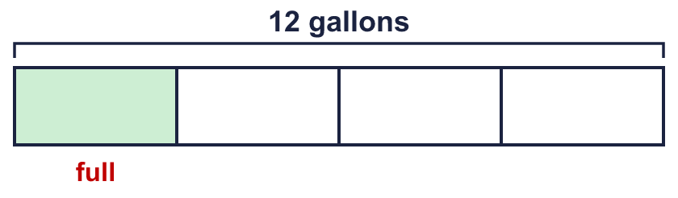  How many pints of petrol does Ms Khan need to fill the tank?  Hint: A quarter is full, so three quarters are empty. Find three quarters of the gallons. Then change gallons to pints.
  11 | Ms Khan’s car has a fuel tank that holds 12 gallons. The tank is a quarter full. 1 gallon = 8 pints.  How many pints of petrol does Ms Khan need to fill the tank?  Hint: A quarter is full, so three quarters are empty. Find three quarters of the gallons. Then change gallons to pints.
  12 | In each pair, which measurement is greater? Write it down. Show your working in your book.  a) 5 pounds or 56 ounces  b) 15 gallons or 152 pints  c) 6 feet 9 inches or 227.5 cm  Hint: Change both measurements to the same unit. 1 foot = 12 inches, 1 inch ≈ 2.5 cm, 1 gallon = 8 pints, 1 stone = 14 pounds, 1 pound = 16 ounces.
  12 | In each pair, which measurement is greater? Write it down. Show your working in your book.  a) 5 pounds or 56 ounces  b) 15 gallons or 152 pints  c) 6 feet 9 inches or 227.5 cm  Hint: Change both measurements to the same unit. 1 foot = 12 inches, 1 inch ≈ 2.5 cm, 1 gallon = 8 pints, 1 stone = 14 pounds, 1 pound = 16 ounces.
  13 | Write <, >, = or ≈ in each box.  a) 3 feet 36 inches  b) 5 pounds 72 ounces  c) 5 gallons 48 pints  Hint: Change one amount so both are in the same unit. Use ≈ when the conversion is only approximate.
  13 | Write <, >, = or ≈ in each box.  a) 3 feet 36 inches  b) 5 pounds 72 ounces  c) 5 gallons 48 pints  Hint: Change one amount so both are in the same unit. Use ≈ when the conversion is only approximate.
  14 | Challenge  An airline lets each passenger take a suitcase with a mass of up to 30 kg. Zach’s suitcase has a mass of 33 pounds. 1 kg ≈ 2.2 pounds.  Is Zach’s suitcase over the limit? Circle yes or no.  Yes / No  Hint: Divide the pounds by 2.2 to change them to kilograms. A good way is to use 11 pounds ≈ 5 kg.
  14 | Challenge  An airline lets each passenger take a suitcase with a mass of up to 30 kg. Zach’s suitcase has a mass of 33 pounds. 1 kg ≈ 2.2 pounds.  Is Zach’s suitcase over the limit? Circle yes or no.  Yes / No  Hint: Divide the pounds by 2.2 to change them to kilograms. A good way is to use 11 pounds ≈ 5 kg.

Year 6 · Converting units · Step 5
Imperial units
Answers (teacher copy)

  1 | Is each unit metric or imperial?  a) pound imperial  b) foot imperial  c) litre metric  d) centimetre metric  e) inch imperial  Hint: Metric units are based on 10, 100 and 1,000. Pounds, feet and gallons are imperial.
  2 | Use the table to write the missing numbers.  a) 1 gallon = 8 pints  b) 1 pound = 16 ounces  c) 1 stone = 14 pounds  d) 1 foot = 12 inches  Hint: Find each unit in the first column of the table.
  3 | 1 foot = 12 inches. Complete the conversions.  Each foot is 12 inches:  a) 3 feet = 36 inches  b) 2 feet = 24 inches  c) 10 feet = 120 inches  d) 6 feet = 72 inches  Hint: Multiply the number of feet by 12.
  4 | 1 gallon = 8 pints. Complete the conversions.  Each gallon is 8 pints:  a) 3 gallons = 24 pints  b) 7 gallons = 56 pints  c) 10 gallons = 80 pints  d) 25 gallons = 200 pints  Hint: To go from gallons to pints multiply by 8. To go from pints to gallons divide by 8.
  5 | 1 pound = 16 ounces and 1 stone = 14 pounds. Complete the conversions.  a) 5 pounds = 80 ounces  b) 4 stone = 56 pounds  c) 3 pounds = 48 ounces  d) 8 stone = 112 pounds  Hint: Multiply to change a big unit into a smaller one. Divide to change a small unit into a bigger one.
  6 | 1 inch ≈ 2.5 cm. Complete the conversions.  a) 2 inches ≈ 5 cm  b) 100 inches ≈ 250 cm  c) 14 inches ≈ 35 cm  d) 6 inches ≈ 15 cm  Hint: Double 2.5 to get 5 cm for 2 inches, or multiply by 2.5 straight away.
  7 | 1 kg ≈ 2.2 pounds. Complete the conversions.  a) 15 kg ≈ 33 pounds  b) 4 kg ≈ 8.8 pounds  c) 15 kg ≈ 33 pounds  d) 4 kg ≈ 8.8 pounds  Hint: Multiply by 2.2 to change kilograms to pounds. Divide by 2.2 to change pounds to kilograms.
  8 | Sam is 5 feet 4 inches tall. 1 foot = 12 inches.  How tall is Sam in inches?  64 inches  Hint: Change 5 feet to inches first. Then add 4 inches.
  9 | 1 stone = 14 pounds and 1 pound = 16 ounces.  Zach has a mass of 5 stone. How many ounces is that?  1,120 ounces  Hint: First change the stone to pounds. Then change the pounds to ounces.
  10 | The world’s tallest man was 8 feet 6 inches tall. 1 foot = 12 inches and 1 inch ≈ 2.5 cm.  How tall was he in inches? About how tall was he in centimetres?  102 inches  255 cm  Hint: Change the feet to inches and add the extra inches. Then multiply the inches by 2.5.
  11 | Ms Khan’s car has a fuel tank that holds 12 gallons. The tank is a quarter full. 1 gallon = 8 pints.  How many pints of petrol does Ms Khan need to fill the tank?  72 pints  Hint: A quarter is full, so three quarters are empty. Find three quarters of the gallons. Then change gallons to pints.
  12 | In each pair, which measurement is greater? Write it down. Show your working in your book.  a) 5 pounds or 56 ounces 5 pounds  b) 15 gallons or 152 pints 152 pints  c) 6 feet 9 inches or 227.5 cm 227.5 cm  Hint: Change both measurements to the same unit. 1 foot = 12 inches, 1 inch ≈ 2.5 cm, 1 gallon = 8 pints, 1 stone = 14 pounds, 1 pound = 16 ounces.
  13 | Write <, >, = or ≈ in each box.  a) 3 feet = 36 inches  b) 5 pounds > 72 ounces  c) 5 gallons < 48 pints  Hint: Change one amount so both are in the same unit. Use ≈ when the conversion is only approximate.
  14 | Challenge  An airline lets each passenger take a suitcase with a mass of up to 30 kg. Zach’s suitcase has a mass of 33 pounds. 1 kg ≈ 2.2 pounds.  Is Zach’s suitcase over the limit? Circle yes or no.  Yes / No  Difference: 15 kg  Hint: Divide the pounds by 2.2 to change them to kilograms. A good way is to use 11 pounds ≈ 5 kg.

