Metric units and how they link:  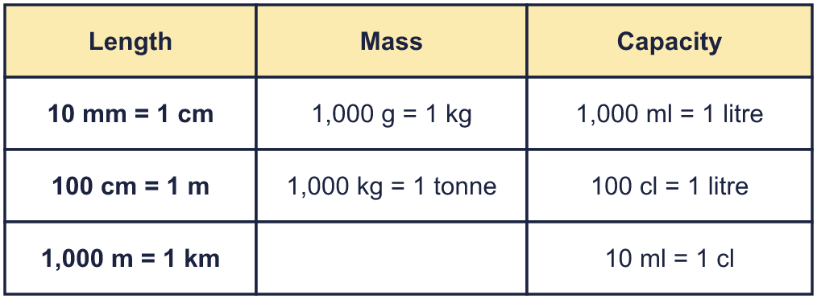 |  | Metric units and how they link:
  Year 6 · Converting units · Step 1  Metric units | 
  Year 6 · Converting units · Step 1
  Metric units
  1 | Sort these units into the correct group: g, km, litre, tonne, m, ml.  Hint: Length is how far, mass is how heavy and capacity is how much liquid a container holds. Write the units in the same order as in the list.
  1 | Sort these units into the correct group: g, km, litre, tonne, m, ml.  Hint: Length is how far, mass is how heavy and capacity is how much liquid a container holds. Write the units in the same order as in the list.
  2 | Is each unit used to measure length, mass or capacity?  a) tonne  b) millimetre  c) millilitre  d) kilogram  Hint: Think of what each unit is used for: a ruler, a pair of scales or a measuring jug.
  2 | Is each unit used to measure length, mass or capacity?  a) tonne  b) millimetre  c) millilitre  d) kilogram  Hint: Think of what each unit is used for: a ruler, a pair of scales or a measuring jug.
  3 | Which is the most sensible unit to measure each one?  a) the mass of an adult: kg, g, tonne  b) the length of a running track lap: km, m, mm  c) the capacity of a mug: litre, cm, ml  d) the length of a road between two towns: mm, km, cm  Hint: Picture the size of each one. Choose the unit that gives a small whole number, such as 8 m.
  3 | Which is the most sensible unit to measure each one?  a) the mass of an adult: kg, g, tonne  b) the length of a running track lap: km, m, mm  c) the capacity of a mug: litre, cm, ml  d) the length of a road between two towns: mm, km, cm  Hint: Picture the size of each one. Choose the unit that gives a small whole number, such as 8 m.
  4 | Which is the best estimate? Write it down.  a) the length of a door: 2 m, 2 cm, 2 mm, 2 km  b) the mass of an apple: 150 tonnes, 150 g, 150 kg, 1,500 g  c) the length of a road between two towns: 25 km, 25 m, 25 cm, 25 mm  Hint: Think of something you know that is about the same size.
  4 | Which is the best estimate? Write it down.  a) the length of a door: 2 m, 2 cm, 2 mm, 2 km  b) the mass of an apple: 150 tonnes, 150 g, 150 kg, 1,500 g  c) the length of a road between two towns: 25 km, 25 m, 25 cm, 25 mm  Hint: Think of something you know that is about the same size.
  5 | Write the units in order, from the smallest to the largest.  a) kg, tonne, g  b) km, m, cm, mm  Hint: A millimetre is tiny and a kilometre is long. Which unit is next?
  5 | Write the units in order, from the smallest to the largest.  a) kg, tonne, g  b) km, m, cm, mm  Hint: A millimetre is tiny and a kilometre is long. Which unit is next?
  6 | Write the missing number in each fact.  a) 1 tonne = kg  b) 1 km = m  c) 1 kg = g  d) 1 litre = ml  Hint: Use the table at the top of the page.
  6 | Write the missing number in each fact.  a) 1 tonne = kg  b) 1 km = m  c) 1 kg = g  d) 1 litre = ml  Hint: Use the table at the top of the page.
  7 | How much water is in the jug?  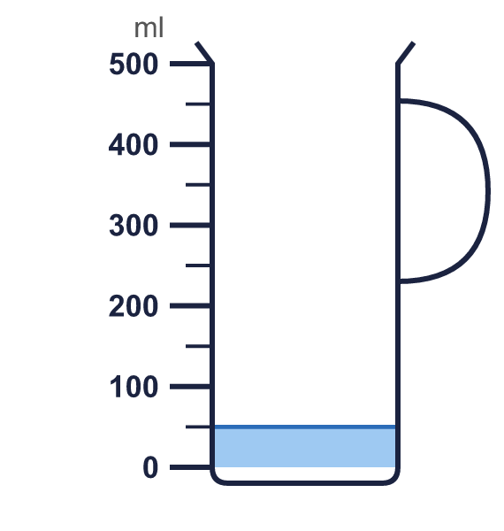  Hint: Look at the numbers on each side of the water level. The marks are 50 ml apart, so count on from the lower number.
  7 | How much water is in the jug?  Hint: Look at the numbers on each side of the water level. The marks are 50 ml apart, so count on from the lower number.
  8 | How long is the strip? Write the length in millimetres and in centimetres.  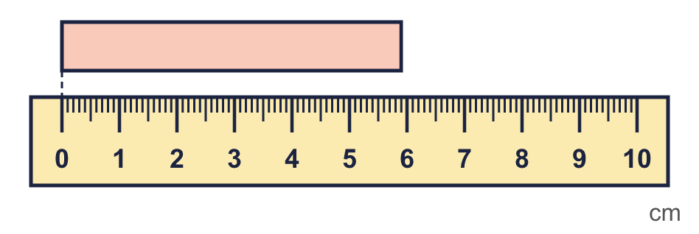  Hint: Each small mark is 1 mm. There are 10 mm in 1 cm, so divide the number of mm by 10.
  8 | How long is the strip? Write the length in millimetres and in centimetres.  Hint: Each small mark is 1 mm. There are 10 mm in 1 cm, so divide the number of mm by 10.

  9 | A lorry has a mass of 4 tonnes.  Eva says: “It is impossible to write the mass in grams.”  Is Eva correct? Circle yes or no.  Yes / No  Explain. Convert the measurement to prove it.  Hint: Multiply by 1,000,000 to change tonnes into g.
  9 | A lorry has a mass of 4 tonnes.  Eva says: “It is impossible to write the mass in grams.”  Is Eva correct? Circle yes or no.  Yes / No  Explain. Convert the measurement to prove it.  Hint: Multiply by 1,000,000 to change tonnes into g.
  10 | A jug really holds 700 ml.  Ron estimates that it holds 2 litres. Tia estimates that it holds 1 litre.  Whose estimate is closer? How many millilitres out is it?  Hint: Change the litres to millilitres. Find the difference between each estimate and the real amount.
  10 | A jug really holds 700 ml.  Ron estimates that it holds 2 litres. Tia estimates that it holds 1 litre.  Whose estimate is closer? How many millilitres out is it?  Hint: Change the litres to millilitres. Find the difference between each estimate and the real amount.
  11 | A bath holds 60 litres of water. Rosie fills it with a 5 ml teaspoon. Zach fills it with a 1 litre jug.  How many times does each of them have to fill their container?  Whose method is quicker? Explain why.  Hint: Change the litres to millilitres first. Then divide.
  11 | A bath holds 60 litres of water. Rosie fills it with a 5 ml teaspoon. Zach fills it with a 1 litre jug.  How many times does each of them have to fill their container?  Whose method is quicker? Explain why.  Hint: Change the litres to millilitres first. Then divide.
  12 | Ron writes: “The length of a maths book is 30 mm.”  Ron has used the wrong unit. Which unit should Ron write instead?  Hint: Picture the real size. Which unit gives a sensible number?
  12 | Ron writes: “The length of a maths book is 30 mm.”  Ron has used the wrong unit. Which unit should Ron write instead?  Hint: Picture the real size. Which unit gives a sensible number?
  13 | Which unit am I?  a) I measure capacity. There are 10 of me in 1 cl.  b) I measure mass. There are 1,000 of me in 1 tonne.  Hint: Look at the table at the top. Find the unit that fits in the bigger unit that many times.
  13 | Which unit am I?  a) I measure capacity. There are 10 of me in 1 cl.  b) I measure mass. There are 1,000 of me in 1 tonne.  Hint: Look at the table at the top. Find the unit that fits in the bigger unit that many times.
  14 | Challenge  A lorry carries 3 tonnes of sand in bags. Each bag has a mass of 25 kg.  How many bags are on the lorry?  Hint: Change the tonnes to kilograms first. Then divide by the mass of one bag.
  14 | Challenge  A lorry carries 3 tonnes of sand in bags. Each bag has a mass of 25 kg.  How many bags are on the lorry?  Hint: Change the tonnes to kilograms first. Then divide by the mass of one bag.

Year 6 · Converting units · Step 1
Metric units
Answers (teacher copy)

Metric units and how they link:
  1 | Sort these units into the correct group: g, km, litre, tonne, m, ml.  Length: km, m  Mass: g, tonne  Capacity: litre, ml  Hint: Length is how far, mass is how heavy and capacity is how much liquid a container holds. Write the units in the same order as in the list.
  2 | Is each unit used to measure length, mass or capacity?  a) tonne mass  b) millimetre length  c) millilitre capacity  d) kilogram mass  Hint: Think of what each unit is used for: a ruler, a pair of scales or a measuring jug.
  3 | Which is the most sensible unit to measure each one?  a) the mass of an adult: kg, g, tonne kg  b) the length of a running track lap: km, m, mm m  c) the capacity of a mug: litre, cm, ml ml  d) the length of a road between two towns: mm, km, cm km  Hint: Picture the size of each one. Choose the unit that gives a small whole number, such as 8 m.
  4 | Which is the best estimate? Write it down.  a) the length of a door: 2 m, 2 cm, 2 mm, 2 km 2 m  b) the mass of an apple: 150 tonnes, 150 g, 150 kg, 1,500 g 150 g  c) the length of a road between two towns: 25 km, 25 m, 25 cm, 25 mm 25 km  Hint: Think of something you know that is about the same size.
  5 | Write the units in order, from the smallest to the largest.  a) kg, tonne, g g, kg, tonne  b) km, m, cm, mm mm, cm, m, km  Hint: A millimetre is tiny and a kilometre is long. Which unit is next?
  6 | Write the missing number in each fact.  a) 1 tonne = 1,000 kg  b) 1 km = 1,000 m  c) 1 kg = 1,000 g  d) 1 litre = 1,000 ml  Hint: Use the table at the top of the page.
  7 | How much water is in the jug?  Water: 50 ml  Hint: Look at the numbers on each side of the water level. The marks are 50 ml apart, so count on from the lower number.
  8 | How long is the strip? Write the length in millimetres and in centimetres.  In mm: 59 mm  In cm: 5.9 cm  Hint: Each small mark is 1 mm. There are 10 mm in 1 cm, so divide the number of mm by 10.
  9 | A lorry has a mass of 4 tonnes.  Eva says: “It is impossible to write the mass in grams.”  Is Eva correct? Circle yes or no.  Yes / No  Explain. Convert the measurement to prove it.  No. 4 tonnes = 4,000,000 g. It is possible, but the number is very big.  Hint: Multiply by 1,000,000 to change tonnes into g.
  10 | A jug really holds 700 ml.  Ron estimates that it holds 2 litres. Tia estimates that it holds 1 litre.  Whose estimate is closer? How many millilitres out is it?  Tia  300 ml out  Hint: Change the litres to millilitres. Find the difference between each estimate and the real amount.
  11 | A bath holds 60 litres of water. Rosie fills it with a 5 ml teaspoon. Zach fills it with a 1 litre jug.  How many times does each of them have to fill their container?  Teaspoons: 12,000  Jugs: 60  Whose method is quicker? Explain why.  Zach’s method is quicker. The jug is much bigger than a teaspoon, so there are far fewer scoops to count.  Hint: Change the litres to millilitres first. Then divide.
  12 | Ron writes: “The length of a maths book is 30 mm.”  Ron has used the wrong unit. Which unit should Ron write instead?  cm  Hint: Picture the real size. Which unit gives a sensible number?
  13 | Which unit am I?  a) I measure capacity. There are 10 of me in 1 cl. ml  b) I measure mass. There are 1,000 of me in 1 tonne. kg  Hint: Look at the table at the top. Find the unit that fits in the bigger unit that many times.
  14 | Challenge  A lorry carries 3 tonnes of sand in bags. Each bag has a mass of 25 kg.  How many bags are on the lorry?  120 bags  Hint: Change the tonnes to kilograms first. Then divide by the mass of one bag.

