Fraction wall to help you:  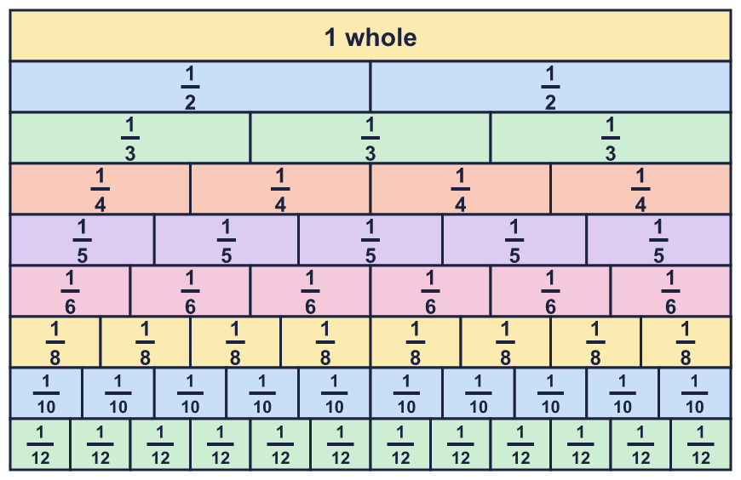 |  | Fraction wall to help you:
  Year 6 · Fractions A · Step 7  Adding mixed numbers | 
  Year 6 · Fractions A · Step 7
  Adding mixed numbers
  1 | Work out each addition. Add the whole numbers first. Then add the fractions.  a) 4 ³⁄₅ + 5 ¹⁄₅ =  b) 3 ¹⁄₆ + 4 ¹⁄₆ =  c) 3 ¹⁄₄ + 4 ¹⁄₄ =  Hint: Add the wholes. Add the fractions. Put the two answers together.
  1 | Work out each addition. Add the whole numbers first. Then add the fractions.  a) 4 ³⁄₅ + 5 ¹⁄₅ =  b) 3 ¹⁄₆ + 4 ¹⁄₆ =  c) 3 ¹⁄₄ + 4 ¹⁄₄ =  Hint: Add the wholes. Add the fractions. Put the two answers together.
  2 | Work out each addition. Write each answer in its simplest form.  a) 4 ¹⁄₄ + 2 ⁷⁄₁₂ =  b) 3 ²⁄₃ + 1 ¹⁄₉ =  c) 3 ⁷⁄₁₀ + 1 ¹⁄₂₀ =  Hint: Change one fraction so both denominators match. Add the wholes and add the fractions.
  2 | Work out each addition. Write each answer in its simplest form.  a) 4 ¹⁄₄ + 2 ⁷⁄₁₂ =  b) 3 ²⁄₃ + 1 ¹⁄₉ =  c) 3 ⁷⁄₁₀ + 1 ¹⁄₂₀ =  Hint: Change one fraction so both denominators match. Add the wholes and add the fractions.
  3 | Work out each addition. The fractions add to more than 1. Write each answer in its simplest form.  a) 3 ⁵⁄₆ + 1 ⁵⁄₆ =  b) 2 ¹⁄₄ + 5 ³⁄₄ =  c) 1 ¹¹⁄₁₂ + 2 ⁷⁄₁₂ =  Hint: Add the wholes and the fractions. The fractions make an improper fraction. Change it to a mixed number and add the extra whole to your total.
  3 | Work out each addition. The fractions add to more than 1. Write each answer in its simplest form.  a) 3 ⁵⁄₆ + 1 ⁵⁄₆ =  b) 2 ¹⁄₄ + 5 ³⁄₄ =  c) 1 ¹¹⁄₁₂ + 2 ⁷⁄₁₂ =  Hint: Add the wholes and the fractions. The fractions make an improper fraction. Change it to a mixed number and add the extra whole to your total.
  4 | Write each mixed number as an improper fraction. Write the missing numerator.  a) 5 ⁵⁄₆ = ?⁄₆  b) 4 ⁴⁄₅ = ?⁄₅  c) 1 ¹⁄₆ = ?⁄₆  Hint: Multiply the whole number by the denominator. Then add the numerator of the fraction.
  4 | Write each mixed number as an improper fraction. Write the missing numerator.  a) 5 ⁵⁄₆ = ?⁄₆  b) 4 ⁴⁄₅ = ?⁄₅  c) 1 ¹⁄₆ = ?⁄₆  Hint: Multiply the whole number by the denominator. Then add the numerator of the fraction.
  5 | Work out each addition. Write each answer as a mixed number in its simplest form.  a) 5 ⁴⁄₅ + 3 ⁵⁄₈ =  b) 5 ¹⁄₆ + 2 ⁷⁄₈ =  c) 2 ²⁄₃ + 2 ⁵⁄₇ =  Hint: Find a common denominator for the fractions. Add the wholes, add the fractions, then combine.
  5 | Work out each addition. Write each answer as a mixed number in its simplest form.  a) 5 ⁴⁄₅ + 3 ⁵⁄₈ =  b) 5 ¹⁄₆ + 2 ⁷⁄₈ =  c) 2 ²⁄₃ + 2 ⁵⁄₇ =  Hint: Find a common denominator for the fractions. Add the wholes, add the fractions, then combine.
  6 | Write the missing number in each calculation.  a) ? + 4 ⁷⁄₁₂ = 9 ³⁄₄  b) 5 ¹⁄₆ + ? = 6 ¹⁄₄  Hint: Take the number you know away from the total.
  6 | Write the missing number in each calculation.  a) ? + 4 ⁷⁄₁₂ = 9 ³⁄₄  b) 5 ¹⁄₆ + ? = 6 ¹⁄₄  Hint: Take the number you know away from the total.
  7 | Use the fact ³⁄₄ + ¹⁄₆ = ¹¹⁄₁₂ to help you work out the answers.  a) 15 ³⁄₄ + 260 ¹⁄₆ =  b) 340 ³⁄₄ + 520 ¹⁄₆ =  Hint: The wholes are easy to add. The fraction parts are the same as in the fact, so you already know their total.
  7 | Use the fact ³⁄₄ + ¹⁄₆ = ¹¹⁄₁₂ to help you work out the answers.  a) 15 ³⁄₄ + 260 ¹⁄₆ =  b) 340 ³⁄₄ + 520 ¹⁄₆ =  Hint: The wholes are easy to add. The fraction parts are the same as in the fact, so you already know their total.
  8 | Work out each addition. Write each answer as a mixed number in its simplest form.  a) 1 ⁴⁄₅ + ⁸⁄₅ =  b) 4 ³⁄₄ + ⁷⁄₄ =  c) 3 ¹⁄₆ + ⁷⁄₆ =  Hint: Change the improper fraction to a mixed number first. Or change both to improper fractions.
  8 | Work out each addition. Write each answer as a mixed number in its simplest form.  a) 1 ⁴⁄₅ + ⁸⁄₅ =  b) 4 ³⁄₄ + ⁷⁄₄ =  c) 3 ¹⁄₆ + ⁷⁄₆ =  Hint: Change the improper fraction to a mixed number first. Or change both to improper fractions.

  9 | Ron and Amir work out 1 ¹⁄₅ + 4 ⁷⁄₈.  Ron adds the wholes, then the fractions, and gets 6 ³⁄₄₀.  Amir changes both numbers to improper fractions, adds them and gets ²⁴³⁄₄₀.  Do they get the same answer? Circle yes or no.  Yes / No  Explain how you know.  Hint: Change the improper fraction into a mixed number. Is it the same?
  9 | Ron and Amir work out 1 ¹⁄₅ + 4 ⁷⁄₈.  Ron adds the wholes, then the fractions, and gets 6 ³⁄₄₀.  Amir changes both numbers to improper fractions, adds them and gets ²⁴³⁄₄₀.  Do they get the same answer? Circle yes or no.  Yes / No  Explain how you know.  Hint: Change the improper fraction into a mixed number. Is it the same?
  10 | A plank is 2 ¹⁄₂ m long.  A second plank is 2 ²⁄₃ m long.  What is the total length of the two planks? Write the answer as a mixed number in its simplest form.  Hint: Add the wholes. Add the fractions. If the fractions make more than 1, carry the extra whole.
  10 | A plank is 2 ¹⁄₂ m long.  A second plank is 2 ²⁄₃ m long.  What is the total length of the two planks? Write the answer as a mixed number in its simplest form.  Hint: Add the wholes. Add the fractions. If the fractions make more than 1, carry the extra whole.
  11 | Three buckets have some water in them: 3 ³⁄₄ litres, 3 ¹⁄₂ litres and 2 ⁷⁄₈ litres.  Each bucket can hold 12 litres. Can all the water fit into one bucket? Circle yes or no.  Yes / No  Show your working.  Hint: Add the three amounts. Then compare the total with the size of one bucket.
  11 | Three buckets have some water in them: 3 ³⁄₄ litres, 3 ¹⁄₂ litres and 2 ⁷⁄₈ litres.  Each bucket can hold 12 litres. Can all the water fit into one bucket? Circle yes or no.  Yes / No  Show your working.  Hint: Add the three amounts. Then compare the total with the size of one bucket.
  12 | Is Zach correct? Circle yes or no.  Yes / No  Explain the mistake and give the correct answer.  Hint: Check the denominator. Then check the whole numbers: do the fractions make another whole?
     | 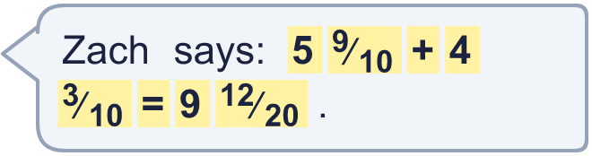
  12 | Is Zach correct? Circle yes or no.  Yes / No  Explain the mistake and give the correct answer.  Hint: Check the denominator. Then check the whole numbers: do the fractions make another whole?
  13 | Two of these numbers add up to 6 ⁸⁄₉. Which two?  4 ²⁄₉ 2 ²⁄₃ 3 ⁵⁄₉ 1 ²⁄₃ 3 ⁴⁄₉  Hint: Take each number away from 6 ⁸⁄₉. Is the answer in the list?
  13 | Two of these numbers add up to 6 ⁸⁄₉. Which two?  4 ²⁄₉ 2 ²⁄₃ 3 ⁵⁄₉ 1 ²⁄₃ 3 ⁴⁄₉  Hint: Take each number away from 6 ⁸⁄₉. Is the answer in the list?
  14 | A piece of rope is cut into two parts. The whole piece is 2 ⁷⁄₁₅ m long. One part is 1 ¹⁄₅ m long.  How long is the other part? Write the answer in its simplest form.  Hint: Take the part you know away from the whole.
  14 | A piece of rope is cut into two parts. The whole piece is 2 ⁷⁄₁₅ m long. One part is 1 ¹⁄₅ m long.  How long is the other part? Write the answer in its simplest form.  Hint: Take the part you know away from the whole.

Year 6 · Fractions A · Step 7
Adding mixed numbers
Answers (teacher copy)

Fraction wall to help you:
  1 | Work out each addition. Add the whole numbers first. Then add the fractions.  a) 4 ³⁄₅ + 5 ¹⁄₅ = 9 ⁴⁄₅  b) 3 ¹⁄₆ + 4 ¹⁄₆ = 7 ¹⁄₃  c) 3 ¹⁄₄ + 4 ¹⁄₄ = 7 ¹⁄₂  Hint: Add the wholes. Add the fractions. Put the two answers together.
  2 | Work out each addition. Write each answer in its simplest form.  a) 4 ¹⁄₄ + 2 ⁷⁄₁₂ = 6 ⁵⁄₆  b) 3 ²⁄₃ + 1 ¹⁄₉ = 4 ⁷⁄₉  c) 3 ⁷⁄₁₀ + 1 ¹⁄₂₀ = 4 ³⁄₄  Hint: Change one fraction so both denominators match. Add the wholes and add the fractions.
  3 | Work out each addition. The fractions add to more than 1. Write each answer in its simplest form.  a) 3 ⁵⁄₆ + 1 ⁵⁄₆ = 5 ²⁄₃  b) 2 ¹⁄₄ + 5 ³⁄₄ = 8  c) 1 ¹¹⁄₁₂ + 2 ⁷⁄₁₂ = 4 ¹⁄₂  Hint: Add the wholes and the fractions. The fractions make an improper fraction. Change it to a mixed number and add the extra whole to your total.
  4 | Write each mixed number as an improper fraction. Write the missing numerator.  a) 5 ⁵⁄₆ = ?⁄₆ 35  b) 4 ⁴⁄₅ = ?⁄₅ 24  c) 1 ¹⁄₆ = ?⁄₆ 7  Hint: Multiply the whole number by the denominator. Then add the numerator of the fraction.
  5 | Work out each addition. Write each answer as a mixed number in its simplest form.  a) 5 ⁴⁄₅ + 3 ⁵⁄₈ = 9 ¹⁷⁄₄₀  b) 5 ¹⁄₆ + 2 ⁷⁄₈ = 8 ¹⁄₂₄  c) 2 ²⁄₃ + 2 ⁵⁄₇ = 5 ⁸⁄₂₁  Hint: Find a common denominator for the fractions. Add the wholes, add the fractions, then combine.
  6 | Write the missing number in each calculation.  a) ? + 4 ⁷⁄₁₂ = 9 ³⁄₄ 5 ¹⁄₆  b) 5 ¹⁄₆ + ? = 6 ¹⁄₄ 1 ¹⁄₁₂  Hint: Take the number you know away from the total.
  7 | Use the fact ³⁄₄ + ¹⁄₆ = ¹¹⁄₁₂ to help you work out the answers.  a) 15 ³⁄₄ + 260 ¹⁄₆ = 275 ¹¹⁄₁₂  b) 340 ³⁄₄ + 520 ¹⁄₆ = 860 ¹¹⁄₁₂  Hint: The wholes are easy to add. The fraction parts are the same as in the fact, so you already know their total.
  8 | Work out each addition. Write each answer as a mixed number in its simplest form.  a) 1 ⁴⁄₅ + ⁸⁄₅ = 3 ²⁄₅  b) 4 ³⁄₄ + ⁷⁄₄ = 6 ¹⁄₂  c) 3 ¹⁄₆ + ⁷⁄₆ = 4 ¹⁄₃  Hint: Change the improper fraction to a mixed number first. Or change both to improper fractions.
  9 | Ron and Amir work out 1 ¹⁄₅ + 4 ⁷⁄₈.  Ron adds the wholes, then the fractions, and gets 6 ³⁄₄₀.  Amir changes both numbers to improper fractions, adds them and gets ²⁴³⁄₄₀.  Do they get the same answer? Circle yes or no.  Yes / No  Explain how you know.  Yes. ²⁴³⁄₄₀ as a mixed number is 6 ³⁄₄₀. That is the same as 6 ³⁄₄₀.  Hint: Change the improper fraction into a mixed number. Is it the same?
  10 | A plank is 2 ¹⁄₂ m long.  A second plank is 2 ²⁄₃ m long.  What is the total length of the two planks? Write the answer as a mixed number in its simplest form.  5 ¹⁄₆ m  Hint: Add the wholes. Add the fractions. If the fractions make more than 1, carry the extra whole.
  11 | Three buckets have some water in them: 3 ³⁄₄ litres, 3 ¹⁄₂ litres and 2 ⁷⁄₈ litres.  Each bucket can hold 12 litres. Can all the water fit into one bucket? Circle yes or no.  Yes / No  Show your working.  Yes. The total is 10 ¹⁄₈ litres. This is less than or equal to 12, so it fits.  Hint: Add the three amounts. Then compare the total with the size of one bucket.
  12 | Is Zach correct? Circle yes or no.  Yes / No  Explain the mistake and give the correct answer.  No. Zach added the denominators. They stay the same. The fractions add to an improper fraction, so the total is 10 ¹⁄₅.  Hint: Check the denominator. Then check the whole numbers: do the fractions make another whole?
  13 | Two of these numbers add up to 6 ⁸⁄₉. Which two?  4 ²⁄₉ 2 ²⁄₃ 3 ⁵⁄₉ 1 ²⁄₃ 3 ⁴⁄₉  4 ²⁄₉ and 2 ²⁄₃  Hint: Take each number away from 6 ⁸⁄₉. Is the answer in the list?
  14 | A piece of rope is cut into two parts. The whole piece is 2 ⁷⁄₁₅ m long. One part is 1 ¹⁄₅ m long.  How long is the other part? Write the answer in its simplest form.  1 ⁴⁄₁₅ m  Hint: Take the part you know away from the whole.

