  Year 6 · Fractions A · Step 2  Equivalent fractions on a number line | 
  Year 6 · Fractions A · Step 2
  Equivalent fractions on a number line
  1 | Write the fraction shown by each lettered box on the number line.  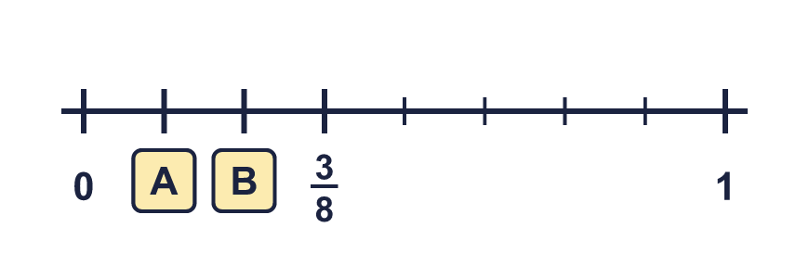
  1 | Write the fraction shown by each lettered box on the number line.
  2 | Each arrow points to a fraction. Write the fraction in its simplest form.  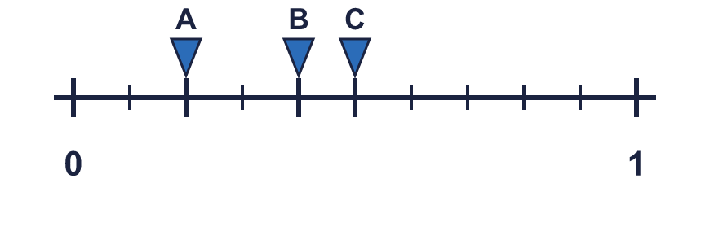
  2 | Each arrow points to a fraction. Write the fraction in its simplest form.
  3 | The number line is split into 8 equal parts. Write the fraction each arrow points to in its simplest form.  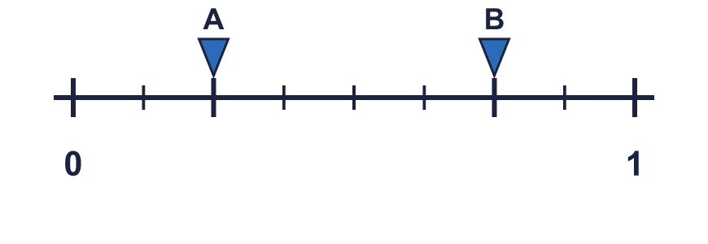
  3 | The number line is split into 8 equal parts. Write the fraction each arrow points to in its simplest form.
  4 | The number line goes from 0 to 2. Write the fraction in each box as a mixed number, or as a fraction in its simplest form if it is less than 1.  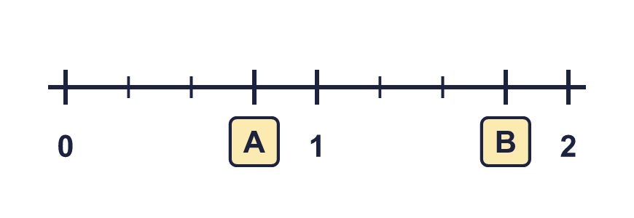
  4 | The number line goes from 0 to 2. Write the fraction in each box as a mixed number, or as a fraction in its simplest form if it is less than 1.
  5 | The jumps on the number line are equal. Write the missing numbers in their simplest form. Use mixed numbers if they are more than 1.  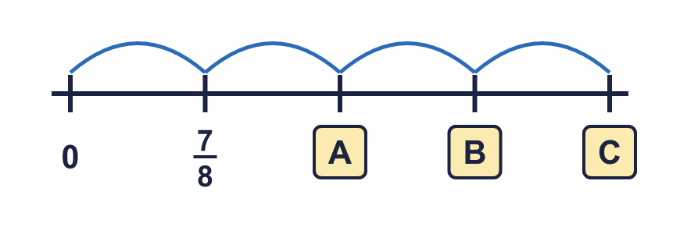
  5 | The jumps on the number line are equal. Write the missing numbers in their simplest form. Use mixed numbers if they are more than 1.
  6 | Which of these fractions are equal to the fraction that arrow A points to? Write them.  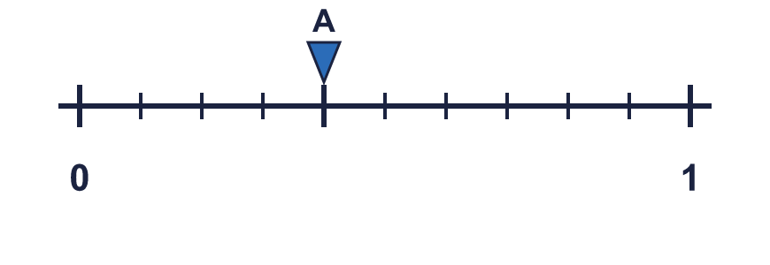  ⁶⁄₁₅ ²⁄₅ ³⁄₆ ²⁄₁₀ ⁸⁄₂₀
  6 | Which of these fractions are equal to the fraction that arrow A points to? Write them.  ⁶⁄₁₅ ²⁄₅ ³⁄₆ ²⁄₁₀ ⁸⁄₂₀
  7 | Arrow A is in the same place on both number lines. Write the missing numerator.  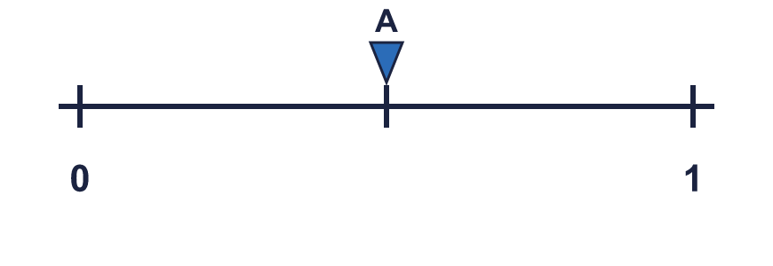  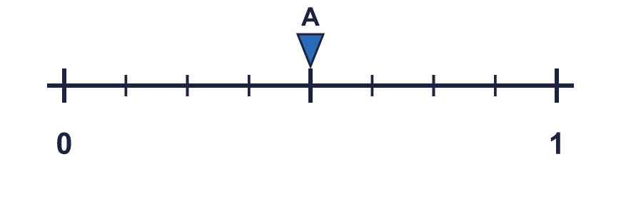  ¹⁄₂ = ?⁄₈
  7 | Arrow A is in the same place on both number lines. Write the missing numerator.  ¹⁄₂ = ?⁄₈
  8 | The number line goes from 0 to 2. Write the fraction in each box as an improper fraction (the top number is bigger than the bottom number).  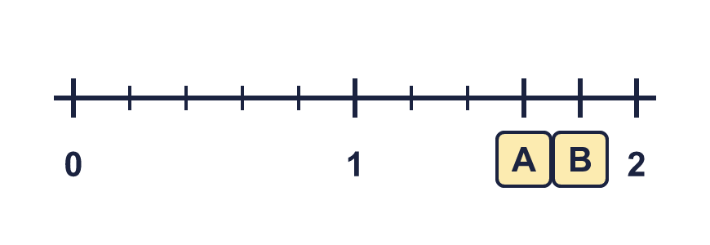
  8 | The number line goes from 0 to 2. Write the fraction in each box as an improper fraction (the top number is bigger than the bottom number).

  9 | Amir says: ¹⁄₄ and ³⁄₆ are in the same place on a number line.  Is Amir correct? Circle yes or no.  Yes / No  Explain how you know.
  9 | Amir says: ¹⁄₄ and ³⁄₆ are in the same place on a number line.  Is Amir correct? Circle yes or no.  Yes / No  Explain how you know.
  10 | Arrow A points to ²⁄₃ on the number line. Write two other fractions that are in the same place.  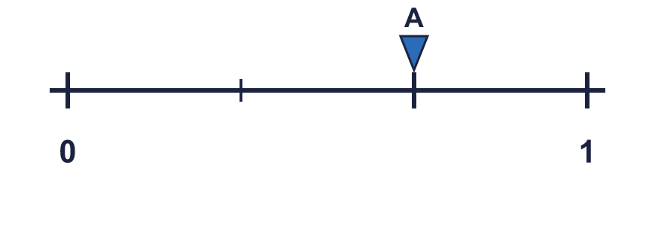
  10 | Arrow A points to ²⁄₃ on the number line. Write two other fractions that are in the same place.
  11 | The jumps on the number line are equal. Work out the missing numbers. Write mixed numbers where the answer is more than 1.  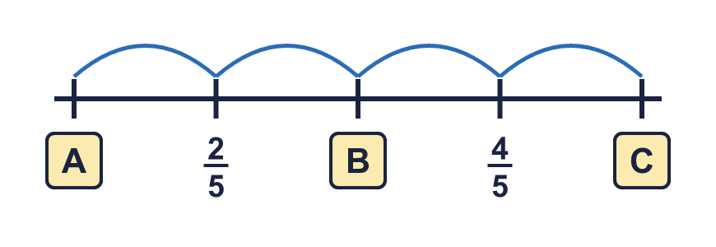
  11 | The jumps on the number line are equal. Work out the missing numbers. Write mixed numbers where the answer is more than 1.
  12 | Tia says: ⁹⁄₁₂ is greater than ³⁄₄, because the numbers are bigger.  Is Tia correct? Circle yes or no.  Yes / No  Explain your answer. You can use a number line.
  12 | Tia says: ⁹⁄₁₂ is greater than ³⁄₄, because the numbers are bigger.  Is Tia correct? Circle yes or no.  Yes / No  Explain your answer. You can use a number line.
  13 | Which arrow is nearer to 1? Write the letter.  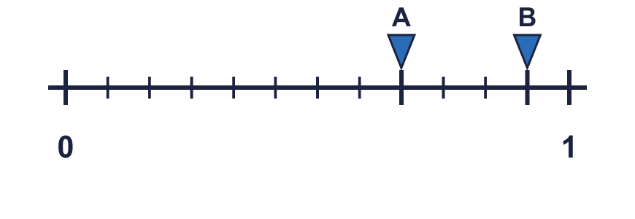  Nearer to 1:
  13 | Which arrow is nearer to 1? Write the letter.  Nearer to 1:
  14 | I am a fraction. I am equal to ¹⁄₃. My denominator is 16 more than my numerator.  What fraction am I?
  14 | I am a fraction. I am equal to ¹⁄₃. My denominator is 16 more than my numerator.  What fraction am I?

Year 6 · Fractions A · Step 2
Equivalent fractions on a number line
Answers (teacher copy)

  1 | Write the fraction shown by each lettered box on the number line.  A = ¹⁄₈ B = ²⁄₈
  2 | Each arrow points to a fraction. Write the fraction in its simplest form.  A = ¹⁄₅ B = ²⁄₅ C = ¹⁄₂
  3 | The number line is split into 8 equal parts. Write the fraction each arrow points to in its simplest form.  A = ¹⁄₄ B = ³⁄₄
  4 | The number line goes from 0 to 2. Write the fraction in each box as a mixed number, or as a fraction in its simplest form if it is less than 1.  A = ³⁄₄ B = 1 ³⁄₄
  5 | The jumps on the number line are equal. Write the missing numbers in their simplest form. Use mixed numbers if they are more than 1.  A = 1 ³⁄₄ B = 2 ⁵⁄₈ C = 3 ¹⁄₂
  6 | Which of these fractions are equal to the fraction that arrow A points to? Write them.  ⁶⁄₁₅ ²⁄₅ ³⁄₆ ²⁄₁₀ ⁸⁄₂₀  ⁶⁄₁₅, ²⁄₅, ⁸⁄₂₀
  7 | Arrow A is in the same place on both number lines. Write the missing numerator.  ¹⁄₂ = ?⁄₈ 4
  8 | The number line goes from 0 to 2. Write the fraction in each box as an improper fraction (the top number is bigger than the bottom number).  A = ⁸⁄₅ B = ⁹⁄₅
  9 | Amir says: ¹⁄₄ and ³⁄₆ are in the same place on a number line.  Is Amir correct? Circle yes or no.  Yes / No  Explain how you know.  No. ¹⁄₄ is not equal to ³⁄₆: ³⁄₆ = ¹⁄₂ but ¹⁄₄ = ¹⁄₄. Adding the same number to the top and the bottom does not keep a fraction equal. You must multiply or divide.
  10 | Arrow A points to ²⁄₃ on the number line. Write two other fractions that are in the same place.  for example ⁴⁄₆, ⁶⁄₉
  11 | The jumps on the number line are equal. Work out the missing numbers. Write mixed numbers where the answer is more than 1.  A = ¹⁄₅ B = ³⁄₅ C = 1
  12 | Tia says: ⁹⁄₁₂ is greater than ³⁄₄, because the numbers are bigger.  Is Tia correct? Circle yes or no.  Yes / No  Explain your answer. You can use a number line.  No. ⁹⁄₁₂ = ³⁄₄. They are equivalent fractions, so they are in the same place on the number line. Bigger numbers do not always mean a bigger fraction.
  13 | Which arrow is nearer to 1? Write the letter.  Nearer to 1: B
  14 | I am a fraction. I am equal to ¹⁄₃. My denominator is 16 more than my numerator.  What fraction am I?  ⁸⁄₂₄

