Fraction wall to help you:  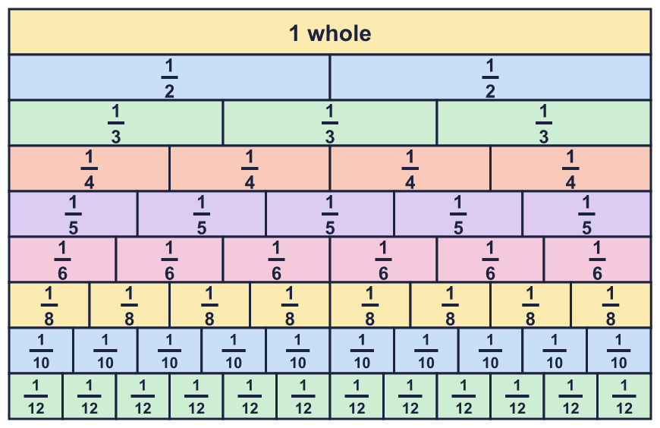 |  | Fraction wall to help you:
  Year 6 · Fractions A · Step 9  Fraction problems with several steps | 
  Year 6 · Fractions A · Step 9
  Fraction problems with several steps
  1 | Work out each calculation. Write each answer in its simplest form.  a) ²⁄₃ + ⁷⁄₁₅ − ⁴⁄₅ =  b) ¹⁄₁₀ + ¹⁄₂ − ²⁄₅ =  Hint: Use one common denominator for all three fractions. Work from left to right.
  1 | Work out each calculation. Write each answer in its simplest form.  a) ²⁄₃ + ⁷⁄₁₅ − ⁴⁄₅ =  b) ¹⁄₁₀ + ¹⁄₂ − ²⁄₅ =  Hint: Use one common denominator for all three fractions. Work from left to right.
  2 | Work out each subtraction. Write each answer as a mixed number in its simplest form.  a) 3 ¹⁄₃ − ²⁄₅ =  b) 4 ¹⁄₄ − ³⁄₈ =  Hint: Change both numbers to improper fractions with the same denominator. Or exchange a whole.
  2 | Work out each subtraction. Write each answer as a mixed number in its simplest form.  a) 3 ¹⁄₃ − ²⁄₅ =  b) 4 ¹⁄₄ − ³⁄₈ =  Hint: Change both numbers to improper fractions with the same denominator. Or exchange a whole.
  3 | Write the missing number in each calculation.  a) ²⁄₃ + ¹⁄₃ + ? = 1 ¹⁄₂  b) ¹⁄₆ + ⁵⁄₆ + ? = 4  c) ²⁄₅ + ²⁄₅ + ? = 1 ¹⁄₂  Hint: Add the two fractions you know. Then take that total away from the number on the right.
  3 | Write the missing number in each calculation.  a) ²⁄₃ + ¹⁄₃ + ? = 1 ¹⁄₂  b) ¹⁄₆ + ⁵⁄₆ + ? = 4  c) ²⁄₅ + ²⁄₅ + ? = 1 ¹⁄₂  Hint: Add the two fractions you know. Then take that total away from the number on the right.
  4 | Complete the part-whole model. Write the missing number in its simplest form.  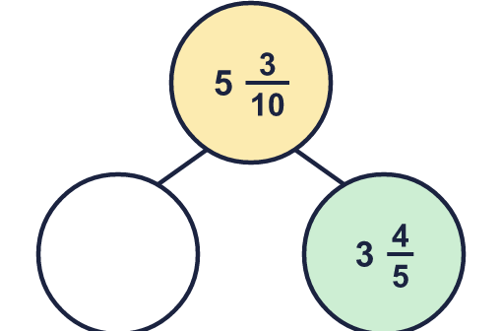  Hint: A part is the whole take away the other part.
  4 | Complete the part-whole model. Write the missing number in its simplest form.  Hint: A part is the whole take away the other part.
  5 | Work out each calculation. Write each answer as a mixed number in its simplest form.  a) 4 ²⁄₃ + 3 ⁵⁄₆ − ²⁄₃ =  b) 4 ²⁄₃ + 3 ¹⁄₄ − ¹⁄₄ =  Hint: Add first. Then subtract. Use a common denominator for all three numbers.
  5 | Work out each calculation. Write each answer as a mixed number in its simplest form.  a) 4 ²⁄₃ + 3 ⁵⁄₆ − ²⁄₃ =  b) 4 ²⁄₃ + 3 ¹⁄₄ − ¹⁄₄ =  Hint: Add first. Then subtract. Use a common denominator for all three numbers.
  6 | Work out each subtraction. Write each answer in its simplest form.  a) 3 − ²⁄₃ − ³⁄₄ =  b) 3 − ¹⁄₂ − ²⁄₃ =  c) 2 − ¹⁄₃ − ³⁄₄ =  Hint: Take away one fraction at a time. Or add the two fractions first and take the total away.
  6 | Work out each subtraction. Write each answer in its simplest form.  a) 3 − ²⁄₃ − ³⁄₄ =  b) 3 − ¹⁄₂ − ²⁄₃ =  c) 2 − ¹⁄₃ − ³⁄₄ =  Hint: Take away one fraction at a time. Or add the two fractions first and take the total away.
  7 | Write the missing number in each calculation.  a) 7 ¹⁄₂ − ? − ¹⁄₄ = 4 ¹⁄₂  b) 6 ¹⁄₃ − ? − ⁵⁄₆ = 3 ¹⁄₃  Hint: Work out the total of the numbers you know first. Then use the opposite operation.
  7 | Write the missing number in each calculation.  a) 7 ¹⁄₂ − ? − ¹⁄₄ = 4 ¹⁄₂  b) 6 ¹⁄₃ − ? − ⁵⁄₆ = 3 ¹⁄₃  Hint: Work out the total of the numbers you know first. Then use the opposite operation.
  8 | Work out each addition. Write each answer in its simplest form.  a) ¹⁄₄ + ¹⁄₆ + ¹⁄₈ =  b) ¹⁄₄ + ³⁄₅ + ⁷⁄₁₀ =  Hint: Find a number that all three denominators divide into. Use it as the common denominator.
  8 | Work out each addition. Write each answer in its simplest form.  a) ¹⁄₄ + ¹⁄₆ + ¹⁄₈ =  b) ¹⁄₄ + ³⁄₅ + ⁷⁄₁₀ =  Hint: Find a number that all three denominators divide into. Use it as the common denominator.

  9 | Which statements are true and which are false? Work them out, or use what you know about the numbers.  A: 2 ¹⁄₄ + 2 ³⁄₄ = 3 ¹⁄₄ + 2 ³⁄₄  B: 5 ³⁄₄ − ¹⁄₂ < 5 ³⁄₄ − ¹⁄₄  C: 5 − ¹⁄₂ = 7 − 2 ¹⁄₂  Hint: Do you need to work out every answer? Think about what happens to a total when you take away more or less.
  9 | Which statements are true and which are false? Work them out, or use what you know about the numbers.  A: 2 ¹⁄₄ + 2 ³⁄₄ = 3 ¹⁄₄ + 2 ³⁄₄  B: 5 ³⁄₄ − ¹⁄₂ < 5 ³⁄₄ − ¹⁄₄  C: 5 − ¹⁄₂ = 7 − 2 ¹⁄₂  Hint: Do you need to work out every answer? Think about what happens to a total when you take away more or less.
  10 | A painter makes green paint with ¹⁄₄ of a litre of blue and ³⁄₅ of a litre of yellow.  She makes purple paint with ²⁄₃ of a litre of red and ¹⁄₆ of a litre of blue.  How much more green paint than purple paint does she have? Write the answer as a fraction of a litre in its simplest form.  Hint: Work out how much green paint there is. Work out how much purple paint there is. Then find the difference.
  10 | A painter makes green paint with ¹⁄₄ of a litre of blue and ³⁄₅ of a litre of yellow.  She makes purple paint with ²⁄₃ of a litre of red and ¹⁄₆ of a litre of blue.  How much more green paint than purple paint does she have? Write the answer as a fraction of a litre in its simplest form.  Hint: Work out how much green paint there is. Work out how much purple paint there is. Then find the difference.
  11 | Amir has found an easier way. Work out the answer to this calculation.  ²⁵⁄₁₀₀ + ²⁄₈ − ³⁄₁₂ + ⁵⁄₂₀  Hint: Simplify each fraction first. What do you notice?
    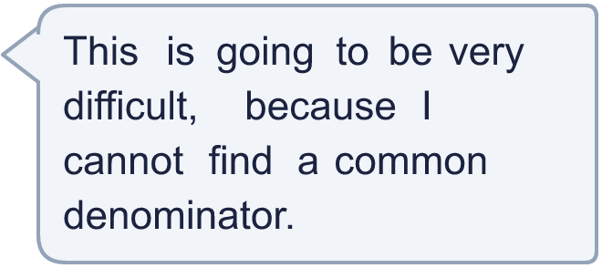
  11 | Amir has found an easier way. Work out the answer to this calculation.  ²⁵⁄₁₀₀ + ²⁄₈ − ³⁄₁₂ + ⁵⁄₂₀  Hint: Simplify each fraction first. What do you notice?
  12 | Cat eats ¹⁄₂ of a cake. Ben eats ¹⁄₃ of the cake. Ana eats ¹⁄₁₂ of the cake.  What fraction of the cake is left? Write the answer in its simplest form.  Hint: Add the three fractions that were eaten. Then take the total away from 1 whole.
  12 | Cat eats ¹⁄₂ of a cake. Ben eats ¹⁄₃ of the cake. Ana eats ¹⁄₁₂ of the cake.  What fraction of the cake is left? Write the answer in its simplest form.  Hint: Add the three fractions that were eaten. Then take the total away from 1 whole.
  13 | Zach says: 4 ¹⁄₂ − 2 ¹⁄₄ + ¹⁄₂ = 3.  Is Zach correct? Circle yes or no.  Yes / No  Work it out to show how you know.  Hint: Do the subtraction first. Then add the last fraction.
  13 | Zach says: 4 ¹⁄₂ − 2 ¹⁄₄ + ¹⁄₂ = 3.  Is Zach correct? Circle yes or no.  Yes / No  Work it out to show how you know.  Hint: Do the subtraction first. Then add the last fraction.
  14 | This sequence goes up by the same amount each time. Write the next two numbers.  ¹⁄₂, 1 ¹⁄₄, 2, 2 ³⁄₄, ..., ...  Hint: Work out how much the sequence goes up by each time. Add that amount to the last number, then again.
  14 | This sequence goes up by the same amount each time. Write the next two numbers.  ¹⁄₂, 1 ¹⁄₄, 2, 2 ³⁄₄, ..., ...  Hint: Work out how much the sequence goes up by each time. Add that amount to the last number, then again.

Year 6 · Fractions A · Step 9
Fraction problems with several steps
Answers (teacher copy)

Fraction wall to help you:
  1 | Work out each calculation. Write each answer in its simplest form.  a) ²⁄₃ + ⁷⁄₁₅ − ⁴⁄₅ = ¹⁄₃  b) ¹⁄₁₀ + ¹⁄₂ − ²⁄₅ = ¹⁄₅  Hint: Use one common denominator for all three fractions. Work from left to right.
  2 | Work out each subtraction. Write each answer as a mixed number in its simplest form.  a) 3 ¹⁄₃ − ²⁄₅ = 2 ¹⁴⁄₁₅  b) 4 ¹⁄₄ − ³⁄₈ = 3 ⁷⁄₈  Hint: Change both numbers to improper fractions with the same denominator. Or exchange a whole.
  3 | Write the missing number in each calculation.  a) ²⁄₃ + ¹⁄₃ + ? = 1 ¹⁄₂ ¹⁄₂  b) ¹⁄₆ + ⁵⁄₆ + ? = 4 3  c) ²⁄₅ + ²⁄₅ + ? = 1 ¹⁄₂ ⁷⁄₁₀  Hint: Add the two fractions you know. Then take that total away from the number on the right.
  4 | Complete the part-whole model. Write the missing number in its simplest form.  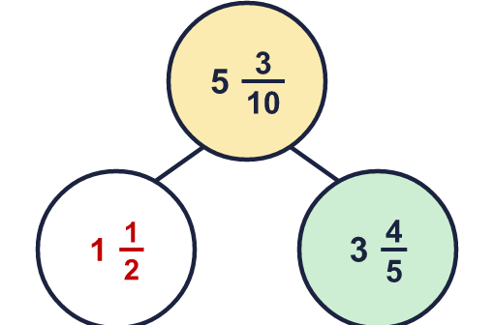  Missing: 1 ¹⁄₂  Hint: A part is the whole take away the other part.
  5 | Work out each calculation. Write each answer as a mixed number in its simplest form.  a) 4 ²⁄₃ + 3 ⁵⁄₆ − ²⁄₃ = 7 ⁵⁄₆  b) 4 ²⁄₃ + 3 ¹⁄₄ − ¹⁄₄ = 7 ²⁄₃  Hint: Add first. Then subtract. Use a common denominator for all three numbers.
  6 | Work out each subtraction. Write each answer in its simplest form.  a) 3 − ²⁄₃ − ³⁄₄ = 1 ⁷⁄₁₂  b) 3 − ¹⁄₂ − ²⁄₃ = 1 ⁵⁄₆  c) 2 − ¹⁄₃ − ³⁄₄ = ¹¹⁄₁₂  Hint: Take away one fraction at a time. Or add the two fractions first and take the total away.
  7 | Write the missing number in each calculation.  a) 7 ¹⁄₂ − ? − ¹⁄₄ = 4 ¹⁄₂ 2 ³⁄₄  b) 6 ¹⁄₃ − ? − ⁵⁄₆ = 3 ¹⁄₃ 2 ¹⁄₆  Hint: Work out the total of the numbers you know first. Then use the opposite operation.
  8 | Work out each addition. Write each answer in its simplest form.  a) ¹⁄₄ + ¹⁄₆ + ¹⁄₈ = ¹³⁄₂₄  b) ¹⁄₄ + ³⁄₅ + ⁷⁄₁₀ = 1 ¹¹⁄₂₀  Hint: Find a number that all three denominators divide into. Use it as the common denominator.
  9 | Which statements are true and which are false? Work them out, or use what you know about the numbers.  A: 2 ¹⁄₄ + 2 ³⁄₄ = 3 ¹⁄₄ + 2 ³⁄₄  B: 5 ³⁄₄ − ¹⁄₂ < 5 ³⁄₄ − ¹⁄₄  C: 5 − ¹⁄₂ = 7 − 2 ¹⁄₂  True: B, C  False: A  Hint: Do you need to work out every answer? Think about what happens to a total when you take away more or less.
  10 | A painter makes green paint with ¹⁄₄ of a litre of blue and ³⁄₅ of a litre of yellow.  She makes purple paint with ²⁄₃ of a litre of red and ¹⁄₆ of a litre of blue.  How much more green paint than purple paint does she have? Write the answer as a fraction of a litre in its simplest form.  ¹⁄₆₀ of a litre  Hint: Work out how much green paint there is. Work out how much purple paint there is. Then find the difference.
  11 | Amir has found an easier way. Work out the answer to this calculation.  ²⁵⁄₁₀₀ + ²⁄₈ − ³⁄₁₂ + ⁵⁄₂₀  Answer: ¹⁄₂  Each fraction simplifies to ¹⁄₄. So the calculation is ¹⁄₄ + ¹⁄₄ − ¹⁄₄ + ¹⁄₄ = ²⁄₄ = ¹⁄₂.  Hint: Simplify each fraction first. What do you notice?
  12 | Cat eats ¹⁄₂ of a cake. Ben eats ¹⁄₃ of the cake. Ana eats ¹⁄₁₂ of the cake.  What fraction of the cake is left? Write the answer in its simplest form.  ¹⁄₁₂  Hint: Add the three fractions that were eaten. Then take the total away from 1 whole.
  13 | Zach says: 4 ¹⁄₂ − 2 ¹⁄₄ + ¹⁄₂ = 3.  Is Zach correct? Circle yes or no.  Yes / No  Work it out to show how you know.  No. 4 ¹⁄₂ − 2 ¹⁄₄ + ¹⁄₂ = 2 ³⁄₄.  Hint: Do the subtraction first. Then add the last fraction.
  14 | This sequence goes up by the same amount each time. Write the next two numbers.  ¹⁄₂, 1 ¹⁄₄, 2, 2 ³⁄₄, ..., ...  3 ¹⁄₂ 4 ¹⁄₄  Hint: Work out how much the sequence goes up by each time. Add that amount to the last number, then again.

