1/5 of 20 = 4. Divide by the denominator, then multiply by the numerator:  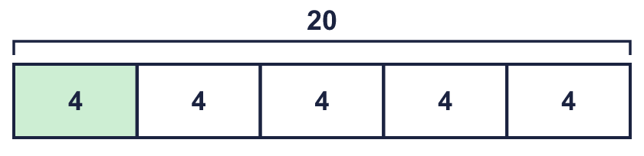 |  | 1/5 of 20 = 4. Divide by the denominator, then multiply by the numerator:
  Year 6 · Fractions B · Step 6  Finding a fraction of an amount | 
  Year 6 · Fractions B · Step 6
  Finding a fraction of an amount
  1 | The bar shows 36 split into 6 equal parts. One part is shaded.  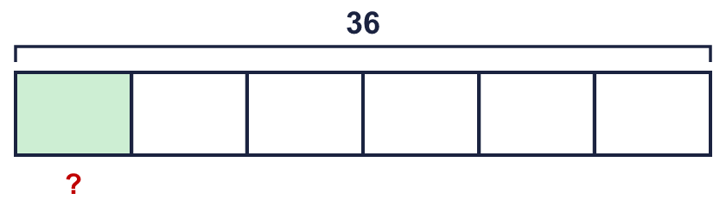  ¹⁄₆ of 36 =  Hint: Divide 36 by 6 to find the size of one part.
  1 | The bar shows 36 split into 6 equal parts. One part is shaded.  ¹⁄₆ of 36 =  Hint: Divide 36 by 6 to find the size of one part.
  2 | Work out each amount. Use your times tables.  a) ¹⁄₃ of 30 m =  b) ¹⁄₈ of 80 =  c) ¹⁄₅ of 10 =  d) ¹⁄₇ of £21 =  Hint: Divide the amount by the denominator.
  2 | Work out each amount. Use your times tables.  a) ¹⁄₃ of 30 m =  b) ¹⁄₈ of 80 =  c) ¹⁄₅ of 10 =  d) ¹⁄₇ of £21 =  Hint: Divide the amount by the denominator.
  3 | Work out each amount.  a) ⁷⁄₈ of 16 cm =  b) ⁷⁄₈ of 48 litres =  c) ⁵⁄₆ of 30 cm =  d) ¹¹⁄₁₂ of 96 m =  Hint: Divide by the denominator to find one part. Multiply by the numerator to find the parts you need.
  3 | Work out each amount.  a) ⁷⁄₈ of 16 cm =  b) ⁷⁄₈ of 48 litres =  c) ⁵⁄₆ of 30 cm =  d) ¹¹⁄₁₂ of 96 m =  Hint: Divide by the denominator to find one part. Multiply by the numerator to find the parts you need.
  4 | Work out each amount.  a) ³⁄₅ of 300 litres =  b) ⁷⁄₈ of 160 litres =  c) ¹⁄₁₂ of 1,200 =  Hint: Divide by the denominator first. Then multiply by the numerator.
  4 | Work out each amount.  a) ³⁄₅ of 300 litres =  b) ⁷⁄₈ of 160 litres =  c) ¹⁄₁₂ of 1,200 =  Hint: Divide by the denominator first. Then multiply by the numerator.
  5 | Here is a fact: ¹⁄₃ of £24 = £8.  Use it to work out the amount below.  ²⁄₃ of £24 =  Hint: ²⁄₃ is 2 times as big as ¹⁄₃. Multiply the fact by 2.
  5 | Here is a fact: ¹⁄₃ of £24 = £8.  Use it to work out the amount below.  ²⁄₃ of £24 =  Hint: ²⁄₃ is 2 times as big as ¹⁄₃. Multiply the fact by 2.
  6 | A club has 200 students. ¹⁄₅ of them are in the choir.  How many are in the choir?  Hint: Find ¹⁄₅ of 200. Then multiply.
  6 | A club has 200 students. ¹⁄₅ of them are in the choir.  How many are in the choir?  Hint: Find ¹⁄₅ of 200. Then multiply.
  7 | Write the missing numerator in each calculation.  a) ?⁄₈ of £80 = £10  b) ?⁄₄ of £20 = £15  Hint: Find one part first: divide the amount by the denominator. How many parts make the answer?
  7 | Write the missing numerator in each calculation.  a) ?⁄₈ of £80 = £10  b) ?⁄₄ of £20 = £15  Hint: Find one part first: divide the amount by the denominator. How many parts make the answer?
  8 | Eva has £120 savings. Eva spends ¹⁄₄ of the savings on a train ticket.  How much money is left?  Hint: Find the fraction of the money that is spent. Then take it away from the total.
  8 | Eva has £120 savings. Eva spends ¹⁄₄ of the savings on a train ticket.  How much money is left?  Hint: Find the fraction of the money that is spent. Then take it away from the total.

  9 | Sam is painting a fence that is 288 m long.  On Monday Sam paints ¹⁄₄ of the fence. On Tuesday Sam paints ¹⁄₂ of the fence that is left.  How much fence is left to paint?  Hint: Work out the fence that is left after Monday. Then find half of that. Then take it away.
  9 | Sam is painting a fence that is 288 m long.  On Monday Sam paints ¹⁄₄ of the fence. On Tuesday Sam paints ¹⁄₂ of the fence that is left.  How much fence is left to paint?  Hint: Work out the fence that is left after Monday. Then find half of that. Then take it away.
  10 | Zach says: ⁵⁄₆ of £108 is less than ²⁄₅ of £75.  Is Zach correct? Circle yes or no.  Yes / No  Explain. Work out both amounts.  Hint: Work out both amounts. Then compare them.
  10 | Zach says: ⁵⁄₆ of £108 is less than ²⁄₅ of £75.  Is Zach correct? Circle yes or no.  Yes / No  Explain. Work out both amounts.  Hint: Work out both amounts. Then compare them.
  11 | Work out ¹⁄₂ of ¹⁄₂ of 40.  Hint: Find ¹⁄₂ of 40 first. Then find ¹⁄₂ of your answer.
  11 | Work out ¹⁄₂ of ¹⁄₂ of 40.  Hint: Find ¹⁄₂ of 40 first. Then find ¹⁄₂ of your answer.
  12 | A shop has 240 items. ³⁄₁₀ of the items are books. ¹⁄₅ of the items are toys. The rest are games.  How many games are there?  Hint: Find the number of books and the number of toys. Add them. Take the total away from all the items.
  12 | A shop has 240 items. ³⁄₁₀ of the items are books. ¹⁄₅ of the items are toys. The rest are games.  How many games are there?  Hint: Find the number of books and the number of toys. Add them. Take the total away from all the items.
  13 | Mo has ²⁄₅ of £60.  Tia has ⁵⁄₆ of £84.  Who has more money? Write the name and show how you know.  Hint: Work out how much each person has. Then compare.
  13 | Mo has ²⁄₅ of £60.  Tia has ⁵⁄₆ of £84.  Who has more money? Write the name and show how you know.  Hint: Work out how much each person has. Then compare.
  14 | Challenge  A bag has 720 sweets. ¹⁄₃ of the sweets are red. ¹⁄₅ of the sweets that are not red are green.  How many green sweets are there?  Hint: Find the number of red sweets. Take them away to find the sweets that are not red. Then find a fraction of that number.
  14 | Challenge  A bag has 720 sweets. ¹⁄₃ of the sweets are red. ¹⁄₅ of the sweets that are not red are green.  How many green sweets are there?  Hint: Find the number of red sweets. Take them away to find the sweets that are not red. Then find a fraction of that number.

Year 6 · Fractions B · Step 6
Finding a fraction of an amount
Answers (teacher copy)

1/5 of 20 = 4. Divide by the denominator, then multiply by the numerator:
  1 | The bar shows 36 split into 6 equal parts. One part is shaded.  ¹⁄₆ of 36 = 6  Hint: Divide 36 by 6 to find the size of one part.
  2 | Work out each amount. Use your times tables.  a) ¹⁄₃ of 30 m = 10 m  b) ¹⁄₈ of 80 = 10  c) ¹⁄₅ of 10 = 2  d) ¹⁄₇ of £21 = £3  Hint: Divide the amount by the denominator.
  3 | Work out each amount.  a) ⁷⁄₈ of 16 cm = 14 cm  b) ⁷⁄₈ of 48 litres = 42 litres  c) ⁵⁄₆ of 30 cm = 25 cm  d) ¹¹⁄₁₂ of 96 m = 88 m  Hint: Divide by the denominator to find one part. Multiply by the numerator to find the parts you need.
  4 | Work out each amount.  a) ³⁄₅ of 300 litres = 180 litres  b) ⁷⁄₈ of 160 litres = 140 litres  c) ¹⁄₁₂ of 1,200 = 100  Hint: Divide by the denominator first. Then multiply by the numerator.
  5 | Here is a fact: ¹⁄₃ of £24 = £8.  Use it to work out the amount below.  ²⁄₃ of £24 = £16  Hint: ²⁄₃ is 2 times as big as ¹⁄₃. Multiply the fact by 2.
  6 | A club has 200 students. ¹⁄₅ of them are in the choir.  How many are in the choir?  40 students  Hint: Find ¹⁄₅ of 200. Then multiply.
  7 | Write the missing numerator in each calculation.  a) ?⁄₈ of £80 = £10 1  b) ?⁄₄ of £20 = £15 3  Hint: Find one part first: divide the amount by the denominator. How many parts make the answer?
  8 | Eva has £120 savings. Eva spends ¹⁄₄ of the savings on a train ticket.  How much money is left?  £90  Hint: Find the fraction of the money that is spent. Then take it away from the total.
  9 | Sam is painting a fence that is 288 m long.  On Monday Sam paints ¹⁄₄ of the fence. On Tuesday Sam paints ¹⁄₂ of the fence that is left.  How much fence is left to paint?  108 m  Hint: Work out the fence that is left after Monday. Then find half of that. Then take it away.
  10 | Zach says: ⁵⁄₆ of £108 is less than ²⁄₅ of £75.  Is Zach correct? Circle yes or no.  Yes / No  Explain. Work out both amounts.  No. ⁵⁄₆ of £108 = £90 and ²⁄₅ of £75 = £30.  Hint: Work out both amounts. Then compare them.
  11 | Work out ¹⁄₂ of ¹⁄₂ of 40.  10  Hint: Find ¹⁄₂ of 40 first. Then find ¹⁄₂ of your answer.
  12 | A shop has 240 items. ³⁄₁₀ of the items are books. ¹⁄₅ of the items are toys. The rest are games.  How many games are there?  120 games  Hint: Find the number of books and the number of toys. Add them. Take the total away from all the items.
  13 | Mo has ²⁄₅ of £60.  Tia has ⁵⁄₆ of £84.  Who has more money? Write the name and show how you know.  Tia  Tia has more. Mo has £24 and Tia has £70.  Hint: Work out how much each person has. Then compare.
  14 | Challenge  A bag has 720 sweets. ¹⁄₃ of the sweets are red. ¹⁄₅ of the sweets that are not red are green.  How many green sweets are there?  96 sweets  Hint: Find the number of red sweets. Take them away to find the sweets that are not red. Then find a fraction of that number.

