3/5 of ? = 36. Each part is 36 ÷ 3 = 12, so the whole is 5 × 12 = 60:  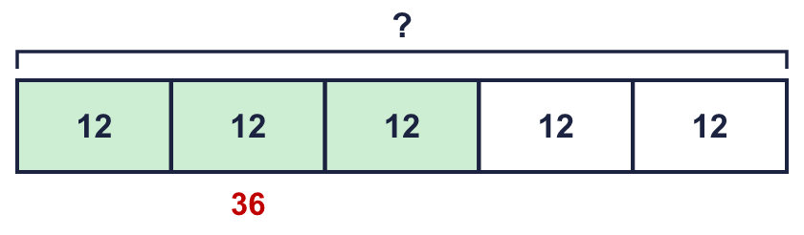 |  | 3/5 of ? = 36. Each part is 36 ÷ 3 = 12, so the whole is 5 × 12 = 60:
  Year 6 · Fractions B · Step 7  Finding the whole from a fraction of an amount | 
  Year 6 · Fractions B · Step 7
  Finding the whole from a fraction of an amount
  1 | Work out the whole number each time. Write the missing number.  a) ¹⁄₁₀ of ? = 12  b) ¹⁄₃ of ? = 2  c) ¹⁄₁₀ of ? = 10  d) ¹⁄₁₀ of ? = 5  Hint: If 1 part is the number given, the whole is that many parts. Multiply by the denominator.
  1 | Work out the whole number each time. Write the missing number.  a) ¹⁄₁₀ of ? = 12  b) ¹⁄₃ of ? = 2  c) ¹⁄₁₀ of ? = 10  d) ¹⁄₁₀ of ? = 5  Hint: If 1 part is the number given, the whole is that many parts. Multiply by the denominator.
  2 | Work out the whole each time. Write the missing number.  a) ²⁄₅ of ? = £10  b) ⁵⁄₆ of ? = £35  c) ²⁄₃ of ? = 24  Hint: Divide the part by the numerator to find 1 part. Multiply by the denominator to find the whole.
  2 | Work out the whole each time. Write the missing number.  a) ²⁄₅ of ? = £10  b) ⁵⁄₆ of ? = £35  c) ²⁄₃ of ? = 24  Hint: Divide the part by the numerator to find 1 part. Multiply by the denominator to find the whole.
  3 | The bar shows a whole split into 8 equal parts. 5 parts are shaded and they are worth 50.  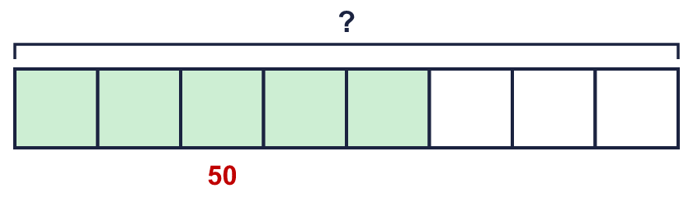  ⁵⁄₈ of ? = 50  Hint: 5 parts = 50. So 1 part = 50 ÷ 5. Then find 8 parts.
  3 | The bar shows a whole split into 8 equal parts. 5 parts are shaded and they are worth 50.  ⁵⁄₈ of ? = 50  Hint: 5 parts = 50. So 1 part = 50 ÷ 5. Then find 8 parts.
  4 | Mr Hall cycles ⁵⁄₆ of the way from the house to work. Mr Hall cycles 25 miles.  How far is it from the start to the end of the whole journey?  Hint: Find what ¹⁄₆ of the journey is. Then find the whole journey.
  4 | Mr Hall cycles ⁵⁄₆ of the way from the house to work. Mr Hall cycles 25 miles.  How far is it from the start to the end of the whole journey?  Hint: Find what ¹⁄₆ of the journey is. Then find the whole journey.
  5 | Work out the whole each time. Look at the numbers. What do you notice?  a) ³⁄₁₀ of ? = 210  b) ³⁄₁₀ of ? = 2,100  c) ³⁄₁₀ of ? = 21  d) ³⁄₁₀₀ of ? = 210  Hint: Use the first answer to help with the others. Each number is 10 times bigger or smaller.
  5 | Work out the whole each time. Look at the numbers. What do you notice?  a) ³⁄₁₀ of ? = 210  b) ³⁄₁₀ of ? = 2,100  c) ³⁄₁₀ of ? = 21  d) ³⁄₁₀₀ of ? = 210  Hint: Use the first answer to help with the others. Each number is 10 times bigger or smaller.
  6 | Write the missing numerator in each calculation.  a) ?⁄₄ of 36 = 27  b) ?⁄₆ of 48 = 8  Hint: Find 1 part first: divide the whole by the denominator. How many parts make the answer?
  6 | Write the missing numerator in each calculation.  a) ?⁄₄ of 36 = 27  b) ?⁄₆ of 48 = 8  Hint: Find 1 part first: divide the whole by the denominator. How many parts make the answer?
  7 | A bucket is ⁷⁄₁₀ full. It holds 280 ml of water.  How much water can it hold when it is full?  Hint: Find 1 part first. Then find all the parts.
  7 | A bucket is ⁷⁄₁₀ full. It holds 280 ml of water.  How much water can it hold when it is full?  Hint: Find 1 part first. Then find all the parts.
  8 | Jack has poured ⁷⁄₈ of a tin of paint into a jug. There is 560 ml in the jug.  How much paint is left in the tin?  Hint: First find how much paint the whole tin holds. Then take away what is in the jug.
  8 | Jack has poured ⁷⁄₈ of a tin of paint into a jug. There is 560 ml in the jug.  How much paint is left in the tin?  Hint: First find how much paint the whole tin holds. Then take away what is in the jug.

  9 | In a park, the trees are oak, elm, fir or apple trees.  ¹⁄₂ of the trees are oak. ¹⁄₅ are elm. ¹⁄₁₀ are fir. The rest are apple trees.  There are 30 oak trees.  How many trees are there in total? How many of them are apple trees?  Hint: Use the oak trees to find the total. Then work out what fraction is apple (take the three fractions away from 1).
  9 | In a park, the trees are oak, elm, fir or apple trees.  ¹⁄₂ of the trees are oak. ¹⁄₅ are elm. ¹⁄₁₀ are fir. The rest are apple trees.  There are 30 oak trees.  How many trees are there in total? How many of them are apple trees?  Hint: Use the oak trees to find the total. Then work out what fraction is apple (take the three fractions away from 1).
  10 | Mo says: if ²⁄₃ of a number is 10, then the number is 9.  Is Mo correct? Circle yes or no.  Yes / No  Explain how you know.  Hint: Divide the part by the numerator. Then multiply by the denominator.
  10 | Mo says: if ²⁄₃ of a number is 10, then the number is 9.  Is Mo correct? Circle yes or no.  Yes / No  Explain how you know.  Hint: Divide the part by the numerator. Then multiply by the denominator.
  11 | Dee spends ⁷⁄₁₀ of her money. Dee spends £84.  How much money did Dee have at the start? How much is left?  Hint: Find the total first: ⁷⁄₁₀ of the money is £84. Then take the money spent away from the total.
  11 | Dee spends ⁷⁄₁₀ of her money. Dee spends £84.  How much money did Dee have at the start? How much is left?  Hint: Find the total first: ⁷⁄₁₀ of the money is £84. Then take the money spent away from the total.
  12 | ⁴⁄₉ of the children in a club are boys. The rest are girls. There are 20 girls.  How many boys are there?  Hint: Work out the fraction that are girls. Then find the whole club. Then find the boys.
  12 | ⁴⁄₉ of the children in a club are boys. The rest are girls. There are 20 girls.  How many boys are there?  Hint: Work out the fraction that are girls. Then find the whole club. Then find the boys.
  13 | Write the missing number in each calculation. You need to work out something different each time.  a) ?⁄₅ of 45 = 36  b) ²⁄? of 18 = 6  c) ⁴⁄₅ of ? = 16  Hint: In a) find 1 part, then count the parts. In b) work out which denominator gives the answer. In c) find the whole.
  13 | Write the missing number in each calculation. You need to work out something different each time.  a) ?⁄₅ of 45 = 36  b) ²⁄? of 18 = 6  c) ⁴⁄₅ of ? = 16  Hint: In a) find 1 part, then count the parts. In b) work out which denominator gives the answer. In c) find the whole.
  14 | Challenge  ⁵⁄₈ of a number is 33 more than ²⁄₈ of the number.  What is the number? Write the number in the box.  Hint: How many fifths (or other parts) is the difference? 5 parts − 2 parts = 3 parts. Those parts are worth 33.
  14 | Challenge  ⁵⁄₈ of a number is 33 more than ²⁄₈ of the number.  What is the number? Write the number in the box.  Hint: How many fifths (or other parts) is the difference? 5 parts − 2 parts = 3 parts. Those parts are worth 33.

Year 6 · Fractions B · Step 7
Finding the whole from a fraction of an amount
Answers (teacher copy)

3/5 of ? = 36. Each part is 36 ÷ 3 = 12, so the whole is 5 × 12 = 60:
  1 | Work out the whole number each time. Write the missing number.  a) ¹⁄₁₀ of ? = 12 120  b) ¹⁄₃ of ? = 2 6  c) ¹⁄₁₀ of ? = 10 100  d) ¹⁄₁₀ of ? = 5 50  Hint: If 1 part is the number given, the whole is that many parts. Multiply by the denominator.
  2 | Work out the whole each time. Write the missing number.  a) ²⁄₅ of ? = £10 25  b) ⁵⁄₆ of ? = £35 42  c) ²⁄₃ of ? = 24 36  Hint: Divide the part by the numerator to find 1 part. Multiply by the denominator to find the whole.
  3 | The bar shows a whole split into 8 equal parts. 5 parts are shaded and they are worth 50.  ⁵⁄₈ of ? = 50 80  Hint: 5 parts = 50. So 1 part = 50 ÷ 5. Then find 8 parts.
  4 | Mr Hall cycles ⁵⁄₆ of the way from the house to work. Mr Hall cycles 25 miles.  How far is it from the start to the end of the whole journey?  30 miles  Hint: Find what ¹⁄₆ of the journey is. Then find the whole journey.
  5 | Work out the whole each time. Look at the numbers. What do you notice?  a) ³⁄₁₀ of ? = 210 700  b) ³⁄₁₀ of ? = 2,100 7,000  c) ³⁄₁₀ of ? = 21 70  d) ³⁄₁₀₀ of ? = 210 7,000  Hint: Use the first answer to help with the others. Each number is 10 times bigger or smaller.
  6 | Write the missing numerator in each calculation.  a) ?⁄₄ of 36 = 27 3  b) ?⁄₆ of 48 = 8 1  Hint: Find 1 part first: divide the whole by the denominator. How many parts make the answer?
  7 | A bucket is ⁷⁄₁₀ full. It holds 280 ml of water.  How much water can it hold when it is full?  400 ml  Hint: Find 1 part first. Then find all the parts.
  8 | Jack has poured ⁷⁄₈ of a tin of paint into a jug. There is 560 ml in the jug.  How much paint is left in the tin?  80 ml  Hint: First find how much paint the whole tin holds. Then take away what is in the jug.
  9 | In a park, the trees are oak, elm, fir or apple trees.  ¹⁄₂ of the trees are oak. ¹⁄₅ are elm. ¹⁄₁₀ are fir. The rest are apple trees.  There are 30 oak trees.  How many trees are there in total? How many of them are apple trees?  Total: 60 Apple: 12  Hint: Use the oak trees to find the total. Then work out what fraction is apple (take the three fractions away from 1).
  10 | Mo says: if ²⁄₃ of a number is 10, then the number is 9.  Is Mo correct? Circle yes or no.  Yes / No  Explain how you know.  No. 10 ÷ 2 = 5, so ¹⁄₃ of the number is 5. The number is 5 × 3 = 15.  Hint: Divide the part by the numerator. Then multiply by the denominator.
  11 | Dee spends ⁷⁄₁₀ of her money. Dee spends £84.  How much money did Dee have at the start? How much is left?  Start: £ 120 Left: £ 36  Hint: Find the total first: ⁷⁄₁₀ of the money is £84. Then take the money spent away from the total.
  12 | ⁴⁄₉ of the children in a club are boys. The rest are girls. There are 20 girls.  How many boys are there?  16 boys  Hint: Work out the fraction that are girls. Then find the whole club. Then find the boys.
  13 | Write the missing number in each calculation. You need to work out something different each time.  a) ?⁄₅ of 45 = 36 4  b) ²⁄? of 18 = 6 6  c) ⁴⁄₅ of ? = 16 20  Hint: In a) find 1 part, then count the parts. In b) work out which denominator gives the answer. In c) find the whole.
  14 | Challenge  ⁵⁄₈ of a number is 33 more than ²⁄₈ of the number.  What is the number? Write the number in the box.  88  Hint: How many fifths (or other parts) is the difference? 5 parts − 2 parts = 3 parts. Those parts are worth 33.

