  Year 6 · Place value · Step 6  Comparing and ordering integers | 
  Year 6 · Place value · Step 6
  Comparing and ordering integers
  1 | Write the number shown in each place value chart. Then write <, > or = to compare them.  Chart A  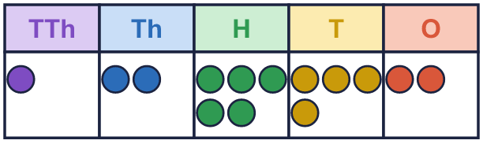  Chart B  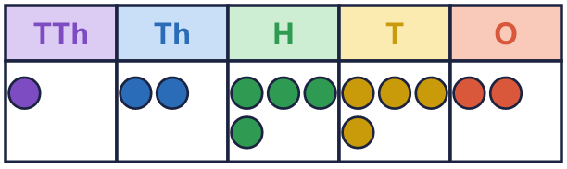
    A |  | B
  1 | Write the number shown in each place value chart. Then write <, > or = to compare them.  Chart A  Chart B
    A |  | B
  2 | Write <, > or = in each box.
    a) | 58,320 |  | 5,832
    b) | 582,305 |  | 582,350
    c) | 583,200 |  | 583,199
  2 | Write <, > or = in each box.
    a) | 58,320 |  | 5,832
    b) | 582,305 |  | 582,350
    c) | 583,200 |  | 583,199
  3 | Write a digit in each box to make the statement correct. There may be more than one answer.
    a) | 3 |  | 4 | > | 359
    b) | 51, |  | 83 | < | 51,685
    c) |  | ,355 | > | 6,354
  3 | Write a digit in each box to make the statement correct. There may be more than one answer.
    a) | 3 |  | 4 | > | 359
    b) | 51, |  | 83 | < | 51,685
    c) |  | ,355 | > | 6,354
  4 | Write the numbers in order.  a) smallest first: 86,430 86,340 8,634 8,643  b) largest first: 864,300 86,430 3,468 8,643
  4 | Write the numbers in order.  a) smallest first: 86,430 86,340 8,634 8,643  b) largest first: 864,300 86,430 3,468 8,643
  5 | 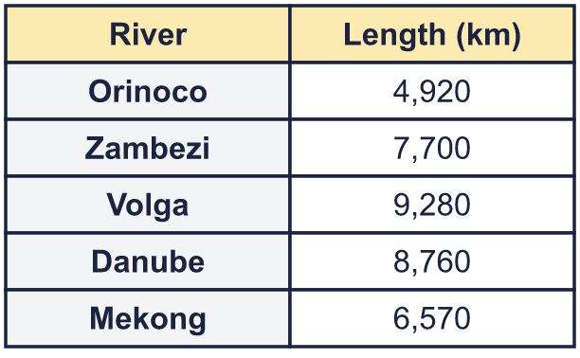  a) Write the rivers in order, shortest first.  b) Which river is the longest?
  5 | a) Write the rivers in order, shortest first.  b) Which river is the longest?
  6 | The numbers are written in different ways. Write their letters in order, smallest first.  a) 55,000  b) 51,000  c) seventy-five thousand  Answer:
  6 | The numbers are written in different ways. Write their letters in order, smallest first.  a) 55,000  b) 51,000  c) seventy-five thousand  Answer:
  7 | Work out the left side. Then write <, > or = in each box.
    a) | 700,000 + 50,000 + 20
    750,200
    b) | 999,999 + 1 |  | 1,000,000
  7 | Work out the left side. Then write <, > or = in each box.
    a) | 700,000 + 50,000 + 20
    750,200
    b) | 999,999 + 1 |  | 1,000,000
  8 | To compare 8,367,425 and 8,368,425, which column tells you which number is greater? Write the name of the column.  Column:
  8 | To compare 8,367,425 and 8,368,425, which column tells you which number is greater? Write the name of the column.  Column:

  9 | 3,007 35,507 5,962,008 617,105  Is Boba correct? Circle yes or no.  Yes / No  Explain how you know.
     | 
  9 | 3,007 35,507 5,962,008 617,105  Is Boba correct? Circle yes or no.  Yes / No  Explain how you know.
  10 | Write four numbers that could go in the middle, in order.
     | 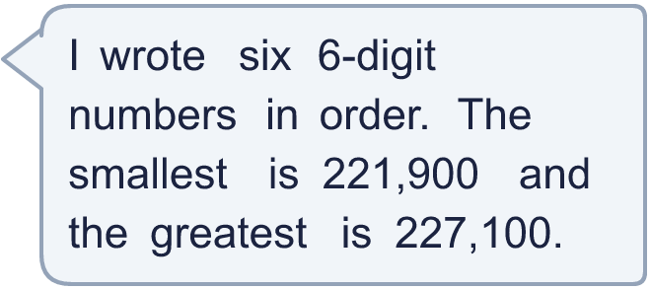
  10 | Write four numbers that could go in the middle, in order.
  11 | Look at the two place value charts.  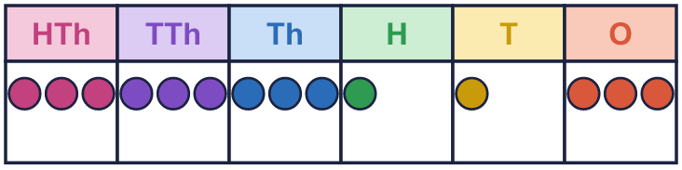  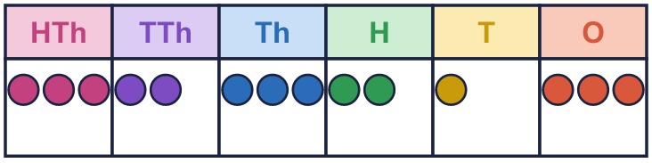  a) Which chart shows the greater number? Write A or B.  b) How much greater is it?
  11 | Look at the two place value charts.  a) Which chart shows the greater number? Write A or B.  b) How much greater is it?
  12 | 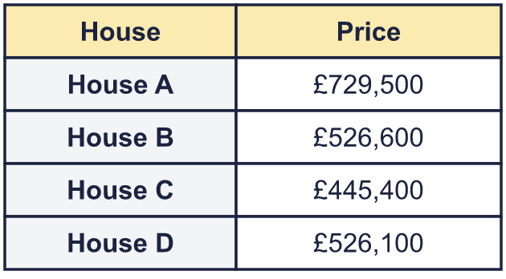  a) Write the houses in order, most expensive first.  b) How much more is the most expensive house than the cheapest?
     | 
  12 | a) Write the houses in order, most expensive first.  b) How much more is the most expensive house than the cheapest?
  13 | 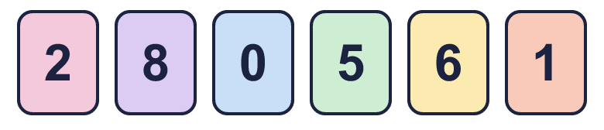  a) Make the smallest number.  b) Make the greatest number.  c) Make the number closest to 500,000.
    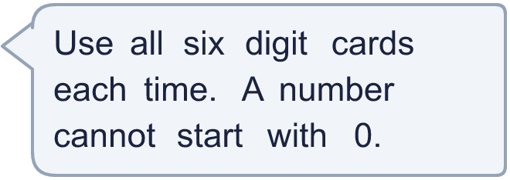
  13 | a) Make the smallest number.  b) Make the greatest number.  c) Make the number closest to 500,000.
  14 | A digit moves one column to the left. What happens to its value? Use an example.
  14 | A digit moves one column to the left. What happens to its value? Use an example.

Year 6 · Place value · Step 6
Comparing and ordering integers
Answers (teacher copy)

  1 | Write the number shown in each place value chart. Then write <, > or = to compare them.  Chart A  Chart B  A = 12,542 B = 12,442  A > B
  2 | Write <, > or = in each box.  a) 58,320 > 5,832  b) 582,305 < 582,350  c) 583,200 > 583,199
  3 | Write a digit in each box to make the statement correct. There may be more than one answer.  a) 3 6, 7, 8, 9 4 > 359  b) 51, 0, 1, 2, 3, 4, 5, 6 83 < 51,685  c) 6, 7, 8, 9 ,355 > 6,354
  4 | Write the numbers in order.  a) smallest first: 86,430 86,340 8,634 8,643  8,634, 8,643, 86,340, 86,430  b) largest first: 864,300 86,430 3,468 8,643  864,300, 86,430, 8,643, 3,468
  5 | a) Write the rivers in order, shortest first. Orinoco, Mekong, Zambezi, Danube, Volga  b) Which river is the longest? Volga
  6 | The numbers are written in different ways. Write their letters in order, smallest first.  a) 55,000  b) 51,000  c) seventy-five thousand  Answer: b, a, c
  7 | Work out the left side. Then write <, > or = in each box.  a) 700,000 + 50,000 + 20 < 750,200  b) 999,999 + 1 = 1,000,000
  8 | To compare 8,367,425 and 8,368,425, which column tells you which number is greater? Write the name of the column.  Column: thousands
  9 | 3,007 35,507 5,962,008 617,105  Is Boba correct? Circle yes or no.  Yes / No  Explain how you know.  5,962,008 is bigger than 617,105, so it should come after it. The numbers should be: 3,007, 35,507, 617,105, 5,962,008.
  10 | Write four numbers that could go in the middle, in order.  Any four numbers between 221,900 and 227,100 in order, for example 222,940, 223,980, 225,020, 226,060
  11 | Look at the two place value charts.  a) Which chart shows the greater number? Write A or B. A  b) How much greater is it? 9,900
  12 | a) Write the houses in order, most expensive first. House A, House B, House D, House C  b) How much more is the most expensive house than the cheapest? £284,100
  13 | a) Make the smallest number. 102,568  b) Make the greatest number. 865,210  c) Make the number closest to 500,000. 501,268
  14 | A digit moves one column to the left. What happens to its value? Use an example.  Its value becomes 10 times bigger. For example, the 8 in 8,000 is worth 8,000. When it moves one column to the left it is worth 80,000.

