Place value chart to help you:  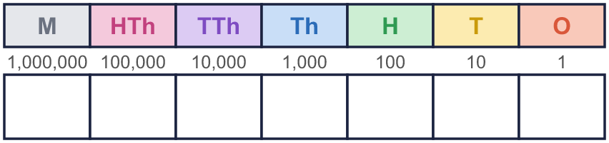 |  | Place value chart to help you:
  Year 6 · Place value · Step 6  Comparing and ordering integers | 
  Year 6 · Place value · Step 6
  Comparing and ordering integers
  1 | Write the number shown in each place value chart. Then write <, > or = to compare them.  Chart A  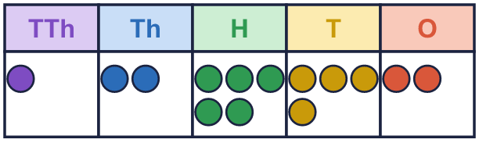  Chart B  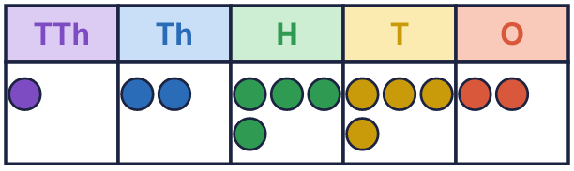  Hint: Read each chart. Then compare from the left: the biggest column first.  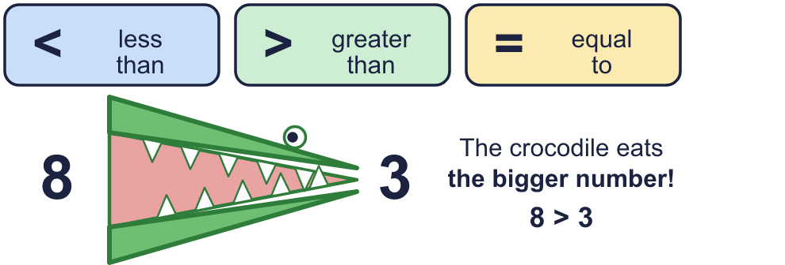
    A |  | B
  1 | Write the number shown in each place value chart. Then write <, > or = to compare them.  Chart A  Chart B  Hint: Read each chart. Then compare from the left: the biggest column first.
    A |  | B
  2 | Write <, > or = in each box.  Hint: Compare from the LEFT: the biggest column first. A number with more digits is bigger.
    a) | 58,320 |  | 5,832
    b) | 582,305 |  | 582,350
    c) | 583,200 |  | 583,199
  2 | Write <, > or = in each box.  Hint: Compare from the LEFT: the biggest column first. A number with more digits is bigger.
    a) | 58,320 |  | 5,832
    b) | 582,305 |  | 582,350
    c) | 583,200 |  | 583,199
  3 | Write a digit in each box to make the statement correct. There may be more than one answer.  Hint: Try each digit from 0 to 9, or think: which digits make this number bigger (or smaller) than the other one?
    a) | 3 |  | 4 | > | 359
    b) | 51, |  | 83 | < | 51,685
    c) |  | ,355 | > | 6,354
  3 | Write a digit in each box to make the statement correct. There may be more than one answer.  Hint: Try each digit from 0 to 9, or think: which digits make this number bigger (or smaller) than the other one?
    a) | 3 |  | 4 | > | 359
    b) | 51, |  | 83 | < | 51,685
    c) |  | ,355 | > | 6,354
  4 | Write the numbers in order.  a) smallest first: 86,430 86,340 8,634 8,643  b) largest first: 864,300 86,430 3,468 8,643  Hint: First sort by the number of digits. Then compare the ones with the same length from the left.
  4 | Write the numbers in order.  a) smallest first: 86,430 86,340 8,634 8,643  b) largest first: 864,300 86,430 3,468 8,643  Hint: First sort by the number of digits. Then compare the ones with the same length from the left.
  5 | 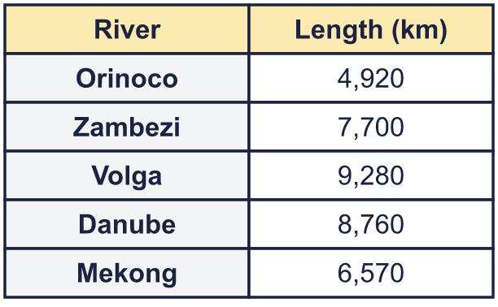  a) Write the rivers in order, shortest first.  b) Which river is the longest?  Hint: Compare the lengths from the left: the thousands first.
  5 | a) Write the rivers in order, shortest first.  b) Which river is the longest?  Hint: Compare the lengths from the left: the thousands first.
  6 | The numbers are written in different ways. Write their letters in order, smallest first.  a) 55,000  b) 51,000  c) seventy-five thousand  Answer:  Hint: Write every number in digits first. Then compare.
  6 | The numbers are written in different ways. Write their letters in order, smallest first.  a) 55,000  b) 51,000  c) seventy-five thousand  Answer:  Hint: Write every number in digits first. Then compare.
  7 | Work out the left side. Then write <, > or = in each box.  Hint: Compare from the LEFT: the biggest column first. A number with more digits is bigger. Add up the left side first.
    a) | 700,000 + 50,000 + 20
    750,200
    b) | 999,999 + 1 |  | 1,000,000
  7 | Work out the left side. Then write <, > or = in each box.  Hint: Compare from the LEFT: the biggest column first. A number with more digits is bigger. Add up the left side first.
    a) | 700,000 + 50,000 + 20
    750,200
    b) | 999,999 + 1 |  | 1,000,000
  8 | To compare 8,367,425 and 8,368,425, which column tells you which number is greater? Write the name of the column.  Column:  Hint: Start on the left. Look at the digits in the same column. The first column where they are different decides.
  8 | To compare 8,367,425 and 8,368,425, which column tells you which number is greater? Write the name of the column.  Column:  Hint: Start on the left. Look at the digits in the same column. The first column where they are different decides.

  9 | 3,007 35,507 5,962,008 617,105  Is Boba correct? Circle yes or no.  Yes / No  Explain how you know.  Hint: Check each pair of neighbours. Is the second always bigger than the first?
     | 
  9 | 3,007 35,507 5,962,008 617,105  Is Boba correct? Circle yes or no.  Yes / No  Explain how you know.  Hint: Check each pair of neighbours. Is the second always bigger than the first?
  10 | Write four numbers that could go in the middle, in order.  Hint: The numbers must be bigger than 221,900 and smaller than 227,100, and each one bigger than the one before.
     | 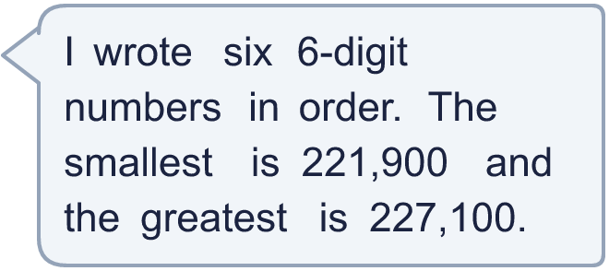
  10 | Write four numbers that could go in the middle, in order.  Hint: The numbers must be bigger than 221,900 and smaller than 227,100, and each one bigger than the one before.
  11 | Look at the two place value charts.  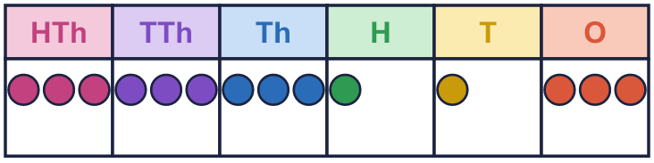  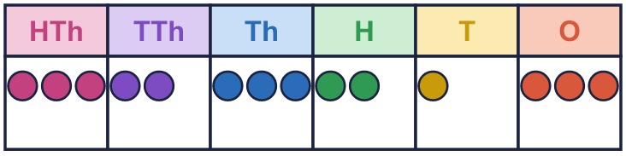  a) Which chart shows the greater number? Write A or B.  b) How much greater is it?  Hint: Write each number in digits first. For b), take the smaller away from the greater.
  11 | Look at the two place value charts.  a) Which chart shows the greater number? Write A or B.  b) How much greater is it?  Hint: Write each number in digits first. For b), take the smaller away from the greater.
  12 | 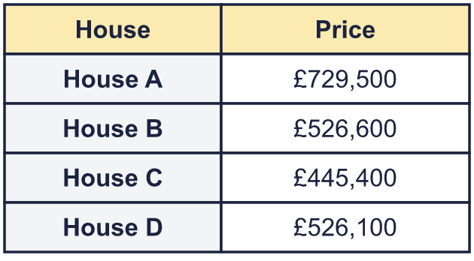  a) Write the houses in order, most expensive first.  b) How much more is the most expensive house than the cheapest?  Hint: a) Compare from the left. b) Take the cheapest price away from the dearest.
     | 
  12 | a) Write the houses in order, most expensive first.  b) How much more is the most expensive house than the cheapest?  Hint: a) Compare from the left. b) Take the cheapest price away from the dearest.
  13 | 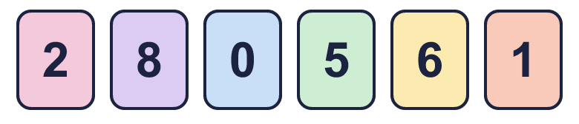  a) Make the smallest number.  b) Make the greatest number.  c) Make the number closest to 500,000.  Hint: a) Smallest digit first (not 0). b) Greatest digit first. c) Start with the digit closest to 5.
    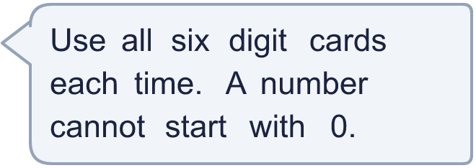
  13 | a) Make the smallest number.  b) Make the greatest number.  c) Make the number closest to 500,000.  Hint: a) Smallest digit first (not 0). b) Greatest digit first. c) Start with the digit closest to 5.
  14 | A digit moves one column to the left. What happens to its value? Use an example.  Hint: Pick a digit in a number. Write it in a place value chart, then move it one column to the left.
  14 | A digit moves one column to the left. What happens to its value? Use an example.  Hint: Pick a digit in a number. Write it in a place value chart, then move it one column to the left.

Year 6 · Place value · Step 6
Comparing and ordering integers
Answers (teacher copy)

Place value chart to help you:
  1 | Write the number shown in each place value chart. Then write <, > or = to compare them.  Chart A  Chart B  A = 12,542 B = 12,442  A > B  Hint: Read each chart. Then compare from the left: the biggest column first.
  2 | Write <, > or = in each box.  a) 58,320 > 5,832  b) 582,305 < 582,350  c) 583,200 > 583,199  Hint: Compare from the LEFT: the biggest column first. A number with more digits is bigger.
  3 | Write a digit in each box to make the statement correct. There may be more than one answer.  a) 3 6, 7, 8, 9 4 > 359  b) 51, 0, 1, 2, 3, 4, 5, 6 83 < 51,685  c) 6, 7, 8, 9 ,355 > 6,354  Hint: Try each digit from 0 to 9, or think: which digits make this number bigger (or smaller) than the other one?
  4 | Write the numbers in order.  a) smallest first: 86,430 86,340 8,634 8,643  8,634, 8,643, 86,340, 86,430  b) largest first: 864,300 86,430 3,468 8,643  864,300, 86,430, 8,643, 3,468  Hint: First sort by the number of digits. Then compare the ones with the same length from the left.
  5 | a) Write the rivers in order, shortest first. Orinoco, Mekong, Zambezi, Danube, Volga  b) Which river is the longest? Volga  Hint: Compare the lengths from the left: the thousands first.
  6 | The numbers are written in different ways. Write their letters in order, smallest first.  a) 55,000  b) 51,000  c) seventy-five thousand  Answer: b, a, c  Hint: Write every number in digits first. Then compare.
  7 | Work out the left side. Then write <, > or = in each box.  a) 700,000 + 50,000 + 20 < 750,200  b) 999,999 + 1 = 1,000,000  Hint: Compare from the LEFT: the biggest column first. A number with more digits is bigger. Add up the left side first.
  8 | To compare 8,367,425 and 8,368,425, which column tells you which number is greater? Write the name of the column.  Column: thousands  Hint: Start on the left. Look at the digits in the same column. The first column where they are different decides.
  9 | 3,007 35,507 5,962,008 617,105  Is Boba correct? Circle yes or no.  Yes / No  Explain how you know.  5,962,008 is bigger than 617,105, so it should come after it. The numbers should be: 3,007, 35,507, 617,105, 5,962,008.  Hint: Check each pair of neighbours. Is the second always bigger than the first?
  10 | Write four numbers that could go in the middle, in order.  Any four numbers between 221,900 and 227,100 in order, for example 222,940, 223,980, 225,020, 226,060  Hint: The numbers must be bigger than 221,900 and smaller than 227,100, and each one bigger than the one before.
  11 | Look at the two place value charts.  a) Which chart shows the greater number? Write A or B. A  b) How much greater is it? 9,900  Hint: Write each number in digits first. For b), take the smaller away from the greater.
  12 | a) Write the houses in order, most expensive first. House A, House B, House D, House C  b) How much more is the most expensive house than the cheapest? £284,100  Hint: a) Compare from the left. b) Take the cheapest price away from the dearest.
  13 | a) Make the smallest number. 102,568  b) Make the greatest number. 865,210  c) Make the number closest to 500,000. 501,268  Hint: a) Smallest digit first (not 0). b) Greatest digit first. c) Start with the digit closest to 5.
  14 | A digit moves one column to the left. What happens to its value? Use an example.  Its value becomes 10 times bigger. For example, the 8 in 8,000 is worth 8,000. When it moves one column to the left it is worth 80,000.  Hint: Pick a digit in a number. Write it in a place value chart, then move it one column to the left.

