  Year 6 · Place value · Step 8  Negative numbers | 
  Year 6 · Place value · Step 8
  Negative numbers
  1 | What number is the arrow pointing to?
    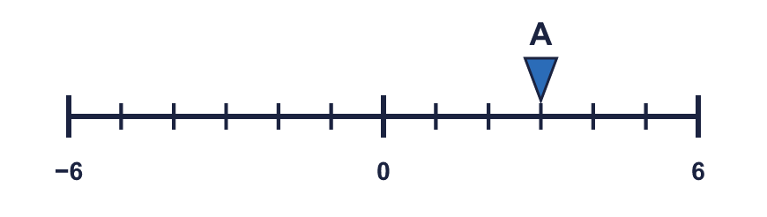
  1 | What number is the arrow pointing to?
  2 | What numbers are the arrows pointing to?  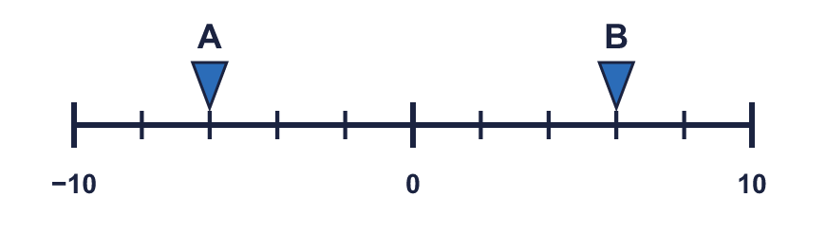
  2 | What numbers are the arrows pointing to?
  3 | Write these temperatures in order, starting with the lowest.  1°C 2°C −6°C −2°C −8°C
  3 | Write these temperatures in order, starting with the lowest.  1°C 2°C −6°C −2°C −8°C
  4 | Write < or > in each box.
    a) | −4 |  | −2
    b) | 7 |  | −4
    c) | −4 |  | −7
  4 | Write < or > in each box.
    a) | −4 |  | −2
    b) | 7 |  | −4
    c) | −4 |  | −7
  5 | Complete the sentences.  a) 7 more than −4 is  b) 7 less than 3 is  c) 2 less than −2 is
  5 | Complete the sentences.  a) 7 more than −4 is  b) 7 less than 3 is  c) 2 less than −2 is
  6 | 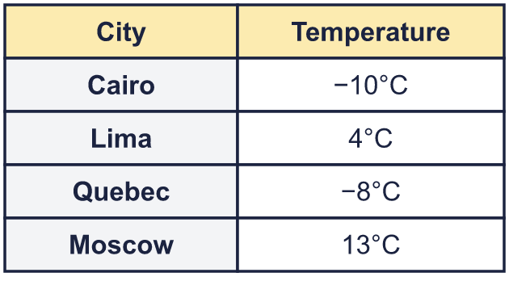  a) How many degrees colder is Cairo than Moscow?  b) The temperature in Quebec rises by 5°C. What is the new temperature?
  6 | a) How many degrees colder is Cairo than Moscow?  b) The temperature in Quebec rises by 5°C. What is the new temperature?
  7 | Work out the calculations.  a) −4 + 5 =  b) 3 − 6 =  c) −3 − 5 =
  7 | Work out the calculations.  a) −4 + 5 =  b) 3 − 6 =  c) −3 − 5 =
  8 | Work out the new temperature or depth.  a) At 6 am it was −5°C. By noon it had risen by 10°C. What was the temperature at noon?  b) A diver is 12 m below sea level (−12 m). She swims up 4 m. Where is she now?
  8 | Work out the new temperature or depth.  a) At 6 am it was −5°C. By noon it had risen by 10°C. What was the temperature at noon?  b) A diver is 12 m below sea level (−12 m). She swims up 4 m. Where is she now?

  9 | 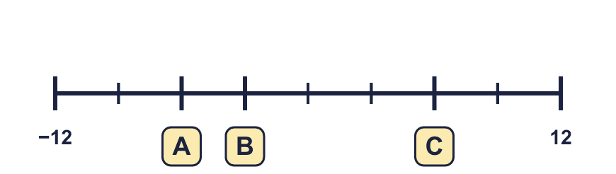
     | 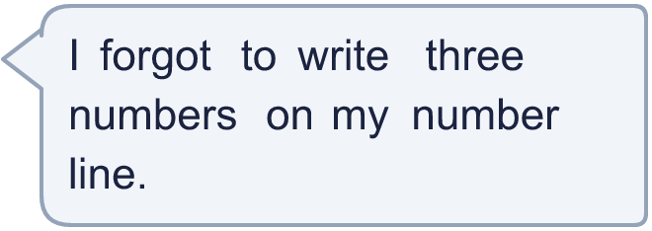
  9
  10 | Is Boba correct? Circle yes or no.  Yes / No  Explain how you know.
     | 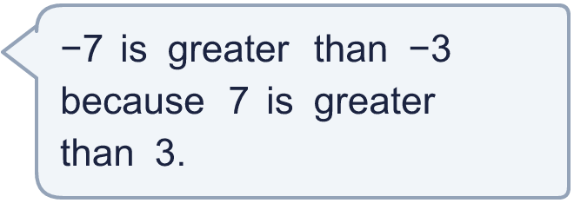
  10 | Is Boba correct? Circle yes or no.  Yes / No  Explain how you know.
  11 | 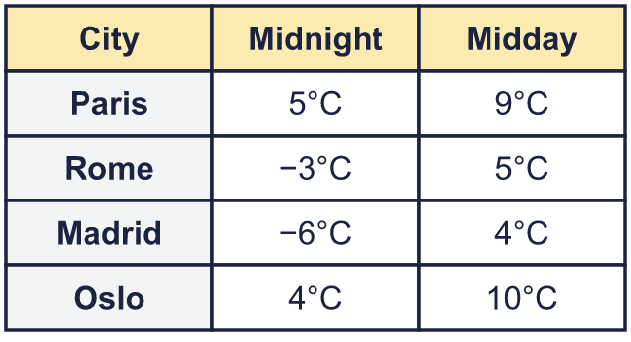  a) At midnight, how many degrees warmer was Paris than Madrid?  b) Which city was 6 degrees colder at midnight than at midday?
     | 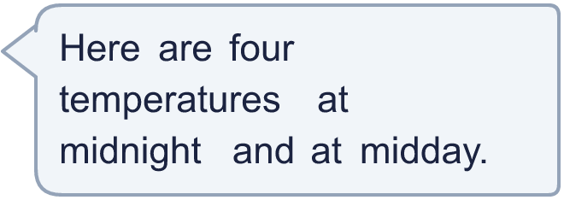
  11 | a) At midnight, how many degrees warmer was Paris than Madrid?  b) Which city was 6 degrees colder at midnight than at midday?
  12 | Each number is 4 less than the one before. Complete the pattern.
    12 | , | 8 | , | 4 | , |  | , |  | ,
  12 | Each number is 4 less than the one before. Complete the pattern.
    12 | , | 8 | , | 4 | , |  | , |  | ,
  13 | a) A kitchen is 23°C and a freezer is −16°C. What is the difference?  b) A tower top is 29 m above sea level and a cave floor is 58 m below it. How far is it from the top to the floor?
    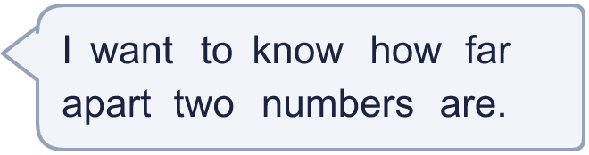
  13 | a) A kitchen is 23°C and a freezer is −16°C. What is the difference?  b) A tower top is 29 m above sea level and a cave floor is 58 m below it. How far is it from the top to the floor?
  14 | Write three different whole numbers that are greater than −7 and smaller than −2.
  14 | Write three different whole numbers that are greater than −7 and smaller than −2.

Year 6 · Place value · Step 8
Negative numbers
Answers (teacher copy)

  1 | What number is the arrow pointing to?
    3
  2 | What numbers are the arrows pointing to?  A = −6 B = 6
  3 | Write these temperatures in order, starting with the lowest.  1°C 2°C −6°C −2°C −8°C  −8°C, −6°C, −2°C, 1°C, 2°C
  4 | Write < or > in each box.  a) −4 < −2  b) 7 > −4  c) −4 > −7
  5 | Complete the sentences.  a) 7 more than −4 is 3  b) 7 less than 3 is −4  c) 2 less than −2 is −4
  6 | a) How many degrees colder is Cairo than Moscow? 23  b) The temperature in Quebec rises by 5°C. What is the new temperature? −3°C
  7 | Work out the calculations.  a) −4 + 5 = 1  b) 3 − 6 = −3  c) −3 − 5 = −8
  8 | Work out the new temperature or depth.  a) At 6 am it was −5°C. By noon it had risen by 10°C. What was the temperature at noon? 5°C  b) A diver is 12 m below sea level (−12 m). She swims up 4 m. Where is she now? −8 m
  9 | A = −6 B = −3 C = 6
  10 | Is Boba correct? Circle yes or no.  Yes / No  Explain how you know.  −3 is to the right of −7 on the number line, so −3 is greater. A negative number with a bigger digit is further below zero, so it is smaller.
  11 | a) At midnight, how many degrees warmer was Paris than Madrid? 11  b) Which city was 6 degrees colder at midnight than at midday? Oslo
  12 | Each number is 4 less than the one before. Complete the pattern.  12 , 8 , 4 , 0 , −4 , −8
  13 | a) A kitchen is 23°C and a freezer is −16°C. What is the difference? 39°C  b) A tower top is 29 m above sea level and a cave floor is 58 m below it. How far is it from the top to the floor? 87 m
  14 | Write three different whole numbers that are greater than −7 and smaller than −2.  Any three whole numbers between −7 and −2, for example −6, −5, −3

