A number line to help you:  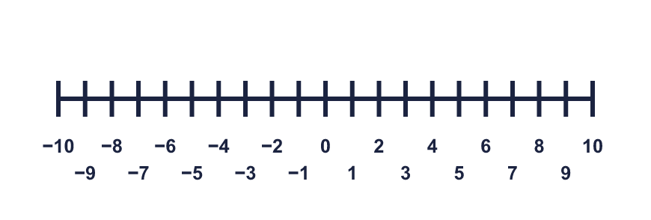 |  | A number line to help you:
  Year 6 · Place value · Step 8  Negative numbers | 
  Year 6 · Place value · Step 8
  Negative numbers
  1 | What number is the arrow pointing to?  Hint: Right (up) means more or warmer. Left (down) means less or colder. Find 0 first. Count the steps to the arrow.  Every mark is labelled:  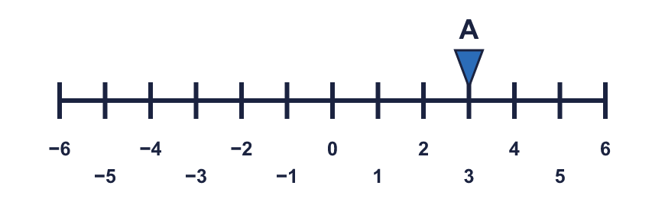
    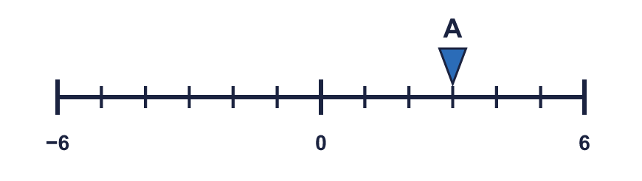
  1 | What number is the arrow pointing to?  Hint: Right (up) means more or warmer. Left (down) means less or colder. Find 0 first. Count the steps to the arrow.  Every mark is labelled:
  2 | What numbers are the arrows pointing to?  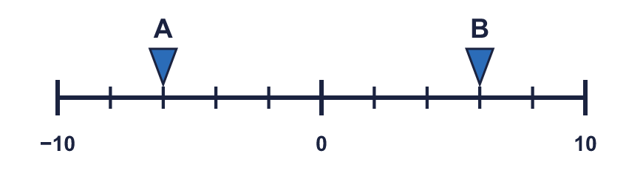  Hint: This line goes up in 2s: 0, 2, 4... or −2, −4... Count the steps from 0.  Every mark is labelled:  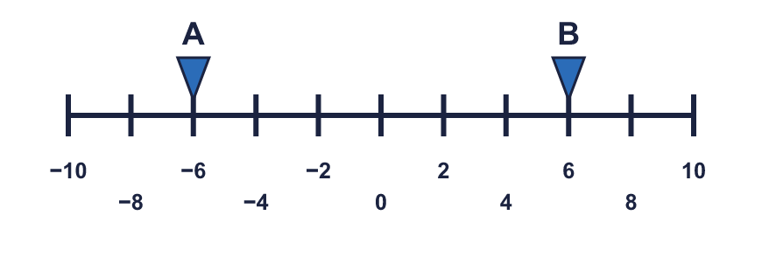
  2 | What numbers are the arrows pointing to?  Hint: This line goes up in 2s: 0, 2, 4... or −2, −4... Count the steps from 0.  Every mark is labelled:
  3 | Write these temperatures in order, starting with the lowest.  1°C 2°C −6°C −2°C −8°C  Hint: The lowest is the coldest. Any negative number is lower than 0. Of two negatives, the one with the BIGGER digit is lower: −9 is lower than −2.  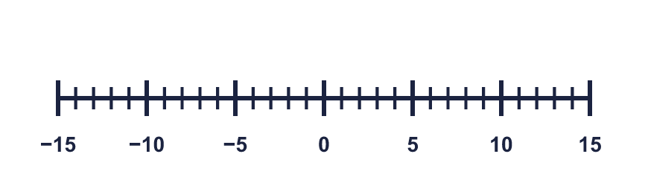
  3 | Write these temperatures in order, starting with the lowest.  1°C 2°C −6°C −2°C −8°C  Hint: The lowest is the coldest. Any negative number is lower than 0. Of two negatives, the one with the BIGGER digit is lower: −9 is lower than −2.
  4 | Write < or > in each box.  Hint: Right (up) means more or warmer. Left (down) means less or colder.  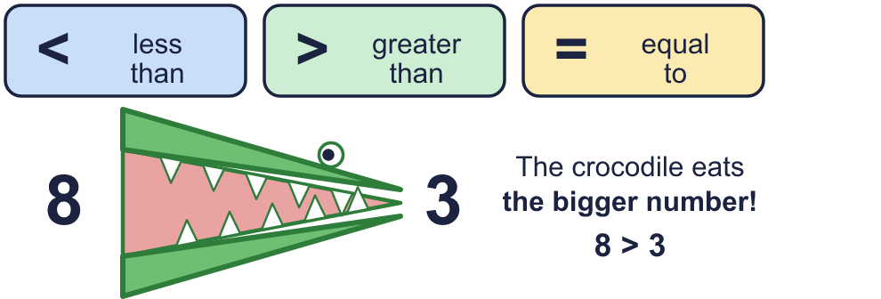
    a) | −4 |  | −2
    b) | 7 |  | −4
    c) | −4 |  | −7
  4 | Write < or > in each box.  Hint: Right (up) means more or warmer. Left (down) means less or colder.
    a) | −4 |  | −2
    b) | 7 |  | −4
    c) | −4 |  | −7
  5 | Complete the sentences.  a) 7 more than −4 is  b) 7 less than 3 is  c) 2 less than −2 is  Hint: Right (up) means more or warmer. Left (down) means less or colder. Start at the number, then jump right for “more” or left for “less”.  Use this number line:
  5 | Complete the sentences.  a) 7 more than −4 is  b) 7 less than 3 is  c) 2 less than −2 is  Hint: Right (up) means more or warmer. Left (down) means less or colder. Start at the number, then jump right for “more” or left for “less”.  Use this number line:
  6 | 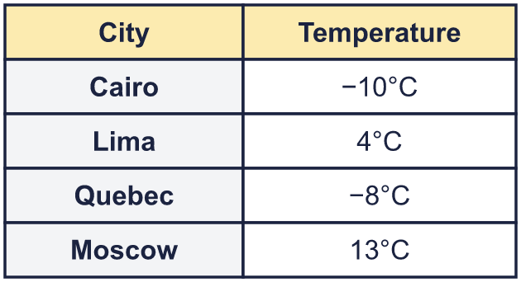  a) How many degrees colder is Cairo than Moscow?  b) The temperature in Quebec rises by 5°C. What is the new temperature?  Hint: a) Count the jump from the colder to the warmer, across 0. b) Start at the temperature and jump right.
  6 | a) How many degrees colder is Cairo than Moscow?  b) The temperature in Quebec rises by 5°C. What is the new temperature?  Hint: a) Count the jump from the colder to the warmer, across 0. b) Start at the temperature and jump right.
  7 | Work out the calculations.  a) −4 + 5 =  b) 3 − 6 =  c) −3 − 5 =  Hint: Adding means jump right. Taking away means jump left. Start at the first number.
  7 | Work out the calculations.  a) −4 + 5 =  b) 3 − 6 =  c) −3 − 5 =  Hint: Adding means jump right. Taking away means jump left. Start at the first number.
  8 | Work out the new temperature or depth.  a) At 6 am it was −5°C. By noon it had risen by 10°C. What was the temperature at noon?  b) A diver is 12 m below sea level (−12 m). She swims up 4 m. Where is she now?  Hint: Draw a quick number line. Start at the number and jump.
  8 | Work out the new temperature or depth.  a) At 6 am it was −5°C. By noon it had risen by 10°C. What was the temperature at noon?  b) A diver is 12 m below sea level (−12 m). She swims up 4 m. Where is she now?  Hint: Draw a quick number line. Start at the number and jump.

  9 | 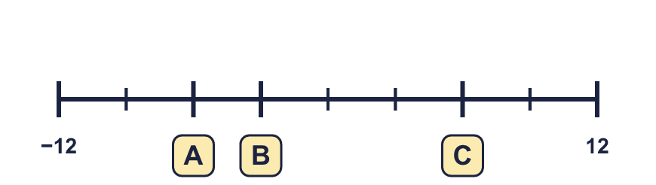  Hint: Each step is worth (end − start) ÷ number of steps = 24 ÷ 8 = 3. Count the steps from the start.  Count the 8 steps:  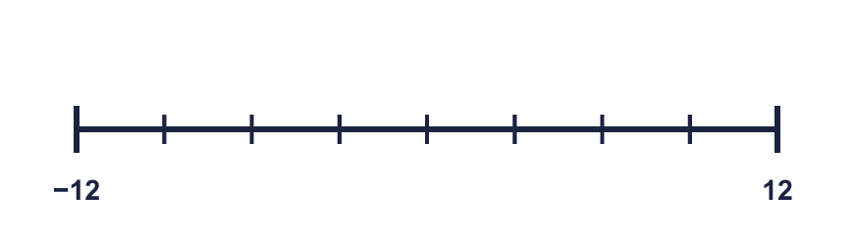
     | 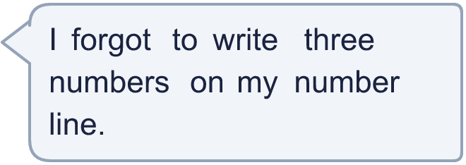
  9 | Hint: Each step is worth (end − start) ÷ number of steps = 24 ÷ 8 = 3. Count the steps from the start.  Count the 8 steps:
  10 | Is Boba correct? Circle yes or no.  Yes / No  Explain how you know.  Hint: Mark both numbers on a number line. Which one is further to the right?
     | 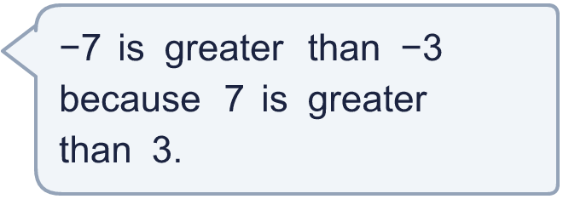
  10 | Is Boba correct? Circle yes or no.  Yes / No  Explain how you know.  Hint: Mark both numbers on a number line. Which one is further to the right?
  11 | 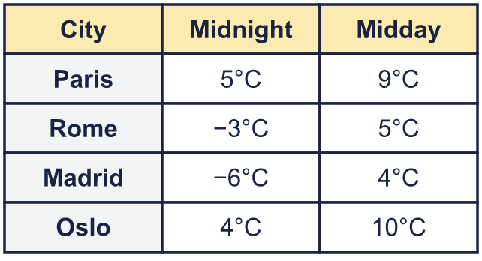  a) At midnight, how many degrees warmer was Paris than Madrid?  b) Which city was 6 degrees colder at midnight than at midday?  Hint: a) Take the colder midnight temperature away from the warmer one: count across 0. b) For each city, find the difference between midnight and midday.
     | 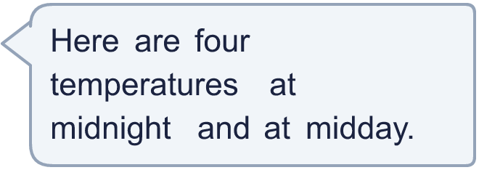
  11 | a) At midnight, how many degrees warmer was Paris than Madrid?  b) Which city was 6 degrees colder at midnight than at midday?  Hint: a) Take the colder midnight temperature away from the warmer one: count across 0. b) For each city, find the difference between midnight and midday.
  12 | Each number is 4 less than the one before. Complete the pattern.  Hint: Take 4 away each time. When you go past 0, the numbers become negative.
    12 | , | 8 | , | 4 | , |  | , |  | ,
  12 | Each number is 4 less than the one before. Complete the pattern.  Hint: Take 4 away each time. When you go past 0, the numbers become negative.
    12 | , | 8 | , | 4 | , |  | , |  | ,
  13 | a) A kitchen is 23°C and a freezer is −16°C. What is the difference?  b) A tower top is 29 m above sea level and a cave floor is 58 m below it. How far is it from the top to the floor?  Hint: Count from the lower number up to 0, then from 0 up to the higher number. Add the two jumps.
    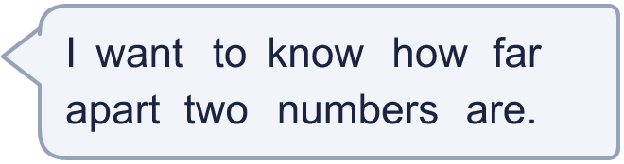
  13 | a) A kitchen is 23°C and a freezer is −16°C. What is the difference?  b) A tower top is 29 m above sea level and a cave floor is 58 m below it. How far is it from the top to the floor?  Hint: Count from the lower number up to 0, then from 0 up to the higher number. Add the two jumps.
  14 | Write three different whole numbers that are greater than −7 and smaller than −2.  Hint: Put −7 and −2 on a number line. Which whole numbers are between them?
  14 | Write three different whole numbers that are greater than −7 and smaller than −2.  Hint: Put −7 and −2 on a number line. Which whole numbers are between them?

Year 6 · Place value · Step 8
Negative numbers
Answers (teacher copy)

A number line to help you:
  1 | What number is the arrow pointing to?  Hint: Right (up) means more or warmer. Left (down) means less or colder. Find 0 first. Count the steps to the arrow.  Every mark is labelled:
    3
  2 | What numbers are the arrows pointing to?  A = −6 B = 6  Hint: This line goes up in 2s: 0, 2, 4... or −2, −4... Count the steps from 0.  Every mark is labelled:
  3 | Write these temperatures in order, starting with the lowest.  1°C 2°C −6°C −2°C −8°C  −8°C, −6°C, −2°C, 1°C, 2°C  Hint: The lowest is the coldest. Any negative number is lower than 0. Of two negatives, the one with the BIGGER digit is lower: −9 is lower than −2.
  4 | Write < or > in each box.  a) −4 < −2  b) 7 > −4  c) −4 > −7  Hint: Right (up) means more or warmer. Left (down) means less or colder.
  5 | Complete the sentences.  a) 7 more than −4 is 3  b) 7 less than 3 is −4  c) 2 less than −2 is −4  Hint: Right (up) means more or warmer. Left (down) means less or colder. Start at the number, then jump right for “more” or left for “less”.  Use this number line:
  6 | a) How many degrees colder is Cairo than Moscow? 23  b) The temperature in Quebec rises by 5°C. What is the new temperature? −3°C  Hint: a) Count the jump from the colder to the warmer, across 0. b) Start at the temperature and jump right.
  7 | Work out the calculations.  a) −4 + 5 = 1  b) 3 − 6 = −3  c) −3 − 5 = −8  Hint: Adding means jump right. Taking away means jump left. Start at the first number.
  8 | Work out the new temperature or depth.  a) At 6 am it was −5°C. By noon it had risen by 10°C. What was the temperature at noon? 5°C  b) A diver is 12 m below sea level (−12 m). She swims up 4 m. Where is she now? −8 m  Hint: Draw a quick number line. Start at the number and jump.
  9 | A = −6 B = −3 C = 6  Hint: Each step is worth (end − start) ÷ number of steps = 24 ÷ 8 = 3. Count the steps from the start.  Count the 8 steps:
  10 | Is Boba correct? Circle yes or no.  Yes / No  Explain how you know.  −3 is to the right of −7 on the number line, so −3 is greater. A negative number with a bigger digit is further below zero, so it is smaller.  Hint: Mark both numbers on a number line. Which one is further to the right?
  11 | a) At midnight, how many degrees warmer was Paris than Madrid? 11  b) Which city was 6 degrees colder at midnight than at midday? Oslo  Hint: a) Take the colder midnight temperature away from the warmer one: count across 0. b) For each city, find the difference between midnight and midday.
  12 | Each number is 4 less than the one before. Complete the pattern.  12 , 8 , 4 , 0 , −4 , −8  Hint: Take 4 away each time. When you go past 0, the numbers become negative.
  13 | a) A kitchen is 23°C and a freezer is −16°C. What is the difference? 39°C  b) A tower top is 29 m above sea level and a cave floor is 58 m below it. How far is it from the top to the floor? 87 m  Hint: Count from the lower number up to 0, then from 0 up to the higher number. Add the two jumps.
  14 | Write three different whole numbers that are greater than −7 and smaller than −2.  Any three whole numbers between −7 and −2, for example −6, −5, −3  Hint: Put −7 and −2 on a number line. Which whole numbers are between them?

