  Year 6 · Place value · Step 5  Number lines up to 10,000,000 | 
  Year 6 · Place value · Step 5
  Number lines up to 10,000,000
  1 | What number is the arrow pointing to?
    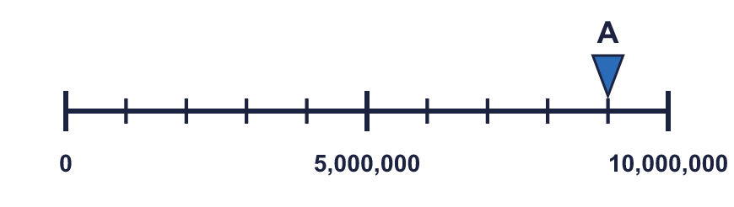
  1 | What number is the arrow pointing to?
  2 | What number is the arrow pointing to?
    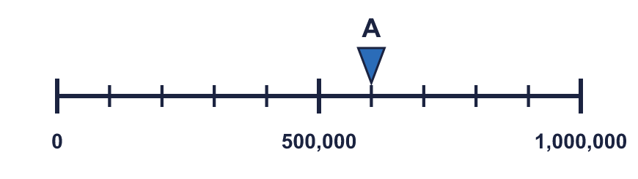
  2 | What number is the arrow pointing to?
  3 | What numbers are the arrows pointing to?  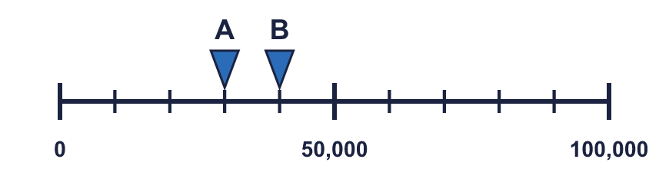
  3 | What numbers are the arrows pointing to?
  4 | Which arrow points to 6,000,000? Write its letter.  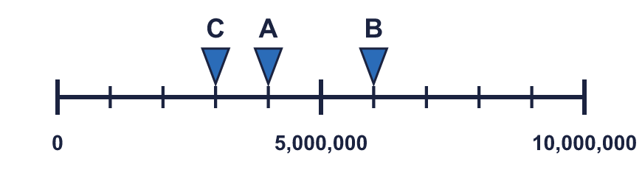  Answer:
  4 | Which arrow points to 6,000,000? Write its letter.  Answer:
  5 | Look at the number line.  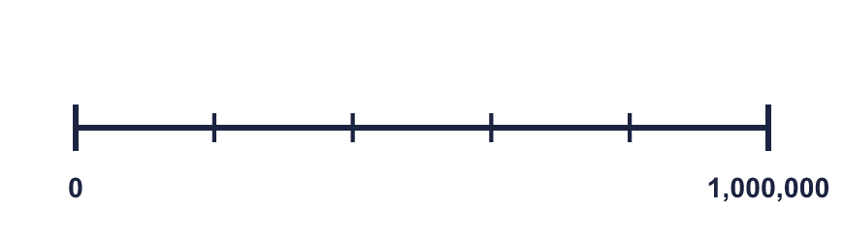  The difference between the start and the end is  The line counts up in
    There are |  | equal intervals.
  5 | Look at the number line.  The difference between the start and the end is  The line counts up in
    There are |  | equal intervals.
  6 | Write the missing numbers on the line.  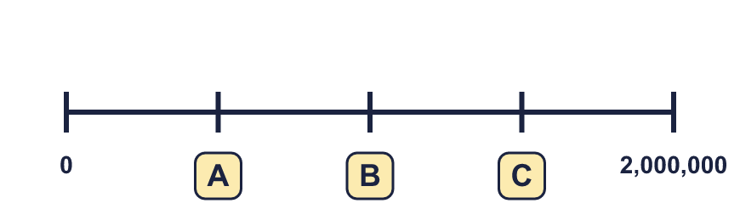
  6 | Write the missing numbers on the line.
  7 | What number is the arrow pointing to?
    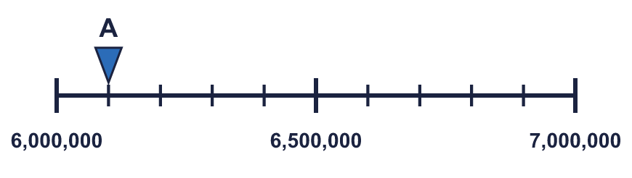
  7 | What number is the arrow pointing to?
  8 | The arrow is between two marks. Which number is it closest to? Write the letter.  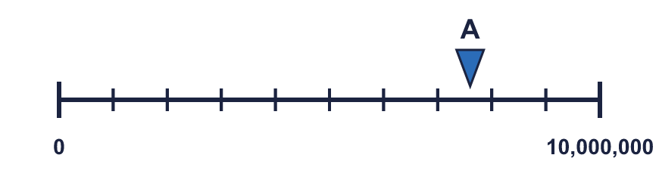  a) 7,500,000  b) 9,000,000  c) 5,500,000  Answer:
  8 | The arrow is between two marks. Which number is it closest to? Write the letter.  a) 7,500,000  b) 9,000,000  c) 5,500,000  Answer:

  9 | 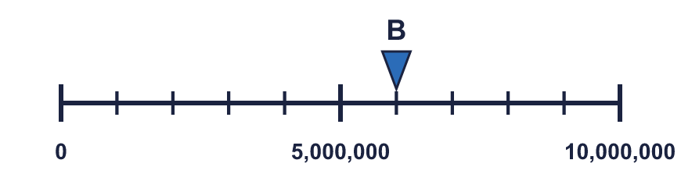  Is Boba correct? Circle yes or no.  Yes / No  Explain how you know.
    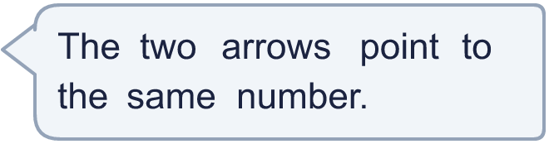
  9 | Is Boba correct? Circle yes or no.  Yes / No  Explain how you know.
  10 | 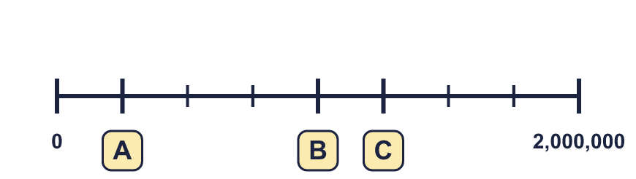
     | 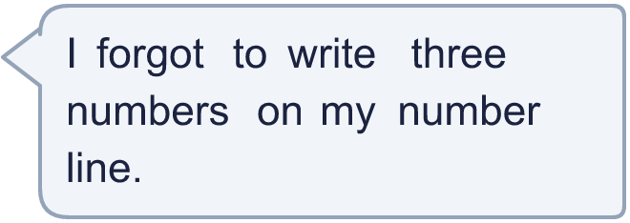
  10
  11 | 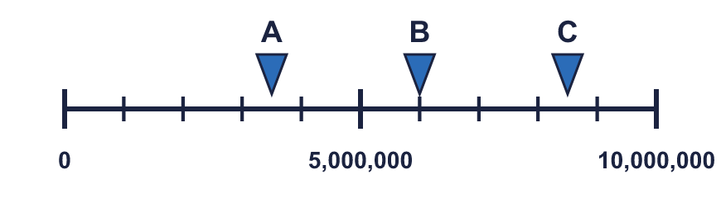  a) What number is arrow A pointing to?  b) What is the difference between B and C?
     | 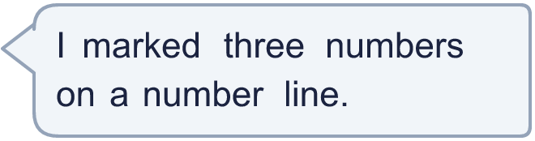
  11 | a) What number is arrow A pointing to?  b) What is the difference between B and C?
  12 | What numbers are the arrows pointing to?  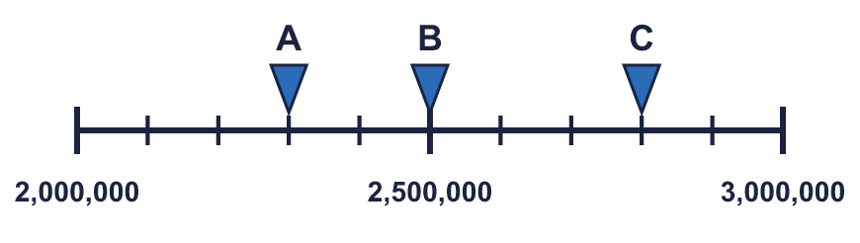
  12 | What numbers are the arrows pointing to?
  13 | 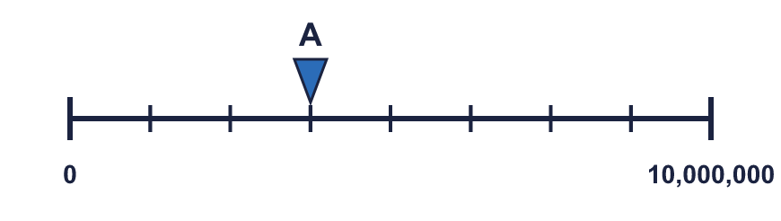  a) What is each step worth?  b) What number is arrow A pointing to?
     | 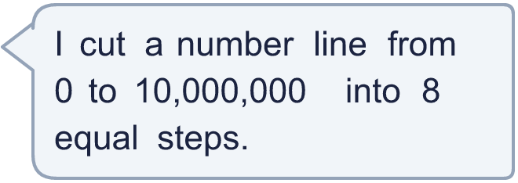
  13 | a) What is each step worth?  b) What number is arrow A pointing to?
  14 | The arrow is exactly halfway along the number line. It points to 6,000,000. Write two different pairs of numbers that the start and end of the line could be.  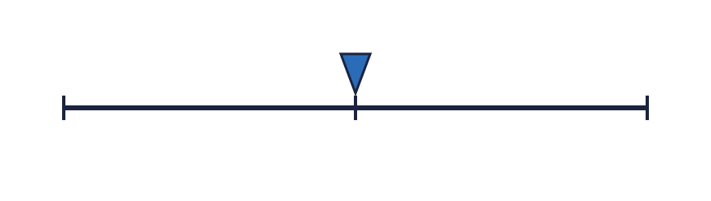
  14 | The arrow is exactly halfway along the number line. It points to 6,000,000. Write two different pairs of numbers that the start and end of the line could be.

Year 6 · Place value · Step 5
Number lines up to 10,000,000
Answers (teacher copy)

  1 | What number is the arrow pointing to?
    9,000,000
  2 | What number is the arrow pointing to?
    600,000
  3 | What numbers are the arrows pointing to?  A = 30,000 B = 40,000
  4 | Which arrow points to 6,000,000? Write its letter.  Answer: B
  5 | Look at the number line.  The difference between the start and the end is 1,000,000  There are 5 equal intervals.  The line counts up in 200,000
  6 | Write the missing numbers on the line.  A = 500,000 B = 1,000,000 C = 1,500,000
  7 | What number is the arrow pointing to?
    6,100,000
  8 | The arrow is between two marks. Which number is it closest to? Write the letter.  a) 7,500,000  b) 9,000,000  c) 5,500,000  Answer: a
  9 | Is Boba correct? Circle yes or no.  Yes / No  Explain how you know.  Arrow A points to 600,000 and arrow B points to 6,000,000. The lines have different scales: line A ends at 1,000,000 and line B ends at 10,000,000.
  10 | A = 250,000 B = 1,000,000 C = 1,250,000
  11 | a) What number is arrow A pointing to? 3,500,000  b) What is the difference between B and C? 2,500,000
  12 | What numbers are the arrows pointing to?  A = 2,300,000 B = 2,500,000 C = 2,800,000
  13 | a) What is each step worth? 1,250,000  b) What number is arrow A pointing to? 3,750,000
  14 | The arrow is exactly halfway along the number line. It points to 6,000,000. Write two different pairs of numbers that the start and end of the line could be.  Any pairs with 6,000,000 exactly halfway, for example 4,000,000 and 8,000,000, 5,000,000 and 7,000,000

