A number line to help you:  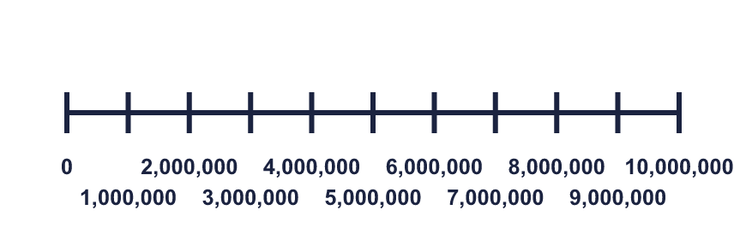 |  | A number line to help you:
  Year 6 · Place value · Step 5  Number lines up to 10,000,000 | 
  Year 6 · Place value · Step 5
  Number lines up to 10,000,000
  1 | What number is the arrow pointing to?  Hint: The line goes from 0 to 10,000,000 in 10 equal steps. Each step is 1,000,000. Count the steps to the arrow.  Every mark is labelled:  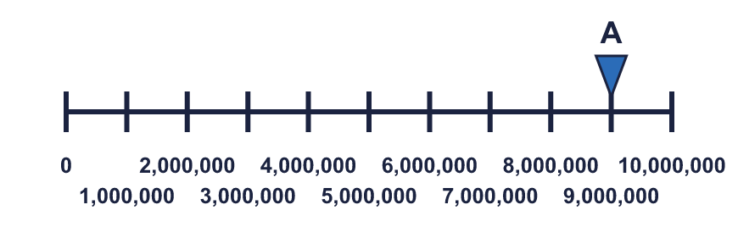
    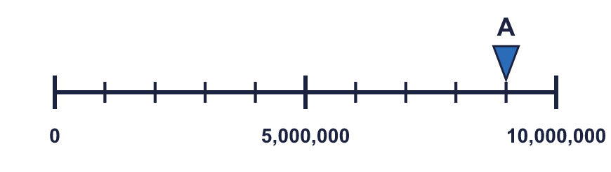
  1 | What number is the arrow pointing to?  Hint: The line goes from 0 to 10,000,000 in 10 equal steps. Each step is 1,000,000. Count the steps to the arrow.  Every mark is labelled:
  2 | What number is the arrow pointing to?  Hint: This line goes from 0 to 1,000,000 in 10 equal steps. Each step is 100,000.  Every mark is labelled:  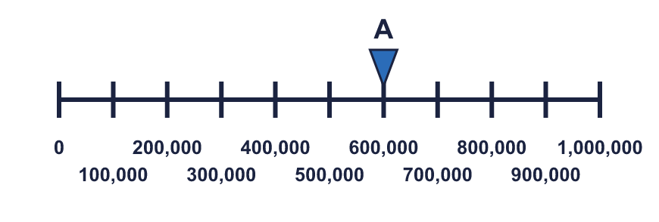
    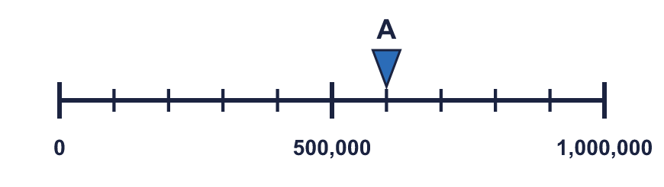
  2 | What number is the arrow pointing to?  Hint: This line goes from 0 to 1,000,000 in 10 equal steps. Each step is 100,000.  Every mark is labelled:
  3 | What numbers are the arrows pointing to?  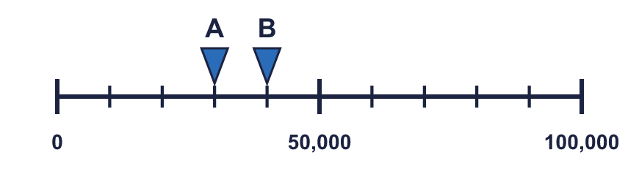  Hint: 0 to 100,000 in 10 equal steps: each step is 10,000.  Every mark is labelled:  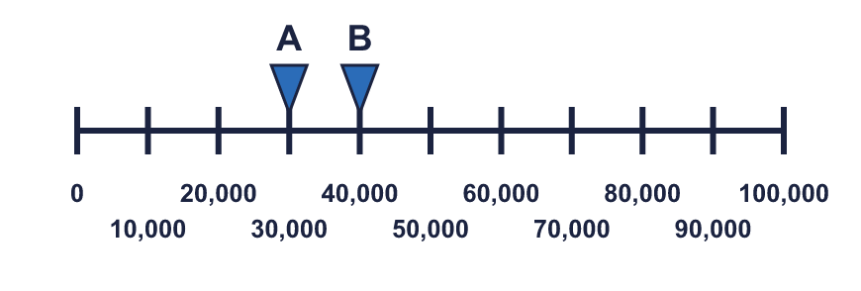
  3 | What numbers are the arrows pointing to?  Hint: 0 to 100,000 in 10 equal steps: each step is 10,000.  Every mark is labelled:
  4 | Which arrow points to 6,000,000? Write its letter.  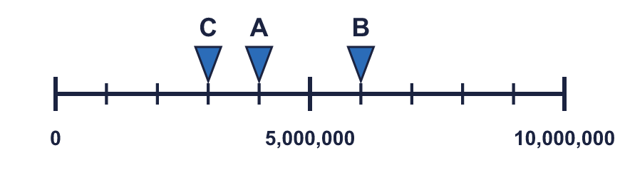  Answer:  Hint: Count the steps. One step is 1,000,000. Find the number of steps for your target first.  Every mark is labelled:  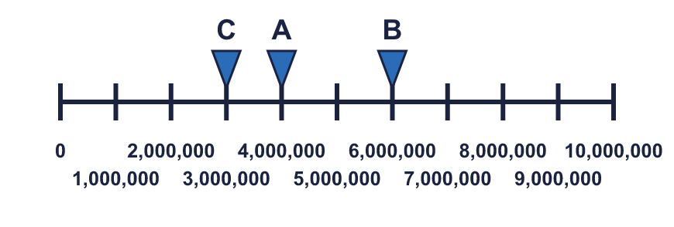
  4 | Which arrow points to 6,000,000? Write its letter.  Answer:  Hint: Count the steps. One step is 1,000,000. Find the number of steps for your target first.  Every mark is labelled:
  5 | Look at the number line.  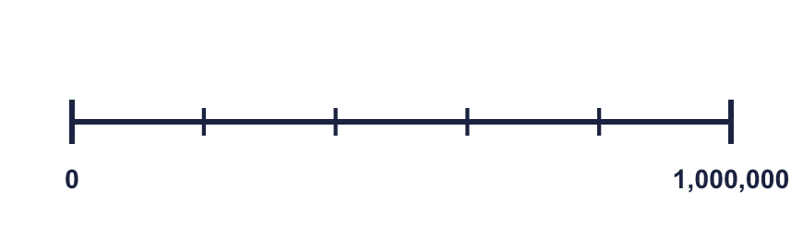  The difference between the start and the end is  The line counts up in  Hint: a) Take the start away from the end. b) Count the gaps between the marks, not the marks. c) Divide the difference by the number of gaps.  Count the gaps:
    There are |  | equal intervals.
  5 | Look at the number line.  The difference between the start and the end is  The line counts up in  Hint: a) Take the start away from the end. b) Count the gaps between the marks, not the marks. c) Divide the difference by the number of gaps.  Count the gaps:
    There are |  | equal intervals.
  6 | Write the missing numbers on the line.  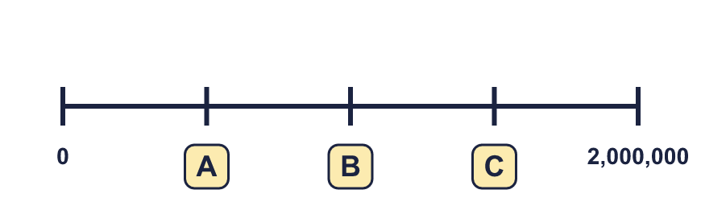  Hint: To find what each step is worth: (end − start) ÷ number of equal steps. Then add that step each time.
  6 | Write the missing numbers on the line.  Hint: To find what each step is worth: (end − start) ÷ number of equal steps. Then add that step each time.
  7 | What number is the arrow pointing to?  Hint: This line starts at 6,000,000 and ends at 7,000,000. There are 10 equal steps, so each step is 100,000.  Every mark is labelled:  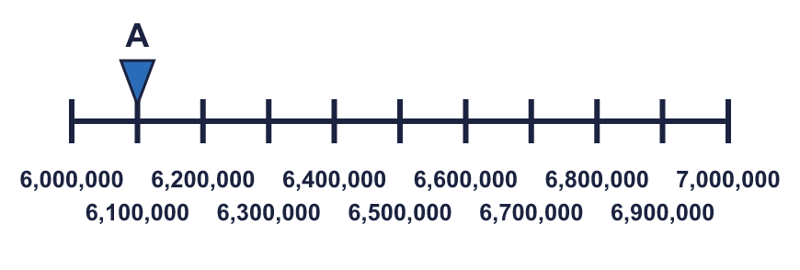
    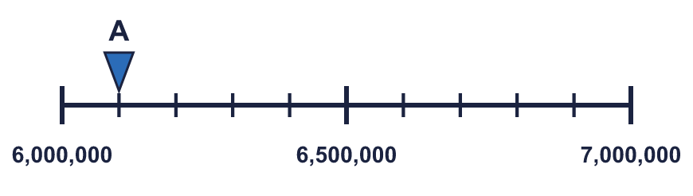
  7 | What number is the arrow pointing to?  Hint: This line starts at 6,000,000 and ends at 7,000,000. There are 10 equal steps, so each step is 100,000.  Every mark is labelled:
  8 | The arrow is between two marks. Which number is it closest to? Write the letter.  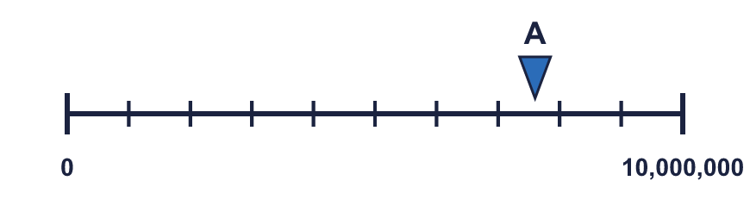  a) 7,500,000  b) 9,000,000  c) 5,500,000  Answer:  Hint: Find the two marks either side of the arrow. Is the arrow nearer the left mark or the right mark?  Every mark is labelled:  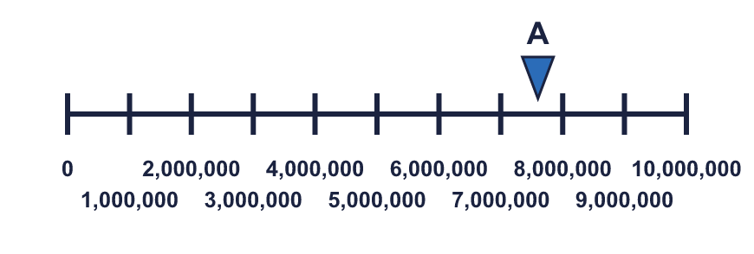
  8 | The arrow is between two marks. Which number is it closest to? Write the letter.  a) 7,500,000  b) 9,000,000  c) 5,500,000  Answer:  Hint: Find the two marks either side of the arrow. Is the arrow nearer the left mark or the right mark?  Every mark is labelled:

  9 | 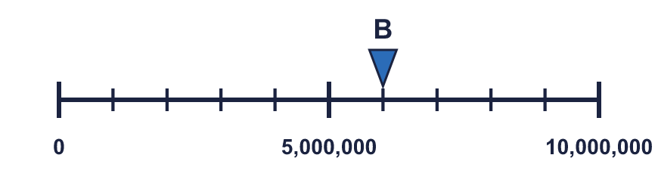  Is Boba correct? Circle yes or no.  Yes / No  Explain how you know.  Hint: Read the numbers at the two ends of each line first. Then work out what one step is on each line.
    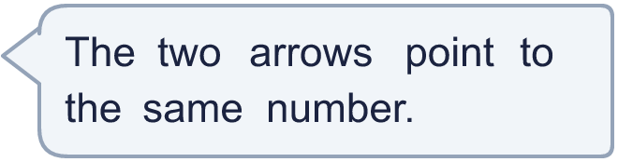
  9 | Is Boba correct? Circle yes or no.  Yes / No  Explain how you know.  Hint: Read the numbers at the two ends of each line first. Then work out what one step is on each line.
  10 | 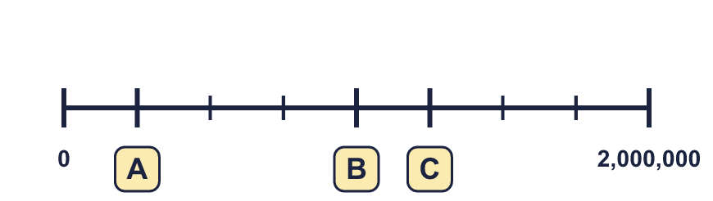  Hint: To find what each step is worth: (end − start) ÷ number of equal steps. Count the steps from the start to each letter.
     | 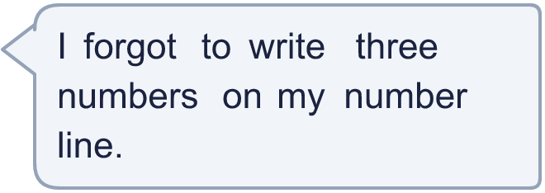
  10 | Hint: To find what each step is worth: (end − start) ÷ number of equal steps. Count the steps from the start to each letter.
  11 | 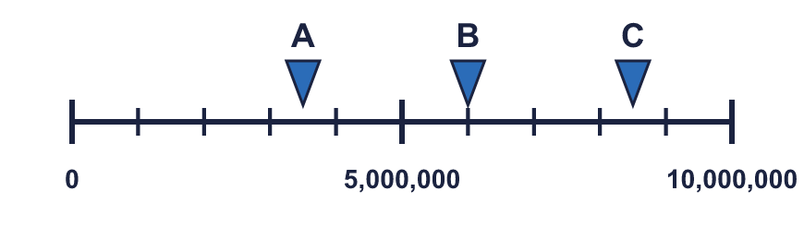  a) What number is arrow A pointing to?  b) What is the difference between B and C?  Hint: A is halfway between two marks. Each mark is 1,000,000, so half a step is 500,000. For b), read B first, then take it away from C.  Every mark is labelled:  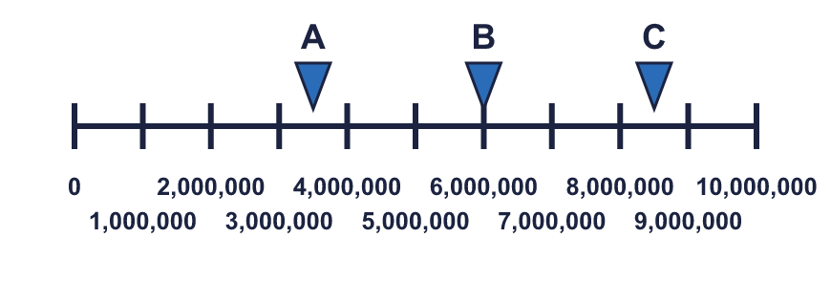
     | 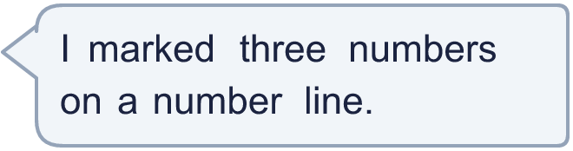
  11 | a) What number is arrow A pointing to?  b) What is the difference between B and C?  Hint: A is halfway between two marks. Each mark is 1,000,000, so half a step is 500,000. For b), read B first, then take it away from C.  Every mark is labelled:
  12 | What numbers are the arrows pointing to?  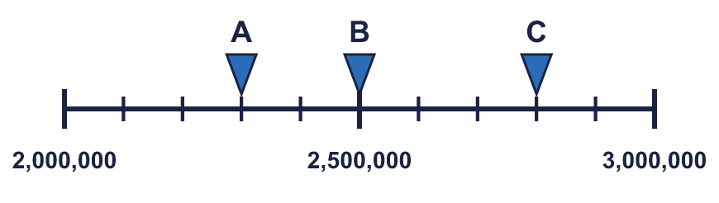  Hint: The line starts at 2,000,000 and goes up by 100,000 each step.  Every mark is labelled:  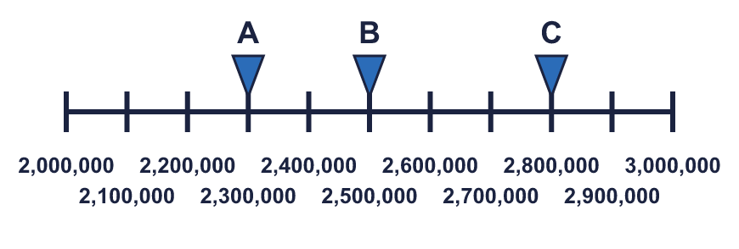
  12 | What numbers are the arrows pointing to?  Hint: The line starts at 2,000,000 and goes up by 100,000 each step.  Every mark is labelled:
  13 | 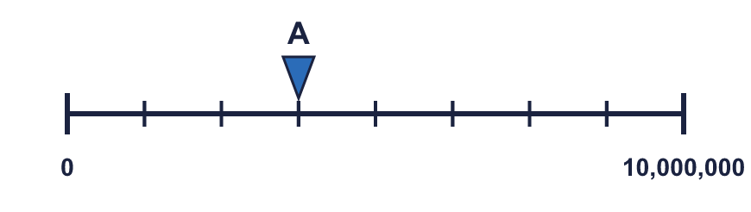  a) What is each step worth?  b) What number is arrow A pointing to?  Hint: To find what each step is worth: (end − start) ÷ number of equal steps. Then count the steps to A.  Every mark is labelled:  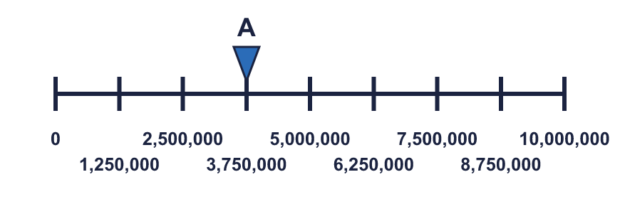
     | 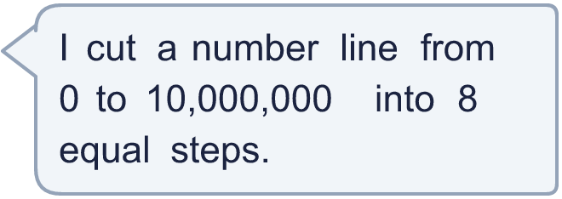
  13 | a) What is each step worth?  b) What number is arrow A pointing to?  Hint: To find what each step is worth: (end − start) ÷ number of equal steps. Then count the steps to A.  Every mark is labelled:
  14 | The arrow is exactly halfway along the number line. It points to 6,000,000. Write two different pairs of numbers that the start and end of the line could be.  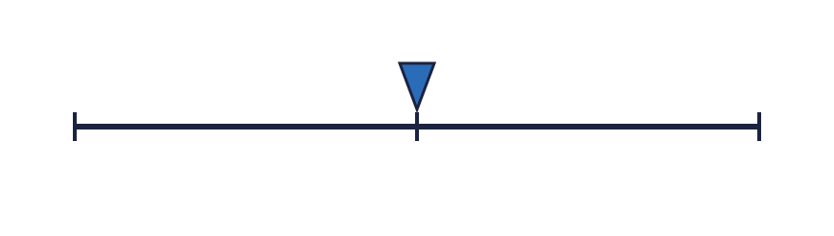  Hint: Halfway means the same distance from each end. Choose a distance, take it from 6,000,000 for the start and add it for the end.
  14 | The arrow is exactly halfway along the number line. It points to 6,000,000. Write two different pairs of numbers that the start and end of the line could be.  Hint: Halfway means the same distance from each end. Choose a distance, take it from 6,000,000 for the start and add it for the end.

Year 6 · Place value · Step 5
Number lines up to 10,000,000
Answers (teacher copy)

A number line to help you:
  1 | What number is the arrow pointing to?  Hint: The line goes from 0 to 10,000,000 in 10 equal steps. Each step is 1,000,000. Count the steps to the arrow.  Every mark is labelled:
    9,000,000
  2 | What number is the arrow pointing to?  Hint: This line goes from 0 to 1,000,000 in 10 equal steps. Each step is 100,000.  Every mark is labelled:
    600,000
  3 | What numbers are the arrows pointing to?  A = 30,000 B = 40,000  Hint: 0 to 100,000 in 10 equal steps: each step is 10,000.  Every mark is labelled:
  4 | Which arrow points to 6,000,000? Write its letter.  Answer: B  Hint: Count the steps. One step is 1,000,000. Find the number of steps for your target first.  Every mark is labelled:
  5 | Look at the number line.  The difference between the start and the end is 1,000,000  There are 5 equal intervals.  The line counts up in 200,000  Hint: a) Take the start away from the end. b) Count the gaps between the marks, not the marks. c) Divide the difference by the number of gaps.  Count the gaps:
  6 | Write the missing numbers on the line.  A = 500,000 B = 1,000,000 C = 1,500,000  Hint: To find what each step is worth: (end − start) ÷ number of equal steps. Then add that step each time.
  7 | What number is the arrow pointing to?  Hint: This line starts at 6,000,000 and ends at 7,000,000. There are 10 equal steps, so each step is 100,000.  Every mark is labelled:
    6,100,000
  8 | The arrow is between two marks. Which number is it closest to? Write the letter.  a) 7,500,000  b) 9,000,000  c) 5,500,000  Answer: a  Hint: Find the two marks either side of the arrow. Is the arrow nearer the left mark or the right mark?  Every mark is labelled:
  9 | Is Boba correct? Circle yes or no.  Yes / No  Explain how you know.  Arrow A points to 600,000 and arrow B points to 6,000,000. The lines have different scales: line A ends at 1,000,000 and line B ends at 10,000,000.  Hint: Read the numbers at the two ends of each line first. Then work out what one step is on each line.
  10 | A = 250,000 B = 1,000,000 C = 1,250,000  Hint: To find what each step is worth: (end − start) ÷ number of equal steps. Count the steps from the start to each letter.
  11 | a) What number is arrow A pointing to? 3,500,000  b) What is the difference between B and C? 2,500,000  Hint: A is halfway between two marks. Each mark is 1,000,000, so half a step is 500,000. For b), read B first, then take it away from C.  Every mark is labelled:
  12 | What numbers are the arrows pointing to?  A = 2,300,000 B = 2,500,000 C = 2,800,000  Hint: The line starts at 2,000,000 and goes up by 100,000 each step.  Every mark is labelled:
  13 | a) What is each step worth? 1,250,000  b) What number is arrow A pointing to? 3,750,000  Hint: To find what each step is worth: (end − start) ÷ number of equal steps. Then count the steps to A.  Every mark is labelled:
  14 | The arrow is exactly halfway along the number line. It points to 6,000,000. Write two different pairs of numbers that the start and end of the line could be.  Any pairs with 6,000,000 exactly halfway, for example 4,000,000 and 8,000,000, 5,000,000 and 7,000,000  Hint: Halfway means the same distance from each end. Choose a distance, take it from 6,000,000 for the start and add it for the end.

