  Year 6 · Place value · Step 2  Numbers up to 10,000,000 | 
  Year 6 · Place value · Step 2
  Numbers up to 10,000,000
  1 | What number is shown in the place value chart?
    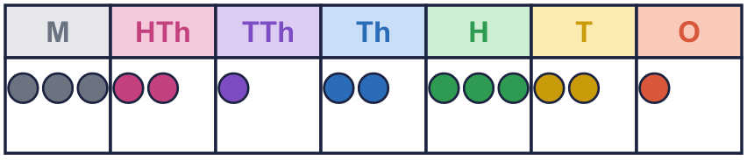
  1 | What number is shown in the place value chart?
  2 | What number is shown in the place value chart?
    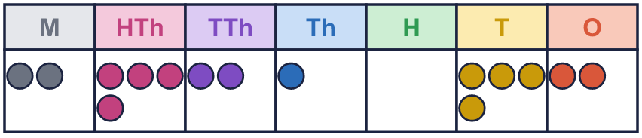
  2 | What number is shown in the place value chart?
  3 | What number is shown in the place value chart?
    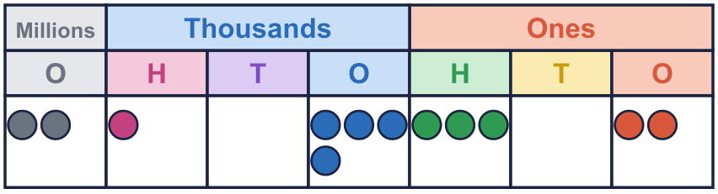
  3 | What number is shown in the place value chart?
  4 | Draw counters to show 3,114,404 in a place value chart.  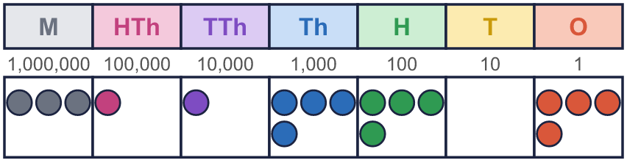
  4 | Draw counters to show 3,114,404 in a place value chart.
  5 | Write this number in digits.  eight million seven hundred and two thousand three hundred and ninety
  5 | Write this number in digits.  eight million seven hundred and two thousand three hundred and ninety
  6 | Write the value of the digit in the box.  a) 844,214 =  b) 9,198,412 =
  6 | Write the value of the digit in the box.  a) 844,214 =  b) 9,198,412 =
  7 | Partition the number. Fill in the missing parts.
    9,707,017 =
    9,000,000 | + | 700,000 | + |  | +
     | + | 7
  7 | Partition the number. Fill in the missing parts.
    9,707,017 =
    9,000,000 | + | 700,000 | + |  | +
     | + | 7
  8 | Work out the missing numbers.  a) 1,000,000 more than 5,619,981 =  b) 100,000 less than 9,803,016 =  c) 10,000 less than 8,907,123 =
  8 | Work out the missing numbers.  a) 1,000,000 more than 5,619,981 =  b) 100,000 less than 9,803,016 =  c) 10,000 less than 8,907,123 =

  9 | Which numbers have a 2 in the thousands column? Write the letters.  a) 832,611  b) 185,991  c) 9,085,293  d) 7,212,490  Answer:
     | 
  9 | Which numbers have a 2 in the thousands column? Write the letters.  a) 832,611  b) 185,991  c) 9,085,293  d) 7,212,490  Answer:
  10 | What mistake has Boba made? Explain how you know.  Write the number correctly:
     | 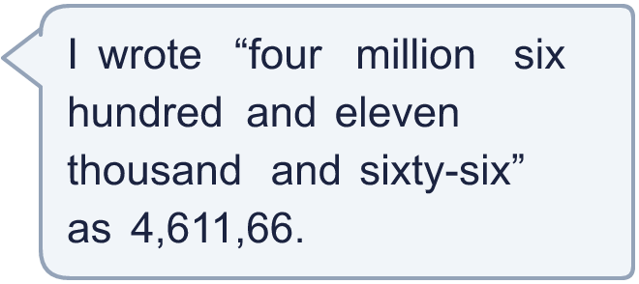
  10 | What mistake has Boba made? Explain how you know.  Write the number correctly:
  11 | Is Boba correct? Circle yes or no.  Yes / No  Explain how you know.
    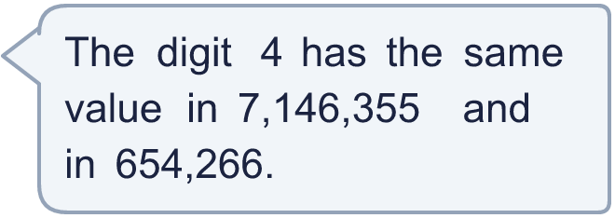
  11 | Is Boba correct? Circle yes or no.  Yes / No  Explain how you know.
  12 | 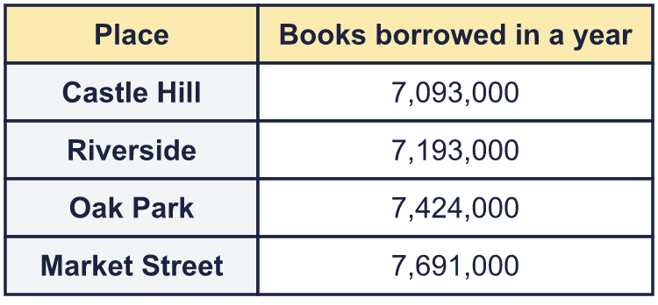  a) Write the libraries in order, smallest number first.  b) Which library had 100,000 more books borrowed than Castle Hill?  c) What is the value of the digit in the box in the Market Street number: 7,691,000?
    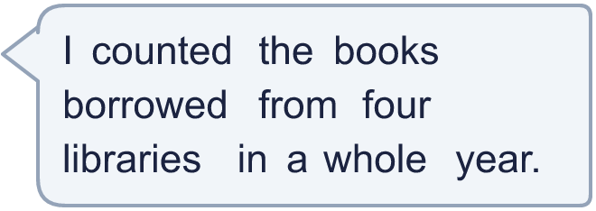
  12 | a) Write the libraries in order, smallest number first.  b) Which library had 100,000 more books borrowed than Castle Hill?  c) What is the value of the digit in the box in the Market Street number: 7,691,000?
  13 | • The digits add up to 39.  • The ten thousands digit is 7.  • The millions digit is 1.  • The thousands digit is double the millions digit.  • The tens digit is 8.  • The hundred thousands digit is 3.  What is my number?
     | 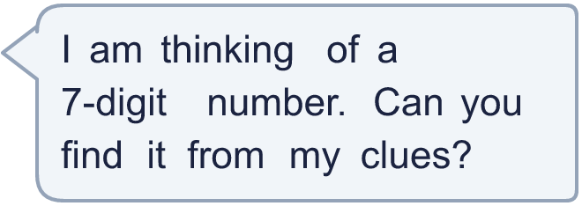
  13 | • The digits add up to 39.  • The ten thousands digit is 7.  • The millions digit is 1.  • The thousands digit is double the millions digit.  • The tens digit is 8.  • The hundred thousands digit is 3.  What is my number?
  14 | Write three different 7-digit numbers in which the digit 4 is worth 4,000.
  14 | Write three different 7-digit numbers in which the digit 4 is worth 4,000.

Year 6 · Place value · Step 2
Numbers up to 10,000,000
Answers (teacher copy)

  1 | What number is shown in the place value chart?
    3,212,321
  2 | What number is shown in the place value chart?
    2,421,042
  3 | What number is shown in the place value chart?
    2,104,302
  4 | Draw counters to show 3,114,404 in a place value chart.
  5 | Write this number in digits.  eight million seven hundred and two thousand three hundred and ninety  8,702,390
  6 | Write the value of the digit in the box.  a) 844,214 = 800,000  b) 9,198,412 = 8,000
  7 | Partition the number. Fill in the missing parts.  9,707,017 = 9,000,000 + 700,000 + 7,000 + 10 + 7
  8 | Work out the missing numbers.  a) 1,000,000 more than 5,619,981 = 6,619,981  b) 100,000 less than 9,803,016 = 9,703,016  c) 10,000 less than 8,907,123 = 8,897,123
  9 | Which numbers have a 2 in the thousands column? Write the letters.  a) 832,611  b) 185,991  c) 9,085,293  d) 7,212,490  Answer: a and d
  10 | What mistake has Boba made? Explain how you know.  Boba left out the zero in the hundreds column. The last group of a number needs three digits, so the zero holds the place. The number is 4,611,066.  Write the number correctly: 4,611,066
  11 | Is Boba correct? Circle yes or no.  Yes / No  Explain how you know.  In 7,146,355 the 4 is worth 40,000. In 654,266 it is worth 4,000. The columns are different, so the values are different.
  12 | a) Write the libraries in order, smallest number first. Castle Hill, Riverside, Oak Park, Market Street  b) Which library had 100,000 more books borrowed than Castle Hill? Riverside  c) What is the value of the digit in the box in the Market Street number: 7,691,000? 600,000
  13 | • The digits add up to 39.  • The ten thousands digit is 7.  • The millions digit is 1.  • The thousands digit is double the millions digit.  • The tens digit is 8.  • The hundred thousands digit is 3.  What is my number?  1,372,989
  14 | Write three different 7-digit numbers in which the digit 4 is worth 4,000.  Any numbers with the 4 in the thousands column, for example 2,004,548, 5,004,000, 8,004,439

