Place value chart to help you:  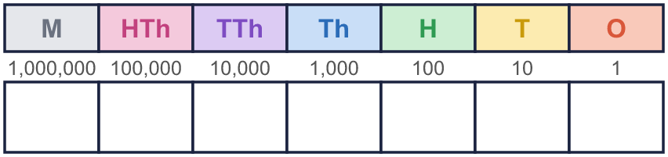 |  | Place value chart to help you:
  Year 6 · Place value · Step 2  Numbers up to 10,000,000 | 
  Year 6 · Place value · Step 2
  Numbers up to 10,000,000
  1 | What number is shown in the place value chart?  Hint: Count the counters in each column, starting on the left (the millions). Write the digits in order, then put the commas in.
    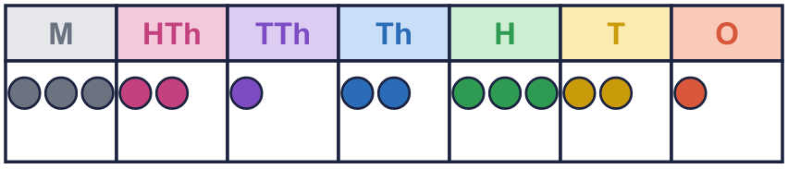
  1 | What number is shown in the place value chart?  Hint: Count the counters in each column, starting on the left (the millions). Write the digits in order, then put the commas in.
  2 | What number is shown in the place value chart?  Hint: An empty column means a zero. Write a 0 to hold the place.
    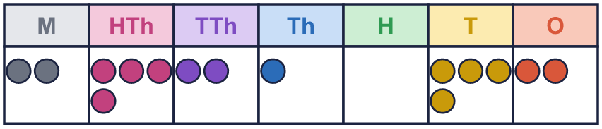
  2 | What number is shown in the place value chart?  Hint: An empty column means a zero. Write a 0 to hold the place.
  3 | What number is shown in the place value chart?  Hint: Read the millions first, then the thousands, then the ones. Say it out loud.
    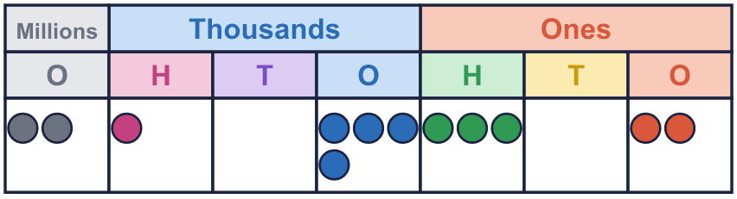
  3 | What number is shown in the place value chart?  Hint: Read the millions first, then the thousands, then the ones. Say it out loud.
  4 | Draw counters to show 3,114,404 in a place value chart.  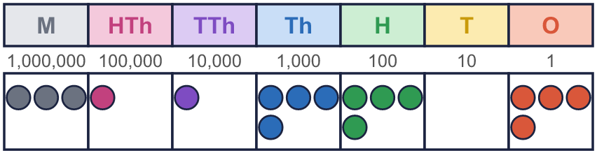  Hint: Put each digit in its column as counters. A zero means no counters.  Draw your counters here:
  4 | Draw counters to show 3,114,404 in a place value chart.  Hint: Put each digit in its column as counters. A zero means no counters.  Draw your counters here:
  5 | Write this number in digits.  eight million seven hundred and two thousand three hundred and ninety  Hint: Find “million” first: that part goes before the first comma. Then the “thousand” part, then the rest.  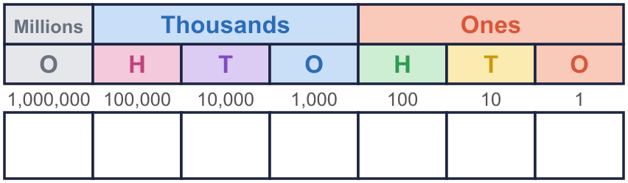
  5 | Write this number in digits.  eight million seven hundred and two thousand three hundred and ninety  Hint: Find “million” first: that part goes before the first comma. Then the “thousand” part, then the rest.
  6 | Write the value of the digit in the box.  a) 844,214 =  b) 9,198,412 =  Hint: Find the column of the digit in the box. Then say how much it is worth there.  a)  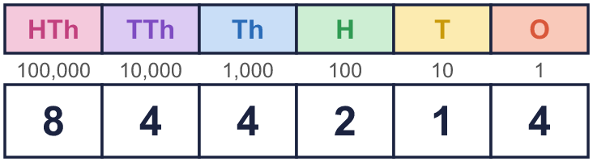  b)  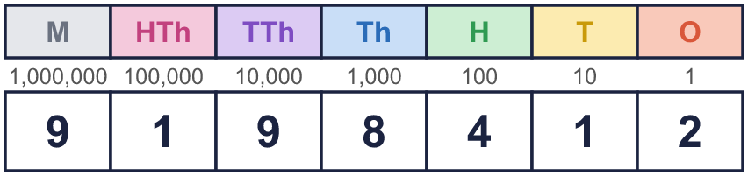
  6 | Write the value of the digit in the box.  a) 844,214 =  b) 9,198,412 =  Hint: Find the column of the digit in the box. Then say how much it is worth there.  a)  b)
  7 | Partition the number. Fill in the missing parts.  Hint: Look at the chart. 7 counters in the thousands column are worth 7,000. 1 counter in the tens column is worth 10.  The number in a place value chart:  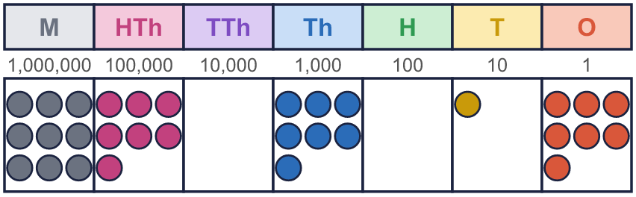
    9,707,017 =
    9,000,000 | + | 700,000 | + |  | +
     | + | 7
  7 | Partition the number. Fill in the missing parts.  Hint: Look at the chart. 7 counters in the thousands column are worth 7,000. 1 counter in the tens column is worth 10.  The number in a place value chart:
    9,707,017 =
    9,000,000 | + | 700,000 | + |  | +
     | + | 7
  8 | Work out the missing numbers.  a) 1,000,000 more than 5,619,981 =  b) 100,000 less than 9,803,016 =  c) 10,000 less than 8,907,123 =  Hint: Only one column changes. a) Add 1 to the millions digit. b) Take 1 from the hundred thousands digit. c) The ten thousands digit is 0, so exchange 1 from the hundred thousands first.
  8 | Work out the missing numbers.  a) 1,000,000 more than 5,619,981 =  b) 100,000 less than 9,803,016 =  c) 10,000 less than 8,907,123 =  Hint: Only one column changes. a) Add 1 to the millions digit. b) Take 1 from the hundred thousands digit. c) The ten thousands digit is 0, so exchange 1 from the hundred thousands first.

  9 | Which numbers have a 2 in the thousands column? Write the letters.  a) 832,611  b) 185,991  c) 9,085,293  d) 7,212,490  Answer:  Hint: Write each number in the chart, one digit in each column, then look in the right column.
     | 
  9 | Which numbers have a 2 in the thousands column? Write the letters.  a) 832,611  b) 185,991  c) 9,085,293  d) 7,212,490  Answer:  Hint: Write each number in the chart, one digit in each column, then look in the right column.
  10 | What mistake has Boba made? Explain how you know.  Write the number correctly:  Hint: Say the number out loud. Count the digits in each group: after a comma there must be three.
     | 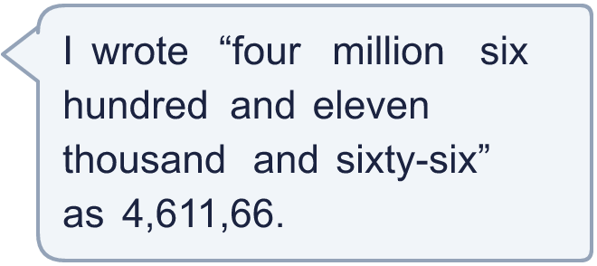
  10 | What mistake has Boba made? Explain how you know.  Write the number correctly:  Hint: Say the number out loud. Count the digits in each group: after a comma there must be three.
  11 | Is Boba correct? Circle yes or no.  Yes / No  Explain how you know.  Hint: Find the column of the digit in each number. Say how much it is worth there.
    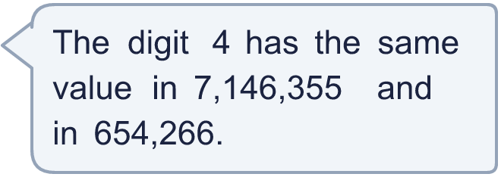
  11 | Is Boba correct? Circle yes or no.  Yes / No  Explain how you know.  Hint: Find the column of the digit in each number. Say how much it is worth there.
  12 | 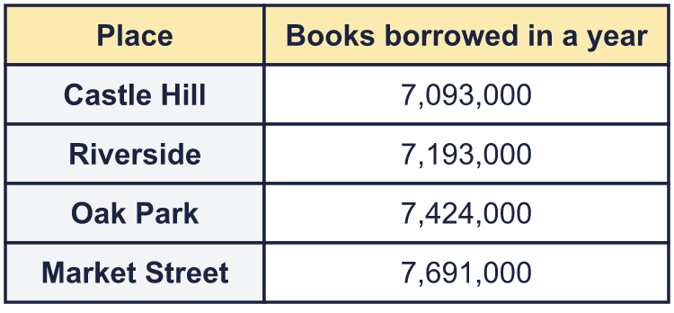  a) Write the libraries in order, smallest number first.  b) Which library had 100,000 more books borrowed than Castle Hill?  c) What is the value of the digit in the box in the Market Street number: 7,691,000?  Hint: For a), compare the millions first, then the hundred thousands.
    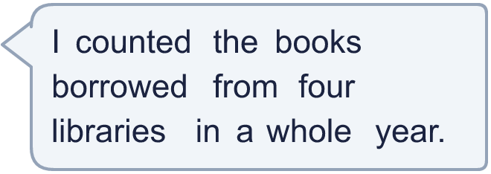
  12 | a) Write the libraries in order, smallest number first.  b) Which library had 100,000 more books borrowed than Castle Hill?  c) What is the value of the digit in the box in the Market Street number: 7,691,000?  Hint: For a), compare the millions first, then the hundred thousands.
  13 | • The digits add up to 39.  • The ten thousands digit is 7.  • The millions digit is 1.  • The thousands digit is double the millions digit.  • The tens digit is 8.  • The hundred thousands digit is 3.  What is my number?  Hint: Start with the clue that tells you a digit exactly. Write it in the chart, then use the next clue.
     | 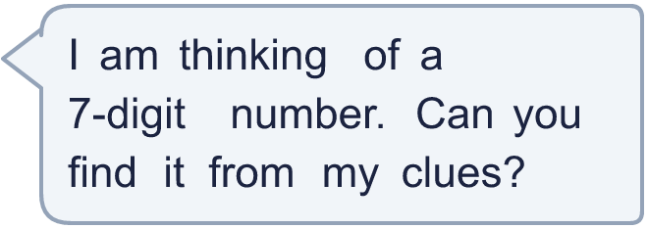
  13 | • The digits add up to 39.  • The ten thousands digit is 7.  • The millions digit is 1.  • The thousands digit is double the millions digit.  • The tens digit is 8.  • The hundred thousands digit is 3.  What is my number?  Hint: Start with the clue that tells you a digit exactly. Write it in the chart, then use the next clue.
  14 | Write three different 7-digit numbers in which the digit 4 is worth 4,000.  Hint: Which column makes the digit worth that much? Put your digit there, then choose the other digits.
  14 | Write three different 7-digit numbers in which the digit 4 is worth 4,000.  Hint: Which column makes the digit worth that much? Put your digit there, then choose the other digits.

Year 6 · Place value · Step 2
Numbers up to 10,000,000
Answers (teacher copy)

Place value chart to help you:
  1 | What number is shown in the place value chart?  Hint: Count the counters in each column, starting on the left (the millions). Write the digits in order, then put the commas in.
    3,212,321
  2 | What number is shown in the place value chart?  Hint: An empty column means a zero. Write a 0 to hold the place.
    2,421,042
  3 | What number is shown in the place value chart?  Hint: Read the millions first, then the thousands, then the ones. Say it out loud.
    2,104,302
  4 | Draw counters to show 3,114,404 in a place value chart.  Hint: Put each digit in its column as counters. A zero means no counters.  Draw your counters here:
  5 | Write this number in digits.  eight million seven hundred and two thousand three hundred and ninety  8,702,390  Hint: Find “million” first: that part goes before the first comma. Then the “thousand” part, then the rest.
  6 | Write the value of the digit in the box.  a) 844,214 = 800,000  b) 9,198,412 = 8,000  Hint: Find the column of the digit in the box. Then say how much it is worth there.  a)  b)
  7 | Partition the number. Fill in the missing parts.  9,707,017 = 9,000,000 + 700,000 + 7,000 + 10 + 7  Hint: Look at the chart. 7 counters in the thousands column are worth 7,000. 1 counter in the tens column is worth 10.  The number in a place value chart:
  8 | Work out the missing numbers.  a) 1,000,000 more than 5,619,981 = 6,619,981  b) 100,000 less than 9,803,016 = 9,703,016  c) 10,000 less than 8,907,123 = 8,897,123  Hint: Only one column changes. a) Add 1 to the millions digit. b) Take 1 from the hundred thousands digit. c) The ten thousands digit is 0, so exchange 1 from the hundred thousands first.
  9 | Which numbers have a 2 in the thousands column? Write the letters.  a) 832,611  b) 185,991  c) 9,085,293  d) 7,212,490  Answer: a and d  Hint: Write each number in the chart, one digit in each column, then look in the right column.
  10 | What mistake has Boba made? Explain how you know.  Boba left out the zero in the hundreds column. The last group of a number needs three digits, so the zero holds the place. The number is 4,611,066.  Write the number correctly: 4,611,066  Hint: Say the number out loud. Count the digits in each group: after a comma there must be three.
  11 | Is Boba correct? Circle yes or no.  Yes / No  Explain how you know.  In 7,146,355 the 4 is worth 40,000. In 654,266 it is worth 4,000. The columns are different, so the values are different.  Hint: Find the column of the digit in each number. Say how much it is worth there.
  12 | a) Write the libraries in order, smallest number first. Castle Hill, Riverside, Oak Park, Market Street  b) Which library had 100,000 more books borrowed than Castle Hill? Riverside  c) What is the value of the digit in the box in the Market Street number: 7,691,000? 600,000  Hint: For a), compare the millions first, then the hundred thousands.
  13 | • The digits add up to 39.  • The ten thousands digit is 7.  • The millions digit is 1.  • The thousands digit is double the millions digit.  • The tens digit is 8.  • The hundred thousands digit is 3.  What is my number?  1,372,989  Hint: Start with the clue that tells you a digit exactly. Write it in the chart, then use the next clue.
  14 | Write three different 7-digit numbers in which the digit 4 is worth 4,000.  Any numbers with the 4 in the thousands column, for example 2,004,548, 5,004,000, 8,004,439  Hint: Which column makes the digit worth that much? Put your digit there, then choose the other digits.

