  Year 6 · Place value · Step 4  Powers of 10 | 
  Year 6 · Place value · Step 4
  Powers of 10
  1 | The place value chart shows a number. What is 10 times the number?
    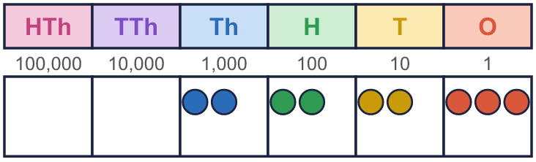
  1 | The place value chart shows a number. What is 10 times the number?
  2 | Work out the multiplications.  a) 6 × 10 =  b) 17 × 1,000 =  c) 130 × 100 =
  2 | Work out the multiplications.  a) 6 × 10 =  b) 17 × 1,000 =  c) 130 × 100 =
  3 | Work out the divisions.  a) 7,000 ÷ 10 =  b) 8,900 ÷ 100 =  c) 73,000 ÷ 1,000 =
  3 | Work out the divisions.  a) 7,000 ÷ 10 =  b) 8,900 ÷ 100 =  c) 73,000 ÷ 1,000 =
  4 | Write the missing number.  c) 6,400 × 100 =
    a) | 200 × |  | = 2,000
    b) |  | ÷ 10 = 4,000
  4 | Write the missing number.  c) 6,400 × 100 =
    a) | 200 × |  | = 2,000
    b) |  | ÷ 10 = 4,000
  5 | How many thousands are there in each number?
    a) | 90,000 | = |  | thousands
    b) | 600,000 | = |  | thousands
    c) | 660,000 | = |  | thousands
    d) | 7,600,000 | = |  | thousands
  5 | How many thousands are there in each number?
    a) | 90,000 | = |  | thousands
    b) | 600,000 | = |  | thousands
    c) | 660,000 | = |  | thousands
    d) | 7,600,000 | = |  | thousands
  6 | Complete the sentences.  a) 84,000 is 10 times the size of  b) 84,000 is one-tenth the size of
    c)
    is 100 times the size of 84,000
    d)
    is one-hundredth the size of 84,000
  6 | Complete the sentences.  a) 84,000 is 10 times the size of  b) 84,000 is one-tenth the size of
    c)
    is 100 times the size of 84,000
    d)
    is one-hundredth the size of 84,000
  7 | Each number is made from the one before it. Complete the pattern.
    a) | × 10 each time:
    9 | → |  | → |  | →
    b) | × 100 each time:
    5 | → |  | →
  7 | Each number is made from the one before it. Complete the pattern.
    a) | × 10 each time:
    9 | → |  | → |  | →
    b) | × 100 each time:
    5 | → |  | →
  8 | Work out the two-step calculations. Do them from left to right.  a) 90 × 100 ÷ 10 =  b) 60,000 ÷ 10 × 1,000 =
  8 | Work out the two-step calculations. Do them from left to right.  a) 90 × 100 ÷ 10 =  b) 60,000 ÷ 10 × 1,000 =

  9 | 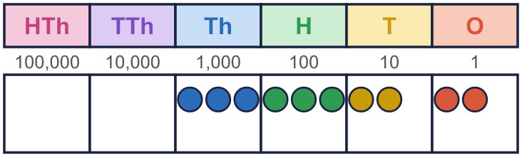  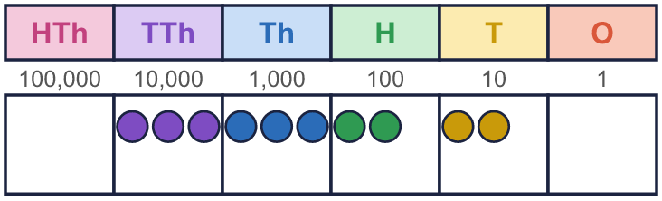  What is the same? What is different?
    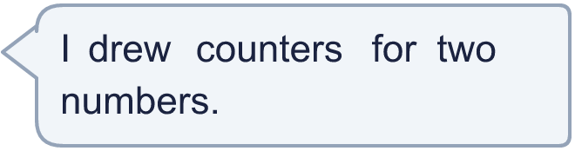
  9 | What is the same? What is different?
  10 | Is Boba correct? Circle yes or no.  Yes / No  Explain how you know.
     | 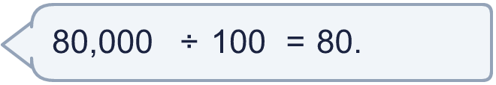
  10 | Is Boba correct? Circle yes or no.  Yes / No  Explain how you know.
  11 | There are 800 pencils in one box.  a) How many pencils are in 10 boxes?  b) How many pencils are in 100 boxes?  c) The school has 54,000 pencils. How many boxes of 1,000 can they fill?
     | 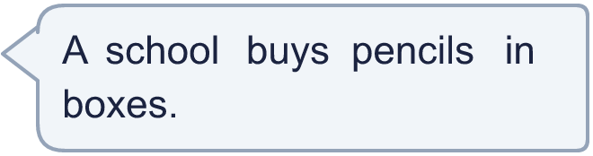
  11 | There are 800 pencils in one box.  a) How many pencils are in 10 boxes?  b) How many pencils are in 100 boxes?  c) The school has 54,000 pencils. How many boxes of 1,000 can they fill?
  12 | a) What is my number?  b) What do I get if I multiply my number by 10?
     | 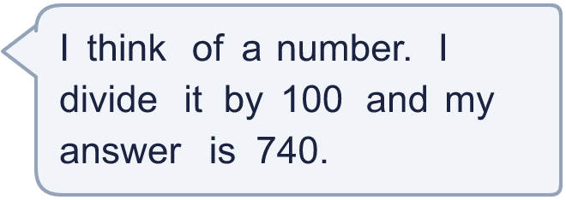
  12 | a) What is my number?  b) What do I get if I multiply my number by 10?
  13 | Which calculations have the same answer as 4,200 × 10? Write the letters.  a) 420,000 ÷ 10  b) 42,000 × 10  c) 42 × 1,000  d) 4,200 × 100  Answer:
  13 | Which calculations have the same answer as 4,200 × 10? Write the letters.  a) 420,000 ÷ 10  b) 42,000 × 10  c) 42 × 1,000  d) 4,200 × 100  Answer:
  14 | Write three different calculations that all have the answer 2,000. Use × or ÷ and 10, 100 or 1,000.
  14 | Write three different calculations that all have the answer 2,000. Use × or ÷ and 10, 100 or 1,000.

Year 6 · Place value · Step 4
Powers of 10
Answers (teacher copy)

  1 | The place value chart shows a number. What is 10 times the number?
    22,230
  2 | Work out the multiplications.  a) 6 × 10 = 60  b) 17 × 1,000 = 17,000  c) 130 × 100 = 13,000
  3 | Work out the divisions.  a) 7,000 ÷ 10 = 700  b) 8,900 ÷ 100 = 89  c) 73,000 ÷ 1,000 = 73
  4 | Write the missing number.  a) 200 × 10 = 2,000  b) 40,000 ÷ 10 = 4,000  c) 6,400 × 100 = 640,000
  5 | How many thousands are there in each number?  a) 90,000 = 90 thousands  b) 600,000 = 600 thousands  c) 660,000 = 660 thousands  d) 7,600,000 = 7,600 thousands
  6 | Complete the sentences.  a) 84,000 is 10 times the size of 8,400  b) 84,000 is one-tenth the size of 840,000  c) 8,400,000 is 100 times the size of 84,000  d) 840 is one-hundredth the size of 84,000
  7 | Each number is made from the one before it. Complete the pattern.  a) × 10 each time: 9 → 90 → 900 → 9,000  b) × 100 each time: 5 → 500 → 50,000
  8 | Work out the two-step calculations. Do them from left to right.  a) 90 × 100 ÷ 10 = 900  b) 60,000 ÷ 10 × 1,000 = 6,000,000
  9 | What is the same? What is different?  The counters make the same pattern, but every counter in the second chart is one column to the left. The second number, 33,220, is 10 times the first number, 3,322.
  10 | Is Boba correct? Circle yes or no.  Yes / No  Explain how you know.  80,000 ÷ 100 = 800. Dividing by 100 moves the digits two columns to the right. Boba moved them three columns, which is dividing by 1,000.
  11 | There are 800 pencils in one box.  a) How many pencils are in 10 boxes? 8,000  b) How many pencils are in 100 boxes? 80,000  c) The school has 54,000 pencils. How many boxes of 1,000 can they fill? 54
  12 | a) What is my number? 74,000  b) What do I get if I multiply my number by 10? 740,000
  13 | Which calculations have the same answer as 4,200 × 10? Write the letters.  a) 420,000 ÷ 10  b) 42,000 × 10  c) 42 × 1,000  d) 4,200 × 100  Answer: a and c
  14 | Write three different calculations that all have the answer 2,000. Use × or ÷ and 10, 100 or 1,000.  Any three correct calculations, for example 200 × 10, 20 × 100, 20,000 ÷ 10

