Place value chart to help you:  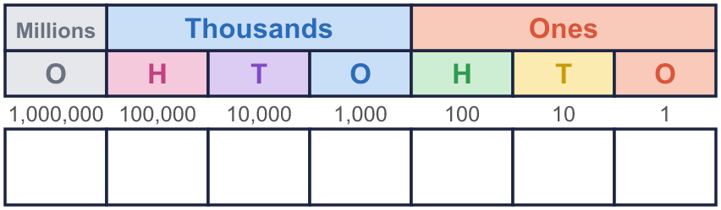 |  | Place value chart to help you:
  Year 6 · Place value · Step 3  Reading and writing numbers up to 10,000,000 | 
  Year 6 · Place value · Step 3
  Reading and writing numbers up to 10,000,000
  1 | Write this number in digits.  eight million eight hundred and twenty-eight thousand one hundred and seventy-five  Hint: Find “million” first: that part goes before the first comma. Then the “thousand” part, then the rest.  Write the digits in the chart if you need to:
  1 | Write this number in digits.  eight million eight hundred and twenty-eight thousand one hundred and seventy-five  Hint: Find “million” first: that part goes before the first comma. Then the “thousand” part, then the rest.  Write the digits in the chart if you need to:
  2 | Write this number in words.  350,412  Hint: Say the thousands part, then the word “thousand”, then the rest. A zero column is not said.
  2 | Write this number in words.  350,412  Hint: Say the thousands part, then the word “thousand”, then the rest. A zero column is not said.
  3 | What number is shown? Write it in digits and in words.  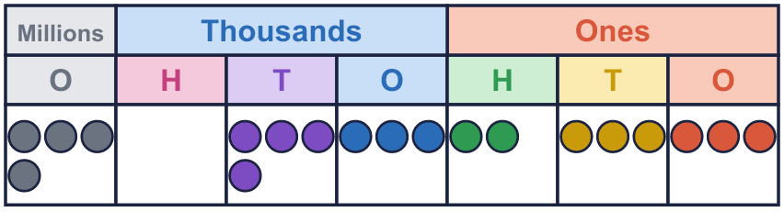  digits  words  Hint: Count the counters in each column and write the digits first. Then read the number out loud and write the words.
  3 | What number is shown? Write it in digits and in words.  digits  words  Hint: Count the counters in each column and write the digits first. Then read the number out loud and write the words.
  4 | Write this number in digits.  five million ninety thousand four hundred and six  Hint: Some columns are not said, so they are zeros. Write the three parts, and fill the empty places with 0.
  4 | Write this number in digits.  five million ninety thousand four hundred and six  Hint: Some columns are not said, so they are zeros. Write the three parts, and fill the empty places with 0.
  5 | Write this number in words.  5,615,125  Hint: Say it in three parts: the millions, then the thousands, then the ones. Write “million”, “thousand”, then the rest.
  5 | Write this number in words.  5,615,125  Hint: Say it in three parts: the millions, then the thousands, then the ones. Write “million”, “thousand”, then the rest.
  6 | Write each as a number.  a) three and a half million =  b) four and a half million =  Hint: A million is 1,000,000. Half a million is 500,000. A quarter of a million is half of that.  Use these to help:  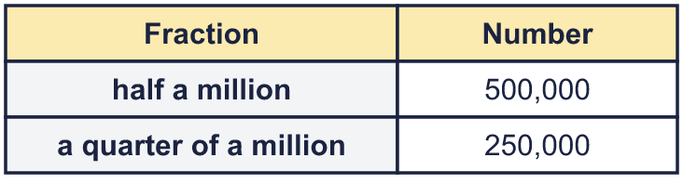
  6 | Write each as a number.  a) three and a half million =  b) four and a half million =  Hint: A million is 1,000,000. Half a million is 500,000. A quarter of a million is half of that.  Use these to help:
  7 | Complete the part-whole models.  Hint: The two parts add to make the whole. Whole − part = the other part. Part + part = whole.
    a)  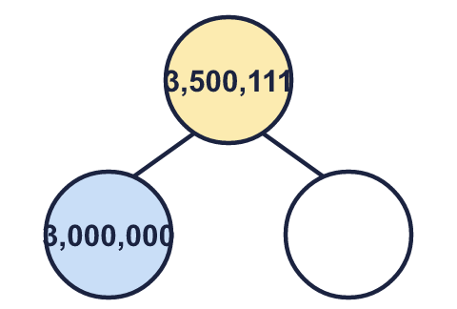 | b)  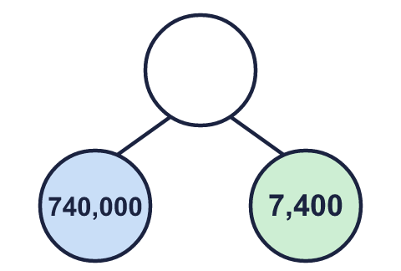
  7 | Complete the part-whole models.  Hint: The two parts add to make the whole. Whole − part = the other part. Part + part = whole.
    a) | b)
  8 | Circle the number that matches the words. Write its letter.  seven million four hundred and forty-five thousand six hundred and one  a) 7,445,610  b) 7,445,061  c) 7,445,601  Answer:  Hint: Say each number out loud and read it in three parts. Cross out the ones that do not match.
  8 | Circle the number that matches the words. Write its letter.  seven million four hundred and forty-five thousand six hundred and one  a) 7,445,610  b) 7,445,061  c) 7,445,601  Answer:  Hint: Say each number out loud and read it in three parts. Cross out the ones that do not match.

  9 | Boba has made a mistake. Write the number correctly in words.  Hint: Read Boba’s words back as digits. Which two digits are the wrong way round?
     | 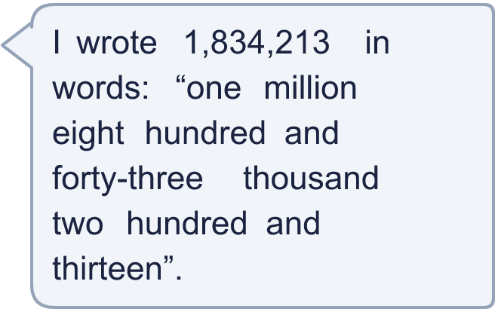
  9 | Boba has made a mistake. Write the number correctly in words.  Hint: Read Boba’s words back as digits. Which two digits are the wrong way round?
  10 | Is Boba correct? Circle yes or no.  Yes / No  Explain how you know.  Hint: Write both numbers in the chart and look at which column the digit is in.
    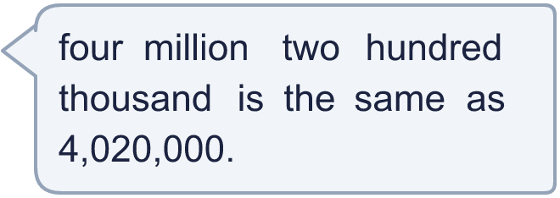
  10 | Is Boba correct? Circle yes or no.  Yes / No  Explain how you know.  Hint: Write both numbers in the chart and look at which column the digit is in.
  11 | 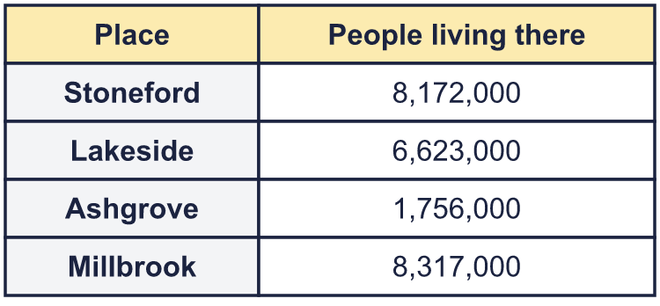  a) Which place has eight million one hundred and seventy-two thousand people?  b) Write the smallest number of people in words.  Hint: For a), read each number in the table out loud, in three parts, until it matches the words.
     | 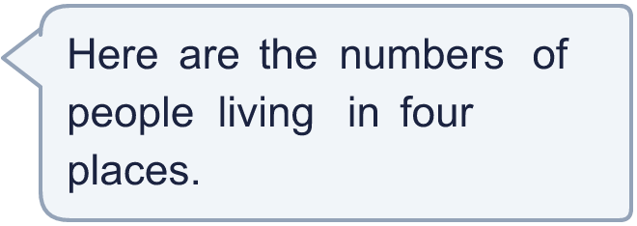
  11 | a) Which place has eight million one hundred and seventy-two thousand people?  b) Write the smallest number of people in words.  Hint: For a), read each number in the table out loud, in three parts, until it matches the words.
  12 | 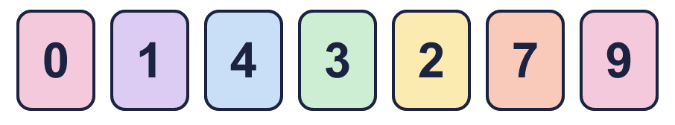  a) Make the smallest number.  b) Make the largest even number.  c) Write your answer to a) in words.  Hint: a) Put the smallest digit first (not 0). b) Even means the last digit is even. c) Say it in three parts.
     | 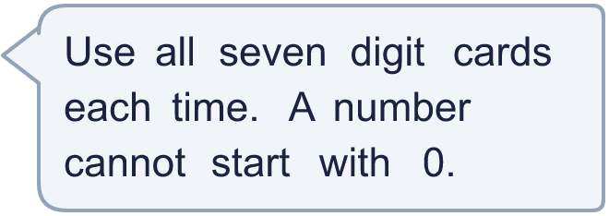
  12 | a) Make the smallest number.  b) Make the largest even number.  c) Write your answer to a) in words.  Hint: a) Put the smallest digit first (not 0). b) Even means the last digit is even. c) Say it in three parts.
  13 | • The thousands digit is 5.  • The hundred thousands digit is 5.  • The millions digit is 5.  • The digits add up to 47.  • The tens digit is 5.  digits  words  Hint: Start with the clue that tells you a digit exactly. Write it in the chart, then use the next clue.
    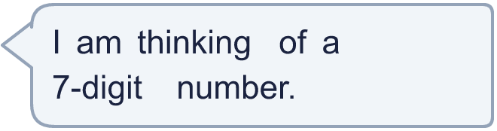
  13 | • The thousands digit is 5.  • The hundred thousands digit is 5.  • The millions digit is 5.  • The digits add up to 47.  • The tens digit is 5.  digits  words  Hint: Start with the clue that tells you a digit exactly. Write it in the chart, then use the next clue.
  14 | Write a 7-digit number that starts with 4 million and has a 0 in the thousands column and a 0 in the hundreds column. Then write it in words.  digits  words  Hint: Write the number in the chart first. Put the zeros in the right columns, then choose the other digits.
  14 | Write a 7-digit number that starts with 4 million and has a 0 in the thousands column and a 0 in the hundreds column. Then write it in words.  digits  words  Hint: Write the number in the chart first. Put the zeros in the right columns, then choose the other digits.

Year 6 · Place value · Step 3
Reading and writing numbers up to 10,000,000
Answers (teacher copy)

Place value chart to help you:
  1 | Write this number in digits.  eight million eight hundred and twenty-eight thousand one hundred and seventy-five  8,828,175  Hint: Find “million” first: that part goes before the first comma. Then the “thousand” part, then the rest.  Write the digits in the chart if you need to:
  2 | Write this number in words.  350,412  three hundred and fifty thousand four hundred and twelve  Hint: Say the thousands part, then the word “thousand”, then the rest. A zero column is not said.
  3 | What number is shown? Write it in digits and in words.  digits 4,043,233  words four million forty-three thousand two hundred and thirty-three  Hint: Count the counters in each column and write the digits first. Then read the number out loud and write the words.
  4 | Write this number in digits.  five million ninety thousand four hundred and six  5,090,406  Hint: Some columns are not said, so they are zeros. Write the three parts, and fill the empty places with 0.
  5 | Write this number in words.  5,615,125  five million six hundred and fifteen thousand one hundred and twenty-five  Hint: Say it in three parts: the millions, then the thousands, then the ones. Write “million”, “thousand”, then the rest.
  6 | Write each as a number.  a) three and a half million = 3,500,000  b) four and a half million = 4,500,000  Hint: A million is 1,000,000. Half a million is 500,000. A quarter of a million is half of that.  Use these to help:
  7 | Complete the part-whole models.  a) 500,111 b) 747,400  Hint: The two parts add to make the whole. Whole − part = the other part. Part + part = whole.
    a)  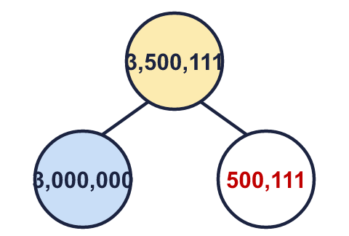 | b)  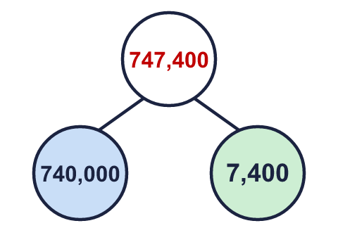
  8 | Circle the number that matches the words. Write its letter.  seven million four hundred and forty-five thousand six hundred and one  a) 7,445,610  b) 7,445,061  c) 7,445,601  Answer: c  Hint: Say each number out loud and read it in three parts. Cross out the ones that do not match.
  9 | Boba has made a mistake. Write the number correctly in words.  one million eight hundred and thirty-four thousand two hundred and thirteen  Hint: Read Boba’s words back as digits. Which two digits are the wrong way round?
  10 | Is Boba correct? Circle yes or no.  Yes / No  Explain how you know.  The words say 4,200,000. In 4,020,000 the 2 is in the ten thousands column, so it is worth only 20,000.  Hint: Write both numbers in the chart and look at which column the digit is in.
  11 | a) Which place has eight million one hundred and seventy-two thousand people? Stoneford  b) Write the smallest number of people in words. one million seven hundred and fifty-six thousand  Hint: For a), read each number in the table out loud, in three parts, until it matches the words.
  12 | a) Make the smallest number. 1,023,479  b) Make the largest even number. 9,743,210  c) Write your answer to a) in words. one million twenty-three thousand four hundred and seventy-nine  Hint: a) Put the smallest digit first (not 0). b) Even means the last digit is even. c) Say it in three parts.
  13 | • The thousands digit is 5.  • The hundred thousands digit is 5.  • The millions digit is 5.  • The digits add up to 47.  • The tens digit is 5.  digits 5,595,959  words five million five hundred and ninety-five thousand nine hundred and fifty-nine  Hint: Start with the clue that tells you a digit exactly. Write it in the chart, then use the next clue.
  14 | Write a 7-digit number that starts with 4 million and has a 0 in the thousands column and a 0 in the hundreds column. Then write it in words.  digits 4,520,079  words four million five hundred and twenty thousand and seventy-nine  Any number that fits, for example 4,520,079: four million five hundred and twenty thousand and seventy-nine  Hint: Write the number in the chart first. Put the zeros in the right columns, then choose the other digits.

