  Year 6 · Place value · Step 7  Rounding integers | 
  Year 6 · Place value · Step 7
  Rounding integers
  1 | Round each number to the nearest 10.  a) 8,069 to the nearest 10 =  b) 3,064 to the nearest 10 =  c) 9,949 to the nearest 10 =
  1 | Round each number to the nearest 10.  a) 8,069 to the nearest 10 =  b) 3,064 to the nearest 10 =  c) 9,949 to the nearest 10 =
  2 | Round each number to the nearest 100.  a) 29,029 to the nearest 100 =  b) 46,669 to the nearest 100 =  c) 77,293 to the nearest 100 =
  2 | Round each number to the nearest 100.  a) 29,029 to the nearest 100 =  b) 46,669 to the nearest 100 =  c) 77,293 to the nearest 100 =
  3 | Round each number to the nearest 1,000.  a) 73,825 to the nearest 1,000 =  b) 45,362 to the nearest 1,000 =  c) 84,865 to the nearest 1,000 =
  3 | Round each number to the nearest 1,000.  a) 73,825 to the nearest 1,000 =  b) 45,362 to the nearest 1,000 =  c) 84,865 to the nearest 1,000 =
  4 | Round each number to the nearest 10,000.  a) 682,879 to the nearest 10,000 =  b) 309,024 to the nearest 10,000 =  c) 218,439 to the nearest 10,000 =
  4 | Round each number to the nearest 10,000.  a) 682,879 to the nearest 10,000 =  b) 309,024 to the nearest 10,000 =  c) 218,439 to the nearest 10,000 =
  5 | The arrows show two numbers: A is 24,420 and B is 24,660. Round each to the nearest 1,000.  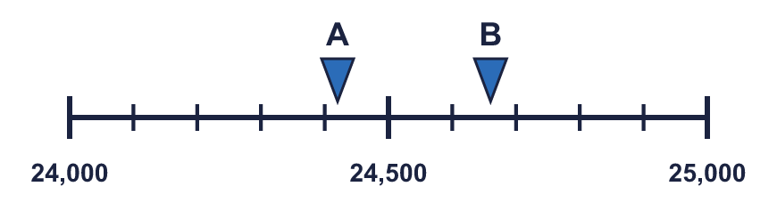  A rounds to B rounds to
  5 | The arrows show two numbers: A is 24,420 and B is 24,660. Round each to the nearest 1,000.  A rounds to B rounds to
  6 | Round each number.  a) 1,965,558 to the nearest 100,000 =  b) 7,157,644 to the nearest 1,000,000 =  c) 501,270 to the nearest 100,000 =
  6 | Round each number.  a) 1,965,558 to the nearest 100,000 =  b) 7,157,644 to the nearest 1,000,000 =  c) 501,270 to the nearest 100,000 =
  7 | Round 7,423,949 to each place.  a) the nearest 10 =  b) the nearest 1,000 =  c) the nearest 100,000 =  d) the nearest 1,000,000 =
  7 | Round 7,423,949 to each place.  a) the nearest 10 =  b) the nearest 1,000 =  c) the nearest 100,000 =  d) the nearest 1,000,000 =
  8 | Circle the numbers that round to 68,000 to the nearest 1,000. Write their letters.  a) 68,142  b) 68,500  c) 67,500  d) 67,508  e) 69,312  f) 66,872  Answer:
  8 | Circle the numbers that round to 68,000 to the nearest 1,000. Write their letters.  a) 68,142  b) 68,500  c) 67,500  d) 67,508  e) 69,312  f) 66,872  Answer:

  9 | a) Who is correct?  b) Explain the mistakes the other two have made.
     | 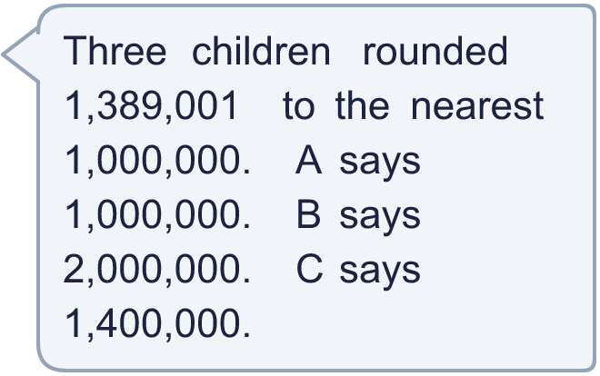
  9 | a) Who is correct?  b) Explain the mistakes the other two have made.
  10 | Is Boba correct? Circle yes or no.  Yes / No  Explain how you know.
    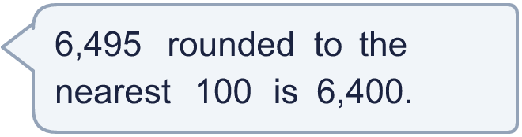
  10 | Is Boba correct? Circle yes or no.  Yes / No  Explain how you know.
  11 | There is a digit missing from each number. Write the digits that make it round to the number shown. There may be more than one.  a) 24,_43 rounds to 25,000 (nearest 1,000)  b) 33_,342 rounds to 340,000 (nearest 10,000)  c) 2_3,510 rounds to 300,000 (nearest 100,000)
  11 | There is a digit missing from each number. Write the digits that make it round to the number shown. There may be more than one.  a) 24,_43 rounds to 25,000 (nearest 1,000)  b) 33_,342 rounds to 340,000 (nearest 10,000)  c) 2_3,510 rounds to 300,000 (nearest 100,000)
  12 | A whole number rounds to 70,000 to the nearest 10,000.  a) What is the greatest it could be?  b) What is the smallest it could be?
  12 | A whole number rounds to 70,000 to the nearest 10,000.  a) What is the greatest it could be?  b) What is the smallest it could be?
  13 | a) Which number did the newspaper round to? Write 10, 100, 1,000 or 10,000.  b) What is the crowd rounded to the nearest 1,000?
     | 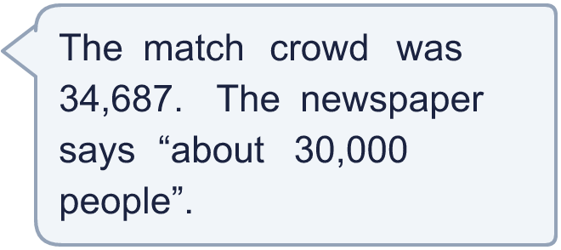
  13 | a) Which number did the newspaper round to? Write 10, 100, 1,000 or 10,000.  b) What is the crowd rounded to the nearest 1,000?
  14 | Write a number that rounds to 50,000 to the nearest 10,000 and to 51,000 to the nearest 1,000.
  14 | Write a number that rounds to 50,000 to the nearest 10,000 and to 51,000 to the nearest 1,000.

Year 6 · Place value · Step 7
Rounding integers
Answers (teacher copy)

  1 | Round each number to the nearest 10.  a) 8,069 to the nearest 10 = 8,070  b) 3,064 to the nearest 10 = 3,060  c) 9,949 to the nearest 10 = 9,950
  2 | Round each number to the nearest 100.  a) 29,029 to the nearest 100 = 29,000  b) 46,669 to the nearest 100 = 46,700  c) 77,293 to the nearest 100 = 77,300
  3 | Round each number to the nearest 1,000.  a) 73,825 to the nearest 1,000 = 74,000  b) 45,362 to the nearest 1,000 = 45,000  c) 84,865 to the nearest 1,000 = 85,000
  4 | Round each number to the nearest 10,000.  a) 682,879 to the nearest 10,000 = 680,000  b) 309,024 to the nearest 10,000 = 310,000  c) 218,439 to the nearest 10,000 = 220,000
  5 | The arrows show two numbers: A is 24,420 and B is 24,660. Round each to the nearest 1,000.  A rounds to 24,000 B rounds to 25,000
  6 | Round each number.  a) 1,965,558 to the nearest 100,000 = 2,000,000  b) 7,157,644 to the nearest 1,000,000 = 7,000,000  c) 501,270 to the nearest 100,000 = 500,000
  7 | Round 7,423,949 to each place.  a) the nearest 10 = 7,423,950  b) the nearest 1,000 = 7,424,000  c) the nearest 100,000 = 7,400,000  d) the nearest 1,000,000 = 7,000,000
  8 | Circle the numbers that round to 68,000 to the nearest 1,000. Write their letters.  a) 68,142  b) 68,500  c) 67,500  d) 67,508  e) 69,312  f) 66,872  Answer: a, c, d
  9 | a) Who is correct? A  b) Explain the mistakes the other two have made.  The correct answer is 1,000,000: the hundred thousands digit is 3, which is less than 5, so we round down. 1,400,000 is rounded to the nearest 100,000, not 1,000,000. 2,000,000 is rounded up when it should stay.
  10 | Is Boba correct? Circle yes or no.  Yes / No  Explain how you know.  The tens digit is 9, which is 5 or more, so we round up. 6,495 rounds to 6,500, not 6,400.
  11 | There is a digit missing from each number. Write the digits that make it round to the number shown. There may be more than one.  a) 24,_43 rounds to 25,000 (nearest 1,000) 5, 6, 7, 8, 9  b) 33_,342 rounds to 340,000 (nearest 10,000) 5, 6, 7, 8, 9  c) 2_3,510 rounds to 300,000 (nearest 100,000) 5, 6, 7, 8, 9
  12 | A whole number rounds to 70,000 to the nearest 10,000.  a) What is the greatest it could be? 74,999  b) What is the smallest it could be? 65,000
  13 | a) Which number did the newspaper round to? Write 10, 100, 1,000 or 10,000. 10,000  b) What is the crowd rounded to the nearest 1,000? 35,000
  14 | Write a number that rounds to 50,000 to the nearest 10,000 and to 51,000 to the nearest 1,000.  Any number from 50,500 to 51,499, for example 50,730

