Rounding rule to help you:  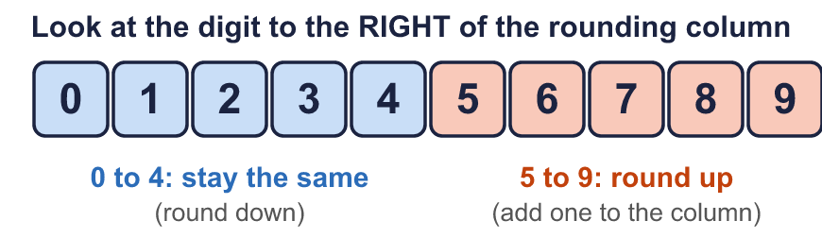 |  | Rounding rule to help you:
  Year 6 · Place value · Step 7  Rounding integers | 
  Year 6 · Place value · Step 7
  Rounding integers
  1 | Round each number to the nearest 10.  a) 8,069 to the nearest 10 =  b) 3,064 to the nearest 10 =  c) 9,949 to the nearest 10 =  Hint: Look at the ones digit. 5 or more: round up. 4 or less: stay the same.
  1 | Round each number to the nearest 10.  a) 8,069 to the nearest 10 =  b) 3,064 to the nearest 10 =  c) 9,949 to the nearest 10 =  Hint: Look at the ones digit. 5 or more: round up. 4 or less: stay the same.
  2 | Round each number to the nearest 100.  a) 29,029 to the nearest 100 =  b) 46,669 to the nearest 100 =  c) 77,293 to the nearest 100 =  Hint: Look at the tens digit (the digit to the right of the hundreds). 5 or more: round up.
  2 | Round each number to the nearest 100.  a) 29,029 to the nearest 100 =  b) 46,669 to the nearest 100 =  c) 77,293 to the nearest 100 =  Hint: Look at the tens digit (the digit to the right of the hundreds). 5 or more: round up.
  3 | Round each number to the nearest 1,000.  a) 73,825 to the nearest 1,000 =  b) 45,362 to the nearest 1,000 =  c) 84,865 to the nearest 1,000 =  Hint: Look at the hundreds digit. 5 or more: round up. 4 or less: stay the same.
  3 | Round each number to the nearest 1,000.  a) 73,825 to the nearest 1,000 =  b) 45,362 to the nearest 1,000 =  c) 84,865 to the nearest 1,000 =  Hint: Look at the hundreds digit. 5 or more: round up. 4 or less: stay the same.
  4 | Round each number to the nearest 10,000.  a) 682,879 to the nearest 10,000 =  b) 309,024 to the nearest 10,000 =  c) 218,439 to the nearest 10,000 =  Hint: Look at the thousands digit. 5 or more: round up. 4 or less: stay the same.
  4 | Round each number to the nearest 10,000.  a) 682,879 to the nearest 10,000 =  b) 309,024 to the nearest 10,000 =  c) 218,439 to the nearest 10,000 =  Hint: Look at the thousands digit. 5 or more: round up. 4 or less: stay the same.
  5 | The arrows show two numbers: A is 24,420 and B is 24,660. Round each to the nearest 1,000.  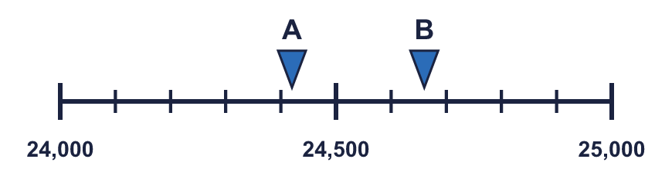  A rounds to B rounds to  Hint: The halfway mark is 24,500. Is the arrow before or after the halfway mark? Then look at the nearer end.
  5 | The arrows show two numbers: A is 24,420 and B is 24,660. Round each to the nearest 1,000.  A rounds to B rounds to  Hint: The halfway mark is 24,500. Is the arrow before or after the halfway mark? Then look at the nearer end.
  6 | Round each number.  a) 1,965,558 to the nearest 100,000 =  b) 7,157,644 to the nearest 1,000,000 =  c) 501,270 to the nearest 100,000 =  Hint: Find the rounding column first. Then look at the digit to its right.
  6 | Round each number.  a) 1,965,558 to the nearest 100,000 =  b) 7,157,644 to the nearest 1,000,000 =  c) 501,270 to the nearest 100,000 =  Hint: Find the rounding column first. Then look at the digit to its right.
  7 | Round 7,423,949 to each place.  a) the nearest 10 =  b) the nearest 1,000 =  c) the nearest 100,000 =  d) the nearest 1,000,000 =  Hint: Take each rounding place on its own. Always start again from the ORIGINAL number.
  7 | Round 7,423,949 to each place.  a) the nearest 10 =  b) the nearest 1,000 =  c) the nearest 100,000 =  d) the nearest 1,000,000 =  Hint: Take each rounding place on its own. Always start again from the ORIGINAL number.
  8 | Circle the numbers that round to 68,000 to the nearest 1,000. Write their letters.  a) 68,142  b) 68,500  c) 67,500  d) 67,508  e) 69,312  f) 66,872  Answer:  Hint: Rounding to the nearest 1,000 gives 68,000 for numbers from 67,500 up to 68,499. Which numbers are in that range?
  8 | Circle the numbers that round to 68,000 to the nearest 1,000. Write their letters.  a) 68,142  b) 68,500  c) 67,500  d) 67,508  e) 69,312  f) 66,872  Answer:  Hint: Rounding to the nearest 1,000 gives 68,000 for numbers from 67,500 up to 68,499. Which numbers are in that range?

  9 | a) Who is correct?  b) Explain the mistakes the other two have made.  Hint: Find the millions column first. Look at the hundred thousands digit: 5 or more rounds up.
     | 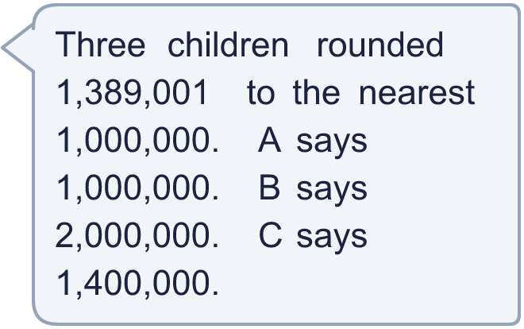
  9 | a) Who is correct?  b) Explain the mistakes the other two have made.  Hint: Find the millions column first. Look at the hundred thousands digit: 5 or more rounds up.
  10 | Is Boba correct? Circle yes or no.  Yes / No  Explain how you know.  Hint: Find the hundreds column, then look at the tens digit to its right.
    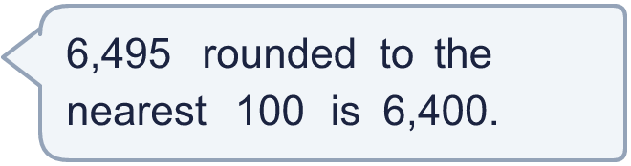
  10 | Is Boba correct? Circle yes or no.  Yes / No  Explain how you know.  Hint: Find the hundreds column, then look at the tens digit to its right.
  11 | There is a digit missing from each number. Write the digits that make it round to the number shown. There may be more than one.  a) 24,_43 rounds to 25,000 (nearest 1,000)  b) 33_,342 rounds to 340,000 (nearest 10,000)  c) 2_3,510 rounds to 300,000 (nearest 100,000)  Hint: Work out which numbers round to the target: they are all within half a step of it. Then try each digit.
  11 | There is a digit missing from each number. Write the digits that make it round to the number shown. There may be more than one.  a) 24,_43 rounds to 25,000 (nearest 1,000)  b) 33_,342 rounds to 340,000 (nearest 10,000)  c) 2_3,510 rounds to 300,000 (nearest 100,000)  Hint: Work out which numbers round to the target: they are all within half a step of it. Then try each digit.
  12 | A whole number rounds to 70,000 to the nearest 10,000.  a) What is the greatest it could be?  b) What is the smallest it could be?  Hint: Half of 10,000 is 5,000. The number can be up to just under 5,000 above 70,000, and down to 5,000 below it.
  12 | A whole number rounds to 70,000 to the nearest 10,000.  a) What is the greatest it could be?  b) What is the smallest it could be?  Hint: Half of 10,000 is 5,000. The number can be up to just under 5,000 above 70,000, and down to 5,000 below it.
  13 | a) Which number did the newspaper round to? Write 10, 100, 1,000 or 10,000.  b) What is the crowd rounded to the nearest 1,000?  Hint: Try each place: round the crowd to the nearest 10, 100, 1,000 and 10,000. Which one gives the newspaper's number?
     | 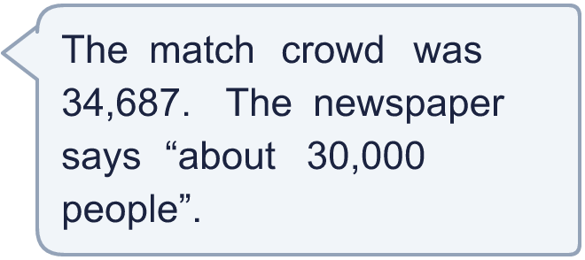
  13 | a) Which number did the newspaper round to? Write 10, 100, 1,000 or 10,000.  b) What is the crowd rounded to the nearest 1,000?  Hint: Try each place: round the crowd to the nearest 10, 100, 1,000 and 10,000. Which one gives the newspaper's number?
  14 | Write a number that rounds to 50,000 to the nearest 10,000 and to 51,000 to the nearest 1,000.  Hint: First find all the numbers that round to 51,000 to the nearest 1,000. Then check which of them also round to 50,000 to the nearest 10,000.
  14 | Write a number that rounds to 50,000 to the nearest 10,000 and to 51,000 to the nearest 1,000.  Hint: First find all the numbers that round to 51,000 to the nearest 1,000. Then check which of them also round to 50,000 to the nearest 10,000.

Year 6 · Place value · Step 7
Rounding integers
Answers (teacher copy)

Rounding rule to help you:
  1 | Round each number to the nearest 10.  a) 8,069 to the nearest 10 = 8,070  b) 3,064 to the nearest 10 = 3,060  c) 9,949 to the nearest 10 = 9,950  Hint: Look at the ones digit. 5 or more: round up. 4 or less: stay the same.
  2 | Round each number to the nearest 100.  a) 29,029 to the nearest 100 = 29,000  b) 46,669 to the nearest 100 = 46,700  c) 77,293 to the nearest 100 = 77,300  Hint: Look at the tens digit (the digit to the right of the hundreds). 5 or more: round up.
  3 | Round each number to the nearest 1,000.  a) 73,825 to the nearest 1,000 = 74,000  b) 45,362 to the nearest 1,000 = 45,000  c) 84,865 to the nearest 1,000 = 85,000  Hint: Look at the hundreds digit. 5 or more: round up. 4 or less: stay the same.
  4 | Round each number to the nearest 10,000.  a) 682,879 to the nearest 10,000 = 680,000  b) 309,024 to the nearest 10,000 = 310,000  c) 218,439 to the nearest 10,000 = 220,000  Hint: Look at the thousands digit. 5 or more: round up. 4 or less: stay the same.
  5 | The arrows show two numbers: A is 24,420 and B is 24,660. Round each to the nearest 1,000.  A rounds to 24,000 B rounds to 25,000  Hint: The halfway mark is 24,500. Is the arrow before or after the halfway mark? Then look at the nearer end.
  6 | Round each number.  a) 1,965,558 to the nearest 100,000 = 2,000,000  b) 7,157,644 to the nearest 1,000,000 = 7,000,000  c) 501,270 to the nearest 100,000 = 500,000  Hint: Find the rounding column first. Then look at the digit to its right.
  7 | Round 7,423,949 to each place.  a) the nearest 10 = 7,423,950  b) the nearest 1,000 = 7,424,000  c) the nearest 100,000 = 7,400,000  d) the nearest 1,000,000 = 7,000,000  Hint: Take each rounding place on its own. Always start again from the ORIGINAL number.
  8 | Circle the numbers that round to 68,000 to the nearest 1,000. Write their letters.  a) 68,142  b) 68,500  c) 67,500  d) 67,508  e) 69,312  f) 66,872  Answer: a, c, d  Hint: Rounding to the nearest 1,000 gives 68,000 for numbers from 67,500 up to 68,499. Which numbers are in that range?
  9 | a) Who is correct? A  b) Explain the mistakes the other two have made.  The correct answer is 1,000,000: the hundred thousands digit is 3, which is less than 5, so we round down. 1,400,000 is rounded to the nearest 100,000, not 1,000,000. 2,000,000 is rounded up when it should stay.  Hint: Find the millions column first. Look at the hundred thousands digit: 5 or more rounds up.
  10 | Is Boba correct? Circle yes or no.  Yes / No  Explain how you know.  The tens digit is 9, which is 5 or more, so we round up. 6,495 rounds to 6,500, not 6,400.  Hint: Find the hundreds column, then look at the tens digit to its right.
  11 | There is a digit missing from each number. Write the digits that make it round to the number shown. There may be more than one.  a) 24,_43 rounds to 25,000 (nearest 1,000) 5, 6, 7, 8, 9  b) 33_,342 rounds to 340,000 (nearest 10,000) 5, 6, 7, 8, 9  c) 2_3,510 rounds to 300,000 (nearest 100,000) 5, 6, 7, 8, 9  Hint: Work out which numbers round to the target: they are all within half a step of it. Then try each digit.
  12 | A whole number rounds to 70,000 to the nearest 10,000.  a) What is the greatest it could be? 74,999  b) What is the smallest it could be? 65,000  Hint: Half of 10,000 is 5,000. The number can be up to just under 5,000 above 70,000, and down to 5,000 below it.
  13 | a) Which number did the newspaper round to? Write 10, 100, 1,000 or 10,000. 10,000  b) What is the crowd rounded to the nearest 1,000? 35,000  Hint: Try each place: round the crowd to the nearest 10, 100, 1,000 and 10,000. Which one gives the newspaper's number?
  14 | Write a number that rounds to 50,000 to the nearest 10,000 and to 51,000 to the nearest 1,000.  Any number from 50,500 to 51,499, for example 50,730  Hint: First find all the numbers that round to 51,000 to the nearest 1,000. Then check which of them also round to 50,000 to the nearest 10,000.

