  Year 6 · Algebra · Step 9  Finding pairs of values | 
  Year 6 · Algebra · Step 9
  Finding pairs of values
  1 | a and b are whole numbers. a + b = 12. Complete the table.  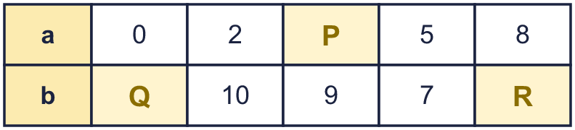
  1 | a and b are whole numbers. a + b = 12. Complete the table.
  2 | x and y are whole numbers. x + y = 14. Write the missing numbers. Some are in the x row and some are in the y row.  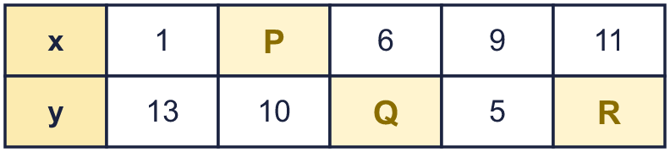
  2 | x and y are whole numbers. x + y = 14. Write the missing numbers. Some are in the x row and some are in the y row.
  3 | c and d are whole numbers. c − d = 3. Complete the table.  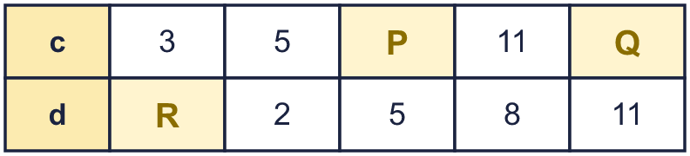
  3 | c and d are whole numbers. c − d = 3. Complete the table.
  4 | a and b are whole numbers and a is not bigger than b. a × b = 20. List all the pairs (a, b).
  4 | a and b are whole numbers and a is not bigger than b. a × b = 20. List all the pairs (a, b).
  5 | g and h are whole numbers from 1 to 9. g + 2h = 22. List all the pairs (g, h), starting with the smallest g.
  5 | g and h are whole numbers from 1 to 9. g + 2h = 22. List all the pairs (g, h), starting with the smallest g.
  6 | Two boxes, A and B, balance the scales with a 700 g weight. The mass of A and B are both whole hundreds of grams. A + B = 700 and A is heavier than B. List all the pairs (A, B).
  6 | Two boxes, A and B, balance the scales with a 700 g weight. The mass of A and B are both whole hundreds of grams. A + B = 700 and A is heavier than B. List all the pairs (A, B).
  7 | Eva only plots points (x, y) where x + y = 10. Which of these points can Eva plot? Write the letters.  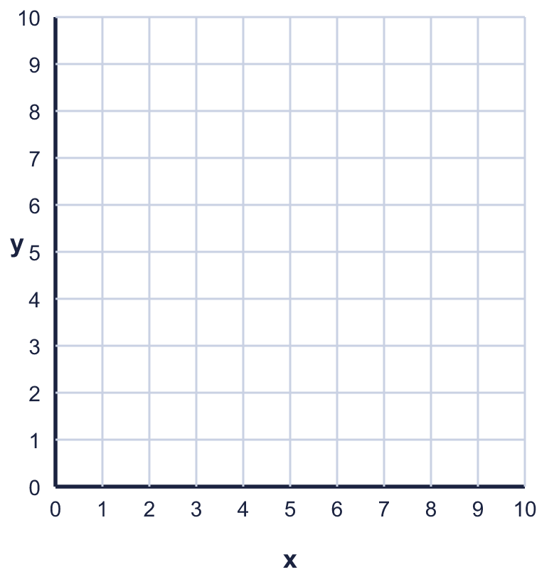  A: (4, 6)  B: (10, 1)  C: (8, 2)  D: (5, 5)
  7 | Eva only plots points (x, y) where x + y = 10. Which of these points can Eva plot? Write the letters.  A: (4, 6)  B: (10, 1)  C: (8, 2)  D: (5, 5)
  8 | Which of these pairs (a, b) make 2a + b = 20 true? Write the letters.  A: (9, 2)  B: (4, 5)  C: (4, 11)  D: (6, 14)
  8 | Which of these pairs (a, b) make 2a + b = 20 true? Write the letters.  A: (9, 2)  B: (4, 5)  C: (4, 11)  D: (6, 14)

  9 | Tia buys a pen and a ruler. The total cost is 90p. Each costs a whole number of pence.  Is it possible that the pen costs 90p? Circle yes or no.  Yes / No  Explain how you know.
  9 | Tia buys a pen and a ruler. The total cost is 90p. Each costs a whole number of pence.  Is it possible that the pen costs 90p? Circle yes or no.  Yes / No  Explain how you know.
  10 | a and b are whole numbers from 0 to 6. a + b = 6.  How many pairs (a, b) are there?
  10 | a and b are whole numbers from 0 to 6. a + b = 6.  How many pairs (a, b) are there?
  11 | x + y = 15
    x =
  11 | x + y = 15
    x =
  12 | k and j are positive whole numbers. k + 2j = 20.  How many pairs (k, j) are there?
  12 | k and j are positive whole numbers. k + 2j = 20.  How many pairs (k, j) are there?
  13 | p and q are positive whole numbers. 3p + 5q = 26. List all the pairs (p, q), starting with the smallest p.
  13 | p and q are positive whole numbers. 3p + 5q = 26. List all the pairs (p, q), starting with the smallest p.
  14 | Challenge  a and b are whole numbers and a is smaller than b. a + b = 8 and a × b = 15. Write the pair (a, b).
  14 | Challenge  a and b are whole numbers and a is smaller than b. a + b = 8 and a × b = 15. Write the pair (a, b).

Year 6 · Algebra · Step 9
Finding pairs of values
Answers (teacher copy)

  1 | a and b are whole numbers. a + b = 12. Complete the table.  P = 3  Q = 12  R = 4
  2 | x and y are whole numbers. x + y = 14. Write the missing numbers. Some are in the x row and some are in the y row.  P = 4  Q = 8  R = 3
  3 | c and d are whole numbers. c − d = 3. Complete the table.  P = 8  Q = 14  R = 0
  4 | a and b are whole numbers and a is not bigger than b. a × b = 20. List all the pairs (a, b).  (1, 20), (2, 10), (4, 5)
  5 | g and h are whole numbers from 1 to 9. g + 2h = 22. List all the pairs (g, h), starting with the smallest g.  (4, 9), (6, 8), (8, 7)
  6 | Two boxes, A and B, balance the scales with a 700 g weight. The mass of A and B are both whole hundreds of grams. A + B = 700 and A is heavier than B. List all the pairs (A, B).  (400, 300), (500, 200), (600, 100)
  7 | Eva only plots points (x, y) where x + y = 10. Which of these points can Eva plot? Write the letters.  A: (4, 6)  B: (10, 1)  C: (8, 2)  D: (5, 5)  A, C, D
  8 | Which of these pairs (a, b) make 2a + b = 20 true? Write the letters.  A: (9, 2)  B: (4, 5)  C: (4, 11)  D: (6, 14)  A
  9 | Tia buys a pen and a ruler. The total cost is 90p. Each costs a whole number of pence.  Is it possible that the pen costs 90p? Circle yes or no.  Yes / No  Explain how you know.  No. If the pen costs 90p, the ruler would cost nothing.
  10 | a and b are whole numbers from 0 to 6. a + b = 6.  How many pairs (a, b) are there? 7
  11 | x + y = 15  x = 15 − y
  12 | k and j are positive whole numbers. k + 2j = 20.  How many pairs (k, j) are there? 9
  13 | p and q are positive whole numbers. 3p + 5q = 26. List all the pairs (p, q), starting with the smallest p.  (2, 4), (7, 1)
  14 | Challenge  a and b are whole numbers and a is smaller than b. a + b = 8 and a × b = 15. Write the pair (a, b).  (3, 5)

