a + b = 8 is true for many pairs of numbers. Each pair adds to 8:  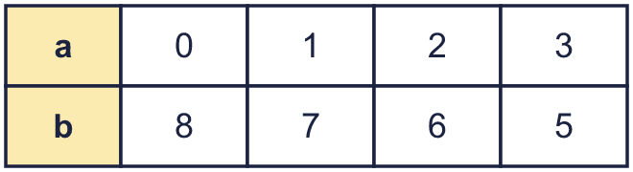 |  | a + b = 8 is true for many pairs of numbers. Each pair adds to 8:
  Year 6 · Algebra · Step 9  Finding pairs of values | 
  Year 6 · Algebra · Step 9
  Finding pairs of values
  1 | a and b are whole numbers. a + b = 12. Complete the table.  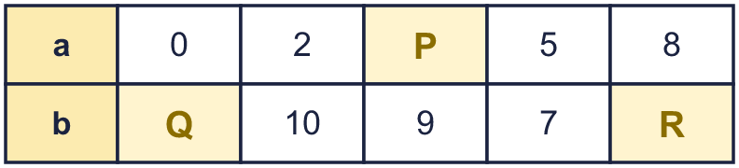  Hint: The two numbers in each column add to 12. What must be added to the top number to make 12?
  1 | a and b are whole numbers. a + b = 12. Complete the table.  Hint: The two numbers in each column add to 12. What must be added to the top number to make 12?
  2 | x and y are whole numbers. x + y = 14. Write the missing numbers. Some are in the x row and some are in the y row.  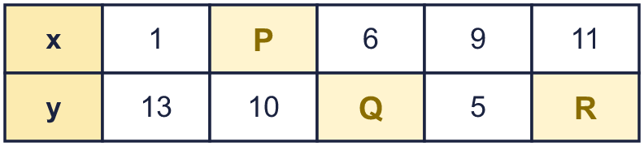  Hint: Each column adds to 14. Take away the number you can see.
  2 | x and y are whole numbers. x + y = 14. Write the missing numbers. Some are in the x row and some are in the y row.  Hint: Each column adds to 14. Take away the number you can see.
  3 | c and d are whole numbers. c − d = 3. Complete the table.  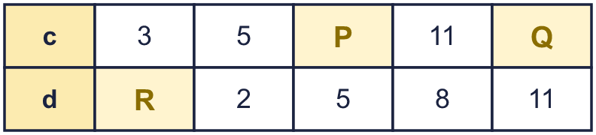  Hint: c is always 3 more than d. Add or take away 3.
  3 | c and d are whole numbers. c − d = 3. Complete the table.  Hint: c is always 3 more than d. Add or take away 3.
  4 | a and b are whole numbers and a is not bigger than b. a × b = 20. List all the pairs (a, b).  Hint: Find all the factor pairs of 20. Start with 1 × 20.
  4 | a and b are whole numbers and a is not bigger than b. a × b = 20. List all the pairs (a, b).  Hint: Find all the factor pairs of 20. Start with 1 × 20.
  5 | g and h are whole numbers from 1 to 9. g + 2h = 22. List all the pairs (g, h), starting with the smallest g.  Hint: 2h is a double. Try h = 9, 8, 7 … and find g each time.
  5 | g and h are whole numbers from 1 to 9. g + 2h = 22. List all the pairs (g, h), starting with the smallest g.  Hint: 2h is a double. Try h = 9, 8, 7 … and find g each time.
  6 | Two boxes, A and B, balance the scales with a 700 g weight. The mass of A and B are both whole hundreds of grams. A + B = 700 and A is heavier than B. List all the pairs (A, B).  Hint: A and B add to 700. A must be more than half of 700.
  6 | Two boxes, A and B, balance the scales with a 700 g weight. The mass of A and B are both whole hundreds of grams. A + B = 700 and A is heavier than B. List all the pairs (A, B).  Hint: A and B add to 700. A must be more than half of 700.
  7 | Eva only plots points (x, y) where x + y = 10. Which of these points can Eva plot? Write the letters.  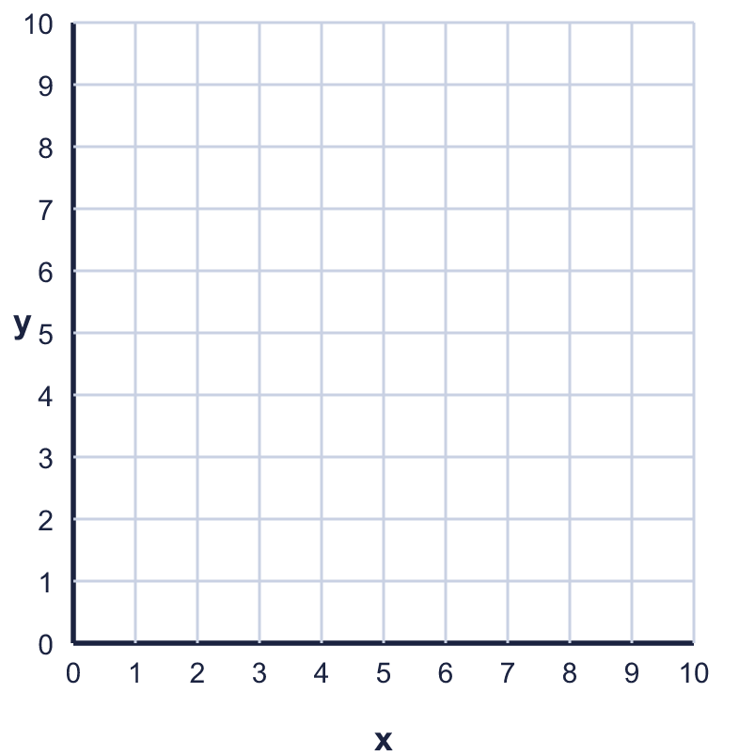  A: (4, 6)  B: (10, 1)  C: (8, 2)  D: (5, 5)  Hint: Add the x and y numbers of each point. Is the total 10?
  7 | Eva only plots points (x, y) where x + y = 10. Which of these points can Eva plot? Write the letters.  A: (4, 6)  B: (10, 1)  C: (8, 2)  D: (5, 5)  Hint: Add the x and y numbers of each point. Is the total 10?
  8 | Which of these pairs (a, b) make 2a + b = 20 true? Write the letters.  A: (9, 2)  B: (4, 5)  C: (4, 11)  D: (6, 14)  Hint: Put the numbers in. Work out 2a first, then add b.
  8 | Which of these pairs (a, b) make 2a + b = 20 true? Write the letters.  A: (9, 2)  B: (4, 5)  C: (4, 11)  D: (6, 14)  Hint: Put the numbers in. Work out 2a first, then add b.

  9 | Tia buys a pen and a ruler. The total cost is 90p. Each costs a whole number of pence.  Is it possible that the pen costs 90p? Circle yes or no.  Yes / No  Explain how you know.  Hint: The two prices add to the total. Both must be more than 0p.
  9 | Tia buys a pen and a ruler. The total cost is 90p. Each costs a whole number of pence.  Is it possible that the pen costs 90p? Circle yes or no.  Yes / No  Explain how you know.  Hint: The two prices add to the total. Both must be more than 0p.
  10 | a and b are whole numbers from 0 to 6. a + b = 6.  How many pairs (a, b) are there?  Hint: Start with a = 0, b = 6. Then a = 1 … and keep going until b = 0.
  10 | a and b are whole numbers from 0 to 6. a + b = 6.  How many pairs (a, b) are there?  Hint: Start with a = 0, b = 6. Then a = 1 … and keep going until b = 0.
  11 | x + y = 15  Hint: If the two numbers make 15, one of them is 15 take away the other.
    x =
  11 | x + y = 15  Hint: If the two numbers make 15, one of them is 15 take away the other.
    x =
  12 | k and j are positive whole numbers. k + 2j = 20.  How many pairs (k, j) are there?  Hint: k must have the same evenness as 20. Try j = 1, 2, 3 … and find k.
  12 | k and j are positive whole numbers. k + 2j = 20.  How many pairs (k, j) are there?  Hint: k must have the same evenness as 20. Try j = 1, 2, 3 … and find k.
  13 | p and q are positive whole numbers. 3p + 5q = 26. List all the pairs (p, q), starting with the smallest p.  Hint: Try q = 1, 2, 3 … Is 26 − 5q a number in the 3 times table?
  13 | p and q are positive whole numbers. 3p + 5q = 26. List all the pairs (p, q), starting with the smallest p.  Hint: Try q = 1, 2, 3 … Is 26 − 5q a number in the 3 times table?
  14 | Challenge  a and b are whole numbers and a is smaller than b. a + b = 8 and a × b = 15. Write the pair (a, b).  Hint: List the pairs that add to 8. Which pair multiplies to 15?
  14 | Challenge  a and b are whole numbers and a is smaller than b. a + b = 8 and a × b = 15. Write the pair (a, b).  Hint: List the pairs that add to 8. Which pair multiplies to 15?

Year 6 · Algebra · Step 9
Finding pairs of values
Answers (teacher copy)

a + b = 8 is true for many pairs of numbers. Each pair adds to 8:
  1 | a and b are whole numbers. a + b = 12. Complete the table.  P = 3  Q = 12  R = 4  Hint: The two numbers in each column add to 12. What must be added to the top number to make 12?
  2 | x and y are whole numbers. x + y = 14. Write the missing numbers. Some are in the x row and some are in the y row.  P = 4  Q = 8  R = 3  Hint: Each column adds to 14. Take away the number you can see.
  3 | c and d are whole numbers. c − d = 3. Complete the table.  P = 8  Q = 14  R = 0  Hint: c is always 3 more than d. Add or take away 3.
  4 | a and b are whole numbers and a is not bigger than b. a × b = 20. List all the pairs (a, b).  (1, 20), (2, 10), (4, 5)  Hint: Find all the factor pairs of 20. Start with 1 × 20.
  5 | g and h are whole numbers from 1 to 9. g + 2h = 22. List all the pairs (g, h), starting with the smallest g.  (4, 9), (6, 8), (8, 7)  Hint: 2h is a double. Try h = 9, 8, 7 … and find g each time.
  6 | Two boxes, A and B, balance the scales with a 700 g weight. The mass of A and B are both whole hundreds of grams. A + B = 700 and A is heavier than B. List all the pairs (A, B).  (400, 300), (500, 200), (600, 100)  Hint: A and B add to 700. A must be more than half of 700.
  7 | Eva only plots points (x, y) where x + y = 10. Which of these points can Eva plot? Write the letters.  A: (4, 6)  B: (10, 1)  C: (8, 2)  D: (5, 5)  A, C, D  Hint: Add the x and y numbers of each point. Is the total 10?
  8 | Which of these pairs (a, b) make 2a + b = 20 true? Write the letters.  A: (9, 2)  B: (4, 5)  C: (4, 11)  D: (6, 14)  A  Hint: Put the numbers in. Work out 2a first, then add b.
  9 | Tia buys a pen and a ruler. The total cost is 90p. Each costs a whole number of pence.  Is it possible that the pen costs 90p? Circle yes or no.  Yes / No  Explain how you know.  No. If the pen costs 90p, the ruler would cost nothing.  Hint: The two prices add to the total. Both must be more than 0p.
  10 | a and b are whole numbers from 0 to 6. a + b = 6.  How many pairs (a, b) are there? 7  Hint: Start with a = 0, b = 6. Then a = 1 … and keep going until b = 0.
  11 | x + y = 15  x = 15 − y  Hint: If the two numbers make 15, one of them is 15 take away the other.
  12 | k and j are positive whole numbers. k + 2j = 20.  How many pairs (k, j) are there? 9  Hint: k must have the same evenness as 20. Try j = 1, 2, 3 … and find k.
  13 | p and q are positive whole numbers. 3p + 5q = 26. List all the pairs (p, q), starting with the smallest p.  (2, 4), (7, 1)  Hint: Try q = 1, 2, 3 … Is 26 − 5q a number in the 3 times table?
  14 | Challenge  a and b are whole numbers and a is smaller than b. a + b = 8 and a × b = 15. Write the pair (a, b).  (3, 5)  Hint: List the pairs that add to 8. Which pair multiplies to 15?

