  Year 6 · Algebra · Step 3  Forming expressions | 
  Year 6 · Algebra · Step 3
  Forming expressions
  1 | Each big cube is x and each small cube is 1. Write an expression for each set of cubes.  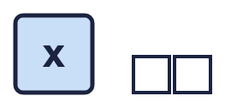  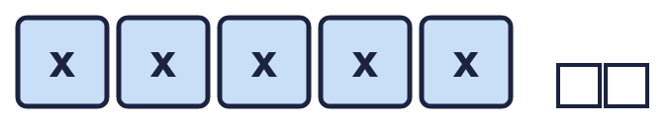  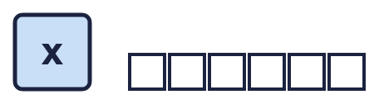
  1 | Each big cube is x and each small cube is 1. Write an expression for each set of cubes.
  2 | Each big cube is x and each small cube is 1. How many of each kind of cube make these expressions?
    a) x + 7: |  | big cubes and
    small cubes
    b) 3x: |  | big cubes and
    small cubes
    c) 3x + 4: |  | big cubes and
    small cubes
  2 | Each big cube is x and each small cube is 1. How many of each kind of cube make these expressions?
    a) x + 7: |  | big cubes and
    small cubes
    b) 3x: |  | big cubes and
    small cubes
    c) 3x + 4: |  | big cubes and
    small cubes
  3 | Simplify each expression. Collect the letters together.
    a) 7p + 6 − 3p =
    b) 3p + 1 + p + p =
    c) 4p + 5 + p =
    d) p + 6 + p + p =
  3 | Simplify each expression. Collect the letters together.
    a) 7p + 6 − 3p =
    b) 3p + 1 + p + p =
    c) 4p + 5 + p =
    d) p + 6 + p + p =
  4 | Write the output of each machine as an expression.  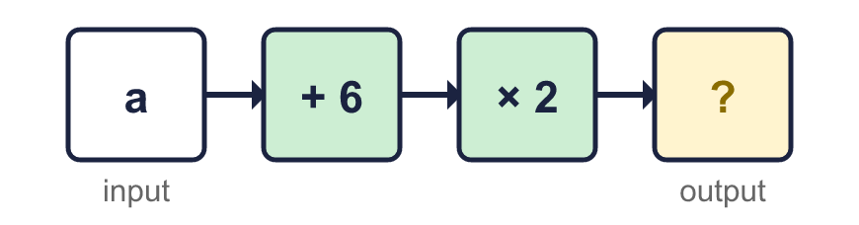  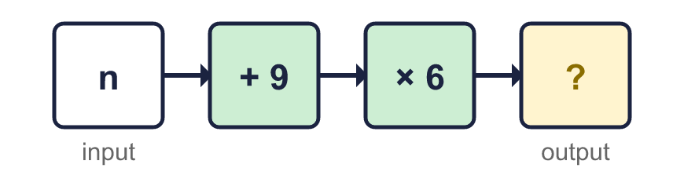
  4 | Write the output of each machine as an expression.
  5 | Write an expression for each statement.
    a) 6 more than n:
    b) p multiplied by 5:
    c) 6 less than n:
    d) p divided by 3:
  5 | Write an expression for each statement.
    a) 6 more than n:
    b) p multiplied by 5:
    c) 6 less than n:
    d) p divided by 3:
  6 | Write an expression for the perimeter of each rectangle.  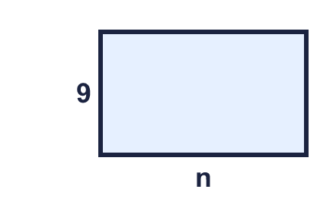  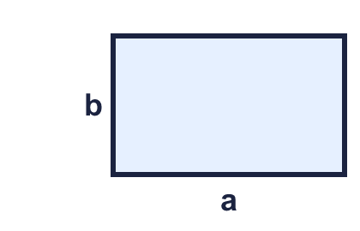  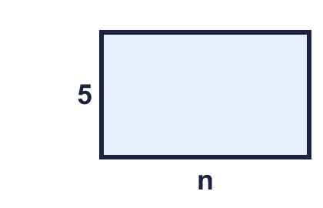
  6 | Write an expression for the perimeter of each rectangle.
  7 | Write an expression for the whole bar in each bar model.  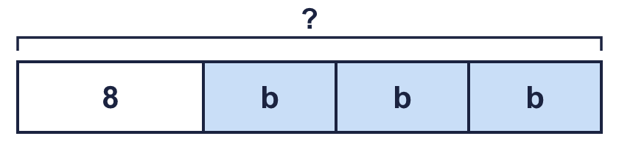  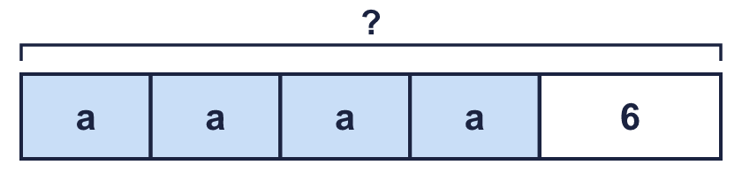
  7 | Write an expression for the whole bar in each bar model.
  8 | Simplify each expression. It has two different letters.
    a) 7a − 2a + 2b + 2b =
    b) 3b + 2b + 7a − 2a =
  8 | Simplify each expression. It has two different letters.
    a) 7a − 2a + 2b + 2b =
    b) 3b + 2b + 7a − 2a =

  9 | Is Amir correct? Circle yes or no.  Yes / No  Explain. You can try n = 2.
     | 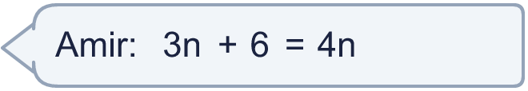
  9 | Is Amir correct? Circle yes or no.  Yes / No  Explain. You can try n = 2.
  10 | Three of these expressions are equal. One is different.  A: 5a  B: 3a + 2a  C: a + 5  D: 4a + a  Which expression is the odd one out? Write its letter.
  10 | Three of these expressions are equal. One is different.  A: 5a  B: 3a + 2a  C: a + 5  D: 4a + a  Which expression is the odd one out? Write its letter.
  11 | Megan has 6 boxes. There are m counters in each box. She puts all the counters in a pile and takes 7 away. Write an expression for the number of counters in the pile.
  11 | Megan has 6 boxes. There are m counters in each box. She puts all the counters in a pile and takes 7 away. Write an expression for the number of counters in the pile.
  12 | Here is a rectangle.  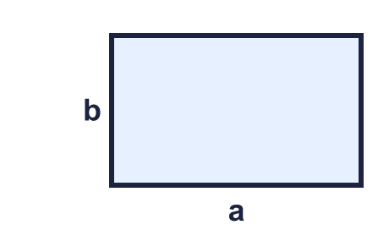
  12 | Here is a rectangle.
  13 | Write an expression for the perimeter of the triangle.  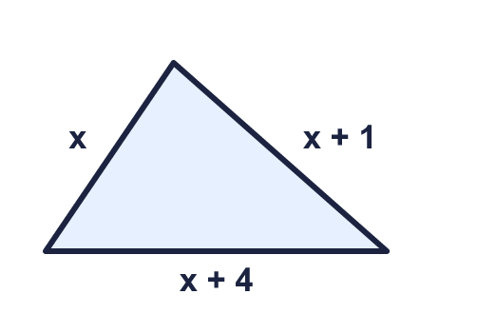
  13 | Write an expression for the perimeter of the triangle.
  14 | Challenge  Here is a rectangle.  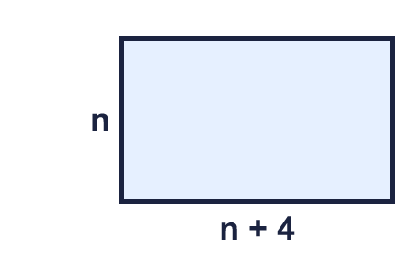  a) Write an expression for the perimeter:  b) The perimeter when n = 5:
  14 | Challenge  Here is a rectangle.  a) Write an expression for the perimeter:  b) The perimeter when n = 5:

Year 6 · Algebra · Step 3
Forming expressions
Answers (teacher copy)

  1 | Each big cube is x and each small cube is 1. Write an expression for each set of cubes.  a) x + 2  b) 5x + 2  c) x + 6
  2 | Each big cube is x and each small cube is 1. How many of each kind of cube make these expressions?  a) x + 7: 1 big cubes and 7 small cubes  b) 3x: 3 big cubes and 0 small cubes  c) 3x + 4: 3 big cubes and 4 small cubes
  3 | Simplify each expression. Collect the letters together.  a) 7p + 6 − 3p = 4p + 6  b) 3p + 1 + p + p = 5p + 1  c) 4p + 5 + p = 5p + 5  d) p + 6 + p + p = 3p + 6
  4 | Write the output of each machine as an expression.  a) 2a + 12  b) 6n + 54
  5 | Write an expression for each statement.  a) 6 more than n: n + 6  b) p multiplied by 5: 5p  c) 6 less than n: n − 6  d) p divided by 3: p ÷ 3
  6 | Write an expression for the perimeter of each rectangle.  a) 2n + 18  b) 2a + 2b  c) 2n + 10
  7 | Write an expression for the whole bar in each bar model.  a) 3b + 8  b) 4a + 6
  8 | Simplify each expression. It has two different letters.  a) 7a − 2a + 2b + 2b = 5a + 4b  b) 3b + 2b + 7a − 2a = 5a + 5b
  9 | Is Amir correct? Circle yes or no.  Yes / No  Explain. You can try n = 2.  No. When n = 2, 3n + 6 = 12 but 4n = 8.
  10 | Three of these expressions are equal. One is different.  A: 5a  B: 3a + 2a  C: a + 5  D: 4a + a  Which expression is the odd one out? Write its letter.  C
  11 | Megan has 6 boxes. There are m counters in each box. She puts all the counters in a pile and takes 7 away. Write an expression for the number of counters in the pile.  6m − 7
  12 | Here is a rectangle.  a) Perimeter: 2a + 2b  b) Area: ab
  13 | Write an expression for the perimeter of the triangle.  3x + 5
  14 | Challenge  Here is a rectangle.  a) Write an expression for the perimeter: 4n + 8  b) The perimeter when n = 5: 28

