Each big cube is x and each small cube is 1. This is 3x + 2 (three x and two ones):  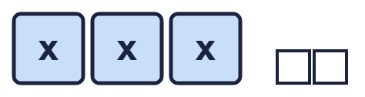 |  | Each big cube is x and each small cube is 1. This is 3x + 2 (three x and two ones):
  Year 6 · Algebra · Step 3  Forming expressions | 
  Year 6 · Algebra · Step 3
  Forming expressions
  1 | Each big cube is x and each small cube is 1. Write an expression for each set of cubes.  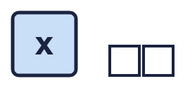  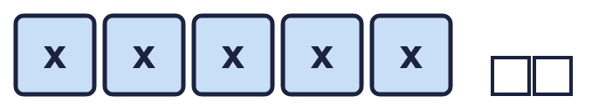  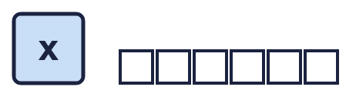  Hint: Count the big cubes: that is the number of x. Then count the small cubes.
  1 | Each big cube is x and each small cube is 1. Write an expression for each set of cubes.  Hint: Count the big cubes: that is the number of x. Then count the small cubes.
  2 | Each big cube is x and each small cube is 1. How many of each kind of cube make these expressions?  Hint: The number in front of x tells you how many big cubes. The number on its own tells you how many small cubes.
    a) x + 7: |  | big cubes and
    small cubes
    b) 3x: |  | big cubes and
    small cubes
    c) 3x + 4: |  | big cubes and
    small cubes
  2 | Each big cube is x and each small cube is 1. How many of each kind of cube make these expressions?  Hint: The number in front of x tells you how many big cubes. The number on its own tells you how many small cubes.
    a) x + 7: |  | big cubes and
    small cubes
    b) 3x: |  | big cubes and
    small cubes
    c) 3x + 4: |  | big cubes and
    small cubes
  3 | Simplify each expression. Collect the letters together.  Hint: Add the terms with the same letter. Then write the number on its own.
    a) 7p + 6 − 3p =
    b) 3p + 1 + p + p =
    c) 4p + 5 + p =
    d) p + 6 + p + p =
  3 | Simplify each expression. Collect the letters together.  Hint: Add the terms with the same letter. Then write the number on its own.
    a) 7p + 6 − 3p =
    b) 3p + 1 + p + p =
    c) 4p + 5 + p =
    d) p + 6 + p + p =
  4 | Write the output of each machine as an expression.  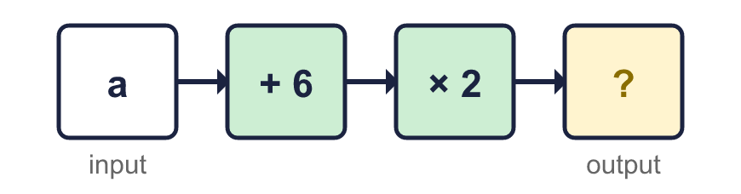  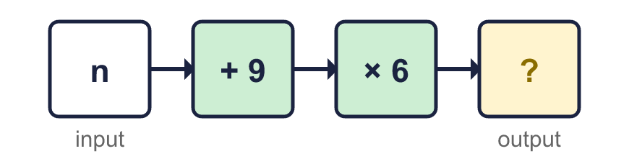  Hint: Put the letter through the machine one step at a time. Remember to multiply the whole of the first answer.
  4 | Write the output of each machine as an expression.  Hint: Put the letter through the machine one step at a time. Remember to multiply the whole of the first answer.
  5 | Write an expression for each statement.  Hint: Think about which number or letter comes first, especially for “less than” and “divided by”.
    a) 6 more than n:
    b) p multiplied by 5:
    c) 6 less than n:
    d) p divided by 3:
  5 | Write an expression for each statement.  Hint: Think about which number or letter comes first, especially for “less than” and “divided by”.
    a) 6 more than n:
    b) p multiplied by 5:
    c) 6 less than n:
    d) p divided by 3:
  6 | Write an expression for the perimeter of each rectangle.  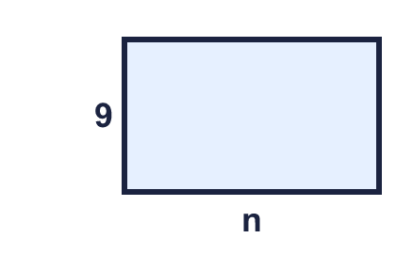  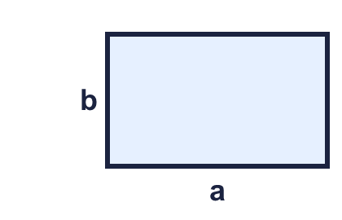  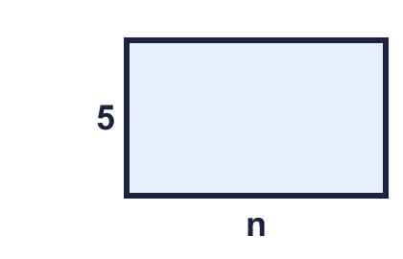  Hint: Add all four sides. Opposite sides are the same length.
  6 | Write an expression for the perimeter of each rectangle.  Hint: Add all four sides. Opposite sides are the same length.
  7 | Write an expression for the whole bar in each bar model.  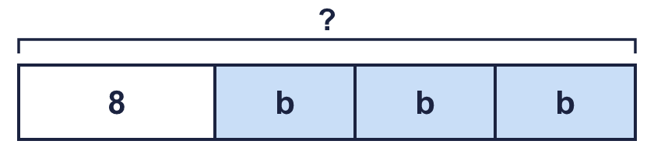  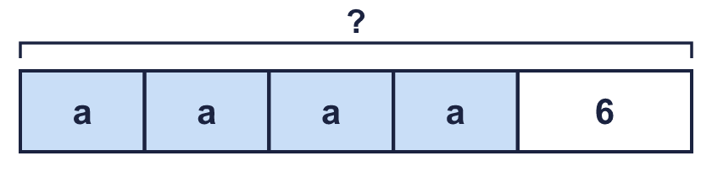  Hint: Add up every part of the bar. The same letter means the same number.
  7 | Write an expression for the whole bar in each bar model.  Hint: Add up every part of the bar. The same letter means the same number.
  8 | Simplify each expression. It has two different letters.  Hint: Collect all the a terms together. Then collect all the b terms.
    a) 7a − 2a + 2b + 2b =
    b) 3b + 2b + 7a − 2a =
  8 | Simplify each expression. It has two different letters.  Hint: Collect all the a terms together. Then collect all the b terms.
    a) 7a − 2a + 2b + 2b =
    b) 3b + 2b + 7a − 2a =

  9 | Is Amir correct? Circle yes or no.  Yes / No  Explain. You can try n = 2.  Hint: Put n = 2 into both sides. Do you get the same number?
     | 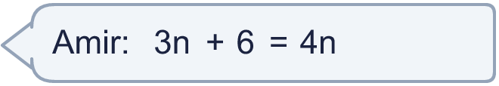
  9 | Is Amir correct? Circle yes or no.  Yes / No  Explain. You can try n = 2.  Hint: Put n = 2 into both sides. Do you get the same number?
  10 | Three of these expressions are equal. One is different.  A: 5a  B: 3a + 2a  C: a + 5  D: 4a + a  Which expression is the odd one out? Write its letter.  Hint: Simplify each expression. Which one is not the same as the others?
  10 | Three of these expressions are equal. One is different.  A: 5a  B: 3a + 2a  C: a + 5  D: 4a + a  Which expression is the odd one out? Write its letter.  Hint: Simplify each expression. Which one is not the same as the others?
  11 | Megan has 6 boxes. There are m counters in each box. She puts all the counters in a pile and takes 7 away. Write an expression for the number of counters in the pile.  Hint: Write down what is repeated, and what is added or taken away.
  11 | Megan has 6 boxes. There are m counters in each box. She puts all the counters in a pile and takes 7 away. Write an expression for the number of counters in the pile.  Hint: Write down what is repeated, and what is added or taken away.
  12 | Here is a rectangle.  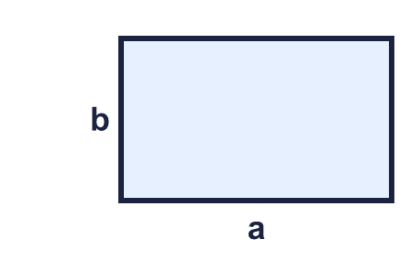  Hint: Perimeter: add all four sides. Area: length × width.
  12 | Here is a rectangle.  Hint: Perimeter: add all four sides. Area: length × width.
  13 | Write an expression for the perimeter of the triangle.  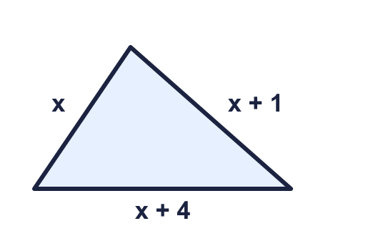  Hint: Add the three sides. Collect the letters, then the numbers.
  13 | Write an expression for the perimeter of the triangle.  Hint: Add the three sides. Collect the letters, then the numbers.
  14 | Challenge  Here is a rectangle.  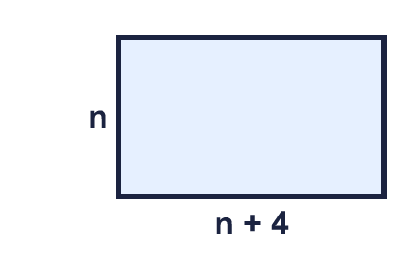  a) Write an expression for the perimeter:  b) The perimeter when n = 5:  Hint: Add the four sides and simplify. Then put the number in for the letter.
  14 | Challenge  Here is a rectangle.  a) Write an expression for the perimeter:  b) The perimeter when n = 5:  Hint: Add the four sides and simplify. Then put the number in for the letter.

Year 6 · Algebra · Step 3
Forming expressions
Answers (teacher copy)

Each big cube is x and each small cube is 1. This is 3x + 2 (three x and two ones):
  1 | Each big cube is x and each small cube is 1. Write an expression for each set of cubes.  a) x + 2  b) 5x + 2  c) x + 6  Hint: Count the big cubes: that is the number of x. Then count the small cubes.
  2 | Each big cube is x and each small cube is 1. How many of each kind of cube make these expressions?  a) x + 7: 1 big cubes and 7 small cubes  b) 3x: 3 big cubes and 0 small cubes  c) 3x + 4: 3 big cubes and 4 small cubes  Hint: The number in front of x tells you how many big cubes. The number on its own tells you how many small cubes.
  3 | Simplify each expression. Collect the letters together.  a) 7p + 6 − 3p = 4p + 6  b) 3p + 1 + p + p = 5p + 1  c) 4p + 5 + p = 5p + 5  d) p + 6 + p + p = 3p + 6  Hint: Add the terms with the same letter. Then write the number on its own.
  4 | Write the output of each machine as an expression.  a) 2a + 12  b) 6n + 54  Hint: Put the letter through the machine one step at a time. Remember to multiply the whole of the first answer.
  5 | Write an expression for each statement.  a) 6 more than n: n + 6  b) p multiplied by 5: 5p  c) 6 less than n: n − 6  d) p divided by 3: p ÷ 3  Hint: Think about which number or letter comes first, especially for “less than” and “divided by”.
  6 | Write an expression for the perimeter of each rectangle.  a) 2n + 18  b) 2a + 2b  c) 2n + 10  Hint: Add all four sides. Opposite sides are the same length.
  7 | Write an expression for the whole bar in each bar model.  a) 3b + 8  b) 4a + 6  Hint: Add up every part of the bar. The same letter means the same number.
  8 | Simplify each expression. It has two different letters.  a) 7a − 2a + 2b + 2b = 5a + 4b  b) 3b + 2b + 7a − 2a = 5a + 5b  Hint: Collect all the a terms together. Then collect all the b terms.
  9 | Is Amir correct? Circle yes or no.  Yes / No  Explain. You can try n = 2.  No. When n = 2, 3n + 6 = 12 but 4n = 8.  Hint: Put n = 2 into both sides. Do you get the same number?
  10 | Three of these expressions are equal. One is different.  A: 5a  B: 3a + 2a  C: a + 5  D: 4a + a  Which expression is the odd one out? Write its letter.  C  Hint: Simplify each expression. Which one is not the same as the others?
  11 | Megan has 6 boxes. There are m counters in each box. She puts all the counters in a pile and takes 7 away. Write an expression for the number of counters in the pile.  6m − 7  Hint: Write down what is repeated, and what is added or taken away.
  12 | Here is a rectangle.  a) Perimeter: 2a + 2b  b) Area: ab  Hint: Perimeter: add all four sides. Area: length × width.
  13 | Write an expression for the perimeter of the triangle.  3x + 5  Hint: Add the three sides. Collect the letters, then the numbers.
  14 | Challenge  Here is a rectangle.  a) Write an expression for the perimeter: 4n + 8  b) The perimeter when n = 5: 28  Hint: Add the four sides and simplify. Then put the number in for the letter.

