To solve an equation, use the opposite operation on both sides: the opposite of + is −, and the opposite of × is ÷:  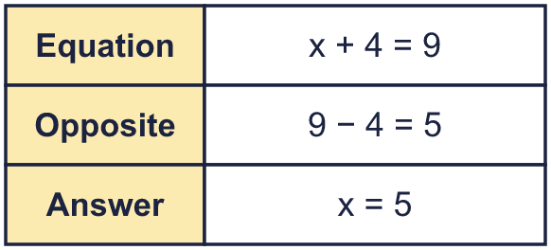 |  | To solve an equation, use the opposite operation on both sides: the opposite of + is −, and the opposite of × is ÷:
  Year 6 · Algebra · Step 7  Solving one-step equations | 
  Year 6 · Algebra · Step 7
  Solving one-step equations
  1 | Each part-whole model is an equation. Work out the value of y.  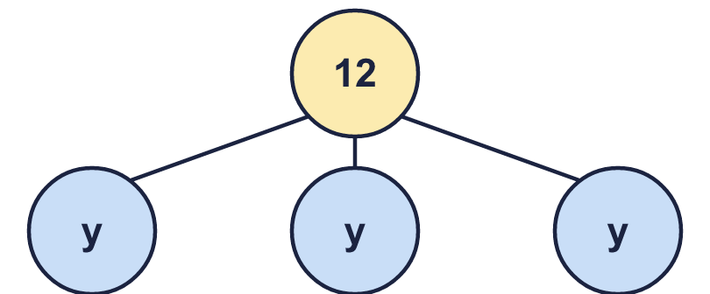  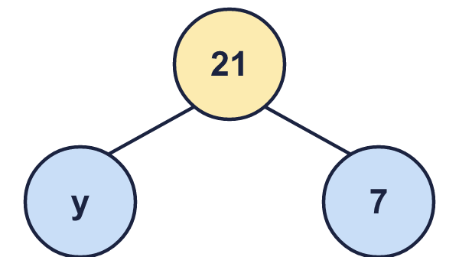  Hint: Add the parts to make the whole. Then work out the missing part.
    a) y =
    b) y =
  1 | Each part-whole model is an equation. Work out the value of y.  Hint: Add the parts to make the whole. Then work out the missing part.
    a) y =
    b) y =
  2 | Solve each equation.  Hint: Use the opposite operation to get the letter on its own.
    a) p − 28 = 4 | p =
    b) g − 30 = 9 | g =
    c) u − 7 = 7 | u =
    d) x + 13 = 16 | x =
  2 | Solve each equation.  Hint: Use the opposite operation to get the letter on its own.
    a) p − 28 = 4 | p =
    b) g − 30 = 9 | g =
    c) u − 7 = 7 | u =
    d) x + 13 = 16 | x =
  3 | Work out the value of the letter in each bar model.  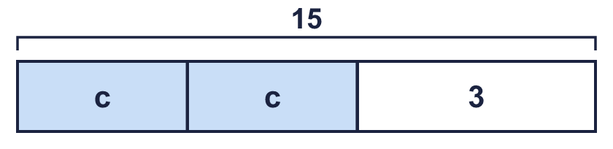  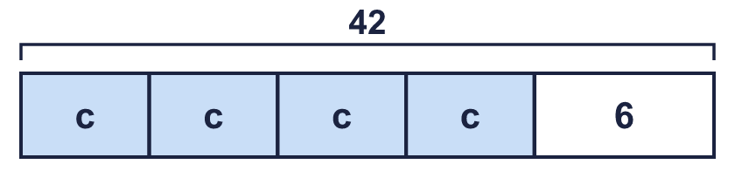  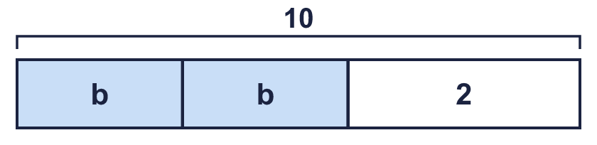  Hint: Take the number away from the total. Then share what is left between the letters.
    a) c =
    b) c =
    c) b =
  3 | Work out the value of the letter in each bar model.  Hint: Take the number away from the total. Then share what is left between the letters.
    a) c =
    b) c =
    c) b =
  4 | Solve each equation.  Hint: ÷ is the opposite of ×. − is the opposite of +.
    a) y + 12 = 24 | y =
    b) 10g = 120 | g =
    c) g ÷ 8 = 15 | g =
    d) 8y = 40 | y =
  4 | Solve each equation.  Hint: ÷ is the opposite of ×. − is the opposite of +.
    a) y + 12 = 24 | y =
    b) 10g = 120 | g =
    c) g ÷ 8 = 15 | g =
    d) 8y = 40 | y =
  5 | Solve each equation. Some answers are not whole numbers.  Hint: Divide. Write the remainder as a decimal.
    a) 5m = 22 | m =
    b) 2u = 3 | u =
    c) 10p = 4 | p =
    d) 5k = 12 | k =
  5 | Solve each equation. Some answers are not whole numbers.  Hint: Divide. Write the remainder as a decimal.
    a) 5m = 22 | m =
    b) 2u = 3 | u =
    c) 10p = 4 | p =
    d) 5k = 12 | k =
  6 | Call my number g. I subtract 2 from my number. The answer is 23.  Hint: Work backwards through the story, doing the opposite each time.
    g =
  6 | Call my number g. I subtract 2 from my number. The answer is 23.  Hint: Work backwards through the story, doing the opposite each time.
    g =
  7 | Dexter builds a tower. Each block is 3a centimetres high. He uses 5 blocks. The tower is 90 cm high.  Hint: 5 blocks of 3a make 15a.
    a) Write an equation:
    b) a =
  7 | Dexter builds a tower. Each block is 3a centimetres high. He uses 5 blocks. The tower is 90 cm high.  Hint: 5 blocks of 3a make 15a.
    a) Write an equation:
    b) a =
  8 | Solve each equation.  Hint: Check your answer by putting it back into the equation.
    a) 2k = 66 | k =
    b) 5g = 65 | g =
    c) u ÷ 8 = 33 | u =
    d) k − 17 = 29 | k =
  8 | Solve each equation.  Hint: Check your answer by putting it back into the equation.
    a) 2k = 66 | k =
    b) 5g = 65 | g =
    c) u ÷ 8 = 33 | u =
    d) k − 17 = 29 | k =

  9 | Nijah solves the equation x − 4 = 36.  Is Boba correct? Circle yes or no.  Yes / No  Explain the mistake. Then write the correct answer.  Hint: Check: put 32 in for x. Does it work?
     | 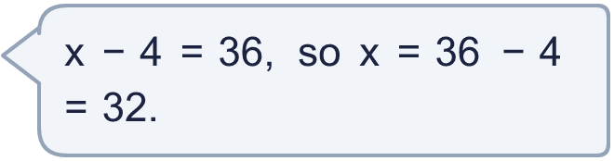
  9 | Nijah solves the equation x − 4 = 36.  Is Boba correct? Circle yes or no.  Yes / No  Explain the mistake. Then write the correct answer.  Hint: Check: put 32 in for x. Does it work?
  10 | Which of these equations have the solution n = 9? Write the letters.  A: n − 1 = 8  B: 2n = 19  C: n + 4 = 13  D: n ÷ 3 = 3  Hint: Put 9 in for n in each equation. Is it true?
  10 | Which of these equations have the solution n = 9? Write the letters.  A: n − 1 = 8  B: 2n = 19  C: n + 4 = 13  D: n ÷ 3 = 3  Hint: Put 9 in for n in each equation. Is it true?
  11 | The perimeter of this rectangle is 26 cm.  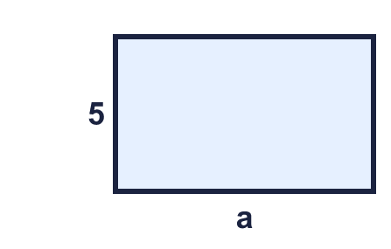  Hint: Write an equation: a + 5 + a + 5 = 26. Then solve it.
    a = |  | cm
  11 | The perimeter of this rectangle is 26 cm.  Hint: Write an equation: a + 5 + a + 5 = 26. Then solve it.
    a = |  | cm
  12 | Call my number u. I divide my number by 5. The answer is 11.  Hint: Multiply to undo dividing.
    u =
  12 | Call my number u. I divide my number by 5. The answer is 11.  Hint: Multiply to undo dividing.
    u =
  13 | Sam is j years old. Jo is 4 years older than Sam. Jo is 18 years old. Solve j + 4 = 18.  Hint: Take 4 away from 18.
    j =
  13 | Sam is j years old. Jo is 4 years older than Sam. Jo is 18 years old. Solve j + 4 = 18.  Hint: Take 4 away from 18.
    j =
  14 | Challenge  5x = 60. Then y = x + 4.  Hint: Solve for x first. Then use it to work out y.
    x = |  | y =
  14 | Challenge  5x = 60. Then y = x + 4.  Hint: Solve for x first. Then use it to work out y.
    x = |  | y =

Year 6 · Algebra · Step 7
Solving one-step equations
Answers (teacher copy)

To solve an equation, use the opposite operation on both sides: the opposite of + is −, and the opposite of × is ÷:
  1 | Each part-whole model is an equation. Work out the value of y.  a) y = 4  b) y = 14  Hint: Add the parts to make the whole. Then work out the missing part.
  2 | Solve each equation.  a) p − 28 = 4 p = 32  b) g − 30 = 9 g = 39  c) u − 7 = 7 u = 14  d) x + 13 = 16 x = 3  Hint: Use the opposite operation to get the letter on its own.
  3 | Work out the value of the letter in each bar model.  a) c = 6  b) c = 9  c) b = 4  Hint: Take the number away from the total. Then share what is left between the letters.
  4 | Solve each equation.  a) y + 12 = 24 y = 12  b) 10g = 120 g = 12  c) g ÷ 8 = 15 g = 120  d) 8y = 40 y = 5  Hint: ÷ is the opposite of ×. − is the opposite of +.
  5 | Solve each equation. Some answers are not whole numbers.  a) 5m = 22 m = 4.4  b) 2u = 3 u = 1.5  c) 10p = 4 p = 0.4  d) 5k = 12 k = 2.4  Hint: Divide. Write the remainder as a decimal.
  6 | Call my number g. I subtract 2 from my number. The answer is 23.  g = 25  Hint: Work backwards through the story, doing the opposite each time.
  7 | Dexter builds a tower. Each block is 3a centimetres high. He uses 5 blocks. The tower is 90 cm high.  a) Write an equation: 15a = 90  b) a = 6  Hint: 5 blocks of 3a make 15a.
  8 | Solve each equation.  a) 2k = 66 k = 33  b) 5g = 65 g = 13  c) u ÷ 8 = 33 u = 264  d) k − 17 = 29 k = 46  Hint: Check your answer by putting it back into the equation.
  9 | Nijah solves the equation x − 4 = 36.  Is Boba correct? Circle yes or no.  Yes / No  Explain the mistake. Then write the correct answer.  No. To undo “− 4” you add 4, so x = 36 + 4 = 40.  x = 40  Hint: Check: put 32 in for x. Does it work?
  10 | Which of these equations have the solution n = 9? Write the letters.  A: n − 1 = 8  B: 2n = 19  C: n + 4 = 13  D: n ÷ 3 = 3  A, C, D  Hint: Put 9 in for n in each equation. Is it true?
  11 | The perimeter of this rectangle is 26 cm.  a = 8 cm  Hint: Write an equation: a + 5 + a + 5 = 26. Then solve it.
  12 | Call my number u. I divide my number by 5. The answer is 11.  u = 55  Hint: Multiply to undo dividing.
  13 | Sam is j years old. Jo is 4 years older than Sam. Jo is 18 years old. Solve j + 4 = 18.  j = 14  Hint: Take 4 away from 18.
  14 | Challenge  5x = 60. Then y = x + 4.  x = 12 y = 16  Hint: Solve for x first. Then use it to work out y.

