  Year 6 · Algebra · Step 4  Substitution | 
  Year 6 · Algebra · Step 4
  Substitution
  1 | Each big cube is worth 3. Each small cube is worth 1. Work out the value of each set of cubes.  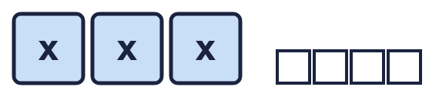    
  1 | Each big cube is worth 3. Each small cube is worth 1. Work out the value of each set of cubes.
  2 | Work out the value of each expression when a = 8 and b = 6.
    a) a + b =
    b) a − b =
    c) 2a =
    d) 2a + b =
  2 | Work out the value of each expression when a = 8 and b = 6.
    a) a + b =
    b) a − b =
    c) 2a =
    d) 2a + b =
  3 | Work out the value of each expression when x = 8.
    a) 3x =
    b) x + 3 =
    c) 4x − 2 =
    d) 5x + 1 =
  3 | Work out the value of each expression when x = 8.
    a) 3x =
    b) x + 3 =
    c) 4x − 2 =
    d) 5x + 1 =
  4 | Work out the value of each expression when a = 11 and b = 5.
    a) 3a − 17 =
    b) 2(a − b) =
    c) ab =
    d) a + 3b =
  4 | Work out the value of each expression when a = 11 and b = 5.
    a) 3a − 17 =
    b) 2(a − b) =
    c) ab =
    d) a + 3b =
  5 | Work out the value of each expression when m = 1.5 and k = 0.2.
    a) m + 2k =
    b) 10m =
    c) m − k =
    d) 4k =
  5 | Work out the value of each expression when m = 1.5 and k = 0.2.
    a) m + 2k =
    b) 10m =
    c) m − k =
    d) 4k =
  6 | Write <, > or = in each box when m = 9 and n = 5.
    a) 2m |  | 18
    b) n − 1 |  | 4
    c) 2n + m |  | 2m + n
    d) m + n |  | n + m
  6 | Write <, > or = in each box when m = 9 and n = 5.
    a) 2m |  | 18
    b) n − 1 |  | 4
    c) 2n + m |  | 2m + n
    d) m + n |  | n + m
  7 | a = 13. Write these expressions in order, starting with the smallest value.  5a a + 5 a − 10 a
  7 | a = 13. Write these expressions in order, starting with the smallest value.  5a a + 5 a − 10 a
  8 | Complete the table. Write the missing values.  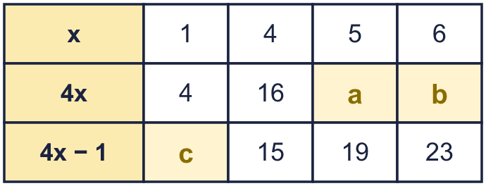
  8 | Complete the table. Write the missing values.

  9 | Is Nina correct? Circle yes or no.  Yes / No  Explain. You can try p = 4 and q = 7.
     | 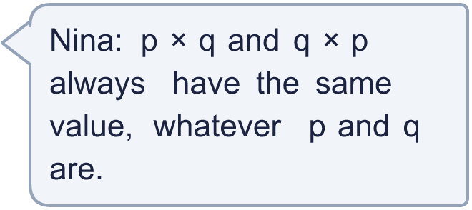
  9 | Is Nina correct? Circle yes or no.  Yes / No  Explain. You can try p = 4 and q = 7.
  10 | a = 10. Write three different expressions that have the value 30. Each one must have the letter a in it.
  10 | a = 10. Write three different expressions that have the value 30. Each one must have the letter a in it.
  11 | n = 3. Which of these expressions have the value 15? Write the letters.  A: 5n  B: 4n + 2  C: 2n + 10  D: n + 12
  11 | n = 3. Which of these expressions have the value 15? Write the letters.  A: 5n  B: 4n + 2  C: 2n + 10  D: n + 12
  12 | 4a + b = 32. Also, a = 6.
  12 | 4a + b = 32. Also, a = 6.
  13 | x = 5 and y = 4.  Expression A is 3x + y.  Expression B is 2y + x.  Which expression has the greater value? By how much?
  13 | x = 5 and y = 4.  Expression A is 3x + y.  Expression B is 2y + x.  Which expression has the greater value? By how much?
  14 | Challenge  Is Sam correct? Circle yes or no.  Yes / No  Explain. Try n = 1.
     | 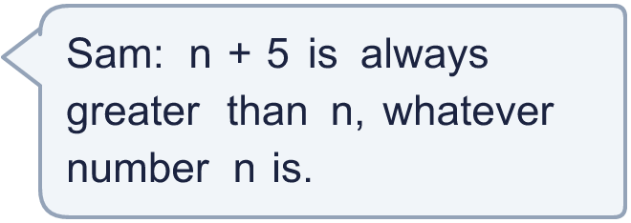
  14 | Challenge  Is Sam correct? Circle yes or no.  Yes / No  Explain. Try n = 1.

Year 6 · Algebra · Step 4
Substitution
Answers (teacher copy)

  1 | Each big cube is worth 3. Each small cube is worth 1. Work out the value of each set of cubes.  a) 13  b) 5  c) 8
  2 | Work out the value of each expression when a = 8 and b = 6.  a) a + b = 14  b) a − b = 2  c) 2a = 16  d) 2a + b = 22
  3 | Work out the value of each expression when x = 8.  a) 3x = 24  b) x + 3 = 11  c) 4x − 2 = 30  d) 5x + 1 = 41
  4 | Work out the value of each expression when a = 11 and b = 5.  a) 3a − 17 = 16  b) 2(a − b) = 12  c) ab = 55  d) a + 3b = 26
  5 | Work out the value of each expression when m = 1.5 and k = 0.2.  a) m + 2k = 1.9  b) 10m = 15  c) m − k = 1.3  d) 4k = 0.8
  6 | Write <, > or = in each box when m = 9 and n = 5.  a) 2m = 18  b) n − 1 = 4  c) 2n + m < 2m + n  d) m + n = n + m
  7 | a = 13. Write these expressions in order, starting with the smallest value.  5a a + 5 a − 10 a  a − 10, a, a + 5, 5a
  8 | Complete the table. Write the missing values.  a = 20  b = 24  c = 3
  9 | Is Nina correct? Circle yes or no.  Yes / No  Explain. You can try p = 4 and q = 7.  Yes. When p = 4 and q = 7, p × q = 28 and q × p = 28. Adding or multiplying in either order gives the same answer.
  10 | a = 10. Write three different expressions that have the value 30. Each one must have the letter a in it.  a + 20, 2a + 10, 3a
  11 | n = 3. Which of these expressions have the value 15? Write the letters.  A: 5n  B: 4n + 2  C: 2n + 10  D: n + 12  A, D
  12 | 4a + b = 32. Also, a = 6.  What is the value of b? 8
  13 | x = 5 and y = 4.  Expression A is 3x + y.  Expression B is 2y + x.  Which expression has the greater value? By how much?  A  6
  14 | Challenge  Is Sam correct? Circle yes or no.  Yes / No  Explain. Try n = 1.  Yes. n + 5 is 5 more than n, so it is always greater. When n = 1, n + 5 = 6 and n = 1.

