Substitution means putting a number in for the letter. If x = 2, then 3x + 1 = 3 × 2 + 1 = 7:  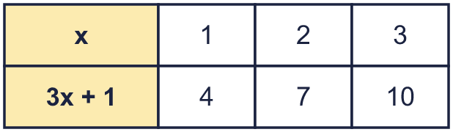 |  | Substitution means putting a number in for the letter. If x = 2, then 3x + 1 = 3 × 2 + 1 = 7:
  Year 6 · Algebra · Step 4  Substitution | 
  Year 6 · Algebra · Step 4
  Substitution
  1 | Each big cube is worth 3. Each small cube is worth 1. Work out the value of each set of cubes.  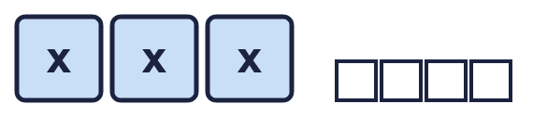  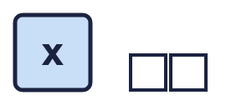  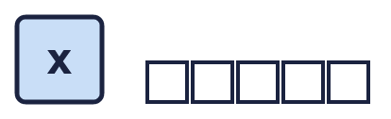  Hint: Count the big cubes and multiply by 3. Then add the small cubes.
  1 | Each big cube is worth 3. Each small cube is worth 1. Work out the value of each set of cubes.  Hint: Count the big cubes and multiply by 3. Then add the small cubes.
  2 | Work out the value of each expression when a = 8 and b = 6.  Hint: Replace each letter with its number. 2a means 2 × a.
    a) a + b =
    b) a − b =
    c) 2a =
    d) 2a + b =
  2 | Work out the value of each expression when a = 8 and b = 6.  Hint: Replace each letter with its number. 2a means 2 × a.
    a) a + b =
    b) a − b =
    c) 2a =
    d) 2a + b =
  3 | Work out the value of each expression when x = 8.  Hint: Put 8 in for x. Do the multiplying before the adding or taking away.
    a) 3x =
    b) x + 3 =
    c) 4x − 2 =
    d) 5x + 1 =
  3 | Work out the value of each expression when x = 8.  Hint: Put 8 in for x. Do the multiplying before the adding or taking away.
    a) 3x =
    b) x + 3 =
    c) 4x − 2 =
    d) 5x + 1 =
  4 | Work out the value of each expression when a = 11 and b = 5.  Hint: Work out brackets first. ab means a × b.
    a) 3a − 17 =
    b) 2(a − b) =
    c) ab =
    d) a + 3b =
  4 | Work out the value of each expression when a = 11 and b = 5.  Hint: Work out brackets first. ab means a × b.
    a) 3a − 17 =
    b) 2(a − b) =
    c) ab =
    d) a + 3b =
  5 | Work out the value of each expression when m = 1.5 and k = 0.2.  Hint: Take care with the decimal point. 10m means 10 × m.
    a) m + 2k =
    b) 10m =
    c) m − k =
    d) 4k =
  5 | Work out the value of each expression when m = 1.5 and k = 0.2.  Hint: Take care with the decimal point. 10m means 10 × m.
    a) m + 2k =
    b) 10m =
    c) m − k =
    d) 4k =
  6 | Write <, > or = in each box when m = 9 and n = 5.  Hint: Work out the value of each side first. Then compare the two numbers.
    a) 2m |  | 18
    b) n − 1 |  | 4
    c) 2n + m |  | 2m + n
    d) m + n |  | n + m
  6 | Write <, > or = in each box when m = 9 and n = 5.  Hint: Work out the value of each side first. Then compare the two numbers.
    a) 2m |  | 18
    b) n − 1 |  | 4
    c) 2n + m |  | 2m + n
    d) m + n |  | n + m
  7 | a = 13. Write these expressions in order, starting with the smallest value.  5a a + 5 a − 10 a  Hint: Work out the value of every expression first.
  7 | a = 13. Write these expressions in order, starting with the smallest value.  5a a + 5 a − 10 a  Hint: Work out the value of every expression first.
  8 | Complete the table. Write the missing values.  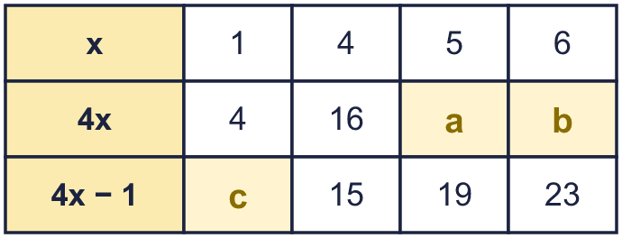  Hint: Use the number in the x row. Put it in for the letter in the expression.
  8 | Complete the table. Write the missing values.  Hint: Use the number in the x row. Put it in for the letter in the expression.

  9 | Is Nina correct? Circle yes or no.  Yes / No  Explain. You can try p = 4 and q = 7.  Hint: Put p = 4 and q = 7 into both expressions.
     | 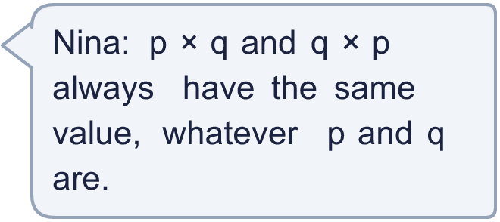
  9 | Is Nina correct? Circle yes or no.  Yes / No  Explain. You can try p = 4 and q = 7.  Hint: Put p = 4 and q = 7 into both expressions.
  10 | a = 10. Write three different expressions that have the value 30. Each one must have the letter a in it.  Hint: For example, start with a and add the number that makes 30. Then try 2a, then 3a.
  10 | a = 10. Write three different expressions that have the value 30. Each one must have the letter a in it.  Hint: For example, start with a and add the number that makes 30. Then try 2a, then 3a.
  11 | n = 3. Which of these expressions have the value 15? Write the letters.  A: 5n  B: 4n + 2  C: 2n + 10  D: n + 12  Hint: Put the number in for the letter in each expression. Work out each answer.
  11 | n = 3. Which of these expressions have the value 15? Write the letters.  A: 5n  B: 4n + 2  C: 2n + 10  D: n + 12  Hint: Put the number in for the letter in each expression. Work out each answer.
  12 | 4a + b = 32. Also, a = 6.  Hint: Put 6 in for a. Work out 4a. What must be added to make 32?
  12 | 4a + b = 32. Also, a = 6.  Hint: Put 6 in for a. Work out 4a. What must be added to make 32?
  13 | x = 5 and y = 4.  Expression A is 3x + y.  Expression B is 2y + x.  Which expression has the greater value? By how much?  Hint: Work out A and B separately. Then compare.
  13 | x = 5 and y = 4.  Expression A is 3x + y.  Expression B is 2y + x.  Which expression has the greater value? By how much?  Hint: Work out A and B separately. Then compare.
  14 | Challenge  Is Sam correct? Circle yes or no.  Yes / No  Explain. Try n = 1.  Hint: Put different numbers in for n. Can you find a number where it is not true?
     | 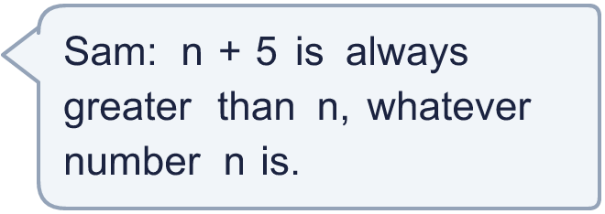
  14 | Challenge  Is Sam correct? Circle yes or no.  Yes / No  Explain. Try n = 1.  Hint: Put different numbers in for n. Can you find a number where it is not true?

Year 6 · Algebra · Step 4
Substitution
Answers (teacher copy)

Substitution means putting a number in for the letter. If x = 2, then 3x + 1 = 3 × 2 + 1 = 7:
  1 | Each big cube is worth 3. Each small cube is worth 1. Work out the value of each set of cubes.  a) 13  b) 5  c) 8  Hint: Count the big cubes and multiply by 3. Then add the small cubes.
  2 | Work out the value of each expression when a = 8 and b = 6.  a) a + b = 14  b) a − b = 2  c) 2a = 16  d) 2a + b = 22  Hint: Replace each letter with its number. 2a means 2 × a.
  3 | Work out the value of each expression when x = 8.  a) 3x = 24  b) x + 3 = 11  c) 4x − 2 = 30  d) 5x + 1 = 41  Hint: Put 8 in for x. Do the multiplying before the adding or taking away.
  4 | Work out the value of each expression when a = 11 and b = 5.  a) 3a − 17 = 16  b) 2(a − b) = 12  c) ab = 55  d) a + 3b = 26  Hint: Work out brackets first. ab means a × b.
  5 | Work out the value of each expression when m = 1.5 and k = 0.2.  a) m + 2k = 1.9  b) 10m = 15  c) m − k = 1.3  d) 4k = 0.8  Hint: Take care with the decimal point. 10m means 10 × m.
  6 | Write <, > or = in each box when m = 9 and n = 5.  a) 2m = 18  b) n − 1 = 4  c) 2n + m < 2m + n  d) m + n = n + m  Hint: Work out the value of each side first. Then compare the two numbers.
  7 | a = 13. Write these expressions in order, starting with the smallest value.  5a a + 5 a − 10 a  a − 10, a, a + 5, 5a  Hint: Work out the value of every expression first.
  8 | Complete the table. Write the missing values.  a = 20  b = 24  c = 3  Hint: Use the number in the x row. Put it in for the letter in the expression.
  9 | Is Nina correct? Circle yes or no.  Yes / No  Explain. You can try p = 4 and q = 7.  Yes. When p = 4 and q = 7, p × q = 28 and q × p = 28. Adding or multiplying in either order gives the same answer.  Hint: Put p = 4 and q = 7 into both expressions.
  10 | a = 10. Write three different expressions that have the value 30. Each one must have the letter a in it.  a + 20, 2a + 10, 3a  Hint: For example, start with a and add the number that makes 30. Then try 2a, then 3a.
  11 | n = 3. Which of these expressions have the value 15? Write the letters.  A: 5n  B: 4n + 2  C: 2n + 10  D: n + 12  A, D  Hint: Put the number in for the letter in each expression. Work out each answer.
  12 | 4a + b = 32. Also, a = 6.  What is the value of b? 8  Hint: Put 6 in for a. Work out 4a. What must be added to make 32?
  13 | x = 5 and y = 4.  Expression A is 3x + y.  Expression B is 2y + x.  Which expression has the greater value? By how much?  A  6  Hint: Work out A and B separately. Then compare.
  14 | Challenge  Is Sam correct? Circle yes or no.  Yes / No  Explain. Try n = 1.  Yes. n + 5 is 5 more than n, so it is always greater. When n = 1, n + 5 = 6 and n = 1.  Hint: Put different numbers in for n. Can you find a number where it is not true?

