  Year 6 · Algebra · Step 2  Two-step function machines | 
  Year 6 · Algebra · Step 2
  Two-step function machines
  1 | Use the function machine to complete the table. Write the missing outputs.  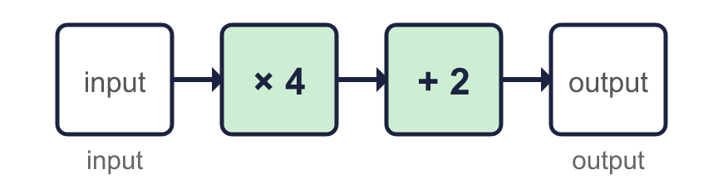  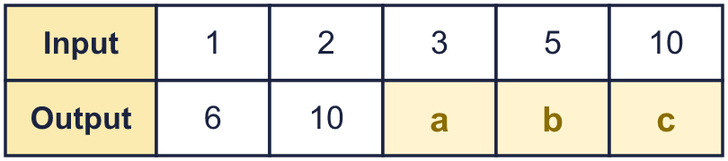
  1 | Use the function machine to complete the table. Write the missing outputs.
  2 | This machine does the same two steps in the other order. Complete the table.  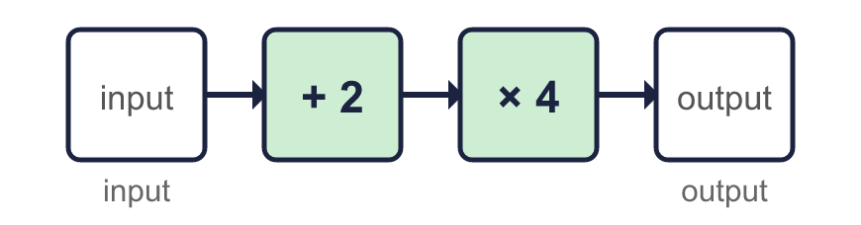  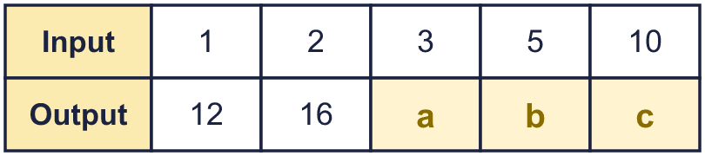
  2 | This machine does the same two steps in the other order. Complete the table.
  3 | Work out the output of each machine.  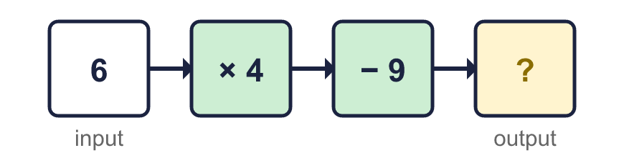  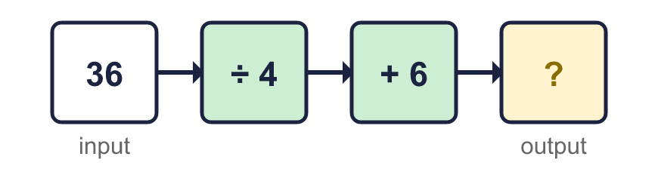  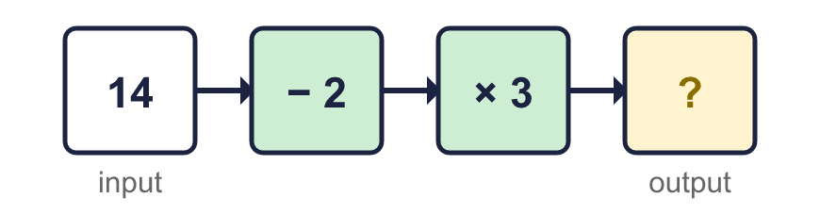
  3 | Work out the output of each machine.
  4 | Work out the input of each machine. Start with the output and use the opposite operations.  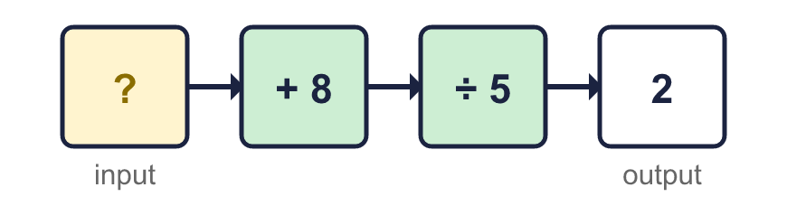  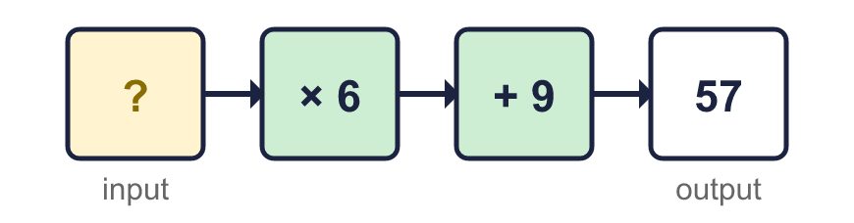  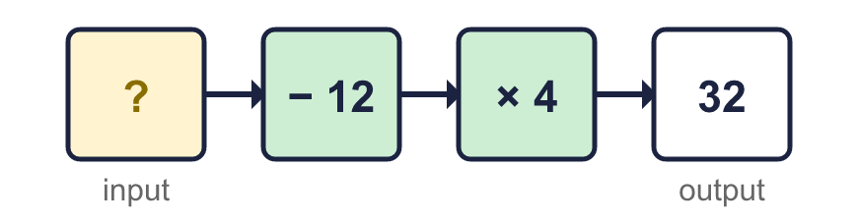
  4 | Work out the input of each machine. Start with the output and use the opposite operations.
  5 | Each pair of machines is made of the same two steps. Which pairs give the same output for every input? Write the letters.  A: + 7, then + 9 and + 9, then + 7  B: + 4, then + 6 and + 6, then + 4  C: + 9, then × 2 and × 2, then + 9
  5 | Each pair of machines is made of the same two steps. Which pairs give the same output for every input? Write the letters.  A: + 7, then + 9 and + 9, then + 7  B: + 4, then + 6 and + 6, then + 4  C: + 9, then × 2 and × 2, then + 9
  6 | Use the function machine to complete the table. Some missing numbers are inputs and some are outputs.  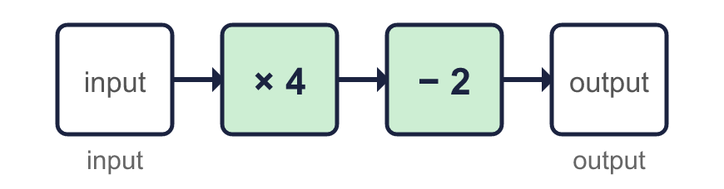  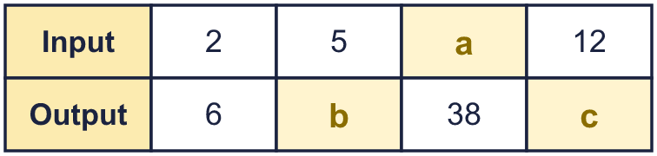
  6 | Use the function machine to complete the table. Some missing numbers are inputs and some are outputs.
  7 | A shop prints photos online. Photos cost 25p each. There is a delivery charge of £1.75 for every order.  How much does an order of 18 photos cost?
  7 | A shop prints photos online. Photos cost 25p each. There is a delivery charge of £1.75 for every order.  How much does an order of 18 photos cost?
  8 | Write one machine that does the same job as each pair of machines.
    a) × 3, then × 5:
    b) − 5, then + 14:
    c) ÷ 4, then × 16:
  8 | Write one machine that does the same job as each pair of machines.
    a) × 3, then × 5:
    b) − 5, then + 14:
    c) ÷ 4, then × 16:

  9 | Machine A: + 6, then + 2.  Machine B: + 2, then + 6.  Is Jack correct? Circle yes or no.  Yes / No  Explain. Use the input 2 to help.
     | 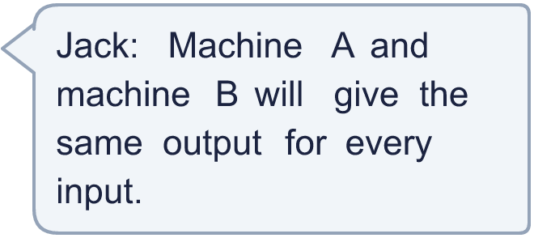
  9 | Machine A: + 6, then + 2.  Machine B: + 2, then + 6.  Is Jack correct? Circle yes or no.  Yes / No  Explain. Use the input 2 to help.
  10 | Dora puts a number into this machine and the number that comes out is the same as the number that went in.  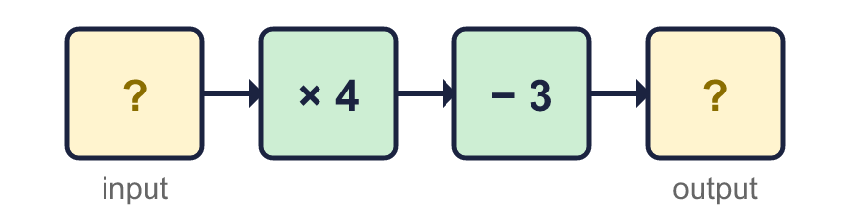
  10 | Dora puts a number into this machine and the number that comes out is the same as the number that went in.
  11 | Photos cost 30p each. Delivery is £1.50 for the whole order. Eva pays £9.30.  How many photos did Eva order?
  11 | Photos cost 30p each. Delivery is £1.50 for the whole order. Eva pays £9.30.  How many photos did Eva order?
  12 | Tables are joined end to end in a row. 1 table seats 8 people. 2 tables seat 10 people. 3 tables seat 12 people.  a) How many people can sit at 9 tables?  b) A party has 70 people. How many tables do they need?
  12 | Tables are joined end to end in a row. 1 table seats 8 people. 2 tables seat 10 people. 3 tables seat 12 people.  a) How many people can sit at 9 tables?  b) A party has 70 people. How many tables do they need?
  13 | A function machine turns these inputs into these outputs.  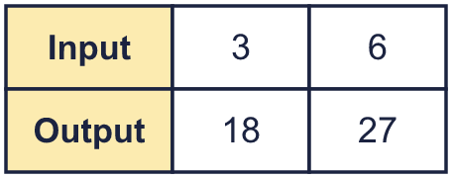  Which machine is it? Write its letter.  A: × 2, then + 4  B: + 2, then × 5  C: + 3, then × 3
  13 | A function machine turns these inputs into these outputs.  Which machine is it? Write its letter.  A: × 2, then + 4  B: + 2, then × 5  C: + 3, then × 3
  14 | Challenge  A two-step machine multiplies by a number and then adds or subtracts a number.  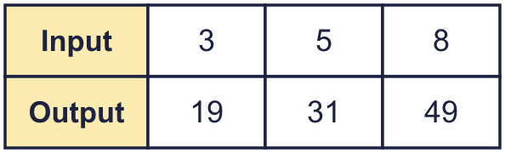
  14 | Challenge  A two-step machine multiplies by a number and then adds or subtracts a number.

Year 6 · Algebra · Step 2
Two-step function machines
Answers (teacher copy)

  1 | Use the function machine to complete the table. Write the missing outputs.  a = 14  b = 22  c = 42
  2 | This machine does the same two steps in the other order. Complete the table.  a = 20  b = 28  c = 48
  3 | Work out the output of each machine.  a) 15  b) 15  c) 36
  4 | Work out the input of each machine. Start with the output and use the opposite operations.  a) 2  b) 8  c) 20
  5 | Each pair of machines is made of the same two steps. Which pairs give the same output for every input? Write the letters.  A: + 7, then + 9 and + 9, then + 7  B: + 4, then + 6 and + 6, then + 4  C: + 9, then × 2 and × 2, then + 9  A, B
  6 | Use the function machine to complete the table. Some missing numbers are inputs and some are outputs.  a = 10  b = 18  c = 46
  7 | A shop prints photos online. Photos cost 25p each. There is a delivery charge of £1.75 for every order.  How much does an order of 18 photos cost? £6.25
  8 | Write one machine that does the same job as each pair of machines.  a) × 3, then × 5: × 15  b) − 5, then + 14: + 9  c) ÷ 4, then × 16: × 4
  9 | Machine A: + 6, then + 2.  Machine B: + 2, then + 6.  Is Jack correct? Circle yes or no.  Yes / No  Explain. Use the input 2 to help.  Yes. With input 2, machine A gives 10 and machine B gives 10.
  10 | Dora puts a number into this machine and the number that comes out is the same as the number that went in.  Dora’s number: 1
  11 | Photos cost 30p each. Delivery is £1.50 for the whole order. Eva pays £9.30.  How many photos did Eva order? 26
  12 | Tables are joined end to end in a row. 1 table seats 8 people. 2 tables seat 10 people. 3 tables seat 12 people.  a) How many people can sit at 9 tables? 24  b) A party has 70 people. How many tables do they need? 32
  13 | A function machine turns these inputs into these outputs.  Which machine is it? Write its letter.  A: × 2, then + 4  B: + 2, then × 5  C: + 3, then × 3  C
  14 | Challenge  A two-step machine multiplies by a number and then adds or subtracts a number.  The two steps are × 6, + 1

