A formula uses letters. d = 7w means the number of days is 7 times the number of weeks. If w = 3, then d = 7 × 3 = 21:  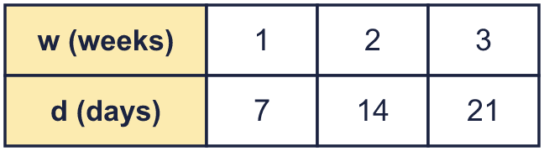 |  | A formula uses letters. d = 7w means the number of days is 7 times the number of weeks. If w = 3, then d = 7 × 3 = 21:
  Year 6 · Algebra · Step 5  Using formulae | 
  Year 6 · Algebra · Step 5
  Using formulae
  1 | Here is a pattern of squares made from lolly sticks. Complete the table.  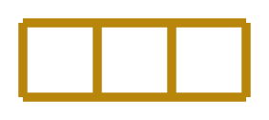  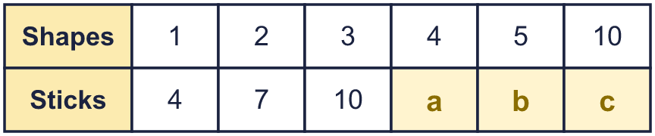  Hint: Count the sticks for 1, 2 and 3 shapes. Look for the pattern.
  1 | Here is a pattern of squares made from lolly sticks. Complete the table.  Hint: Count the sticks for 1, 2 and 3 shapes. Look for the pattern.
  2 | Each shape has t triangles and c circles. The table shows the pattern. Which formula fits? Write the letter.  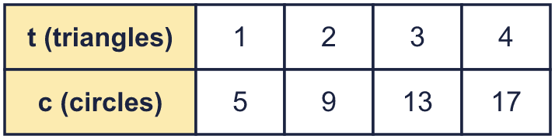  A: c = 4t + 2  B: t = 4c + 1  C: c = t + 5  D: c = 4t + 1  Hint: Put the numbers from the table into each formula. Which formula works for every column?
  2 | Each shape has t triangles and c circles. The table shows the pattern. Which formula fits? Write the letter.  A: c = 4t + 2  B: t = 4c + 1  C: c = t + 5  D: c = 4t + 1  Hint: Put the numbers from the table into each formula. Which formula works for every column?
  3 | The table shows the number of eggs (e) in boxes (b).  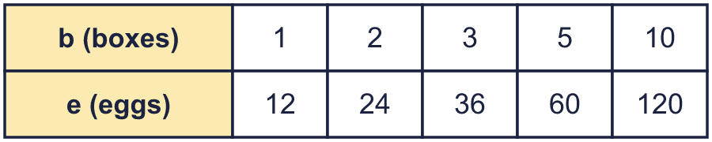  b) e when b = 45:  Hint: Look at the first column. How many are there for 1?
    a) e = |  | b
  3 | The table shows the number of eggs (e) in boxes (b).  b) e when b = 45:  Hint: Look at the first column. How many are there for 1?
    a) e = |  | b
  4 | A shop prints designs on T-shirts. This formula gives the price in pence: p = 40c + 150 (p is the price in pence and c is the number of colours).  Price of a design with 4 colours:  Hint: Put 4 in for c. Work out 40c first, then add 150.
  4 | A shop prints designs on T-shirts. This formula gives the price in pence: p = 40c + 150 (p is the price in pence and c is the number of colours).  Price of a design with 4 colours:  Hint: Put 4 in for c. Work out 40c first, then add 150.
  5 | A rectangle has length a cm and width b cm. Use the formulae to work out the area and perimeter when a = 12 and b = 7.  Hint: ab means a × b. Perimeter is the distance around the rectangle.
    a) A = ab cm²:
    b) P = 2a + 2b cm:
  5 | A rectangle has length a cm and width b cm. Use the formulae to work out the area and perimeter when a = 12 and b = 7.  Hint: ab means a × b. Perimeter is the distance around the rectangle.
    a) A = ab cm²:
    b) P = 2a + 2b cm:
  6 | A dog walker charges £10 for each hour plus £5 for travel.  b) The cost of 2 hours (£):  Hint: Each hour costs the same. Then add the travel cost once.
    a) Write a formula for the cost c pounds of h hours:
  6 | A dog walker charges £10 for each hour plus £5 for travel.  b) The cost of 2 hours (£):  Hint: Each hour costs the same. Then add the travel cost once.
    a) Write a formula for the cost c pounds of h hours:
  7 | Wooden letters cost £2 each. There is a delivery charge of £5 for every order.  b) How many letters can you buy for £21?  Hint: The cost of the letters is a number times n. Then add the delivery.
    a) Write a formula for the cost c pounds of n letters:
  7 | Wooden letters cost £2 each. There is a delivery charge of £5 for every order.  b) How many letters can you buy for £21?  Hint: The cost of the letters is a number times n. Then add the delivery.
    a) Write a formula for the cost c pounds of n letters:
  8 | This formula estimates the mass m kilograms of a child aged a years: m = 3(a + 5).  a) The mass of a child aged 8: kg  b) The age of a child with a mass of 27 kg: years  Hint: For a), put the age in for a. For b), work backwards: divide, then take away.
  8 | This formula estimates the mass m kilograms of a child aged a years: m = 3(a + 5).  a) The mass of a child aged 8: kg  b) The age of a child with a mass of 27 kg: years  Hint: For a), put the age in for a. For b), work backwards: divide, then take away.

  9 | Dora makes a square pattern from lolly sticks. 1 square needs 4 sticks. 2 squares need 7 sticks. 3 squares need 10 sticks.  Is Amir correct? Circle yes or no.  Yes / No  Explain. Then write the correct number.  Hint: Find how many sticks each new square adds. Find the number for 1 square, then add.
     | 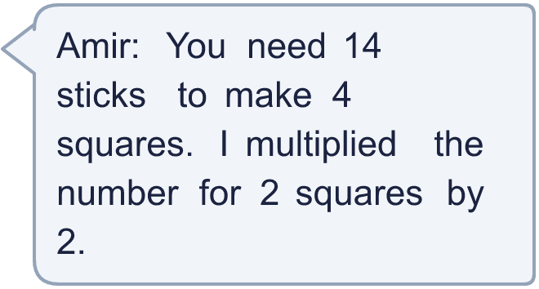
  9 | Dora makes a square pattern from lolly sticks. 1 square needs 4 sticks. 2 squares need 7 sticks. 3 squares need 10 sticks.  Is Amir correct? Circle yes or no.  Yes / No  Explain. Then write the correct number.  Hint: Find how many sticks each new square adds. Find the number for 1 square, then add.
  10 | A taxi charges £6 to start and then £2 for every mile.  b) A journey costs £22. How many miles?  Hint: Think of the cost for 1 mile, for 2 miles … then write the rule.
    a) Write a formula for the cost c pounds of m miles:
  10 | A taxi charges £6 to start and then £2 for every mile.  b) A journey costs £22. How many miles?  Hint: Think of the cost for 1 mile, for 2 miles … then write the rule.
    a) Write a formula for the cost c pounds of m miles:
  11 | A rule for cooking a chicken is t = 45m + 15, where t is the time in minutes and m is the mass in kilograms.  a) The time for a 2 kg chicken: minutes  b) The mass of a chicken that takes 105 minutes: kg  Hint: For b), take away the number first, then divide.
  11 | A rule for cooking a chicken is t = 45m + 15, where t is the time in minutes and m is the mass in kilograms.  a) The time for a 2 kg chicken: minutes  b) The mass of a chicken that takes 105 minutes: kg  Hint: For b), take away the number first, then divide.
  12 | The area A of a triangle is given by A = bh ÷ 2, where b is the base and h is the height.  The area when b = 6 cm and h = 6 cm: cm²  Hint: Multiply the base by the height. Then divide by 2.
  12 | The area A of a triangle is given by A = bh ÷ 2, where b is the base and h is the height.  The area when b = 6 cm and h = 6 cm: cm²  Hint: Multiply the base by the height. Then divide by 2.
  13 | The table shows the price p pence for n pencils.  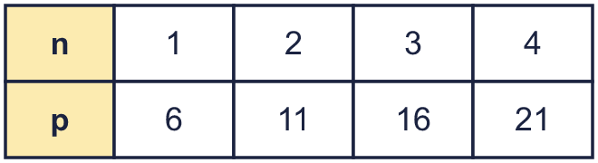  Which formula is correct? Write the letter.  A: p = 6n + 1  B: p = n + 5  C: p = n + 6  D: p = 5n + 1  Hint: Try n = 1 in each formula. Then check with n = 2.
  13 | The table shows the price p pence for n pencils.  Which formula is correct? Write the letter.  A: p = 6n + 1  B: p = n + 5  C: p = n + 6  D: p = 5n + 1  Hint: Try n = 1 in each formula. Then check with n = 2.
  14 | Challenge  A rule is k = 100 − 2n.  a) k when n = 6:  b) n when k = 86:  Hint: For b), the number you take away from 100 is 100 − k. Then divide.
  14 | Challenge  A rule is k = 100 − 2n.  a) k when n = 6:  b) n when k = 86:  Hint: For b), the number you take away from 100 is 100 − k. Then divide.

Year 6 · Algebra · Step 5
Using formulae
Answers (teacher copy)

A formula uses letters. d = 7w means the number of days is 7 times the number of weeks. If w = 3, then d = 7 × 3 = 21:
  1 | Here is a pattern of squares made from lolly sticks. Complete the table.  a = 13  b = 16  c = 31  Hint: Count the sticks for 1, 2 and 3 shapes. Look for the pattern.
  2 | Each shape has t triangles and c circles. The table shows the pattern. Which formula fits? Write the letter.  A: c = 4t + 2  B: t = 4c + 1  C: c = t + 5  D: c = 4t + 1  D  Hint: Put the numbers from the table into each formula. Which formula works for every column?
  3 | The table shows the number of eggs (e) in boxes (b).  a) e = 12 b  b) e when b = 45: 540  Hint: Look at the first column. How many are there for 1?
  4 | A shop prints designs on T-shirts. This formula gives the price in pence: p = 40c + 150 (p is the price in pence and c is the number of colours).  Price of a design with 4 colours: £3.10  Hint: Put 4 in for c. Work out 40c first, then add 150.
  5 | A rectangle has length a cm and width b cm. Use the formulae to work out the area and perimeter when a = 12 and b = 7.  a) A = ab cm²: 84  b) P = 2a + 2b cm: 38  Hint: ab means a × b. Perimeter is the distance around the rectangle.
  6 | A dog walker charges £10 for each hour plus £5 for travel.  a) Write a formula for the cost c pounds of h hours: c = 10h + 5  b) The cost of 2 hours (£): 25  Hint: Each hour costs the same. Then add the travel cost once.
  7 | Wooden letters cost £2 each. There is a delivery charge of £5 for every order.  a) Write a formula for the cost c pounds of n letters: c = 2n + 5  b) How many letters can you buy for £21? 8  Hint: The cost of the letters is a number times n. Then add the delivery.
  8 | This formula estimates the mass m kilograms of a child aged a years: m = 3(a + 5).  a) The mass of a child aged 8: 39 kg  b) The age of a child with a mass of 27 kg: 4 years  Hint: For a), put the age in for a. For b), work backwards: divide, then take away.
  9 | Dora makes a square pattern from lolly sticks. 1 square needs 4 sticks. 2 squares need 7 sticks. 3 squares need 10 sticks.  Is Amir correct? Circle yes or no.  Yes / No  Explain. Then write the correct number.  No. Squares share sticks, so you cannot just multiply. Each new square needs 3 more sticks, so 4 squares need 3 × 4 + 1 = 13 sticks.  Correct number of sticks: 13  Hint: Find how many sticks each new square adds. Find the number for 1 square, then add.
  10 | A taxi charges £6 to start and then £2 for every mile.  a) Write a formula for the cost c pounds of m miles: c = 2m + 6  b) A journey costs £22. How many miles? 8  Hint: Think of the cost for 1 mile, for 2 miles … then write the rule.
  11 | A rule for cooking a chicken is t = 45m + 15, where t is the time in minutes and m is the mass in kilograms.  a) The time for a 2 kg chicken: 105 minutes  b) The mass of a chicken that takes 105 minutes: 2 kg  Hint: For b), take away the number first, then divide.
  12 | The area A of a triangle is given by A = bh ÷ 2, where b is the base and h is the height.  The area when b = 6 cm and h = 6 cm: 18 cm²  Hint: Multiply the base by the height. Then divide by 2.
  13 | The table shows the price p pence for n pencils.  Which formula is correct? Write the letter.  A: p = 6n + 1  B: p = n + 5  C: p = n + 6  D: p = 5n + 1  D  Hint: Try n = 1 in each formula. Then check with n = 2.
  14 | Challenge  A rule is k = 100 − 2n.  a) k when n = 6: 88  b) n when k = 86: 7  Hint: For b), the number you take away from 100 is 100 − k. Then divide.

