  Year 6 · Area, perimeter, volume · Step 2  Area and perimeter | 
  Year 6 · Area, perimeter, volume · Step 2
  Area and perimeter
  1 | Choose the best unit to measure each one: cm, cm², m or m².  a) the area of a postage stamp  b) the distance round a football pitch
    Unit:
    Unit:
  1 | Choose the best unit to measure each one: cm, cm², m or m².  a) the area of a postage stamp  b) the distance round a football pitch
    Unit:
    Unit:
  2 | Work out the perimeter and the area of the rectangle.  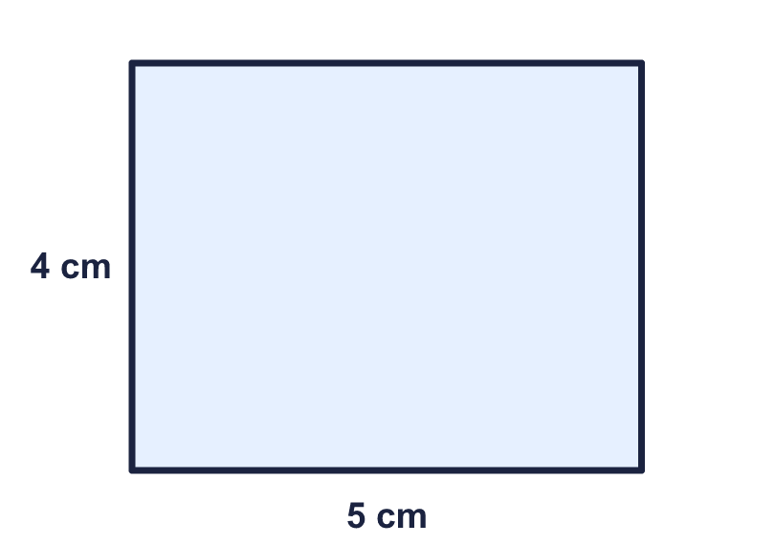
    Perimeter = |  | cm.
    Area = |  | cm²
  2 | Work out the perimeter and the area of the rectangle.
    Perimeter = |  | cm.
    Area = |  | cm²
  3 | Work out the perimeter and the area of the playground.  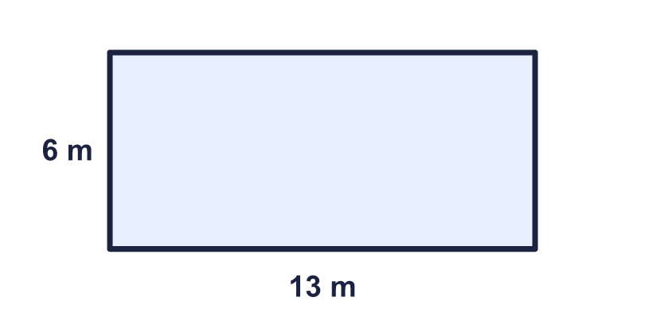
    Perimeter = |  | m.
    Area = |  | m²
  3 | Work out the perimeter and the area of the playground.
    Perimeter = |  | m.
    Area = |  | m²
  4 | Work out the perimeter of the shape.  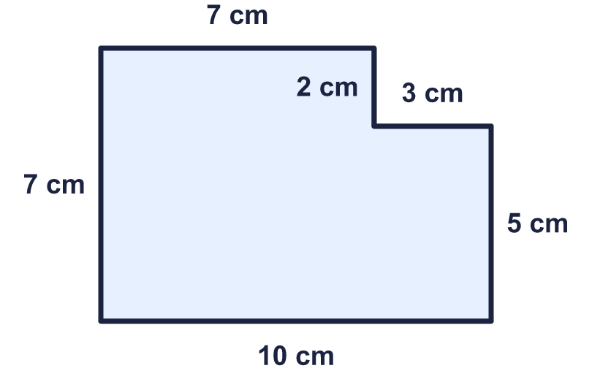
    Perimeter = |  | cm.
  4 | Work out the perimeter of the shape.
    Perimeter = |  | cm.
  5 | A rectangle has an area of 48 cm² and a width of 6 cm.
    Length = |  | cm.
    Perimeter = |  | cm.
  5 | A rectangle has an area of 48 cm² and a width of 6 cm.
    Length = |  | cm.
    Perimeter = |  | cm.
  6 | This rectangle has a perimeter of 32 cm. Find the missing width.  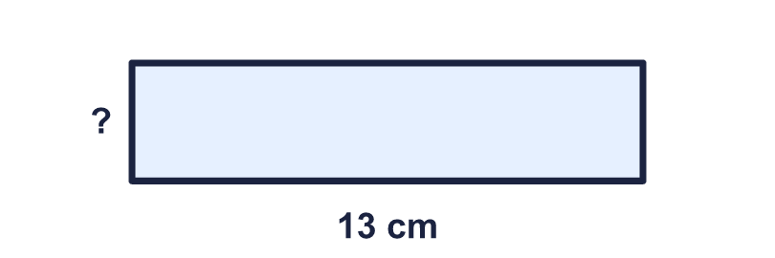
    Width = |  | cm.
  6 | This rectangle has a perimeter of 32 cm. Find the missing width.
    Width = |  | cm.
  7 | A square has a perimeter of 16 cm.
    Length of one side = |  | cm.
    Area of the square = |  | cm²
  7 | A square has a perimeter of 16 cm.
    Length of one side = |  | cm.
    Area of the square = |  | cm²
  8 | Count squares to work out the perimeter and the area of the shape.  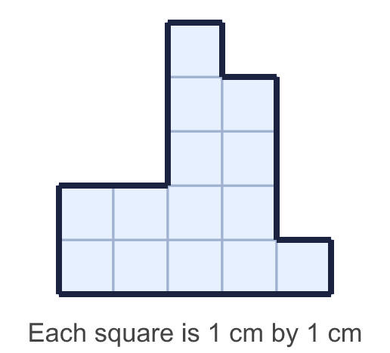
    Perimeter = |  | cm.
    Area = |  | cm²
  8 | Count squares to work out the perimeter and the area of the shape.
    Perimeter = |  | cm.
    Area = |  | cm²

  9 | Look at the two rectangles.  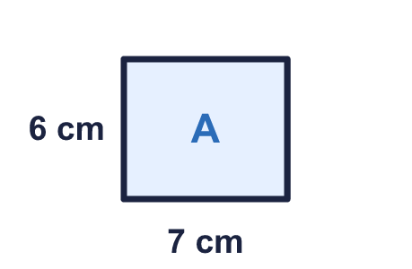  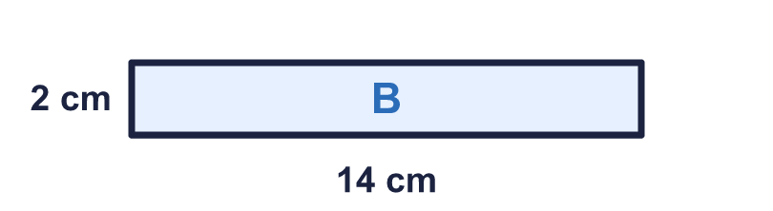
    Greater perimeter: rectangle
    Greater area: rectangle
  9 | Look at the two rectangles.
    Greater perimeter: rectangle
    Greater area: rectangle
  10 | Work out the area of the shape.  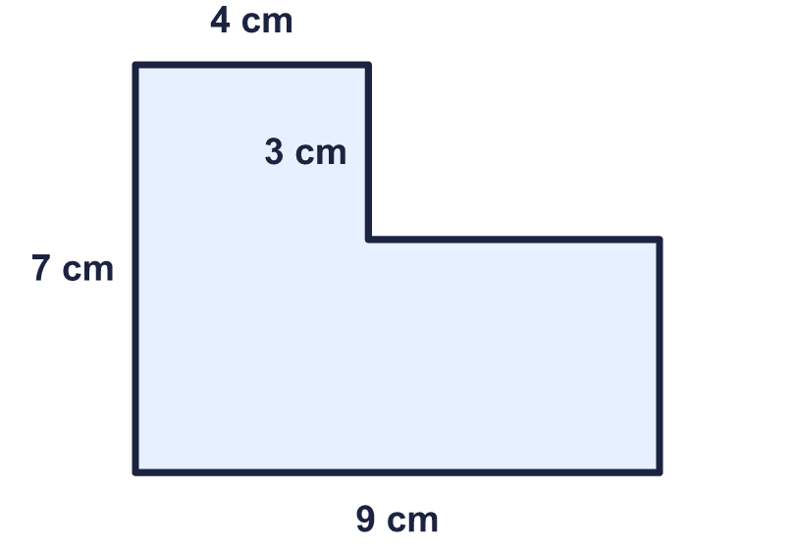
    Area = |  | cm²
  10 | Work out the area of the shape.
    Area = |  | cm²
  11 | A rectangular garden is 15 m long and 12 m wide. Fencing for the whole edge costs £9 for each metre.
    Cost = £
  11 | A rectangular garden is 15 m long and 12 m wide. Fencing for the whole edge costs £9 for each metre.
    Cost = £
  12 | A rectangle has a perimeter of 34 cm. One side is 9 cm long.
    Area = |  | cm²
  12 | A rectangle has a perimeter of 34 cm. One side is 9 cm long.
    Area = |  | cm²
  13 | A lawn is 15 m long and 6 m wide. Grass seed costs £3 for each square metre. A fence round the edge costs £6 for each metre.  How much does it cost to buy the seed and the fence?
    Total cost = £
  13 | A lawn is 15 m long and 6 m wide. Grass seed costs £3 for each square metre. A fence round the edge costs £6 for each metre.  How much does it cost to buy the seed and the fence?
    Total cost = £
  14 | Challenge  A rectangle has a perimeter of 16 cm. Its sides are whole numbers of centimetres. What is the greatest area it could have?
    Greatest area = |  | cm²
  14 | Challenge  A rectangle has a perimeter of 16 cm. Its sides are whole numbers of centimetres. What is the greatest area it could have?
    Greatest area = |  | cm²

Year 6 · Area, perimeter, volume · Step 2
Area and perimeter
Answers (teacher copy)

  1 | Choose the best unit to measure each one: cm, cm², m or m².  a) the area of a postage stamp  Unit: cm²  b) the distance round a football pitch  Unit: m
  2 | Work out the perimeter and the area of the rectangle.  Perimeter = 18 cm.  Area = 20 cm²
  3 | Work out the perimeter and the area of the playground.  Perimeter = 38 m.  Area = 78 m²
  4 | Work out the perimeter of the shape.  Perimeter = 34 cm.
  5 | A rectangle has an area of 48 cm² and a width of 6 cm.  Length = 8 cm.  Perimeter = 28 cm.
  6 | This rectangle has a perimeter of 32 cm. Find the missing width.  Width = 3 cm.
  7 | A square has a perimeter of 16 cm.  Length of one side = 4 cm.  Area of the square = 16 cm²
  8 | Count squares to work out the perimeter and the area of the shape.  Perimeter = 20 cm.  Area = 14 cm²
  9 | Look at the two rectangles.  Greater perimeter: rectangle B  Greater area: rectangle A
  10 | Work out the area of the shape.  Area = 48 cm²
  11 | A rectangular garden is 15 m long and 12 m wide. Fencing for the whole edge costs £9 for each metre.  Cost = £ 486
  12 | A rectangle has a perimeter of 34 cm. One side is 9 cm long.  Area = 72 cm²
  13 | A lawn is 15 m long and 6 m wide. Grass seed costs £3 for each square metre. A fence round the edge costs £6 for each metre.  How much does it cost to buy the seed and the fence?  Total cost = £ 522
  14 | Challenge  A rectangle has a perimeter of 16 cm. Its sides are whole numbers of centimetres. What is the greatest area it could have?  Greatest area = 16 cm²

