  Year 6 · Area, perimeter, volume · Step 6  Area of a parallelogram | 
  Year 6 · Area, perimeter, volume · Step 6
  Area of a parallelogram
  1 | Cut off the triangle and slide it across to make a rectangle.  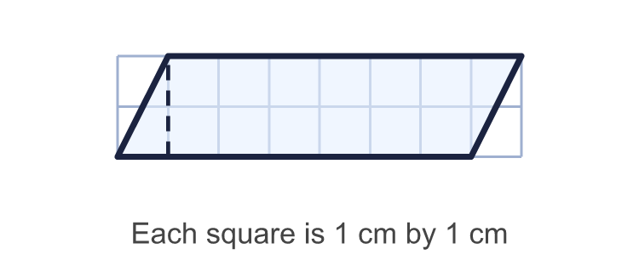
    Area of the rectangle =
    squares
    Area of the parallelogram =
    squares
  1 | Cut off the triangle and slide it across to make a rectangle.
    Area of the rectangle =
    squares
    Area of the parallelogram =
    squares
  2 | Work out the area of each parallelogram.  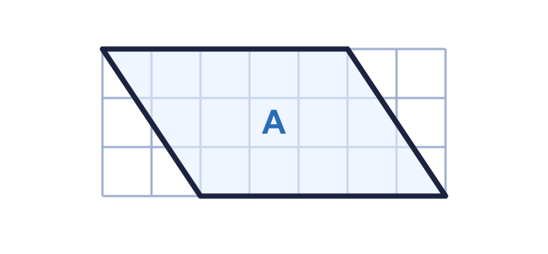  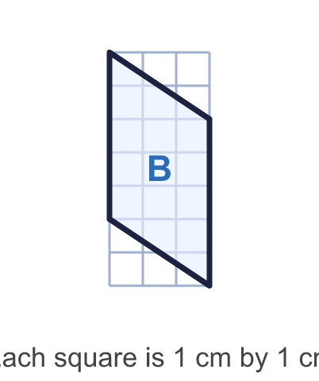
    a) Parallelogram A: |  | cm²
    b) Parallelogram B: |  | cm²
  2 | Work out the area of each parallelogram.
    a) Parallelogram A: |  | cm²
    b) Parallelogram B: |  | cm²
  3 | Work out the area of the parallelogram.  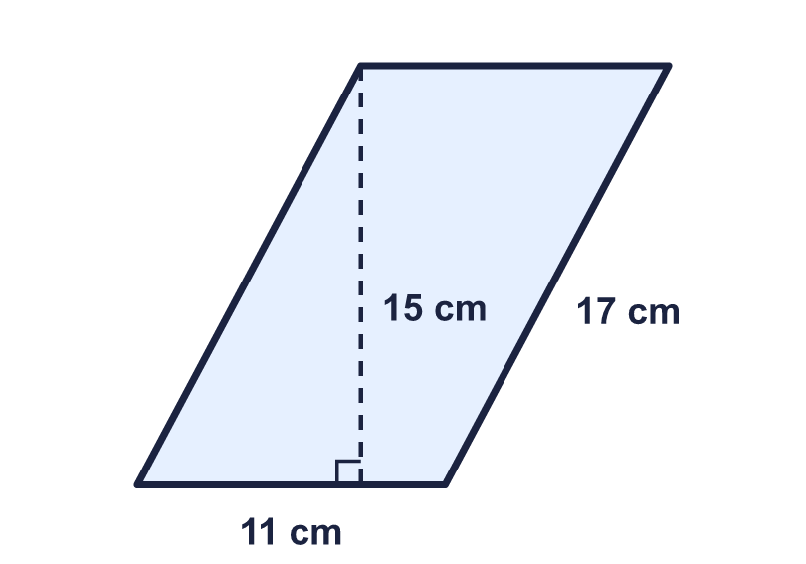
    Area = |  | cm²
  3 | Work out the area of the parallelogram.
    Area = |  | cm²
  4 | Work out the area of the parallelogram.  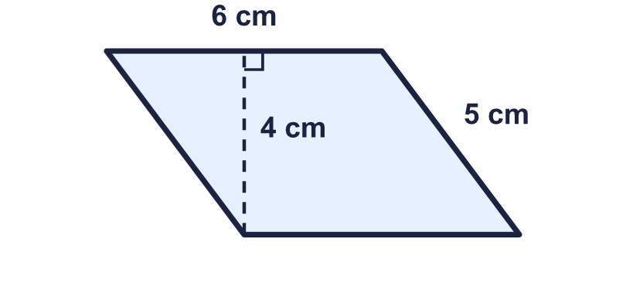
    Area = |  | cm²
  4 | Work out the area of the parallelogram.
    Area = |  | cm²
  5 | The area of this parallelogram is 65 cm². Find the perpendicular height.  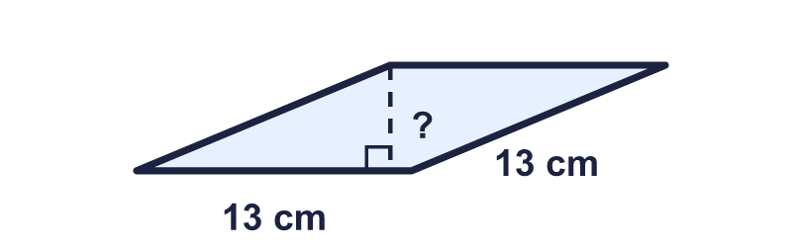
    Height = |  | cm.
  5 | The area of this parallelogram is 65 cm². Find the perpendicular height.
    Height = |  | cm.
  6 | The area of this parallelogram is 150 cm². Find the base.  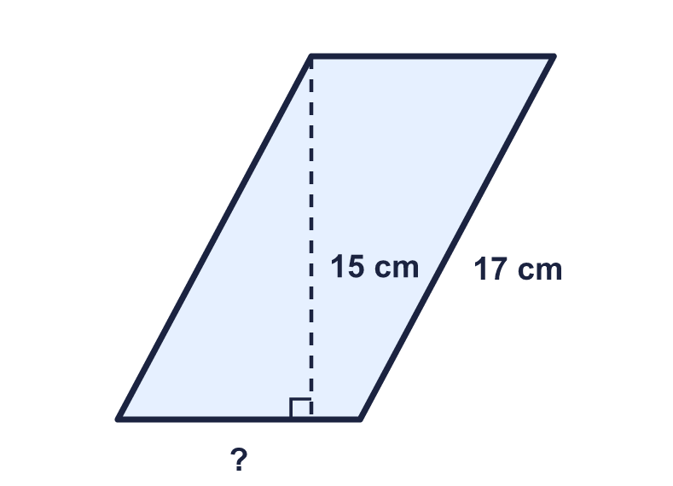
    Base = |  | cm.
  6 | The area of this parallelogram is 150 cm². Find the base.
    Base = |  | cm.
  7 | Work out the area of the parallelogram.  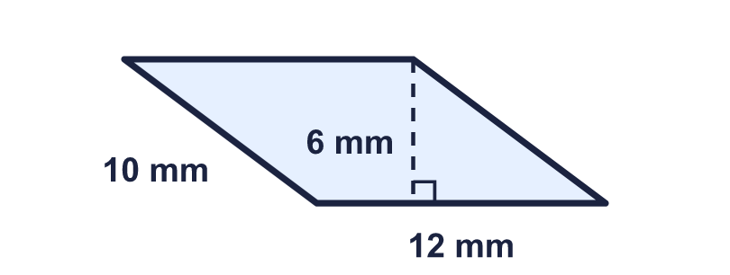
    Area = |  | mm²
  7 | Work out the area of the parallelogram.
    Area = |  | mm²
  8 | The rectangle and the parallelogram have the same base and the same height.  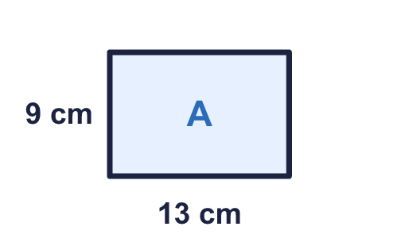  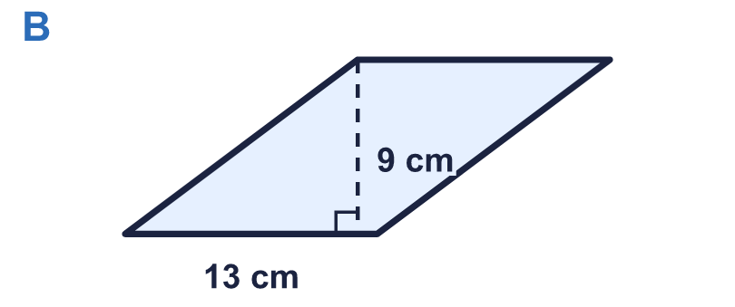
    Area of A = |  | cm²
    Area of B = |  | cm²
  8 | The rectangle and the parallelogram have the same base and the same height.
    Area of A = |  | cm²
    Area of B = |  | cm²

  9 | Rosie works out the area of the parallelogram: "13 × 5 = 65 cm²".  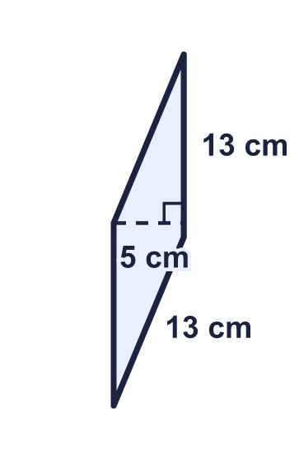  Do you agree with Rosie? Circle yes or no.  Yes / No  Explain your answer.
    Correct area = |  | cm²
  9 | Rosie works out the area of the parallelogram: "13 × 5 = 65 cm²".  Do you agree with Rosie? Circle yes or no.  Yes / No  Explain your answer.
    Correct area = |  | cm²
  10 | Each parallelogram has a base, b, and a height, h. Only some are labelled correctly. Write the letters of the correct ones.  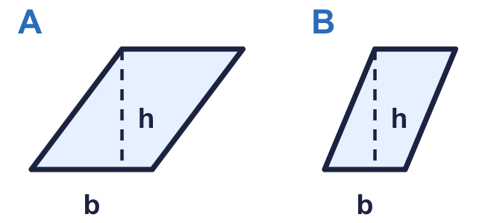  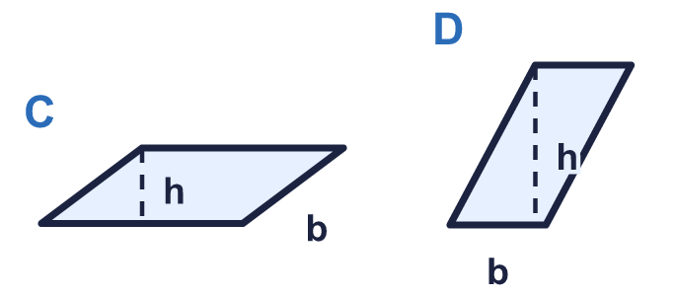
  10 | Each parallelogram has a base, b, and a height, h. Only some are labelled correctly. Write the letters of the correct ones.
  11 | A parallelogram has an area of 60 cm² and a base of 12 cm.
    Perpendicular height = |  | cm.
  11 | A parallelogram has an area of 60 cm² and a base of 12 cm.
    Perpendicular height = |  | cm.
  12 | Which parallelogram has the greater area? How much greater?  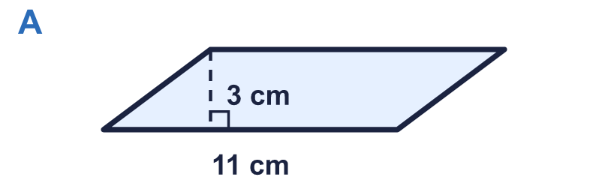  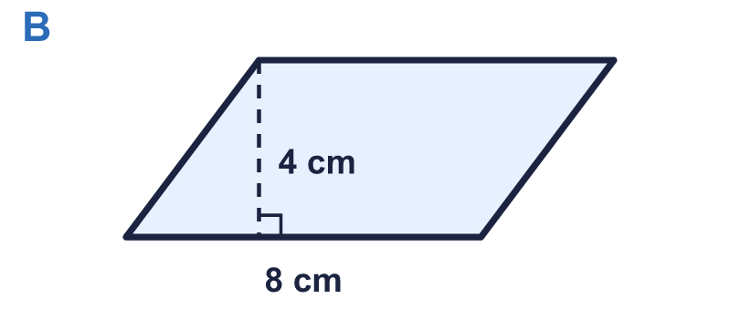
    Greater area: parallelogram
    It is greater by |  | cm²
  12 | Which parallelogram has the greater area? How much greater?
    Greater area: parallelogram
    It is greater by |  | cm²
  13 | A field is a parallelogram with a base of 100 m and a perpendicular height of 80 m. One bag of grass seed covers 200 m².
    Bags needed =
  13 | A field is a parallelogram with a base of 100 m and a perpendicular height of 80 m. One bag of grass seed covers 200 m².
    Bags needed =
  14 | Challenge  A parallelogram has an area of 192 cm². Its base is 3 times as long as its perpendicular height.
    Base = |  | cm.
    Height = |  | cm.
  14 | Challenge  A parallelogram has an area of 192 cm². Its base is 3 times as long as its perpendicular height.
    Base = |  | cm.
    Height = |  | cm.

Year 6 · Area, perimeter, volume · Step 6
Area of a parallelogram
Answers (teacher copy)

  1 | Cut off the triangle and slide it across to make a rectangle.  Area of the rectangle = 14 squares  Area of the parallelogram = 14 squares
  2 | Work out the area of each parallelogram.  a) Parallelogram A: 15 cm²  b) Parallelogram B: 15 cm²
  3 | Work out the area of the parallelogram.  Area = 165 cm²
  4 | Work out the area of the parallelogram.  Area = 24 cm²
  5 | The area of this parallelogram is 65 cm². Find the perpendicular height.  Height = 5 cm.
  6 | The area of this parallelogram is 150 cm². Find the base.  Base = 10 cm.
  7 | Work out the area of the parallelogram.  Area = 72 mm²
  8 | The rectangle and the parallelogram have the same base and the same height.  Area of A = 117 cm²  Area of B = 117 cm²
  9 | Rosie works out the area of the parallelogram: "13 × 5 = 65 cm²".  Do you agree with Rosie? Circle yes or no.  Yes / No  Explain your answer.  Yes. 13 cm is the base and 5 cm is the perpendicular height. 13 × 5 = 65 cm².  Correct area = 65 cm²
  10 | Each parallelogram has a base, b, and a height, h. Only some are labelled correctly. Write the letters of the correct ones.  A, B, D
  11 | A parallelogram has an area of 60 cm² and a base of 12 cm.  Perpendicular height = 5 cm.
  12 | Which parallelogram has the greater area? How much greater?  Greater area: parallelogram A  It is greater by 1 cm²
  13 | A field is a parallelogram with a base of 100 m and a perpendicular height of 80 m. One bag of grass seed covers 200 m².  Bags needed = 40
  14 | Challenge  A parallelogram has an area of 192 cm². Its base is 3 times as long as its perpendicular height.  Base = 24 cm.  Height = 8 cm.

