  Year 6 · Area, perimeter, volume · Step 3  Area of a triangle (counting squares) | 
  Year 6 · Area, perimeter, volume · Step 3
  Area of a triangle (counting squares)
  1 | Count the squares to find the area of the triangle.  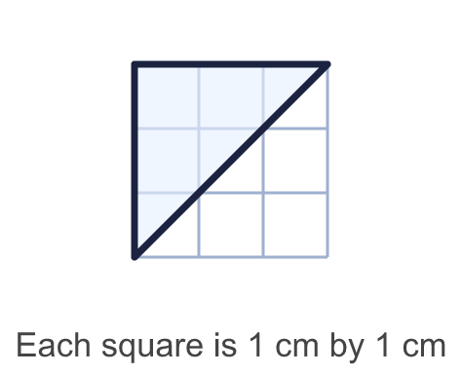
    Whole squares =
    Half squares =
    Area = |  | cm²
  1 | Count the squares to find the area of the triangle.
    Whole squares =
    Half squares =
    Area = |  | cm²
  2 | Count squares to work out the area of each triangle.  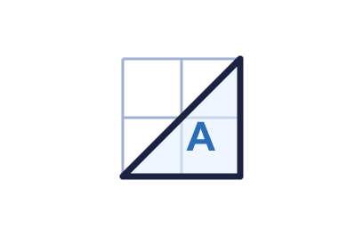  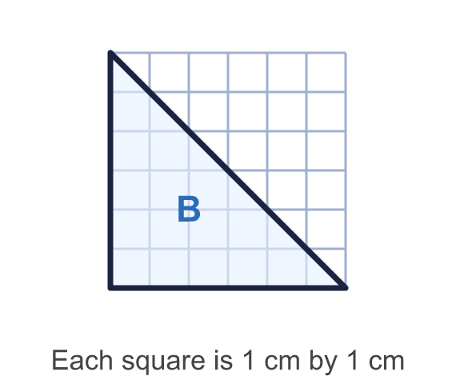
    a) Triangle A: |  | cm²
    b) Triangle B: |  | cm²
  2 | Count squares to work out the area of each triangle.
    a) Triangle A: |  | cm²
    b) Triangle B: |  | cm²
  3 | Count squares to work out the area of the triangle.  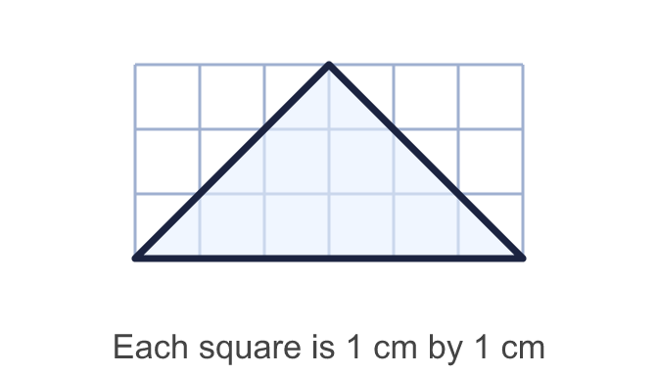
    Area = |  | cm²
  3 | Count squares to work out the area of the triangle.
    Area = |  | cm²
  4 | Complete the sentences.  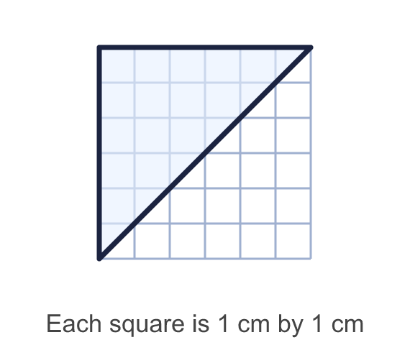
    The triangle has
    whole squares
    and |  | half squares.
    The area is |  | cm²
  4 | Complete the sentences.
    The triangle has
    whole squares
    and |  | half squares.
    The area is |  | cm²
  5 | A triangle covers 8 whole squares and 6 half squares. Each square is 1 cm².
    Area = |  | cm²
  5 | A triangle covers 8 whole squares and 6 half squares. Each square is 1 cm².
    Area = |  | cm²
  6 | A 9 cm by 6 cm rectangle is cut along a diagonal into two identical triangles.  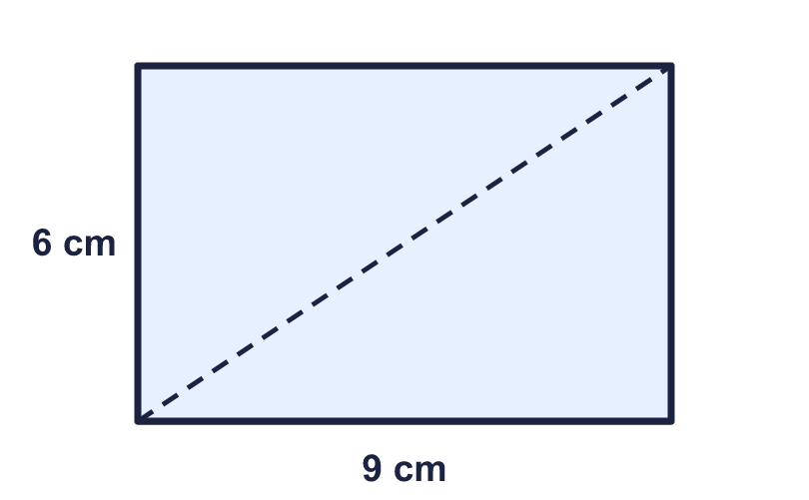
    Area of the rectangle = |  | cm²
    Area of one triangle = |  | cm²
  6 | A 9 cm by 6 cm rectangle is cut along a diagonal into two identical triangles.
    Area of the rectangle = |  | cm²
    Area of one triangle = |  | cm²
  7 | Which triangle has the greater area? How much greater?  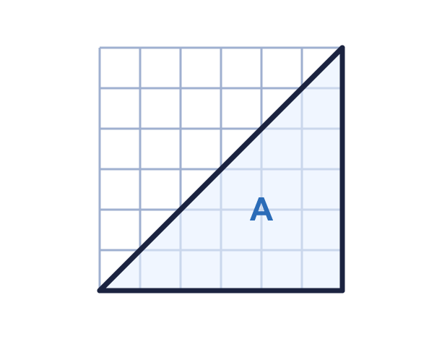  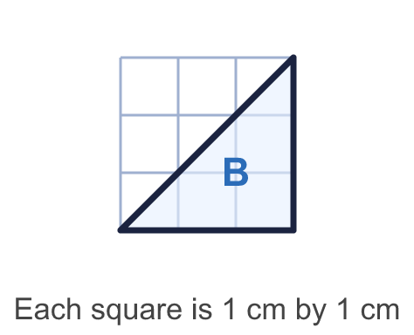
    Greater area: triangle
    It is greater by |  | cm²
  7 | Which triangle has the greater area? How much greater?
    Greater area: triangle
    It is greater by |  | cm²
  8 | Count squares to work out the area of the shape.  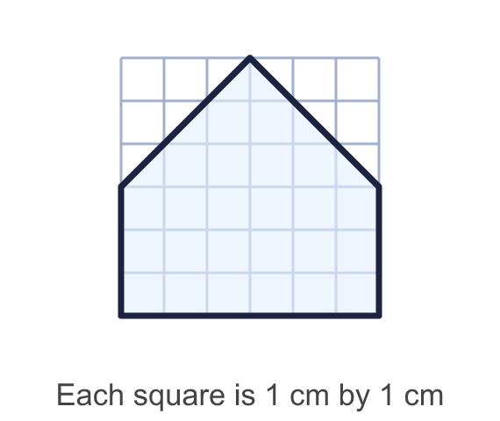
    Area = |  | cm²
  8 | Count squares to work out the area of the shape.
    Area = |  | cm²

  9 | Jo counts 7 whole squares and 4 half squares in a triangle. "I add them up, so the area is 11 cm²."  Is Jo correct? Circle yes or no.  Yes / No  Explain how you know.
  9 | Jo counts 7 whole squares and 4 half squares in a triangle. "I add them up, so the area is 11 cm²."  Is Jo correct? Circle yes or no.  Yes / No  Explain how you know.
  10 | Zach says: "The triangle is 8 squares wide and 6 squares high, so the area is 48 cm²."  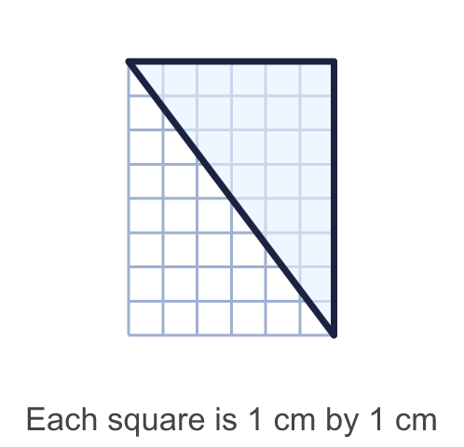  Is Zach correct? Circle yes or no.  Yes / No  Explain how you know.
  10 | Zach says: "The triangle is 8 squares wide and 6 squares high, so the area is 48 cm²."  Is Zach correct? Circle yes or no.  Yes / No  Explain how you know.
  11 | Count squares to work out the area of the shape.  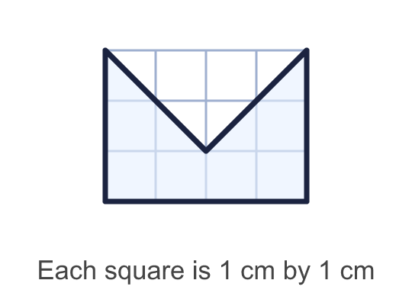
    Area = |  | cm²
  11 | Count squares to work out the area of the shape.
    Area = |  | cm²
  12 | A triangle has an area of 14 cm². It covers 7 whole squares and some half squares.
    How many half squares?
  12 | A triangle has an area of 14 cm². It covers 7 whole squares and some half squares.
    How many half squares?
  13 | A right-angled triangle has two short sides that are the same length. Its area is 18 cm².
    Length of each short side =
    cm.
  13 | A right-angled triangle has two short sides that are the same length. Its area is 18 cm².
    Length of each short side =
    cm.
  14 | Challenge  A right-angled triangle has an area of 20 cm². Its two short sides are whole numbers of centimetres. A triangle with short sides 2 cm and 3 cm is the same as one with short sides 3 cm and 2 cm.
    How many different triangles are there?
  14 | Challenge  A right-angled triangle has an area of 20 cm². Its two short sides are whole numbers of centimetres. A triangle with short sides 2 cm and 3 cm is the same as one with short sides 3 cm and 2 cm.
    How many different triangles are there?

Year 6 · Area, perimeter, volume · Step 3
Area of a triangle (counting squares)
Answers (teacher copy)

  1 | Count the squares to find the area of the triangle.  Whole squares = 3  Half squares = 3  Area = 4.5 cm²
  2 | Count squares to work out the area of each triangle.  a) Triangle A: 2 cm²  b) Triangle B: 18 cm²
  3 | Count squares to work out the area of the triangle.  Area = 9 cm²
  4 | Complete the sentences.  The triangle has 15 whole squares  and 6 half squares.  The area is 18 cm²
  5 | A triangle covers 8 whole squares and 6 half squares. Each square is 1 cm².  Area = 11 cm²
  6 | A 9 cm by 6 cm rectangle is cut along a diagonal into two identical triangles.  Area of the rectangle = 54 cm²  Area of one triangle = 27 cm²
  7 | Which triangle has the greater area? How much greater?  Greater area: triangle A  It is greater by 13.5 cm²
  8 | Count squares to work out the area of the shape.  Area = 27 cm²
  9 | Jo counts 7 whole squares and 4 half squares in a triangle. "I add them up, so the area is 11 cm²."  Is Jo correct? Circle yes or no.  Yes / No  Explain how you know.  No. Two half squares make one whole square, so the area is 7 + 2 = 9 cm².
  10 | Zach says: "The triangle is 8 squares wide and 6 squares high, so the area is 48 cm²."  Is Zach correct? Circle yes or no.  Yes / No  Explain how you know.  No. 8 × 6 = 48 cm² is the area of the rectangle round the triangle. The triangle is half of it, so its area is 24 cm².
  11 | Count squares to work out the area of the shape.  Area = 8 cm²
  12 | A triangle has an area of 14 cm². It covers 7 whole squares and some half squares.  How many half squares? 14
  13 | A right-angled triangle has two short sides that are the same length. Its area is 18 cm².  Length of each short side = 6 cm.
  14 | Challenge  A right-angled triangle has an area of 20 cm². Its two short sides are whole numbers of centimetres. A triangle with short sides 2 cm and 3 cm is the same as one with short sides 3 cm and 2 cm.  How many different triangles are there? 4

