  Year 6 · Area, perimeter, volume · Step 5  Area of any triangle | 
  Year 6 · Area, perimeter, volume · Step 5
  Area of any triangle
  1 | Work out the area of the triangle.  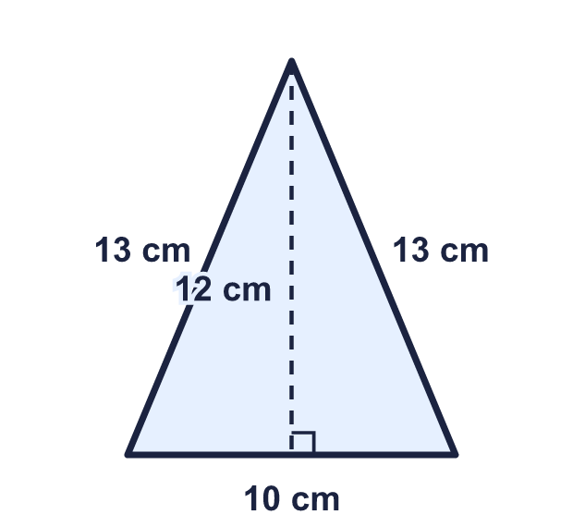
    Area = |  | cm²
  1 | Work out the area of the triangle.
    Area = |  | cm²
  2 | Work out the area of each triangle.  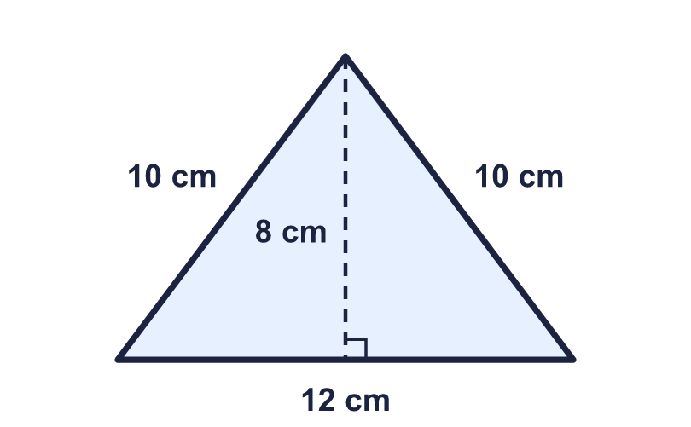  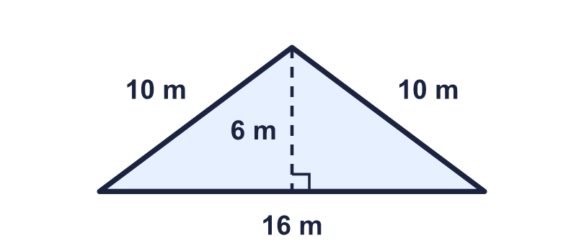
    a) |  | cm²
    b) |  | m²
  2 | Work out the area of each triangle.
    a) |  | cm²
    b) |  | m²
  3 | Write the base and the perpendicular height of the triangle.  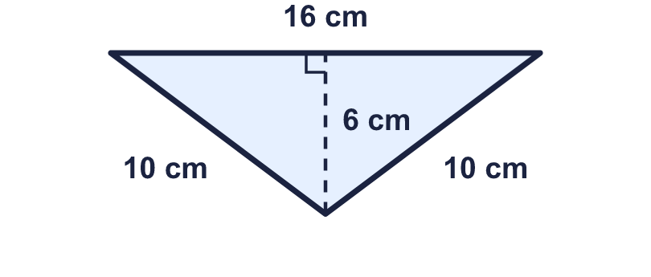
    Base = |  | cm.
    Height = |  | cm.
  3 | Write the base and the perpendicular height of the triangle.
    Base = |  | cm.
    Height = |  | cm.
  4 | Work out the area of the triangle.  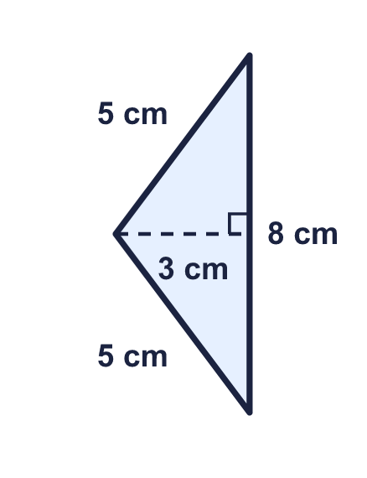
    Area = |  | cm²
  4 | Work out the area of the triangle.
    Area = |  | cm²
  5 | The area of this triangle is 84 cm². Find the perpendicular height.  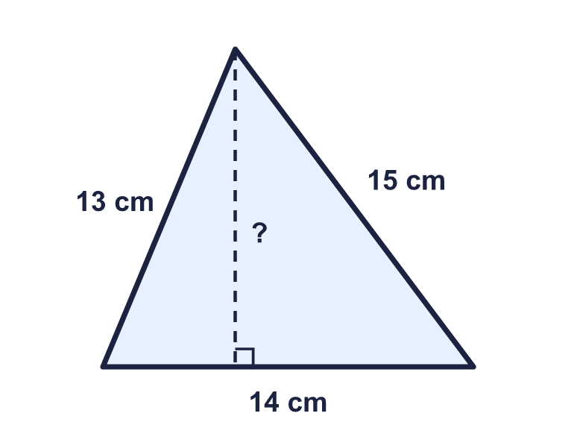
    Height = |  | cm.
  5 | The area of this triangle is 84 cm². Find the perpendicular height.
    Height = |  | cm.
  6 | Work out the perimeter and the area of the triangle.  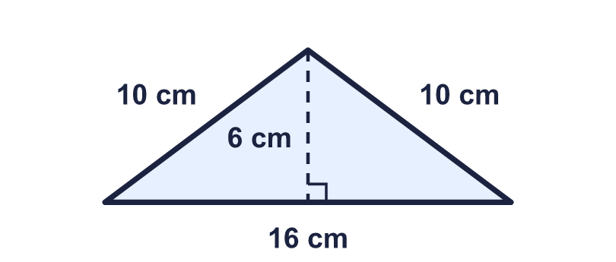
    Perimeter = |  | cm.
    Area = |  | cm²
  6 | Work out the perimeter and the area of the triangle.
    Perimeter = |  | cm.
    Area = |  | cm²
  7 | Triangles A and B have the same base and the same height.  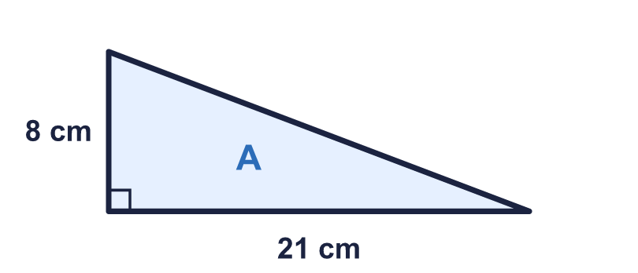  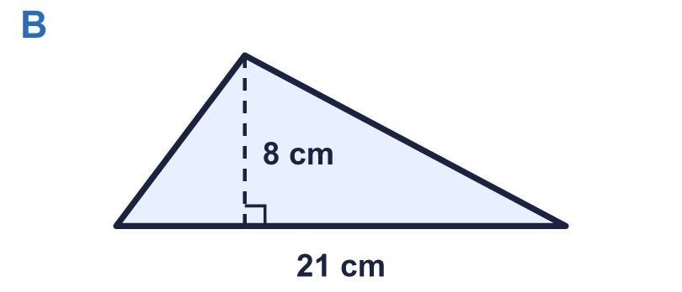
    Area of A = |  | cm²
    Area of B = |  | cm²
  7 | Triangles A and B have the same base and the same height.
    Area of A = |  | cm²
    Area of B = |  | cm²
  8 | Work out the area of the triangular field.  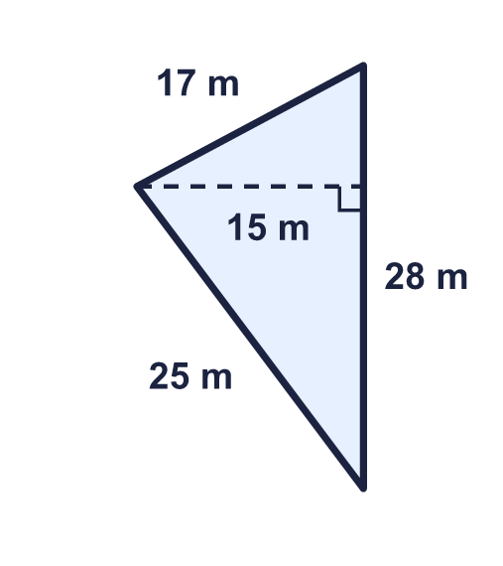
    Area = |  | m²
  8 | Work out the area of the triangular field.
    Area = |  | m²

  9 | Sam works out the area of the triangle: "16 × 6 ÷ 2".  Do you agree with Sam? Circle yes or no.  Yes / No  Explain your answer.
  9 | Sam works out the area of the triangle: "16 × 6 ÷ 2".  Do you agree with Sam? Circle yes or no.  Yes / No  Explain your answer.
  10 | Write the base and the perpendicular height of each triangle.  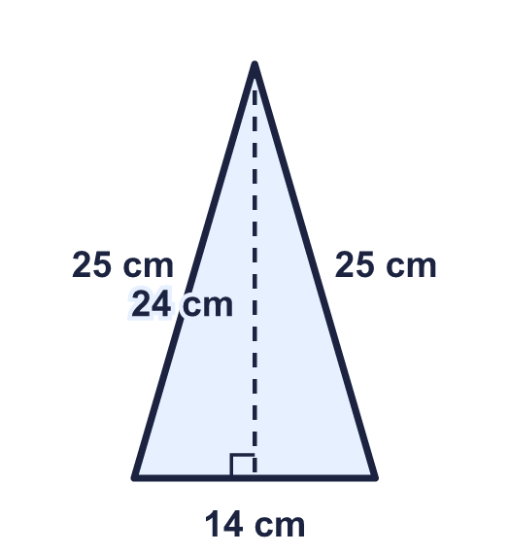  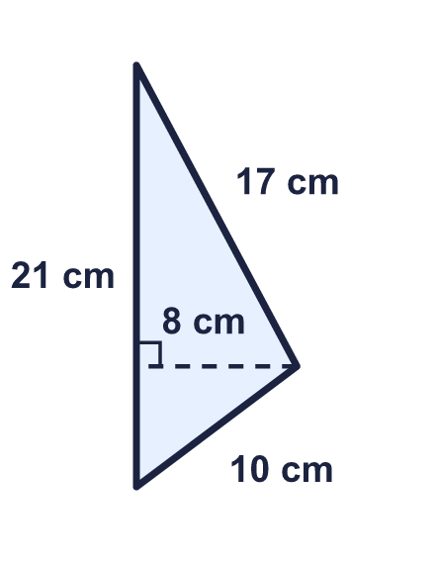
    a) Base = |  | cm.
    a) Height = |  | cm.
    b) Base = |  | cm.
    b) Height = |  | cm.
  10 | Write the base and the perpendicular height of each triangle.
    a) Base = |  | cm.
    a) Height = |  | cm.
    b) Base = |  | cm.
    b) Height = |  | cm.
  11 | A triangle has an area of 77 cm². Its perpendicular height is 11 cm.
    Base = |  | cm.
  11 | A triangle has an area of 77 cm². Its perpendicular height is 11 cm.
    Base = |  | cm.
  12 | A triangle and a rectangle both have a base of 12 cm and a height of 9 cm. What is the difference between their areas?
    Difference in area = |  | cm²
  12 | A triangle and a rectangle both have a base of 12 cm and a height of 9 cm. What is the difference between their areas?
    Difference in area = |  | cm²
  13 | A flag is a triangle with a base of 60 cm and a perpendicular height of 50 cm. 8 flags are cut from a roll of cloth.
    Total area of the flags = |  | cm²
  13 | A flag is a triangle with a base of 60 cm and a perpendicular height of 50 cm. 8 flags are cut from a roll of cloth.
    Total area of the flags = |  | cm²
  14 | Challenge  A triangle has an area of 15 cm². Its base and its perpendicular height are whole numbers of centimetres. A base of 6 cm with a height of 4 cm is different from a base of 4 cm with a height of 6 cm, so only count triangles with a base that is longer than or the same as the height.
    How many different triangles are there?
  14 | Challenge  A triangle has an area of 15 cm². Its base and its perpendicular height are whole numbers of centimetres. A base of 6 cm with a height of 4 cm is different from a base of 4 cm with a height of 6 cm, so only count triangles with a base that is longer than or the same as the height.
    How many different triangles are there?

Year 6 · Area, perimeter, volume · Step 5
Area of any triangle
Answers (teacher copy)

  1 | Work out the area of the triangle.  Area = 60 cm²
  2 | Work out the area of each triangle.  a) 48 cm²  b) 48 m²
  3 | Write the base and the perpendicular height of the triangle.  Base = 16 cm.  Height = 6 cm.
  4 | Work out the area of the triangle.  Area = 12 cm²
  5 | The area of this triangle is 84 cm². Find the perpendicular height.  Height = 12 cm.
  6 | Work out the perimeter and the area of the triangle.  Perimeter = 36 cm.  Area = 48 cm²
  7 | Triangles A and B have the same base and the same height.  Area of A = 84 cm²  Area of B = 84 cm²
  8 | Work out the area of the triangular field.  Area = 210 m²
  9 | Sam works out the area of the triangle: "16 × 6 ÷ 2".  Do you agree with Sam? Circle yes or no.  Yes / No  Explain your answer.  Yes. 16 cm is the base and 6 cm is the perpendicular height. 16 × 6 ÷ 2 = 48 cm².
  10 | Write the base and the perpendicular height of each triangle.  a) Base = 14 cm.  a) Height = 24 cm.  b) Base = 21 cm.  b) Height = 8 cm.
  11 | A triangle has an area of 77 cm². Its perpendicular height is 11 cm.  Base = 14 cm.
  12 | A triangle and a rectangle both have a base of 12 cm and a height of 9 cm. What is the difference between their areas?  Difference in area = 54 cm²
  13 | A flag is a triangle with a base of 60 cm and a perpendicular height of 50 cm. 8 flags are cut from a roll of cloth.  Total area of the flags = 12,000 cm²
  14 | Challenge  A triangle has an area of 15 cm². Its base and its perpendicular height are whole numbers of centimetres. A base of 6 cm with a height of 4 cm is different from a base of 4 cm with a height of 6 cm, so only count triangles with a base that is longer than or the same as the height.  How many different triangles are there? 4

