  Year 6 · Area, perimeter, volume · Step 7  Volume (counting cubes) | 
  Year 6 · Area, perimeter, volume · Step 7
  Volume (counting cubes)
  1 | How many cubes are needed to make the shape? There are no hidden cubes.  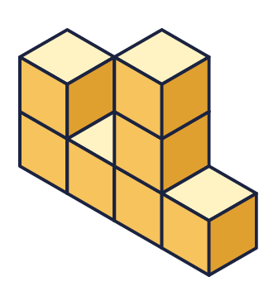
    Number of cubes =
  1 | How many cubes are needed to make the shape? There are no hidden cubes.
    Number of cubes =
  2 | How many cubes are needed to make each shape? There are no hidden cubes.  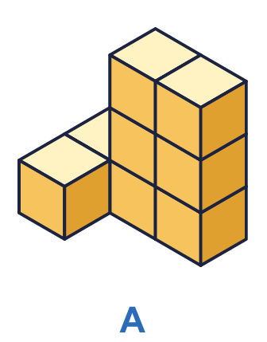  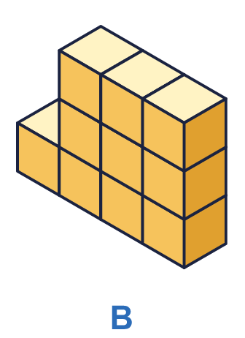
    a) Shape A: |  | cubes
    b) Shape B: |  | cubes
  2 | How many cubes are needed to make each shape? There are no hidden cubes.
    a) Shape A: |  | cubes
    b) Shape B: |  | cubes
  3 | The cuboid is made from cubes. Count the cubes in one layer, then work out the total.  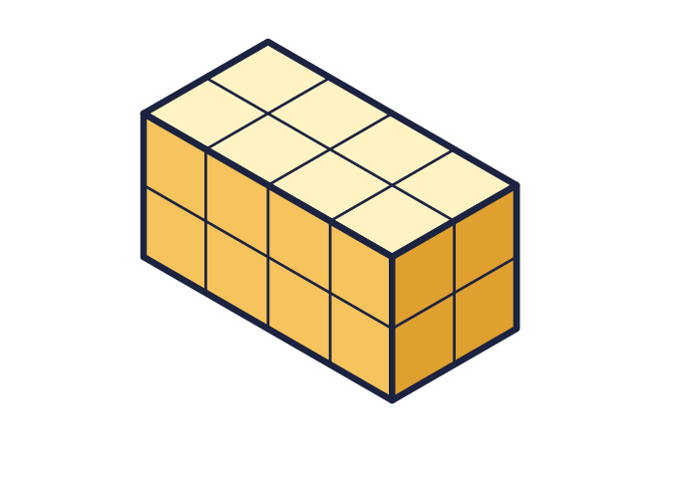
    Cubes in one layer =
    Number of layers =
    Total cubes =
  3 | The cuboid is made from cubes. Count the cubes in one layer, then work out the total.
    Cubes in one layer =
    Number of layers =
    Total cubes =
  4 | Each cube is 1 cm³. Work out the volume of each cuboid.  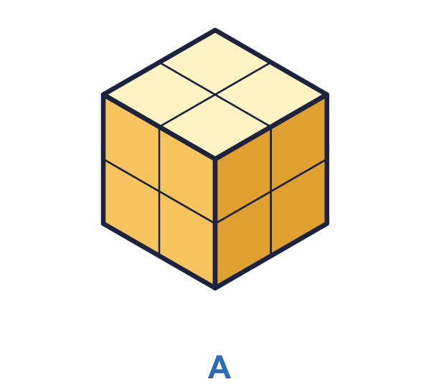  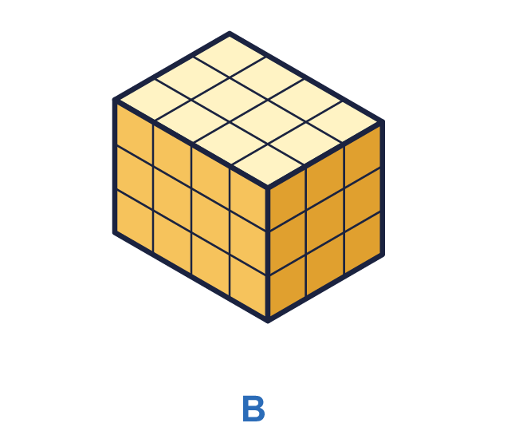
    a) Cuboid A: |  | cm³
    b) Cuboid B: |  | cm³
  4 | Each cube is 1 cm³. Work out the volume of each cuboid.
    a) Cuboid A: |  | cm³
    b) Cuboid B: |  | cm³
  5 | Each cube is 1 cm³. What is the volume of each shape?  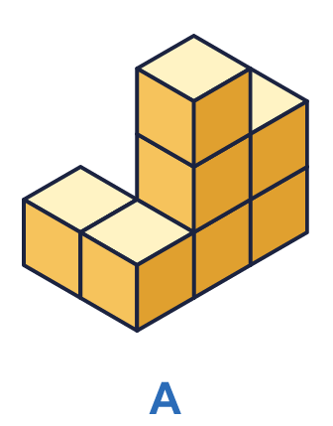  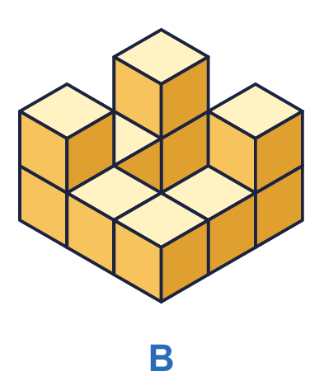
    a) Shape A: |  | cm³
    b) Shape B: |  | cm³
  5 | Each cube is 1 cm³. What is the volume of each shape?
    a) Shape A: |  | cm³
    b) Shape B: |  | cm³
  6 | A cuboid is made from cubes. It is 4 cubes long, 6 cubes wide and 4 cubes high.
    Number of cubes =
  6 | A cuboid is made from cubes. It is 4 cubes long, 6 cubes wide and 4 cubes high.
    Number of cubes =
  7 | A box is filled with 5 layers of cubes. Each layer has 9 cubes.
    Number of cubes =
  7 | A box is filled with 5 layers of cubes. Each layer has 9 cubes.
    Number of cubes =
  8 | Look at the two shapes. There are no hidden cubes.  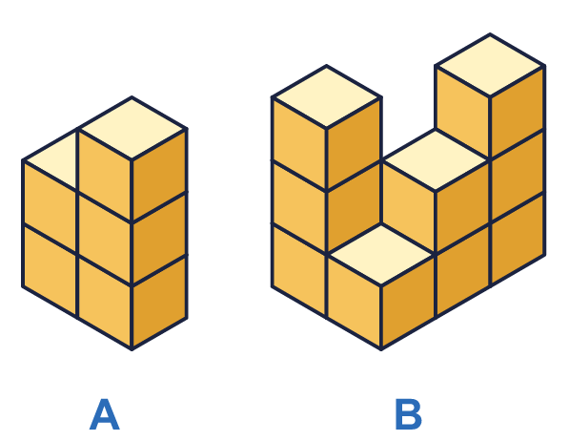
    Shape A: |  | cubes
    Shape B: |  | cubes
    Shape B has
    more cubes than shape A.
  8 | Look at the two shapes. There are no hidden cubes.
    Shape A: |  | cubes
    Shape B: |  | cubes
    Shape B has
    more cubes than shape A.

  9 | Mia says: "There are 19 cubes in the cuboid."  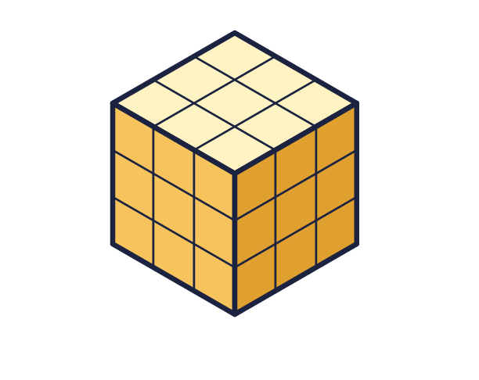  Is Mia correct? Circle yes or no.  Yes / No  Explain what mistake has been made.
  9 | Mia says: "There are 19 cubes in the cuboid."  Is Mia correct? Circle yes or no.  Yes / No  Explain what mistake has been made.
  10 | Each cube is 1 cm³. Which cuboid has the greater volume? How much greater?  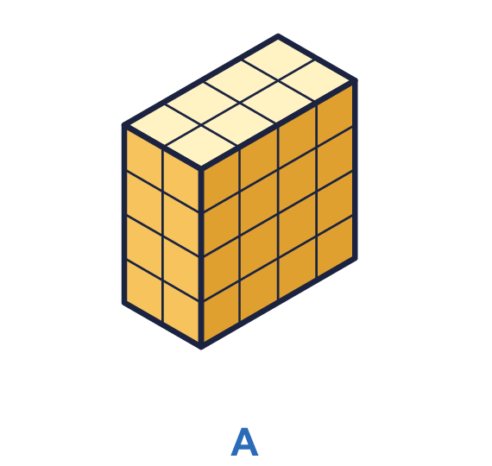  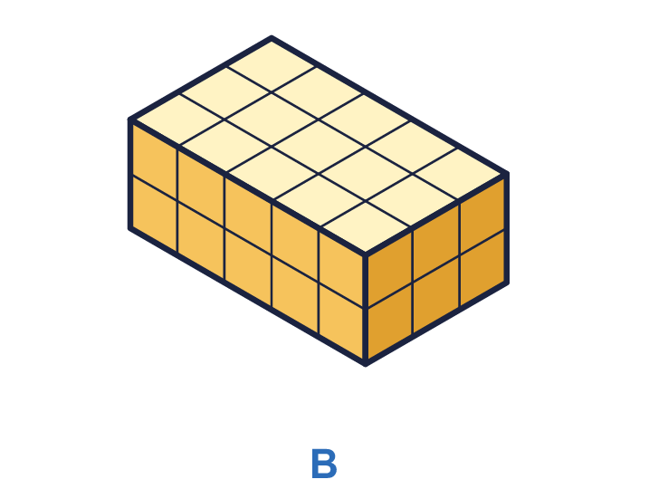
    Greater volume: cuboid
    It is greater by |  | cm³
  10 | Each cube is 1 cm³. Which cuboid has the greater volume? How much greater?
    Greater volume: cuboid
    It is greater by |  | cm³
  11 | A cuboid is made from 60 cubes. It is 4 cubes long and 3 cubes wide.
    It is |  | cubes high.
  11 | A cuboid is made from 60 cubes. It is 4 cubes long and 3 cubes wide.
    It is |  | cubes high.
  12 | A box holds 24 cubes in 4 equal layers. Each layer is 2 cubes wide.
    Cubes in one layer =
    Each layer is |  | cubes long.
  12 | A box holds 24 cubes in 4 equal layers. Each layer is 2 cubes wide.
    Cubes in one layer =
    Each layer is |  | cubes long.
  13 | You have 12 cubes. You use all of them to make a cuboid. A cuboid that is 1 cube by 2 cubes by 6 cubes is the same as one that is 2 by 6 by 1.
    How many different cuboids can you make?
  13 | You have 12 cubes. You use all of them to make a cuboid. A cuboid that is 1 cube by 2 cubes by 6 cubes is the same as one that is 2 by 6 by 1.
    How many different cuboids can you make?
  14 | Challenge  A cuboid is made from 48 cubes in 3 layers. Every layer is a square.
    Each side of the square is
    cubes long.
  14 | Challenge  A cuboid is made from 48 cubes in 3 layers. Every layer is a square.
    Each side of the square is
    cubes long.

Year 6 · Area, perimeter, volume · Step 7
Volume (counting cubes)
Answers (teacher copy)

  1 | How many cubes are needed to make the shape? There are no hidden cubes.  Number of cubes = 7
  2 | How many cubes are needed to make each shape? There are no hidden cubes.  a) Shape A: 8 cubes  b) Shape B: 10 cubes
  3 | The cuboid is made from cubes. Count the cubes in one layer, then work out the total.  Cubes in one layer = 8  Number of layers = 2  Total cubes = 16
  4 | Each cube is 1 cm³. Work out the volume of each cuboid.  a) Cuboid A: 8 cm³  b) Cuboid B: 36 cm³
  5 | Each cube is 1 cm³. What is the volume of each shape?  a) Shape A: 7 cm³  b) Shape B: 10 cm³
  6 | A cuboid is made from cubes. It is 4 cubes long, 6 cubes wide and 4 cubes high.  Number of cubes = 96
  7 | A box is filled with 5 layers of cubes. Each layer has 9 cubes.  Number of cubes = 45
  8 | Look at the two shapes. There are no hidden cubes.  Shape A: 5 cubes  Shape B: 10 cubes  Shape B has 5 more cubes than shape A.
  9 | Mia says: "There are 19 cubes in the cuboid."  Is Mia correct? Circle yes or no.  Yes / No  Explain what mistake has been made.  No. Mia has counted only the cubes that can be seen. The cuboid is 3 cubes long, 3 wide and 3 high, so it has 3 × 3 × 3 = 27 cubes.
  10 | Each cube is 1 cm³. Which cuboid has the greater volume? How much greater?  Greater volume: cuboid A  It is greater by 2 cm³
  11 | A cuboid is made from 60 cubes. It is 4 cubes long and 3 cubes wide.  It is 5 cubes high.
  12 | A box holds 24 cubes in 4 equal layers. Each layer is 2 cubes wide.  Cubes in one layer = 6  Each layer is 3 cubes long.
  13 | You have 12 cubes. You use all of them to make a cuboid. A cuboid that is 1 cube by 2 cubes by 6 cubes is the same as one that is 2 by 6 by 1.  How many different cuboids can you make? 4
  14 | Challenge  A cuboid is made from 48 cubes in 3 layers. Every layer is a square.  Each side of the square is 4 cubes long.

