  Year 6 · Area, perimeter, volume · Step 8  Volume of a cuboid | 
  Year 6 · Area, perimeter, volume · Step 8
  Volume of a cuboid
  1 | The cuboid is made from 1 cm³ cubes. Work out its volume.  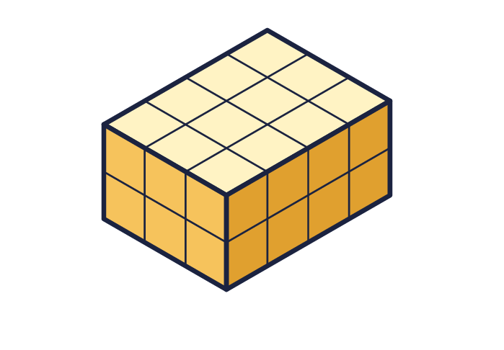
    Volume = |  | cm³
  1 | The cuboid is made from 1 cm³ cubes. Work out its volume.
    Volume = |  | cm³
  2 | Work out the volume of the cuboid.  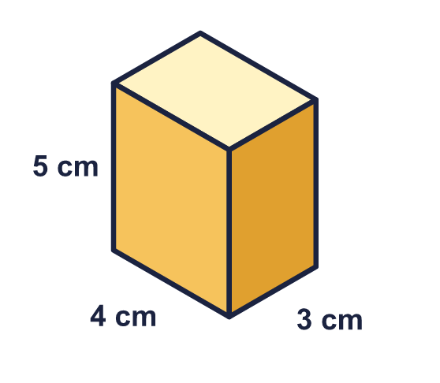
    Volume = |  | cm³
  2 | Work out the volume of the cuboid.
    Volume = |  | cm³
  3 | Work out the volume of the cube.  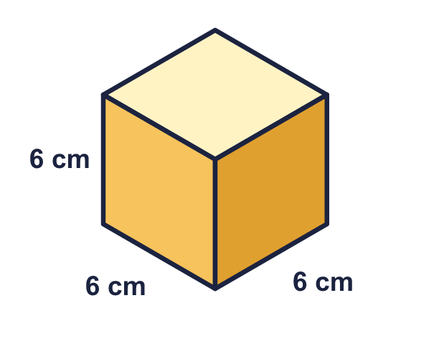
    Volume = |  | cm³
  3 | Work out the volume of the cube.
    Volume = |  | cm³
  4 | Work out the volume of the cuboid.  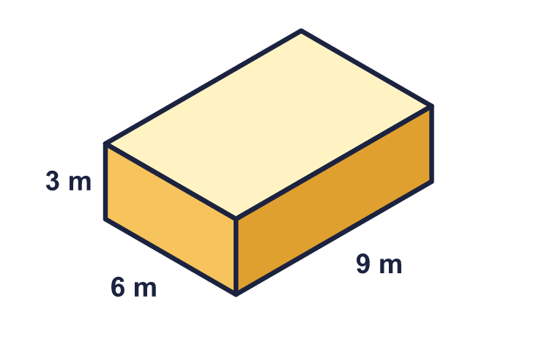
    Volume = |  | m³
  4 | Work out the volume of the cuboid.
    Volume = |  | m³
  5 | The volume of the cuboid is 135 cm³. Find the missing length.  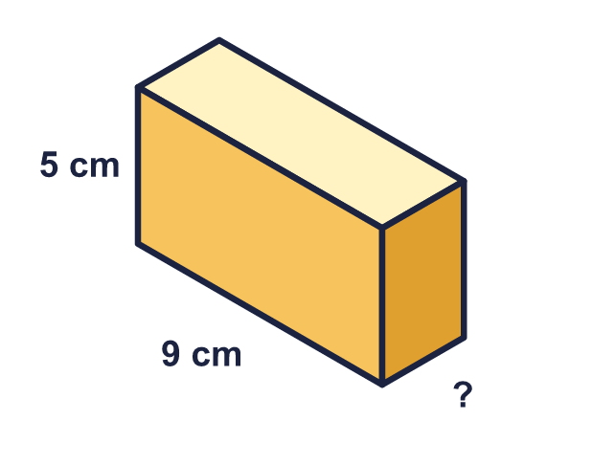
    Missing length = |  | cm.
  5 | The volume of the cuboid is 135 cm³. Find the missing length.
    Missing length = |  | cm.
  6 | A box is 13 cm long, 7 cm wide and 3 cm high.
    Volume = |  | cm³
  6 | A box is 13 cm long, 7 cm wide and 3 cm high.
    Volume = |  | cm³
  7 | Which cuboid has the greater volume? How much greater?  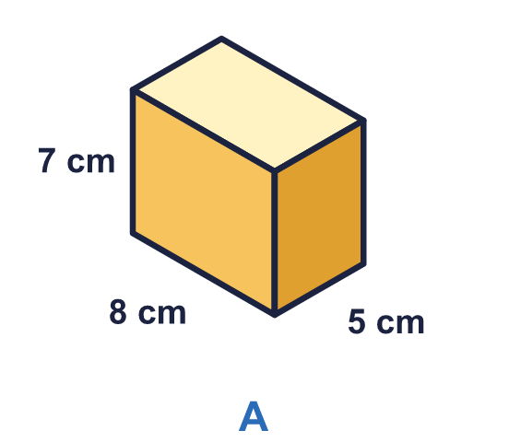  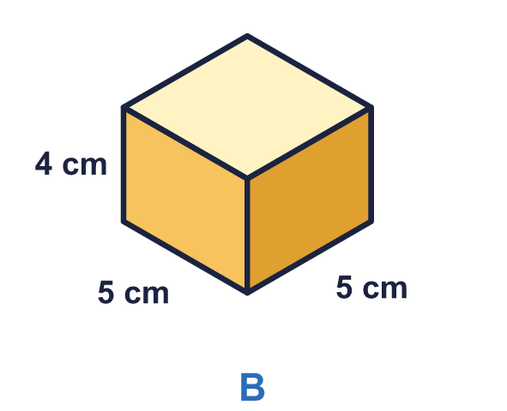
    Greater volume: cuboid
    It is greater by |  | cm³
  7 | Which cuboid has the greater volume? How much greater?
    Greater volume: cuboid
    It is greater by |  | cm³
  8 | A cube has a volume of 125 cm³.
    Length of one edge = |  | cm.
  8 | A cube has a volume of 125 cm³.
    Length of one edge = |  | cm.

  9 | Leo says: "Cuboid A looks bigger than cuboid B, so it must have the greater volume."  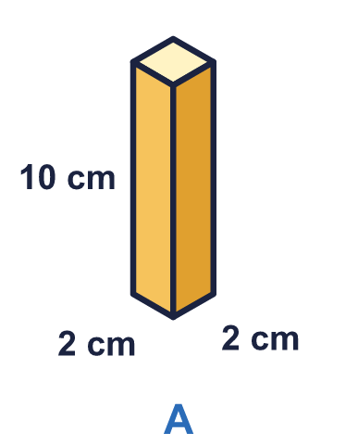  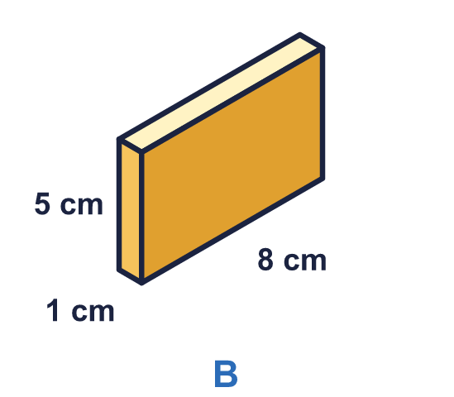  Is Leo correct? Circle yes or no.  Yes / No  Explain how you know.
  9 | Leo says: "Cuboid A looks bigger than cuboid B, so it must have the greater volume."  Is Leo correct? Circle yes or no.  Yes / No  Explain how you know.
  10 | Cuboid A and cuboid B are joined together to make one solid. Work out the volume of the whole solid.  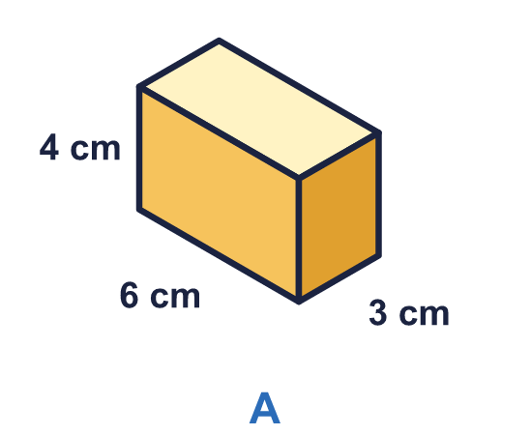  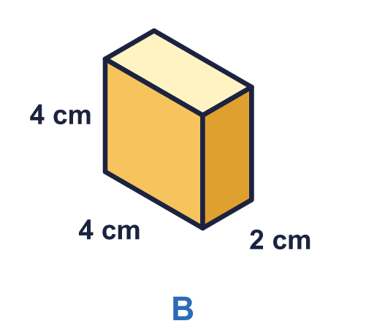
    Volume of the solid = |  | cm³
  10 | Cuboid A and cuboid B are joined together to make one solid. Work out the volume of the whole solid.
    Volume of the solid = |  | cm³
  11 | A cuboid has a volume of 36 cm³. The area of its base is 12 cm².
    Height = |  | cm.
  11 | A cuboid has a volume of 36 cm³. The area of its base is 12 cm².
    Height = |  | cm.
  12 | A swimming pool is 25 m long, 10 m wide and 3 m deep. It is full of water.
    Volume of water = |  | m³
  12 | A swimming pool is 25 m long, 10 m wide and 3 m deep. It is full of water.
    Volume of water = |  | m³
  13 | Which of these cuboids have a volume of 60 cm³? Write the letters.  A: 3 cm by 4 cm by 5 cm  B: 3 cm by 5 cm by 6 cm  C: 2 cm by 5 cm by 6 cm  D: 4 cm by 4 cm by 5 cm
  13 | Which of these cuboids have a volume of 60 cm³? Write the letters.  A: 3 cm by 4 cm by 5 cm  B: 3 cm by 5 cm by 6 cm  C: 2 cm by 5 cm by 6 cm  D: 4 cm by 4 cm by 5 cm
  14 | Challenge  A cuboid has a square base. Its height is 6 cm and its volume is 96 cm³.
    Each side of the square base =
    cm.
  14 | Challenge  A cuboid has a square base. Its height is 6 cm and its volume is 96 cm³.
    Each side of the square base =
    cm.

Year 6 · Area, perimeter, volume · Step 8
Volume of a cuboid
Answers (teacher copy)

  1 | The cuboid is made from 1 cm³ cubes. Work out its volume.  Volume = 24 cm³
  2 | Work out the volume of the cuboid.  Volume = 60 cm³
  3 | Work out the volume of the cube.  Volume = 216 cm³
  4 | Work out the volume of the cuboid.  Volume = 162 m³
  5 | The volume of the cuboid is 135 cm³. Find the missing length.  Missing length = 3 cm.
  6 | A box is 13 cm long, 7 cm wide and 3 cm high.  Volume = 273 cm³
  7 | Which cuboid has the greater volume? How much greater?  Greater volume: cuboid A  It is greater by 180 cm³
  8 | A cube has a volume of 125 cm³.  Length of one edge = 5 cm.
  9 | Leo says: "Cuboid A looks bigger than cuboid B, so it must have the greater volume."  Is Leo correct? Circle yes or no.  Yes / No  Explain how you know.  No. Cuboid A has a volume of 2 × 2 × 10 = 40 cm³ and cuboid B has a volume of 1 × 8 × 5 = 40 cm³. They are the same.
  10 | Cuboid A and cuboid B are joined together to make one solid. Work out the volume of the whole solid.  Volume of the solid = 104 cm³
  11 | A cuboid has a volume of 36 cm³. The area of its base is 12 cm².  Height = 3 cm.
  12 | A swimming pool is 25 m long, 10 m wide and 3 m deep. It is full of water.  Volume of water = 750 m³
  13 | Which of these cuboids have a volume of 60 cm³? Write the letters.  A: 3 cm by 4 cm by 5 cm  B: 3 cm by 5 cm by 6 cm  C: 2 cm by 5 cm by 6 cm  D: 4 cm by 4 cm by 5 cm  A, C
  14 | Challenge  A cuboid has a square base. Its height is 6 cm and its volume is 96 cm³.  Each side of the square base = 4 cm.

