  Year 6 · Decimals · Step 2  Place value with whole numbers and decimals | 
  Year 6 · Decimals · Step 2
  Place value with whole numbers and decimals
  1 | Write the number shown on each place value chart.  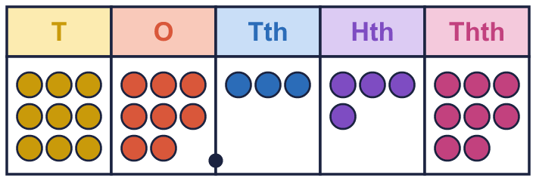  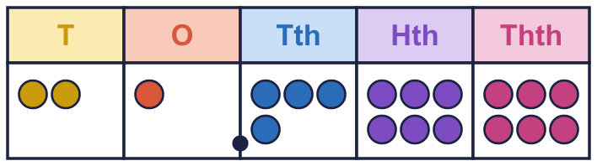
    a) The number is
    b) The number is
  1 | Write the number shown on each place value chart.
    a) The number is
    b) The number is
  2 | Use counters to make each number. Write how many counters go in each column.  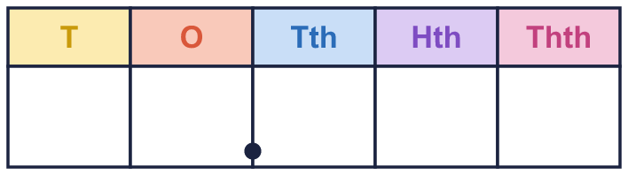
    a) 70.479:
    b) 42.582:
  2 | Use counters to make each number. Write how many counters go in each column.
    a) 70.479:
    b) 42.582:
  3 | Write the value of the digit in each number.
    a) the 5 in 56.417:
    b) the 6 in 58.602:
    c) the 8 in 12.896:
    d) the 7 in 13.274:
  3 | Write the value of the digit in each number.
    a) the 5 in 56.417:
    b) the 6 in 58.602:
    c) the 8 in 12.896:
    d) the 7 in 13.274:
  4 | Write the missing number.
    a) 65.147 = 60 + 5 +
    + 0.04 + 0.007
    b) 31.745 = 30 +
    + 0.7 + 0.04 + 0.005
    c) 72.311 = 70 +
    + 0.3 + 0.01 + 0.001
  4 | Write the missing number.
    a) 65.147 = 60 + 5 +
    + 0.04 + 0.007
    b) 31.745 = 30 +
    + 0.7 + 0.04 + 0.005
    c) 72.311 = 70 +
    + 0.3 + 0.01 + 0.001
  5 | Write the missing number.
    a) 41.777 = 40 +
    + 0.7 + 0.07 + 0.007
    b) 79.383 = 70 +
    + 0.3 + 0.08 + 0.003
    c) 31.728 = 30 +
    + 0.7 + 0.02 + 0.008
  5 | Write the missing number.
    a) 41.777 = 40 +
    + 0.7 + 0.07 + 0.007
    b) 79.383 = 70 +
    + 0.3 + 0.08 + 0.003
    c) 31.728 = 30 +
    + 0.7 + 0.02 + 0.008
  6 | Write the missing number. The tenths change each time.
    a) 4.785 = 4 + 0.7 +
    + 0.005
    b) 4.785 = 4 + 0.6 +
    + 0.005
    c) 4.785 = 4 + 0.5 +
    + 0.005
    d) 4.785 = 4 + 0.4 +
    + 0.005
  6 | Write the missing number. The tenths change each time.
    a) 4.785 = 4 + 0.7 +
    + 0.005
    b) 4.785 = 4 + 0.6 +
    + 0.005
    c) 4.785 = 4 + 0.5 +
    + 0.005
    d) 4.785 = 4 + 0.4 +
    + 0.005
  7 | Write <, > or = in each box.
    a) 24.251 |  | 24.351
    b) 27.63 |  | 27.62
    c) 28.2 |  | 28.19
    d) 7.8 |  | 7.799
  7 | Write <, > or = in each box.
    a) 24.251 |  | 24.351
    b) 27.63 |  | 27.62
    c) 28.2 |  | 28.19
    d) 7.8 |  | 7.799
  8 | Write these numbers in order, starting with the greatest.  3.36 3.11 3.87 3.91
  8 | Write these numbers in order, starting with the greatest.  3.36 3.11 3.87 3.91

  9 | Is Mia correct? Circle yes or no.  Yes / No  Explain how you know.
     | 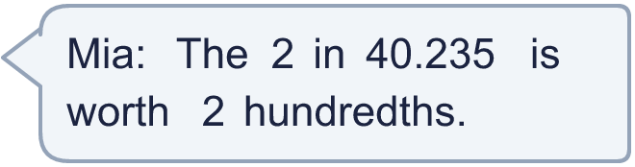
  9 | Is Mia correct? Circle yes or no.  Yes / No  Explain how you know.
  10 | Which of these are equal to 93.142? Write the letters.  A: 93.242  B: 93.1420  C: 93 + 0.142  D: 90 + 3 + 0.1 + 0.04 + 0.002
  10 | Which of these are equal to 93.142? Write the letters.  A: 93.242  B: 93.1420  C: 93 + 0.142  D: 90 + 3 + 0.1 + 0.04 + 0.002
  11 | Here are four digit cards: 2 8 9 5.  Use each card once to make the smallest number of the form __.__ (two digits, a decimal point, two digits).
  11 | Here are four digit cards: 2 8 9 5.  Use each card once to make the smallest number of the form __.__ (two digits, a decimal point, two digits).
  12 | Work out each answer.
    a) 18.937 + 0.001 =
    b) 18.937 − 0.01 =
    c) 18.937 + 0.1 =
  12 | Work out each answer.
    a) 18.937 + 0.001 =
    b) 18.937 − 0.01 =
    c) 18.937 + 0.1 =
  13 | Write a decimal that is between 2.6 and 2.7.
  13 | Write a decimal that is between 2.6 and 2.7.
  14 | Challenge  Work out 5 × 10 + 1 + 4 ÷ 100.
  14 | Challenge  Work out 5 × 10 + 1 + 4 ÷ 100.

Year 6 · Decimals · Step 2
Place value with whole numbers and decimals
Answers (teacher copy)

  1 | Write the number shown on each place value chart.  a) The number is 98.348  b) The number is 21.466
  2 | Use counters to make each number. Write how many counters go in each column.  a) 70.479: 7 0 4 7 9  b) 42.582: 4 2 5 8 2
  3 | Write the value of the digit in each number.  a) the 5 in 56.417: 50  b) the 6 in 58.602: 0.6  c) the 8 in 12.896: 0.8  d) the 7 in 13.274: 0.07
  4 | Write the missing number.  a) 65.147 = 60 + 5 + 0.1 + 0.04 + 0.007  b) 31.745 = 30 + 1 + 0.7 + 0.04 + 0.005  c) 72.311 = 70 + 2 + 0.3 + 0.01 + 0.001
  5 | Write the missing number.  a) 41.777 = 40 + 1 + 0.7 + 0.07 + 0.007  b) 79.383 = 70 + 9 + 0.3 + 0.08 + 0.003  c) 31.728 = 30 + 1 + 0.7 + 0.02 + 0.008
  6 | Write the missing number. The tenths change each time.  a) 4.785 = 4 + 0.7 + 0.08 + 0.005  b) 4.785 = 4 + 0.6 + 0.18 + 0.005  c) 4.785 = 4 + 0.5 + 0.28 + 0.005  d) 4.785 = 4 + 0.4 + 0.38 + 0.005
  7 | Write <, > or = in each box.  a) 24.251 < 24.351  b) 27.63 > 27.62  c) 28.2 > 28.19  d) 7.8 > 7.799
  8 | Write these numbers in order, starting with the greatest.  3.36 3.11 3.87 3.91  3.91, 3.87, 3.36, 3.11
  9 | Is Mia correct? Circle yes or no.  Yes / No  Explain how you know.  No. In 40.235 the 2 is in the tenths column, so it is worth 2 tenths.
  10 | Which of these are equal to 93.142? Write the letters.  A: 93.242  B: 93.1420  C: 93 + 0.142  D: 90 + 3 + 0.1 + 0.04 + 0.002  B, C, D
  11 | Here are four digit cards: 2 8 9 5.  Use each card once to make the smallest number of the form __.__ (two digits, a decimal point, two digits).  25.89
  12 | Work out each answer.  a) 18.937 + 0.001 = 18.938  b) 18.937 − 0.01 = 18.927  c) 18.937 + 0.1 = 19.037
  13 | Write a decimal that is between 2.6 and 2.7.  2.65
  14 | Challenge  Work out 5 × 10 + 1 + 4 ÷ 100.  51.04

